Supervisor: Navigation

INTRODUCTION

This Job Aid will provide guidance for a Supervisor to complete the Navigation within GSA’s new Online University which is utilizing the Cornerstone Learning Management System.
Contents
INTRODUCTION 1
LOG IN 2
WELCOME PAGE/HOME PAGE 3
a. Main Navigation 3
b. Scrolling Welcome Banner 3
c. Main Learning Areas 3
d. What’s New 3
e. Additional Information 3
f. Welcome Video 3
MAIN NAVIGATION 4
Online University Logo 4
Global Search 4
Universal Profile 4
Settings 5
LEARNING 6
View Your Transcript 6
Active Training 6
Completed Training 8
Learner Home 10
Events Calendar 12
Development Plans 14
Access Team Transcript 15
Assign Training to Subordinate 16
Approve Training Requests 17
REPORTS 18
Standard Reports 18
Reporting 2.0 20
MENTORING 20

LOG IN
To log in to GSA’s new Online University, please access: https://corporateapps.gsa.gov/gsa-olu/ or https://gsa.csod.com/.

- Select Single Sign-On.
- eSkillz Live Support is available 365/24/7 to assist you with any technical issues upon login or within the system itself.
- If you are a GSA user on VPN, you will enter into Online University and must acknowledge the statement provided before proceeding through the site.
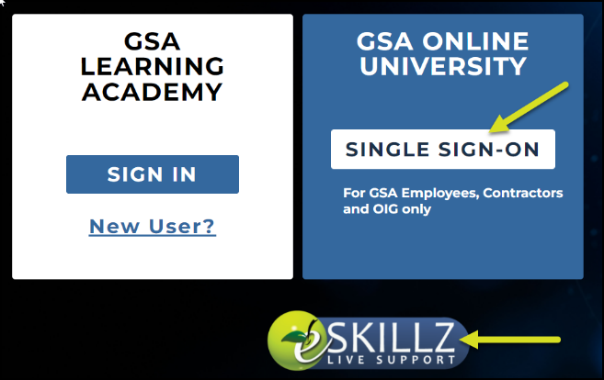

WELCOME PAGE/HOME PAGE
Please note, the homepage is a resource to display new initiatives within the Online University. At the time of system roll out, the welcome page displays the items presented below. While the sections remain the same in nature, the content itself will be periodically updated.
- Main Navigation Contains the Online University logo, Global Search, Universal Profile, and Settings
- Scrolling Welcome Banner Provides images and information for the Online University
- Main Learning Areas Highlights My Learning which directs you to your transcript page, My Individual Development Plan directs you to your IDP, Find Learning directs you to Learner Home, Events & Calendar directs you to the calendar of upcoming instructor-led session, and the Need Help? directs you to the Live Support chat room
- What’s New Highlights new initiatives and additional information to assist in your access to Online University items
- Additional Information Provides insight to the featured training and agency wide initiatives
- Welcome Video Provides a walk through of OLU and highlights key features within the system

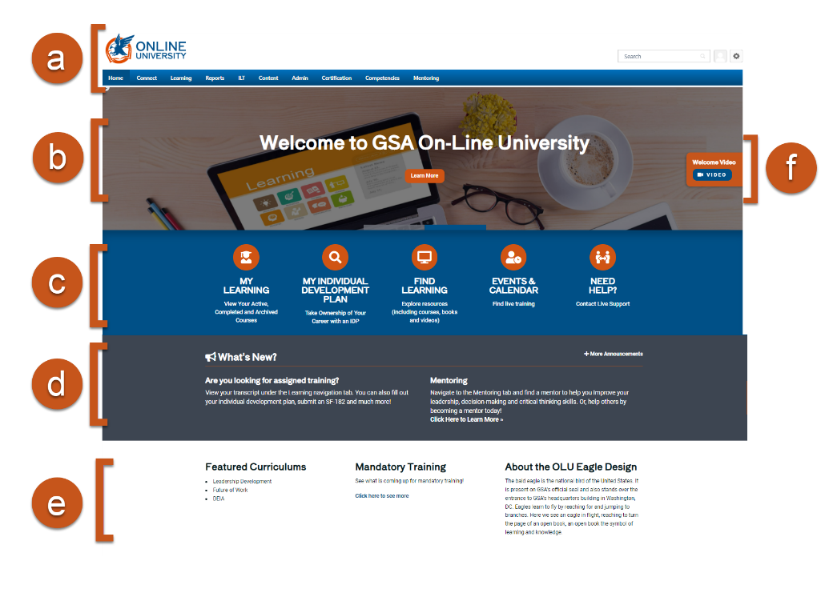

MAIN NAVIGATION

Online University Logo
- In the top left corner of the page is the Online University logo. By clicking this logo, you navigate back to the Welcome Page regardless of where you are in the portal. This is a convenient tool if you are lost or want to refresh the page.

Alternatively, you can access the Welcome Page in the navigation bar by clicking Home, then Welcome.

Global Search
- The Global Search, in the upper right-hand corner, provides an option to search people, training, certifications, Connect postings, and forms within the system. The Search option remains visible in the upper-right hand corner of the site regardless of which page you are on within the portal.
- To use this feature, enter keywords or relevant search criteria in the Search field; then click the magnifying glass or click Enter on your keyboard. As you begin to type, the search bar will populate related choices based on the words you enter.
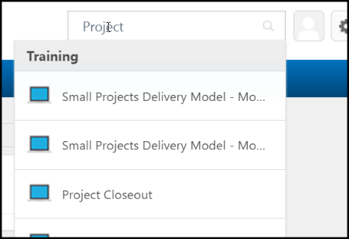

Universal Profile

- The Universal Profile provides quick access to your user information. You can access the Universal Profile by the person icon in the upper right corner of the screen.
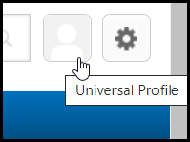

- Your Universal Profile contains pages for your Bio, Transcript, Actions, Snapshot, and View Team.
  - Bio displays your basic user information in the About section and lists your Summary, Subject, and Team information. Here, you can personalize your account.
  - Transcript is your personalized transcript which allows you to manage your active, complete, removed, and archived training.
  - Actions displays all your action items. Action items will vary based on position and portal permissions.
  - Snapshot provides your developmental progress (if you have created a development plan within the system).
  - View Team gives supervisors quick access to subordinates’ profiles and transcripts at any time and is available on all Universal Profile pages.
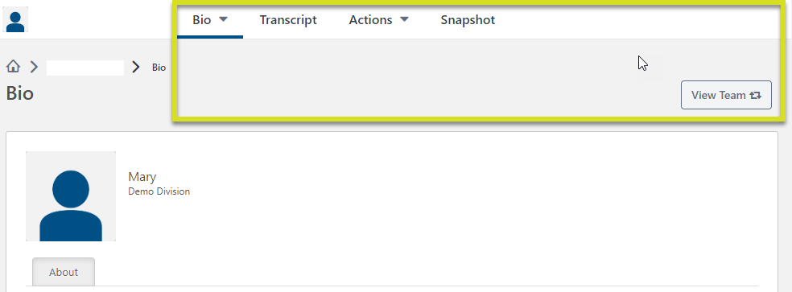

Settings

- The My Account allows you to modify your preferences including managing your absent status, social accounts, devices, course reviews, and view order history.
- The Help navigates you to the Online Help site where a wealth of additional information can be found to support you with Online University.
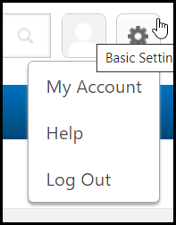

LEARNING

View Your Transcript
- Navigate to your transcript by clicking Learning in the top menu bar; then View Your Transcript.
- In Universal Profile, click Transcript.
Alternatively, you can access your transcript by clicking Universal Profile, then clicking Transcript.

- In the Transcript page you can filter by Active, Completed, and Archived Training.
  - Active Training currently assigned or registered
  - Completed Training completed in the past three years
  - Archived Training completed over 3+ years prior, or ones manually moved to archived
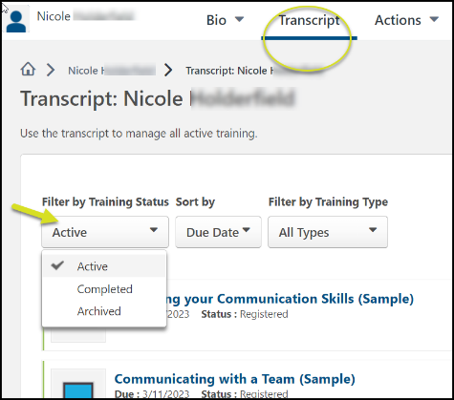
- When reviewing Active training, trainings can be sorted by
  - Due Date
  - Status
  - Date Added
  - Training Type

Active Training

Web-Based Training

- From the transcript, you can continue assigned, previously registered, or initiated training by clicking the Launch button to the right left of the training’s name.

- For additional actions, click the down arrow on the Launch button
  - Launch Opens the course window
  - View Training Details List details associated with the training including the training type, status, hours associated and your current progress
  - Request Exemption Allows you to provide a reason for a training exemption
  - Move to Archived Transcript Moves the training from your Active transcript page to your Archived but will not remove the responsibility you have to complete the training
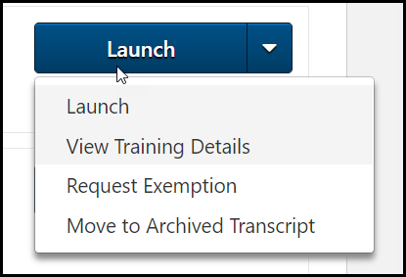

Instructor Led Sessions
- If you are pending approval for an Instructor-Led Training session, you would find that status on your Transcript.
- If you are Registered for an upcoming Instructor-led Training session, you can click the down arrow on the View Training Details button for additional options.
  - Withdraw If you are still within the withdrawal timeframe, you will be able to withdraw from the upcoming session
  - View Training Details List details associated with the training including the training type, status, hours, start/end time, instructor, and location
  - Request Exemption Allows you to provide a reason for a training exemption
  - Move to Archived Transcript Moves the training from your Active transcript page to your Archived but will not remove the responsibility you have to complete the training
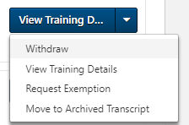

SF-182s or External Training
Your status of a submitted SF-182 or External Training can be found within your Transcript. Please refer to the GSA_JobAid_EndUser_SF182 for more specific information on submitting an SF-182.

Tests
- From the transcript, you can start or continue a test you have previously registered for, been assigned, or have started, click the Launch Test button to the left of the training.
- If you are Registered for a test, you can click the down arrow on the Launch button for additional options.
  - Launch Opens the test window
  - View Training Details List details associated with the training including the training type, status, hours associated, due date, allowed attempts, etc.
  - Request Exemption Allows you to provide a reason for a training exemption
  - Move to Archived Transcript. Moves the training from your Active transcript page to your Archived but will not remove the responsibility you have to complete the training
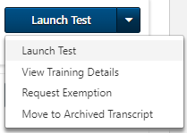

Completed Training

- After you complete a training, the training can be found by selecting Completed from the Filter by Training Status drop-down menu.
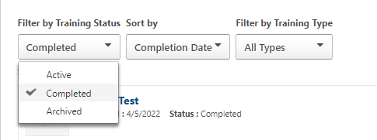

- The button to the right of the learning will vary depending on the current state of the object within the system.
  - View Completion Page Ability to rate the training on a five star scale, view certificate (if associated)
  - View Training Details List details associated with the training including the training type, description, status, credit/hours earned, due date(s) if applicable, etc.
  - Inactive The training is no longer available within the system for access.

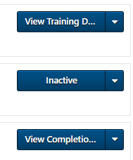

If the item is still active within the system, you can relaunch the training to review the content. Depending on the settings, you may or may not receive an additional completion for the training.

Learner Home
Learner Home serves as a learning hub, facilitating a seamless Online University experience. It allows you to browse, request, and filter relevant training. It also helps you prioritize and act on required tasks.

- To access Learner Home, navigate to the Learning menu and select Learner Home.
Alternatively, you can access Learner Home within the Welcome/Homepage’s main learning area by clicking Find Learning.

- Find the Search for learning box just below your greeting and “What would you like to learn today?” message.
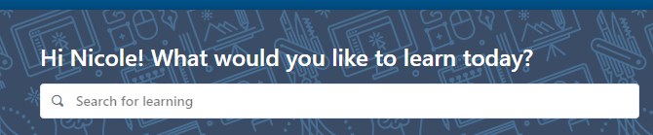
- Enter a training title or keywords and select the magnifying glass or click enter on your keyboard.
- The results page comes up and the number of results are listed.
- There are additional Filters (down the left side of the page) to choose from if the list is still too long.
  - Duration – filter by the length of time in training
  - Type – filter by the training types, i.e. Online Class, Event, Material, etc.
  - Modality – Watch, Read, Listen, Attend, Practice, etc.
  - Subject – filter by the list of options under this tab
  - Rating – filter by ratings 1-5 or Any Rating
  - Provider – filter by the list of option under this tab
  - Use the Reset option to clear all set filters and start again if needed
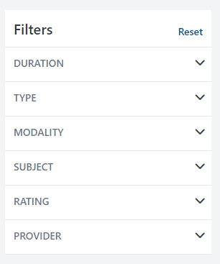

- Under the results there are tiles with titles, training hours and a more options ellipsis.
  - Select the Event Title to review more detail about the training to include the description.
  - Select the more options Ellipsis to:
    - Launch
    - Assign (if you have permission)
    - Save for Later
    - Add to Playlist (if you have permission)
    - Etc.
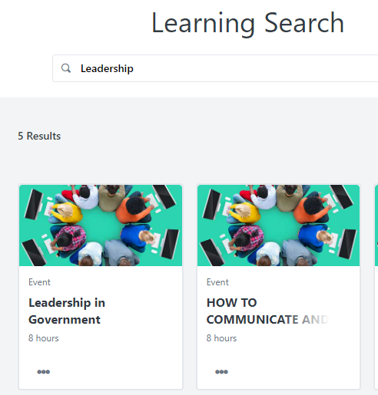

Events Calendar
Events are courses with scheduled dates and times (sessions) for delivery as Instructor-led or Virtually Instructor-led.

- To access the Events Calendar, navigate to the Learning menu and select Events Calendar.
Alternatively, you can access the Events Calendar within the Welcome/Homepage’s main learning area by clicking Events & Calendar.
- Review the calendar to see available sessions to attend
  - Options to view and narrow the focus are:
    - A Single Day
    - Full Week
    - Full Month
    - Agenda
    - All Events – set available to you
    - My Events – on your transcript

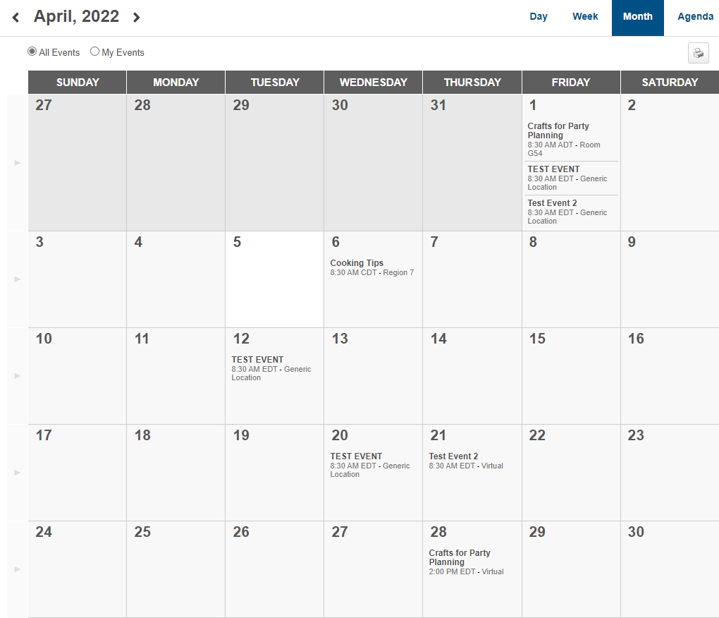

- Down the left side of the calendar view are filters to further narrow your search and Display options.
  - Filters Available:
    - Event Title – full or partial title
    - Session ID – full or partial number
    - Location – look-up an available location
    - Session Contact – look-up an available contact
    - Subject – add subjects of interest
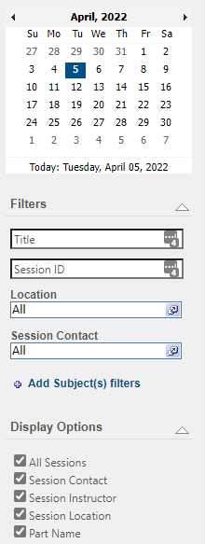
  - Display options will adjust how session detail is displayed on the calendar view

- Select the Event title to open the event details.
  - Event Details will provide more detail about the Event’s Session
- Clicking the Event title opens the session details pop-up
  - Review all details of the session
  - Request to attend
  - Assign (if permissible)
  - Close pop-up with the “X” in the upper right corner
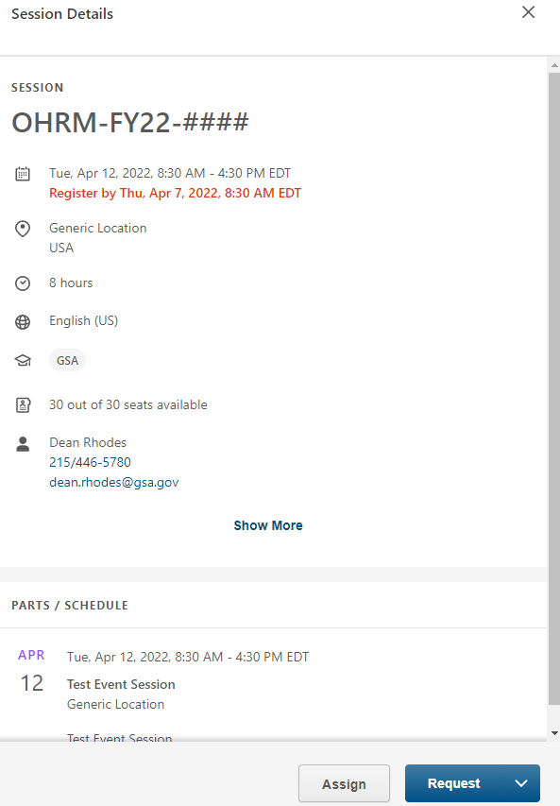

Development Plans
- To access the Development Plans, navigate to the Learning menu and select Development Plans.
Alternatively, you can access Development Plans within the Welcome/Homepage’s main learning area by clicking My Individual Development Plan.
- Within the Development Plan area of the system you can create and update your progress through your Individual Development Plan. Please refer to the GSA_JobAid_EndUser_IDP for more specific information on creating an IDP.

Access Team Transcript
Use the View Team button to open a flyout with all subordinates listed.
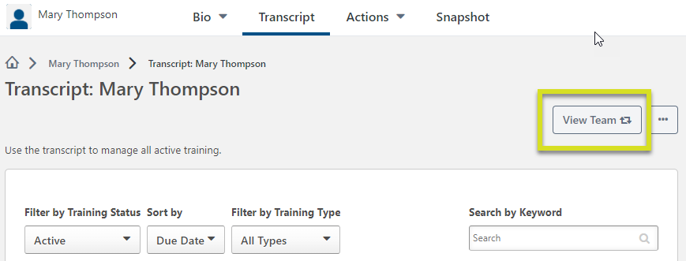

- Select any Name from the flyout to access a transcript
- Navigate through the user transcript, as needed
- Select the View Team button to get back to the flyout
- Select your name to get back to your transcript
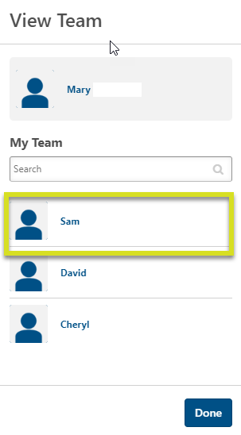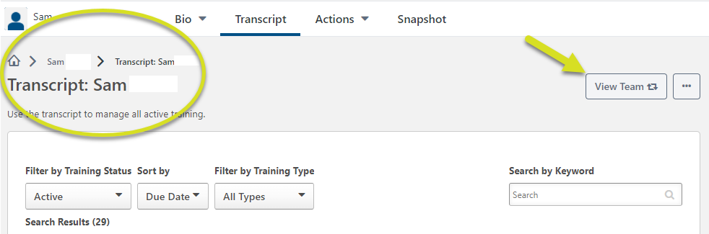

Assign Training to Subordinate
Supervisors have the ability to assign training to direct reports. If a training is recommended or found in the course catalog, take the following steps to assign it.

- Search for the training you want to assign to your direct report(s).
- From the Learning Details Page, select the Assign button

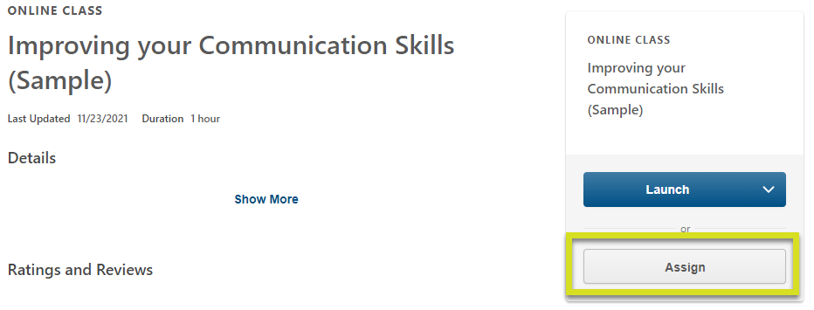

On the Assign Training page:
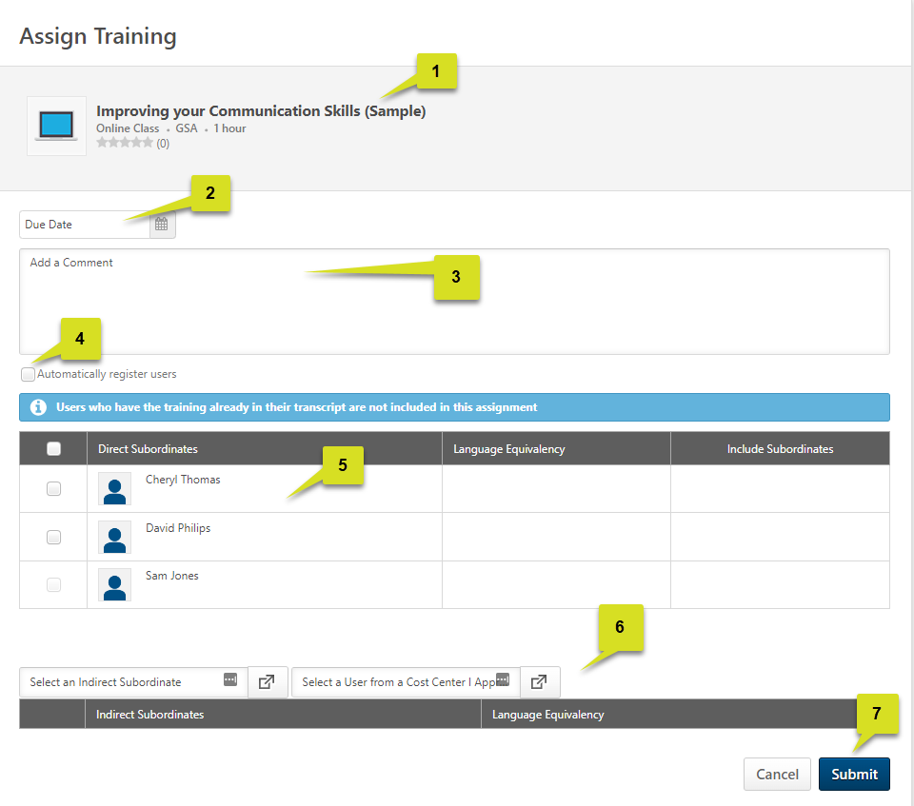
- Ensure the course listed is the one to be assigned.
- Select a Due Date – optional.
- Add a Comment – optional.
- Check the box to Automatically register users – highly recommended.
- Select the Direct Subordinate(s) to assign training.
  - Select ALL by checking the box in the dark gray banner next to Direct Subordinates.
  - Select individuals by checking the box next to their name.
    - If a subordinate is grayed out, they already have this training on their transcript.
- If any direct subordinates are also supervisors, there will be the option to assign to Indirect Subordinates.
  - Use the look-up button and search for the users you want to add to this assignment.
- When ready, select the Submit button and the assignment will process.
For more in depth detail about Assigning Training to direct reports, please reference the “GSA_JobAid_Supervisor_LOAssignment”.

Approve Training Requests
When direct reports request to attend Instructor Led Training (ILT), supervisors have an opportunity to approve or deny the request.

To access Pending Requests, navigate to the Reports menu and select Standard Reports.
- Select Pending Requests from the list of reports.
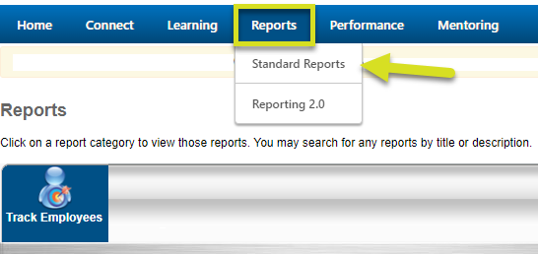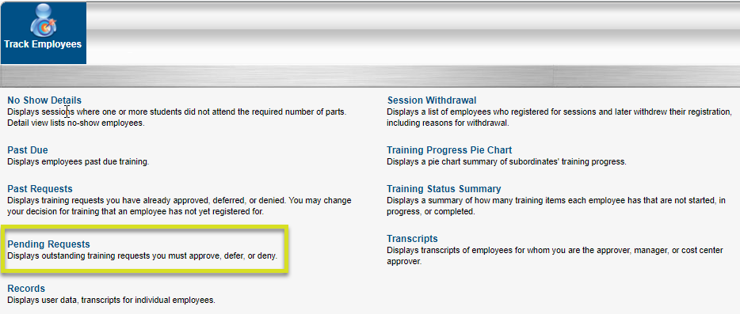
A list of all pending requests appear on the page. Use the search by name feature to narrow the focus.
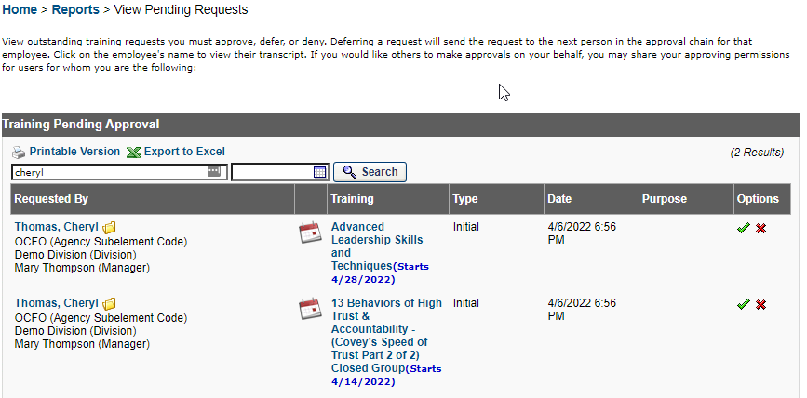
- Select the Requested By Name which redirects you to the user’s transcript view.
- Select the Training Title, and a pop-up with all Session Details will appear.
- Select the Options to Approve or Deny this request.

When approving the request, provide any additional comments and indicate payment requirements, then Submit.

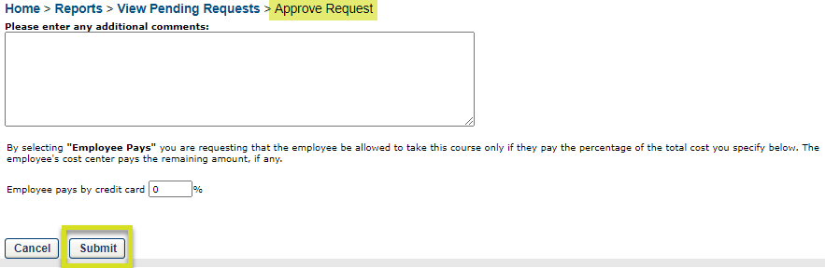

When denying the request, provide any additional comments and select the Submit button.

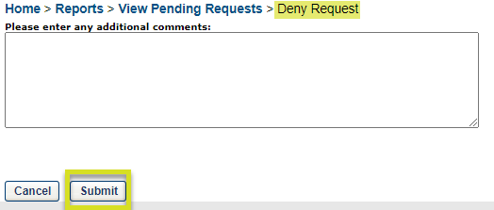

REPORTS
Access to reports are based on roles and permissions. There are two report types available.

Standard Reports
To access Standard Reports, navigate to the Reports menu and select Standard Reports.

Under Track Employees, there is a list of report titles with descriptions of the outputs.
- In this instance, the Training Progress Pie Chart will be the example report.
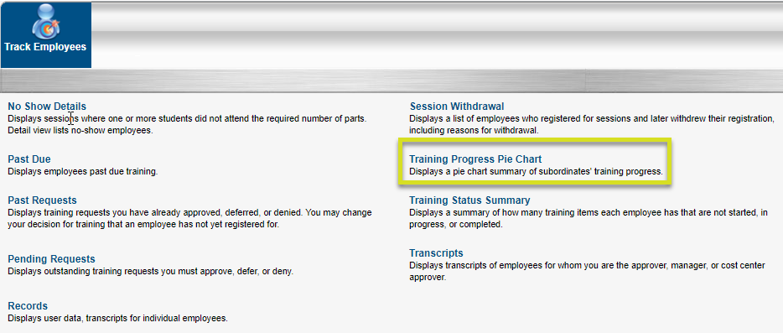

The report criteria page will come up. There is a minor set up to access the report needs.

- Date Criteria: The date range used will trigger the output to look for training registrations that occurred on the transcript.
  - Leave blank to get all instances of a specific training.
- Advance Criteria: There are a variety of options to select or deselect as needed.
  - Training Type – Narrow the focus of the report to a specific type of training or combination by unchecking types you do not want in the report.
  - Training Title – Use the lookup icon to select a specific training title from the catalog or leave this blank to view all titles on the transcript(s).
  - Options – Check the box to do the operation stated, uncheck to not do the operation.
  - Display – Select the radio button you wish to include in the report.
  - Equivalent Training – Check if you wish to include users with Completed Equivalent statuses.
  - Include Removed Training – Check if you wish to see training that is removed from user transcripts.
  - User Status – Check if you need to see Inactive Users in the report.
- Search: This will run the report with the selected settings.
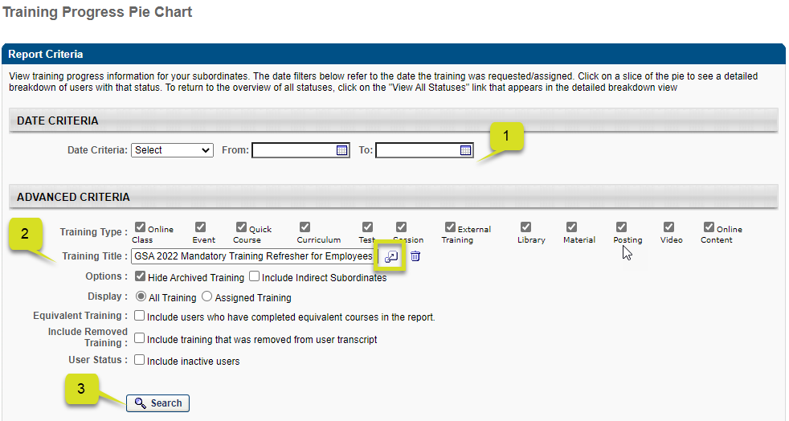
Once the report processes, scroll down to find the pie chart.

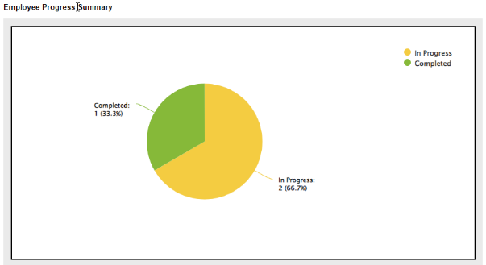
Below the pie chart will be a list of direct reports that make up the chart data and their statuses on the training(s). 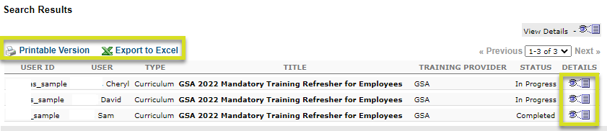

- Print Options – Select Printable Version or Export to Excel.
- Details – Select this icon to review the details of the curriculum in this example.

Reporting 2.0
To access the Reports, navigate to the Report menu and select Reporting 2.0.
- Your access in reports is limited to what is shared with you and your individual permissions. Each end user will have access to the Available Mentors report.
- Please refer to the GSA_JobAid_EndUser_Mentoring for more specific information on the use of the Available Mentors Report.

MENTORING
To access the GSA Mentoring Program, navigate to the Mentoring menu and select GSA Mentoring Program.
- Please refer to the GSA_JobAid_EndUser_Mentoring for more specific information.

