Supervisor: Individual Development Plans
Table of Contents
INTRODUCTION 1
CREATING AN IDP 1
Add Objectives Error! Bookmark not defined.
Associate Learning Objects Error! Bookmark not defined.
DEVELOPMENT PLAN ASSIGNMENT 6
APPROVING AN IDP 7
CONTINUOUS REVIEW OF EMPLOYEE PLANS 9

INTRODUCTION

This Job Aid will provide guidance for a supervisor to create an Individual Development Plan (IDP) for their employees and approve an IDP created by their employees within GSA’s new Online University which is utilizing the Cornerstone Learning Management System.

Please note: What is saved in the system, stays in the system. Take consideration as to how you populate open fields like descriptions, objectives, and comments.

CREATING AN IDP

- Navigate to Development Plans by selecting Learning from the top navigation, then Development Plans.
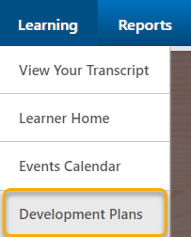

- Click Create New Plan.
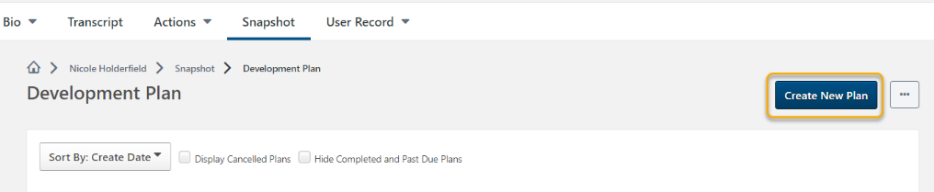
- Place a title for your plan in the Plan Title text box.
- Select a Category from the drop down menu.
- Include a description of the IDP.

Add Objectives

- In the Development Objectives area of the Create a Plan page, click Add Objective.

- In the Add Development Objectives provide the following:
- An Objective Title
- The Category the objective

Associate Training
Associate training with the objective you want to complete. You are able to associate training in three ways; Search for Learning, Browse Recommended, and Add Development Action.

1
2
3

1) Search for Learning
Provides the training available within Online University.
- To find a specific training, use the top search bar, or browse training by type, subject or duration.
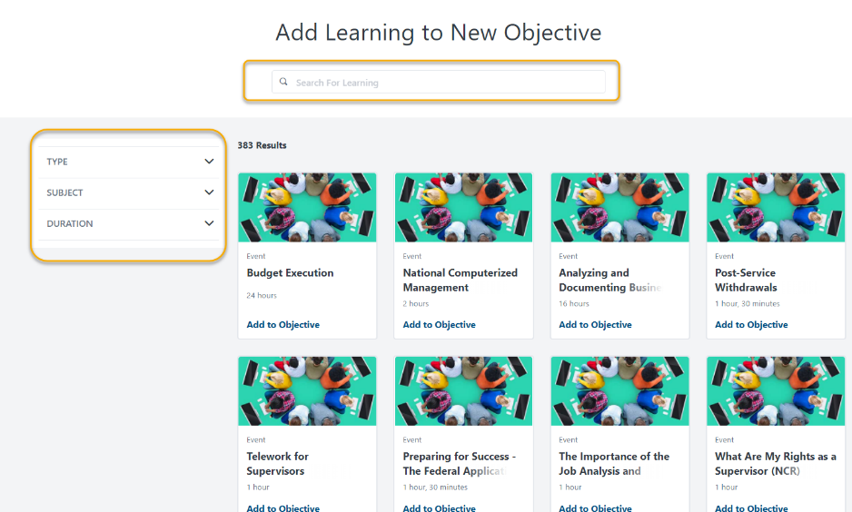

- Upon finding an appropriate learning object, select Add to Objective.
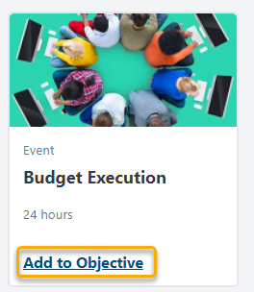

- Once all learning objects are selected, click Return to Objective found at the bottom of the page.

2) Browse Recommended
Within the Recommended Learning & Development Actions for New Objectives, page you ca filter the selections by using three options.
- Competency Model
- Competency Assessment
- Continue Learning
  - Competency Model
Competency Model allows you to select a model with training associated with the competencies within the model itself.
  - Competency Assessments
Competency assessments display training recommended after completing a competency assessment. At this time, this option is not implemented at GSA.

  - Continue Learning
Continue Learning includes any training you are currently registered for and in progress as well as any SF-182s or External Trainings on your transcript.
- Upon finding an appropriate learning object, select Add to Objective.
- Once all trainings are selected, click Return to Objective found at the bottom of the page.

3) Add Development Actions
Allows input of various activity types which take place externally from Online University.
- Populate the Description
- Select an Activity Type
- Identify a Due Date
- Track ongoing % of progress

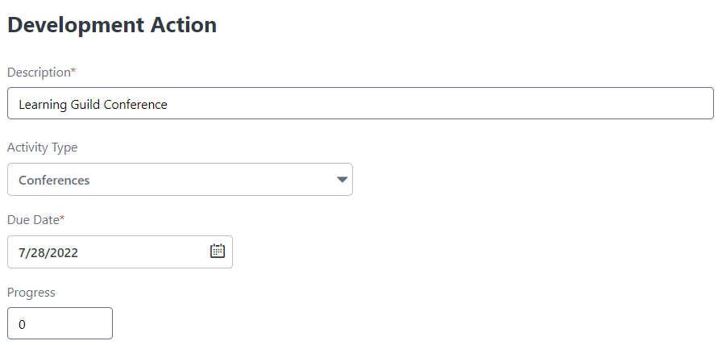

- Upon completion of associating training to objectives, additional objectives can be added by repeating the process until all objectives are associated.

DEVELOPMENT PLAN ASSIGNMENT

- To assign the plan to your team, select My Team in the Assignment area of the Create a Plan page.
- Once the My Team radio button is selected, team members are automatically selected for assignment. Deselect employees as needed, and/or Include Subordinates as required for the plan.
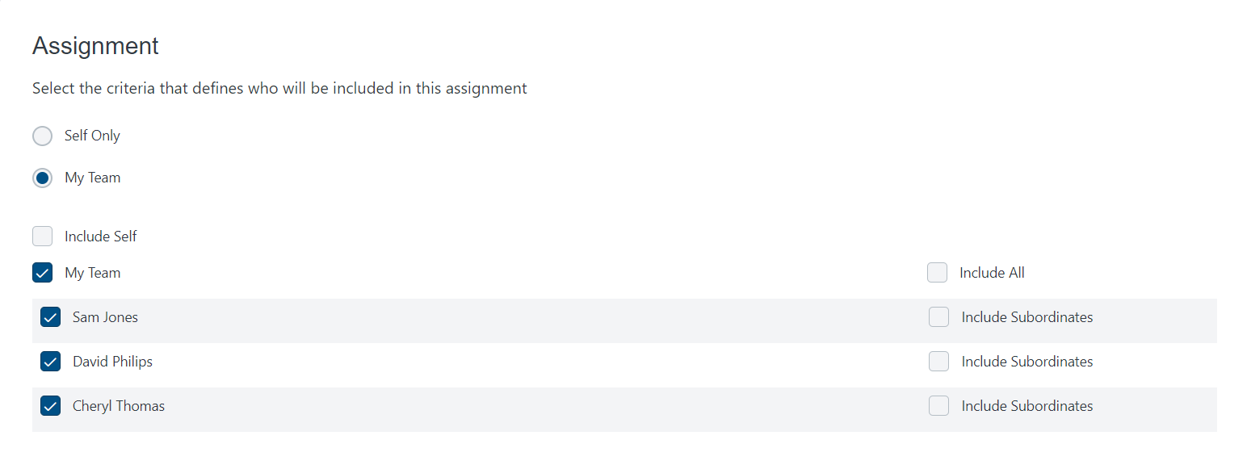

- Once your selections have been made, select Submit Plan.

APPROVING AN IDP
- Once an Development Plan has been submitted by an employee, you will need to review the plan in order to Approve or Deny the IDP. Navigate to the Development Plans by selecting Learning from the top navigation, then Development Plans.
Alternatively, you can access the Development Plan by clicking on Universal Profile, then Snapshot.
- To view all plans pending approval, click the ellipses then click Approve Plans
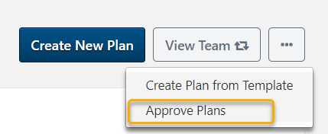

- To review the contents of the plan, click the Plan Title.
  - If you wish to modify the objectives of a plan, click Options in the right corner and then click Edit Development Plan.
    - Modifications can be made by following the steps listed in Creating an IDP.
  - Objective comments can be added by clicking Add a Comment below the selected Development Objective.
  - Overall Plan Comments can also be added by clicking Add a Comment under Plan Comments.
  - Attachments such as certificates or transcript histories from another system can be added by clicking Upload Attachment in the Attachments area.
- Once you have reviewed the plan and made any necessary updates, you can click Approve or Deny found at the top of the page.

CONTINUOUS REVIEW OF EMPLOYEE PLANS

- To review progress of an employee’s development plan you can revisit the plan by navigating to the Development Plans by selecting Learning from the top navigation, then Development Plans.
Alternatively, you can access the Development Plan by clicking on Universal Profile, then Snapshot.
- Then, click View Team.
- Select an employee’s name then, select the plan you wish to review by clicking the name of the plan.
- Within this area, you can;
  - Edit the Plan to modify objectives.
  - Update an employee’s progress of a Development Action.
  - Objective comments can be added by clicking Add a Comment below the selected Development Objective.
  - Overall Plan Comments can also be added by clicking Add a Comment under Plan Comments.
  - Attachments such as certificates or transcript histories from another system can be added by clicking Upload Attachment in the Attachments area.

