End User: Navigation

INTRODUCTION

This Job Aid will provide guidance for an End User to complete the Navigation within GSA’s new Online University which is utilizing the Cornerstone Learning Management System.
Contents
INTRODUCTION 1
LOG IN 2
WELCOME PAGE/HOME PAGE 3
a. Main 3
b. Scrolling Welcome Banner 3
c. Main Learning Areas 3
d. What’s New 3
e. Additional Information 3
f. Welcome Video 3
MAIN NAVIGATION 4
Online University Logo 4
Global Search 4
Universal Profile 4
Settings 6
LEARNING 7
View Your Transcript 7
Active Learning Objects 7
Completed Learning Objects 9
Learner Home 11
Events Calendar 13
Development Plans 16
REPORTS 16
MENTORING 16

LOG IN

Users access Online University via Insite https://corporateapps.gsa.gov/gsa-olu/ or https://gsa.csod.com/.

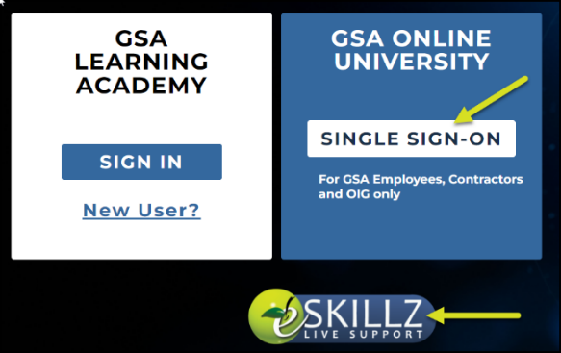

- Select Single Sign-On.
- eSkillz Live Support is available 365/24/7 to assist you with any technical issues upon login or within the system itself.
- If you are a GSA user on VPN, you will enter into Online University and must acknowledge the statement provided before proceeding through the site.

WELCOME PAGE/HOME PAGE
Please note, the homepage will be a resource to display new initiatives within Online University. At the time of system roll out, the welcome page displayed the items presented below. While the sections remain the same in nature, the content itself will be updated periodically.

- Main Navigation Contains the Online University logo, Global Search, Universal Profile, and Settings.
- Scrolling Welcome Banner Provides images and information for Online University.
- Main Learning Areas Highlights My Learning which directs you to your transcript page, My Individual Development Plan which will direct you to your IDP, Find Learning which will direct you to Learner Home, Events & Calendar which will direct you to the calendar of upcoming instructor-led session, and Need Help? Will direct you to the Live Support chat room.
- What’s New Highlights new initiatives and additional information to assist you with Online University items.
- Additional Information Provides insight to the featured training and agency wide initiatives.
- Welcome Video Provides a walk-through of Online University and highlights key features within the system.
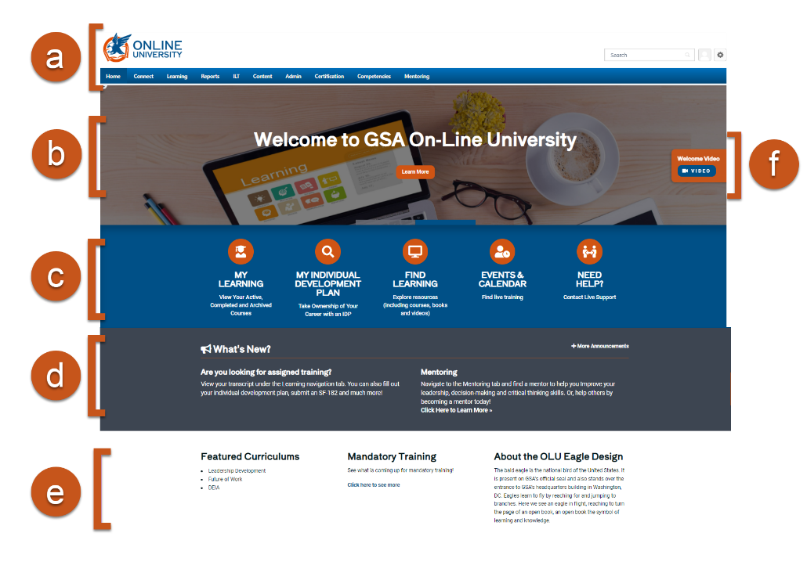

MAIN NAVIGATION

Online University Logo
- In the top left corner of the page is the Online University logo. By clicking this logo, you will navigate back to the Welcome Page regardless of where you are in the portal. This is a convenient tool if you are lost or want to refresh the page.

Alternatively, you can access the Welcome Page in the navigation bar by clicking Home, then Welcome.

Global Search
- The Global Search in the upper right-hand corner provides an option to search people, training, certifications, Connect postings, and forms within the system. The Search option remains visible in the upper-right hand corner of the site regardless of which page you are on within the portal.
- To use this feature, enter keywords or relevant search criteria in the Search field, then click the magnifying glass or click the Enter button on your keyboard. As you begin to type, the search bar will populate related choices based on the words you enter.
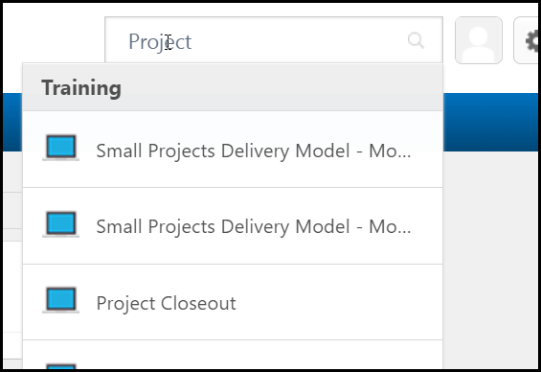

Universal Profile

- The Universal Profile provides quick access to your user information. You can access the Universal Profile by the person icon in the upper right corner of the screen.
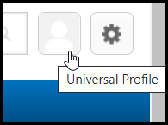

- Your Universal Profile contains pages for your Bio, Transcript, Actions, and Snapshot.
  - Bio displays your basic user information in the About section and lists your Summary, Subject, and Team information. Here, you can personalize your account.
  - Transcript is your personalized transcript which allows you to manage your active, complete, removed, and archived training.
  - Actions display all your action items. Action items will vary based on position and portal permissions.
  - Snapshot provides your development progress (if you have created a development plan within the system).
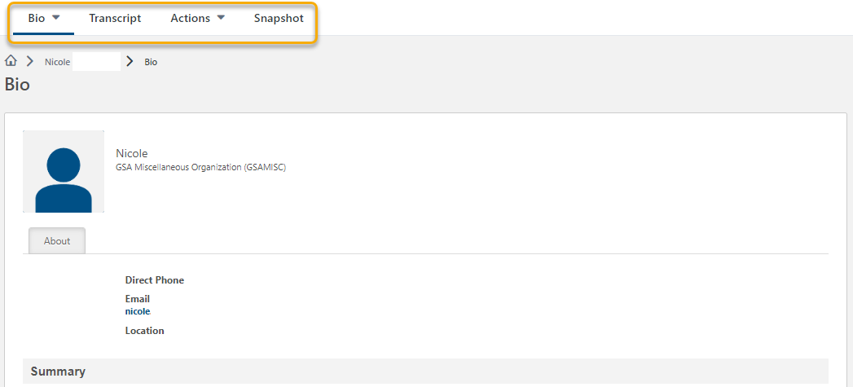

Settings

- The My Account area allows you to modify your preferences including your absent status, manage social accounts, manage devices, manage course reviews, and view order history.
- The Help section navigates you to the Online Help site where a wealth of additional information can be found to help you navigate and function within Online University.
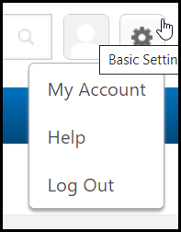

LEARNING

View Your Transcript
- Navigate to your transcript by clicking Learning in the top menu bar, then View Your Transcript.
Alternatively, you can access your transcript by clicking Universal Profile; then clicking Transcript as seen below.

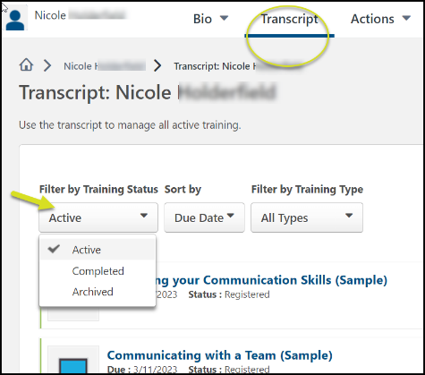

- In the Transcript page you can filter by Active, Completed, and Archived Training.
  - Active Learning Objects currently assigned or registered.
  - Completed Learning Objects completed in the past three years.
  - Archived Learning Objects completed over 3+ years prior, or ones manually moved to archived.
- When reviewing Active learning objects, training can be sorted by:
  - Due Date
  - Status
  - Date Added
  - Training Type
  - Due Date

Active Learning Objects

Web-Based Training

- From the transcript, you can continue assigned, previously registered, or initiated by clicking the Launch button to the right of the training’s name.

- For additional options, click the down arrow on the Launch button.
  - Launch Opens the course window.
  - View Training Details List details associated with the training including the training type, status, hours associated and your current progress.
  - Request Exemption Allows you to provide a reason for a training exemption.
  - Move to Archived Transcript Moves the training from your Active transcript page to your Archived but will not remove the responsibility you have to complete the training.
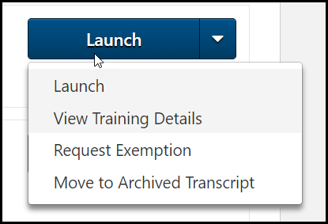

Instructor Led Sessions

- If you are pending approval for an Instructor-Led Training session, you would find that status on your Transcript.
- If you are Registered for an upcoming Instructor-led Training session, you can click the down arrow on the View Training Details button for additional options.
  - Withdraw If you are still within the withdraw timeframe, you can withdraw from the upcoming session.
  - View Training Details Lists details associated with the training including the training type, status, hours, start/end time, instructor, and location.
  - Request Exemption Allows you to provide a reason for a training exemption.
  - Move to Archived Transcript Moves the training from your Active transcript page to your Archived but will not remove the responsibility you have to complete the training.
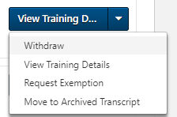

SF-182s or External Training

- Your status of a submitted SF-182 or External Training can be found within your Transcript. For more information on submitting your SF-182, please refer to the GSA_JobAid_EndUser_SF182.

Tests

- If you are Registered for a test, you can click the down arrow on the Launch button for additional options. From the transcript, you can start or continue a test you were previously assigned . Click the Launch Test button to the right of the training to access the test.
- If you are Registered for a test and need additional options, you can click the down arrow on the Launch button.
- Launch Opens the test window.
  - View Training Details List details associated with the training, including the training type, status, hours, due date, allowed attempts, etc.
  - Request Exemption Allows you to provide a reason for a training exemption.
  - Move to Archived Transcript. Moves the training from your Active transcript page to your Archived but will not remove the responsibility you have to complete the training.
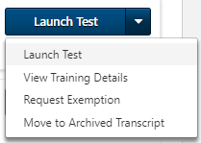

Completed Learning Objects

- After you complete a training, the training can be found by selecting Completed from the Filter by Training Status drop-down.
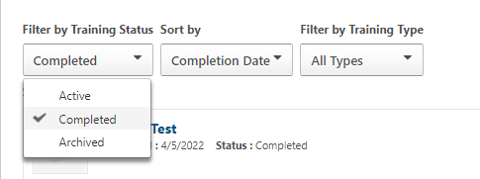

- The button to the right of the learning will vary depending on the status of the training.
  - View Training Details List details associated with the training including the training type, description, status, credit/hours earned, etc.
  - Inactive The training is no longer available within the system for access.
  - View Completion Page Allows you to rate the training and view your certificate.
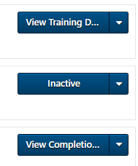
If the item is still active within the system, you can relaunch the training to review the content. Depending on the learning object settings, you may or may not receive an additional recorded completion for the training (i.e. a new date and time stamp will not appear on your transcript records to reflect an additional completion of the course).

Learner Home
Learner Home serves as a learning hub, facilitating a seamless Online University experience. It allows you to browse, request, and filter relevant training. It also helps you prioritize and act on required tasks.

- To access Learner Home, navigate to the Learning menu and select Learner Home.
Alternatively, you can access Learner Home within the Welcome/Homepage’s main learning area by clicking Find Learning.

- Find the Search for learning box just below your greeting and “What would you like to learn today?” message.
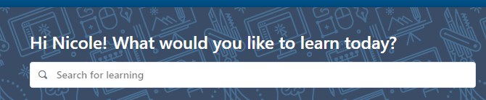
- Enter a training title or keywords, and select the magnifying glass, or click enter on your keyboard.
- The results page comes up and the number of results are listed.
- There are additional Filters (down the left side of the page) to choose from if the results are still too long.
  - Duration – filter by the length of time to complete training.
  - Type – filter by the training types, i.e., Online Class, Event, Material, etc.
  - Modality – Watch, Read, Listen, Attend, Practice, etc.
  - Subject – filter by the list of topics under this tab.
  - Rating – filter by ratings 1-5 or Any Rating.
  - Provider – filter by the list of options under this tab.
  - Reset - Use the Reset option to clear all set filters and start again if needed.
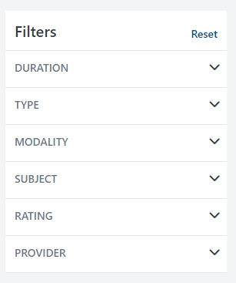

- Under the results, there are tiles with titles, training hours, and a more options ellipsis.
  - Select the Event Title to review more detail about the training to include the description.
  - Select the more options Ellipsis to:
    - Launch
    - Assign (if you have permission)
    - Save for Later
    - Add to Playlist (if you have permission)
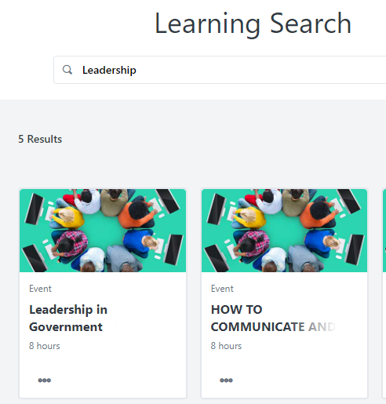

Events Calendar

Events are courses with scheduled dates and times (sessions) for delivery as Instructor-led or Virtually Instructor-led training.

- To access the Events Calendar, navigate to the Learning menu and select Events Calendar.
Alternatively, you can access the Events Calendar within the Welcome/Homepage’s main learning areas by clicking Events & Calendar.

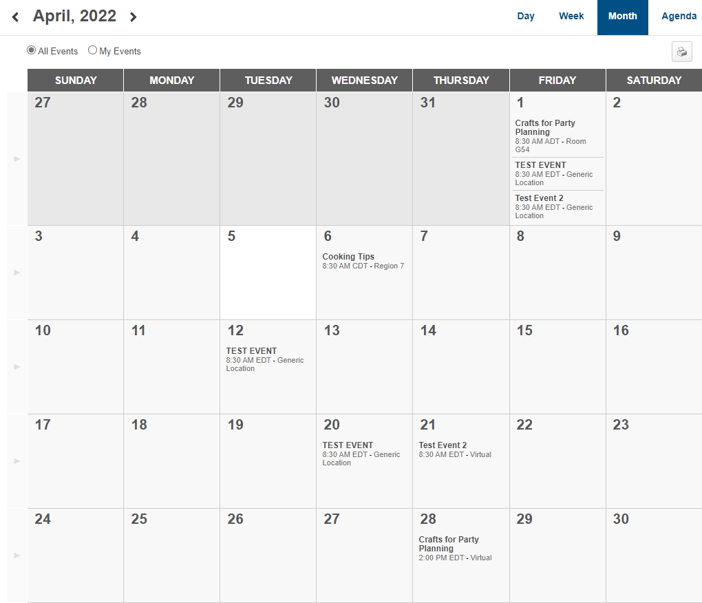

- Review the calendar to see available sessions to attend.
  - Options to view and narrow the focus are:
    - A Single Day
    - Full Week
    - Full Month
    - Agenda
    - All Events – training available to you
    - My Events – on your transcript

- Down the left side of the calendar view are filters to further narrow your search and Display options.
  - Filters Available:
    - Event Title – full or partial title
    - Session ID – full or partial number
    - Location – look-up an available location
    - Session Contact – look-up an available contact
    - Subject – add subjects of interest
  - Display Options will adjust how session details are displayed on the calendar view.
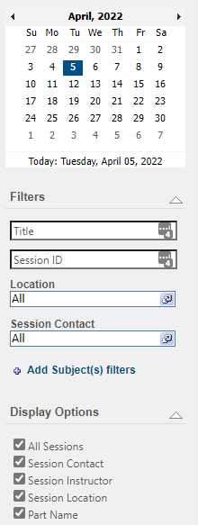
- Selecting the Event Title opens the event details.
  - Event Details will provide more detail about the Event’s Sessions.

- Clicking the Event Title opens the session details pop-up.
  - Review all details of the session
  - Request to attend
  - Assign (if permissible)
  - Close pop-up with the “X” in the upper right corner
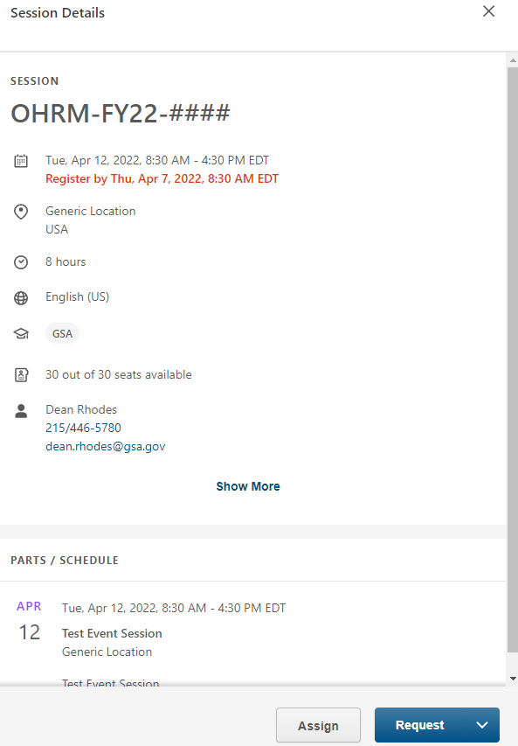

Individual Development Plans (IDP)

- To access the IDP, navigate to the Learning menu and select Development Plans.
Alternatively, you can access Development Plans within the Welcome/Homepage’s main learning area by clicking My Individual Development Plan.
- Within the Development Plan, you can create and update your profile. Please refer to the GSA_JobAid_EndUser_IDP for more specific information on creating an IDP.

REPORTS
- To access the Reports navigate to the Report menu and select Reporting 2.0.
Your access to reports is limited to what is shared with you and your individual permissions. Each end user will have access to the Available Mentors report. Please refer to the GSA_JobAid_EndUser_Mentoring for more specific information on the use of the Available Mentors Report.

MENTORING
- To access the GSA Mentoring Program, navigate to the Mentoring menu and select GSA Mentoring Program.
Please refer to the GSA_JobAid_EndUser_Mentoring for more specific information on the use of the Available Mentors Report.

