End User: Individual Development Plans

INTRODUCTION

This Job Aid will provide guidance for an end user to complete an Individual Development Plan (IDP) within GSA’s new Online University which is utilizing the Cornerstone Learning Management System.

Please note: What is saved in the system, stays in the system. Take consideration as to how you populate open fields like descriptions, objectives, and comments.

Table of Contents
INTRODUCTION 1
CREATING AN IDP 1
Add Objectives 2
Associate Training 2
DEVELOPMENT PLAN ASSIGNMENT 5
COMPLETING YOUR IDP 6

CREATING AN IDP

- Navigate to your Development Plans by selecting Learning from the top navigation, then Development Plans.
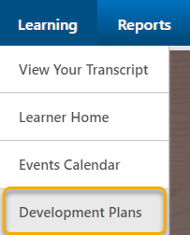

- Click Create New Plan.
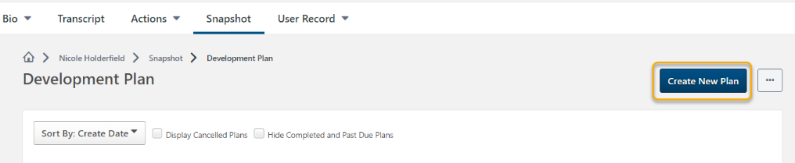

- Place a title for your plan in the Plan Title text box.
- Select a Category from the drop down menu.
- Include a description of your IDP.

Add Objectives

- In the Development Objectives area of the Create a Plan page, click Add Objective.

- In the Add Development Objectives provide the following:
- An Objective Title
- The Category the objective

Associate Training
Associate training with the objective you want to complete. You are able to associate training in three ways; Search for Learning, Browse Recommended, and Add Development Action.

1
2
3

1) Search for Learning
Provides the training available within Online University.
- To find a specific training, use the top search bar, or browse training by type, subject or duration.
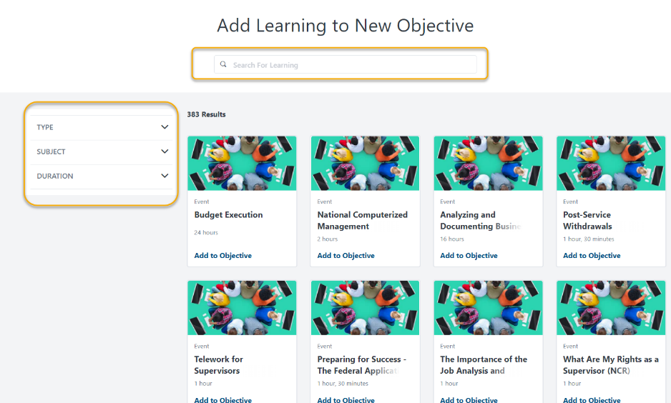

- Upon finding an appropriate learning object, select Add to Objective.

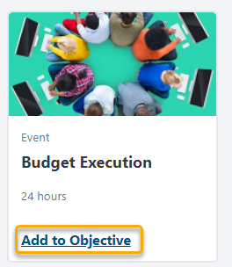

- Once all learning objects are selected, click Return to Objective found at the bottom of the page.

2) Browse Recommended
Within the Recommended Learning & Development Actions for New Objectives, page you ca filter the selections by using three options.
- Competency Model
- Competency Assessment
- Continue Learning
  - Competency Model
Competency Model allows you to select a model with training associated with the competencies within the model itself.
  - Competency Assessments
Competency assessments display training recommended after completing a competency assessment. At this time, this option is not implemented at GSA.
  - Continue Learning
Continue Learning includes any training you are currently registered for and in progress as well as any SF-182s or External Trainings on your transcript.
- Upon finding an appropriate learning object, select Add to Objective.
- Once all trainings are selected, click Return to Objective found at the bottom of the page.

3) Add Development Actions
Allows input of various activity types which take place externally from Online University.
- Populate the Description
- Select an Activity Type
- Identify a Due Date
- Track ongoing % of progress
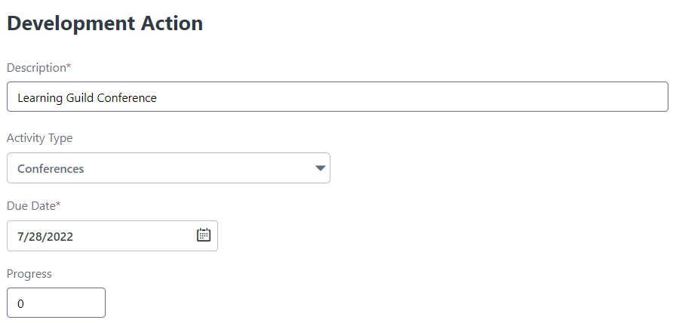

- Upon completion of associating training to objectives, additional objectives can be added by repeating the process until all objectives are associated.

DEVELOPMENT PLAN ASSIGNMENT
- The plan can be assigned to self only, or custom assignment in which selected users can be identified.
- Once completed, select Submit Plan.
- Your plan will then be listed as Pending Acceptance Approval by your manager; however you are able to complete the items within your plan while in this status.

COMPLETING YOUR IDP
- Navigate to your Development Plans by selecting Learning from the top navigation, then Development Plans.
Alternatively, you can access the Development Plan by clicking on Universal Profile, then Snapshot.
- Click on the plan title.
- In the Development Objectives area of the plan, depending on your training types, you can update your progress, launch training, or edit External Training or SF-182 items as needed.

  - Development Actions Progress can be updated by sliding the progress bar to show the current status of the Development Actions listed.
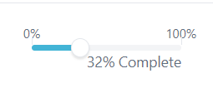
  - Web-based Training Training can be launched from the development plan for completion. If a training has been completed within the transcript, the status of the training is carried over to the development plan. You can also view the training material within the development plan.
  - External Trainings/SF-182 External Trainings or SF-182s are reviewed or modified within the development plan (dependent on current status).
- Objective comments are added by yourself or your manager by clicking Add a Comment below the selected Development Objective.
- Overall Plan Comments are added by yourself or your manager by clicking Add a Comment under Plan Comments.
- Attachments such as certificates or transcript histories from another system are added by clicking Upload Attachment in the Attachments area.

