End User: General Use of Learning

INTRODUCTION

This Job Aid will provide guidance for an End User to complete the General Use of Learning within GSA’s new Online University which is utilizing the Cornerstone Learning Management System.

Contents
INTRODUCTION 1
END USER SEARCH FOR TRAINING 2
Course Catalog via Global Search 2
Course Catalog via Learner Home - Search 4
Events Calendar 6
LAUNCH AN ONLINE WEB-BASED TRAINING 9
Launch via Training Details from Global Search or Learner Home Search 9
Launch via Learner Home - Continue Learning Carousel 9
Launch via Transcript View 10
REGISTER FOR AN INSTRUCTOR-LED TRAINING (ILT) 10
Request via Training Details from Global Search, Learner Home Search, or Events Calendar 11
Request via Learner Home - Continue Learning Carousel 13
Request via Transcript View 13
SUBMIT AN EXTERNAL TRAINING 14
Add External Training (Transcript) 15

END USER SEARCH FOR TRAINING

There are three ways to search for training within the Online University: Global Search, Learner Home, and the Events Calendar.

Course Catalog via Global Search

Global Search can be used to search for People or Training.

- To search for training content within the Online University, enter relevant search criteria (keywords, title, part of the title, etc.) in the Global Search field in the upper right corner of the screen.
- Then, click the magnifying glass or click enter on your keyboard to view the full list of learning items that match your search criteria.
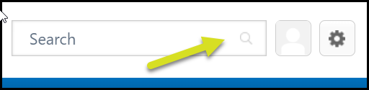

- Use the options on the left side of the screen to filter the search results.
  - Show All – Results from both Training and People
  - Training – Results from the Course Catalog
  - People – Results from Users in the Organization
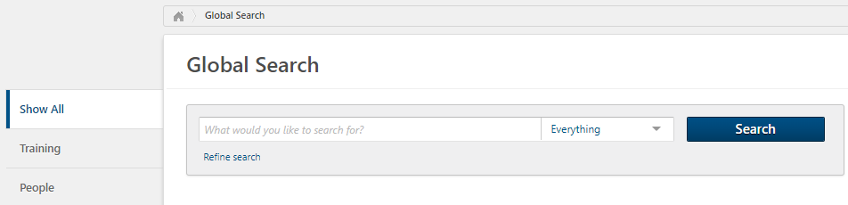

- Select Training on the left side bar and find icons for each training type in the catalog. Filter results for the following individually or in combination:

  - Top Row Left to Right Icons –
    - Online Classes
    - Events
    - Curricula
    - Materials
  - Middle Row Left to Right Icons –
    - Library
    - Tests
    - Videos
    - Playlists
  - Bottom Row Left to Right Icons –
    - External Content
    - Online Content
    - Programs
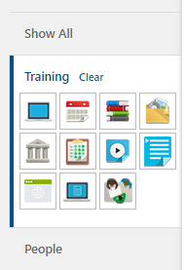

- Additionally, you can use the Refine Search option, shown below, to further refine your search results. Click Refine Search to expand the options.

- The Refine your search options can be used individually or in combination.
  - Enter any known information for Title, Description or Keywords
  - Use the Lookup button within Subject, Provider, Location, or Company to select from the list of options
  - Toggle the Rating scale to determine a minimum desired course rating in the results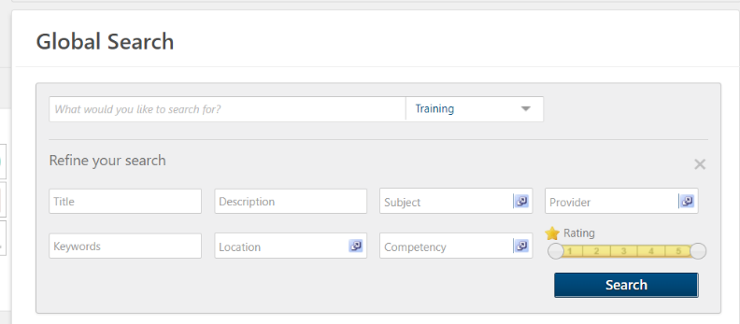

Course Catalog via Learner Home - Search

Learner Home serves as a learning hub, facilitating a seamless Online University experience. It allows you to browse, request, and filter relevant training. It also helps you prioritize and act on required tasks.

- To access Learner Home, navigate to the Learning menu and select Learner Home.

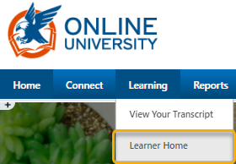

- Find the Search for learning box just below your greeting and “What would you like to learn today?” message.
- Enter a training title or keywords. Then select the magnifying glass or click enter on your keyboard.
- The results page will come up, and the number of results will be listed.
- If the list is too long, there are additional filters in which to narrow your search.
  - Duration – filter by the duration of the training
  - Type – filter by the training types, i.e. Online Class, Event, Material, etc.
  - Modality – Watch, Read, Listen, Attend, Practice, etc.
  - Subject – filter by the list of topics under this tab
  - Rating – filter by ratings 1-5 or Any Rating
  - Provider – filter by the list of option under this tab
  - Reset – Rest to clear all filters
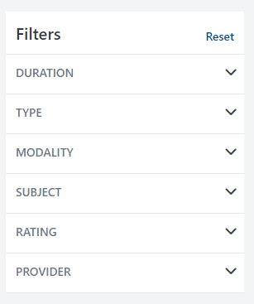

- Under the results there are tiles with titles, training hours and a more options ellipsis.
  - Select the Event Title to review the training’s description.
  - Select the more options Ellipsis to:
    - Launch
    - Assign (if you have permission)
    - Save for Later
    - Add to Playlist (if you have permission)
    - Etc.

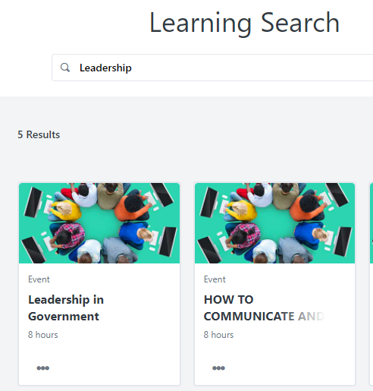

Events Calendar

Events are courses with scheduled dates and times (sessions) for delivery as Instructor-led or Virtually Instructor-led.

- To access the Events Calendar, navigate to the Learning menu and select Events Calendar.

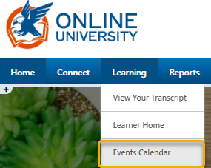

- Review the calendar to see available sessions to attend.
  - Options to view and narrow the focus are:
    - A Single Day
    - Full Week
    - Full Month
    - Agenda
    - All Events – set available to you
    - My Events – on your transcript

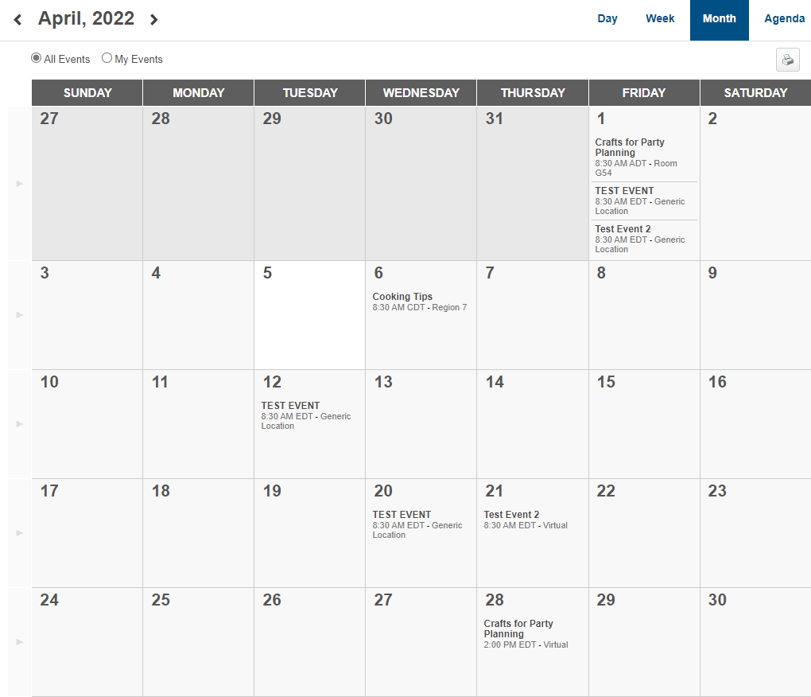

Down the left side in the calendar view are filters to further narrow your search and Display options.
  - Filters Available:
    - Event Title – full or partial title
    - Session ID – full or partial number
    - Location – look-up an available location
    - Session Contact – look-up an available contact
    - Subject – add subjects of interest
  - Display Options will adjust how session details are displayed in the calendar view.
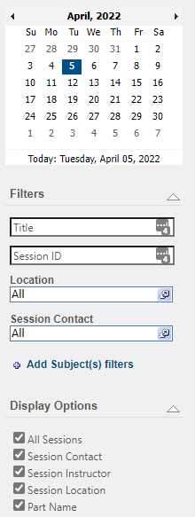

- Moving your cursor over an Event title opens the event details.
  - Event Details will provide more details about the Event’s Session.

- Clicking the Event title opens the session details pop-up.
  - Review all details of the session
  - Request to attend
  - Assign (if permissible)
  - Close pop-up with the “X” in the upper right corner
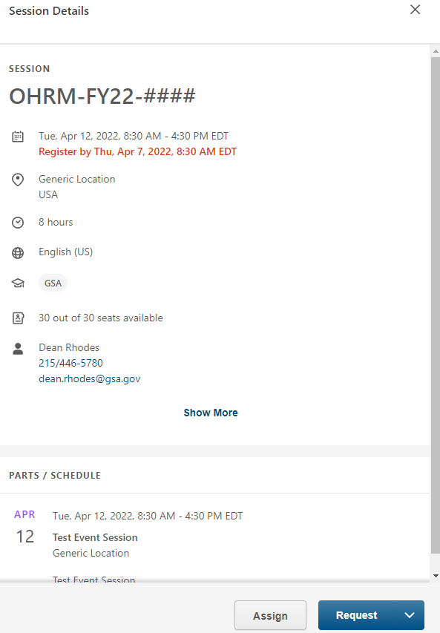

LAUNCH AN ONLINE WEB-BASED TRAINING

Upon finding an Online Course, use the Transcript view or Learner Home to Launch a course you are starting or continuing.

NOTE: These courses open in a pop-up window. Be sure to check your browser settings and allow the pop-up each time you launch.

Launch via Training Details from Global Search or Learner Home Search
- Locate an Online Web-Based Training in the catalog.
- Click on the Training Title to view the details.
- Select the Launch button to the right of the learning object details to Launch the training.
  - The training will automatically be added to your transcript and launched simultaneously.
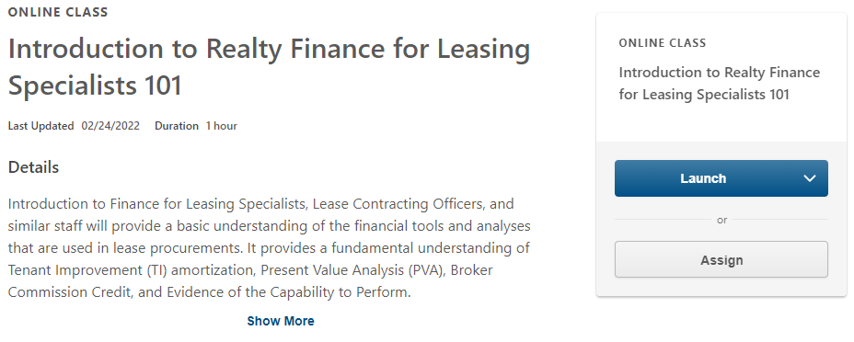

Launch via Learner Home - Continue Learning Carousel
- If you previously requested training and are returning to the portal to continue, navigate to the Learning menu.
- Select Learner Home.
- On the Learner Home page, find the Continue Learning Carousel (about mid-page).
- Find the Online course title you wish to launch.
- Select Launch.

Launch via Transcript View
- If you previously requested training and are returning to the portal to continue, navigate to the Learning menu.
- Select View Your Transcript.
- Locate the training item on your Active Transcript view.
  - The computer icon indicates an Online Web-Based Course.
- Click the Launch button beside the training name.

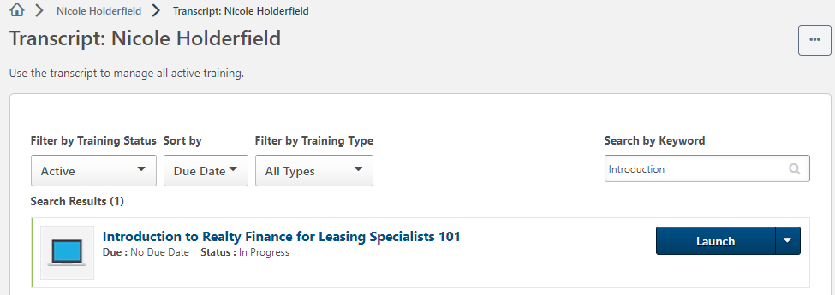

REGISTER FOR AN INSTRUCTOR-LED TRAINING (ILT)

Instructor-Led Training (ILT) events are instructor-led training courses that contain general information about the course, such as the description, the objectives, the vendor, and the subjects. Because there are typically many instances of one course held at different times and locations by different instructors, every event can occur at a variety of times and places. In the system, these scheduled instances of an event are called sessions.

NOTE: There may be approval workflows in place that must be completed before you are officially Registered to attend.

Request via Training Details from Global Search, Learner Home Search, or Events Calendar
- Locate an event you wish to attend via any search option.
- Select the Training Title to view the Training Details page.
- If the details are lengthy, click on the Select a Session button.
  - Or, scroll down the page to see the Upcoming Sessions section.

- A list of available sessions will be listed with the option to view the details of each (optional).

- Once you find a date and time that fits your schedule, use the drop-down caret to the right side of the View Details button to select Request.
  - The request will trigger any assigned approval workflows.
  - Until approval workflows are completed, your status will be Pending Approval.
  - If the session is full, you might be added to a Waitlist.
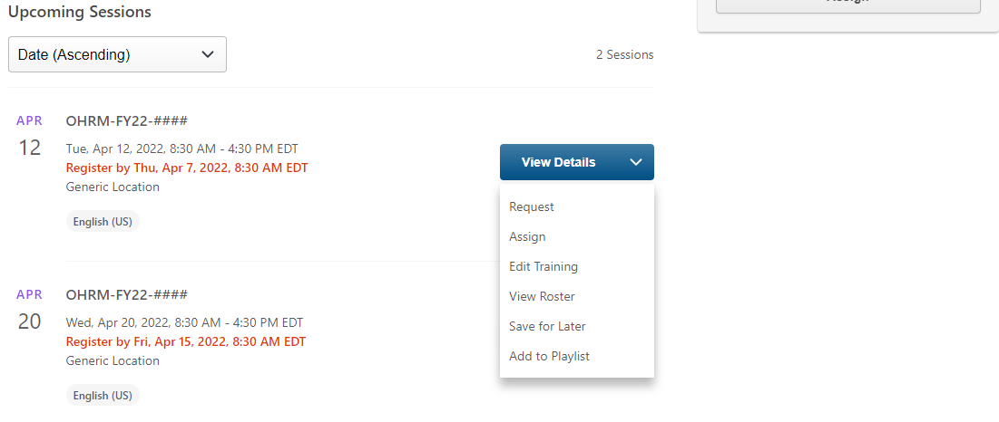
- Depending on your approval workflow and the session’s waitlist, the training now appears on the Active tab of your Transcript in a Registered status.
- During the schedule time of a virtual instructor-led session you can launch the training via the link placed on your Google Calendar, or refer back to your transcript to access the link.

Request via Learner Home - Continue Learning Carousel
- If an event was assigned or self-requested, the Select Session option will be available on the Learner Home page in one of two locations.
  - Look through the Continue Learning Carousel to find the Event and Select Session option.
  - If there was a due date associated with the Event, it may also be under Due Soon.
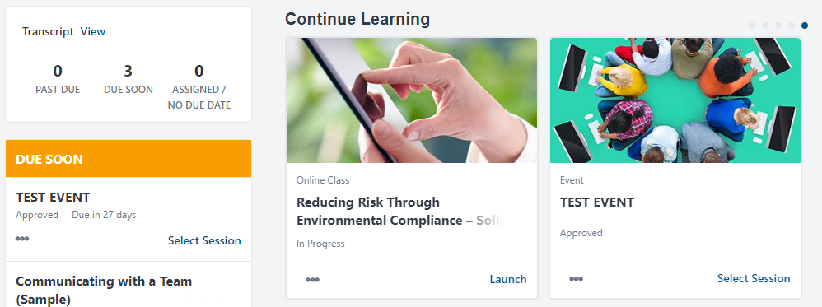
- Once you click the Select Session hyperlink, you will land on the training details page. You can then request a session as outlined at the start of this section (Register for an Instructor-led Training (ILT)).
- The Learner Home view will show the session in a Registered Status once all approval workflows have been processed or waitlists granted.
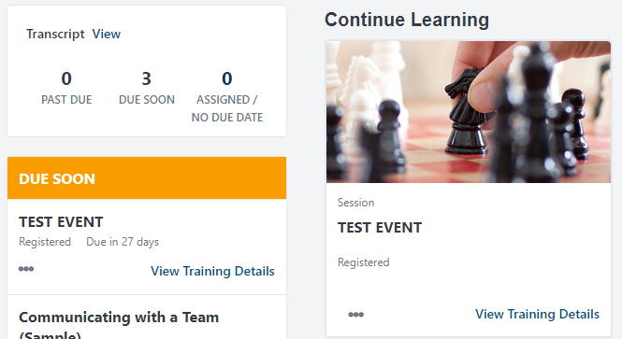

Request via Transcript View
- If an event was assigned or self-requested, the Select Session option will be available on the Active Transcript view.
- Events/Sessions are identified in the list by the Calendar Icon.
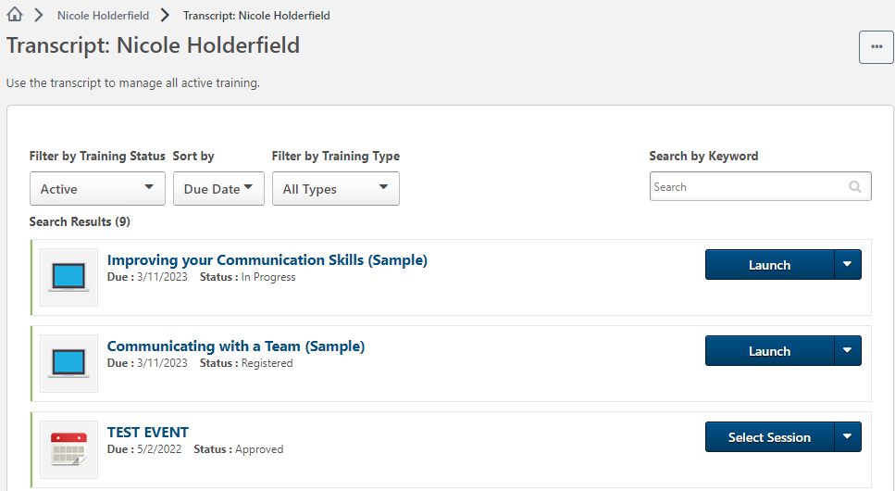
- Once you have used the Select Session hyperlink, you will land on the training details page. You can then request a session as outlined at the start of this section (Register for an Instructor-led Training (ILT)).
- The Active Transcript view will show the session in a Registered Status once all approval workflows have been processed or waitlists granted.
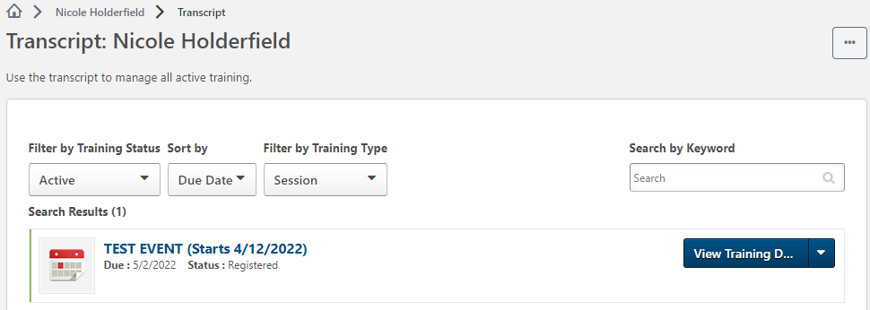

SUBMIT AN EXTERNAL TRAINING

You may participate in training outside of Online University that you can include in your Transcript. Many off site learning opportunities provide completion certificates that can be uploaded into Online University.

NOTE: It is a best practice to submit the Add External Training within five days of completion. The completion date is based on the date of the approval workflow process not the date you complete the training.

Add External Training (Transcript)
- Navigate to the Learning menu, and select View Your Transcript.
- On the Active Transcript page, find the options ellipsis .
- Select Add External Training.
- This will take you to the Add External Training page where you can provide information about your educational experience.
- Review the disclaimers at the start of the form.
- Fill in the details as completely as possible.
  - It is highly recommended to use the exact title found on the Certificate of Completion.
  - If possible, copy the description from the source site.
  - Upload the Certificate of Completion in the Attachment section.
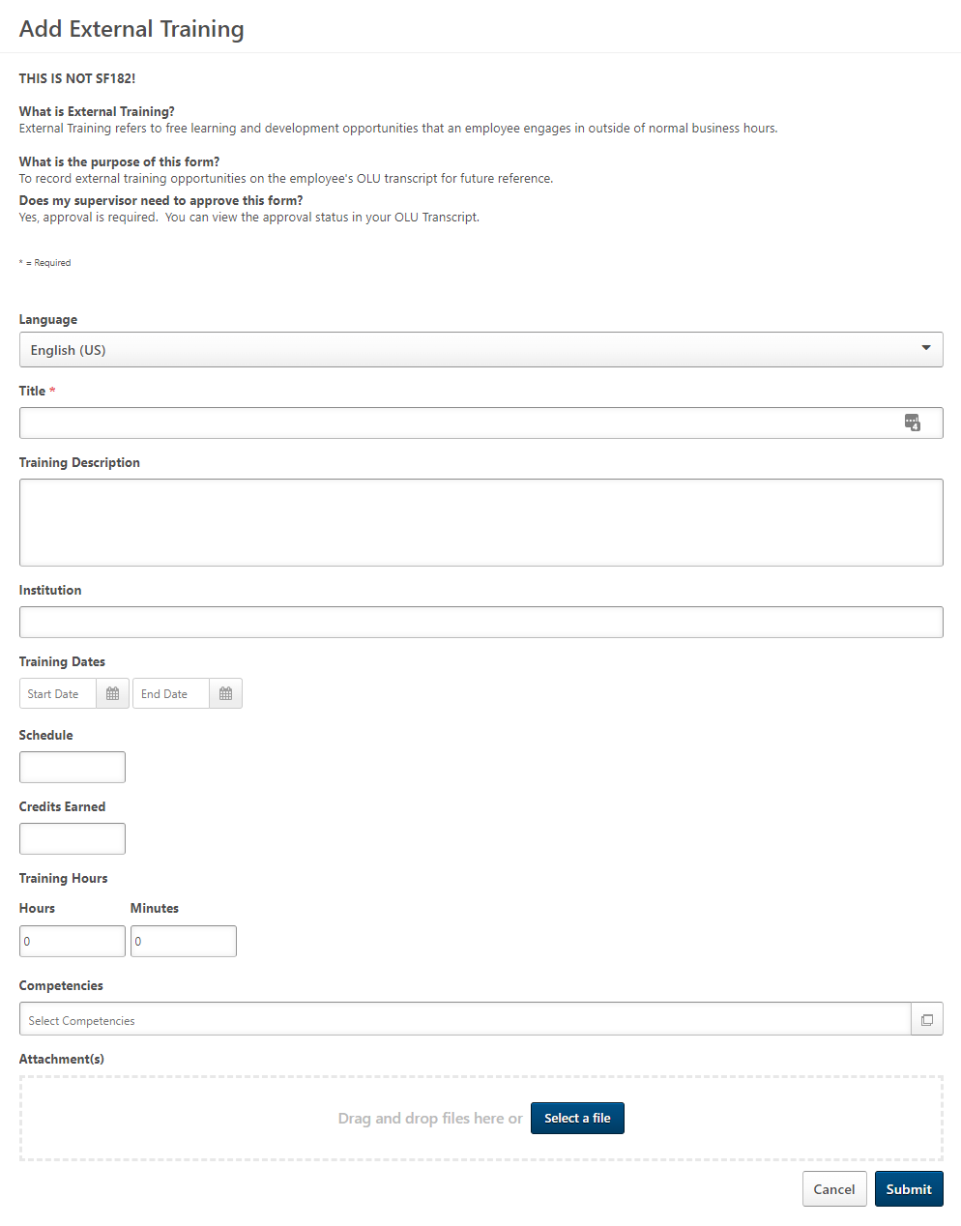

- Attachment(s):
  - Choose Select a File to browse for the document in your computer, or
  - Drag and Drop the file from File Explorer to the Attachment(s) box.
- The file name appears under Attachment(s).
  - Multiple files can be loaded if necessary.
- Click the Submit button to add the External Training and its certificate to your Transcript.
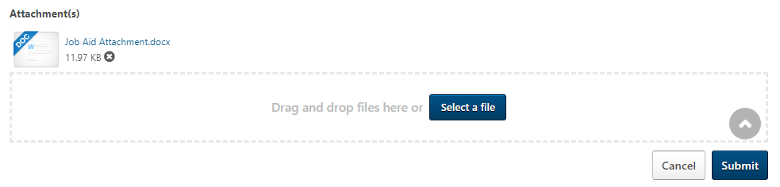
- You will be navigated back to your Active Transcript where the External Training will appear in the list.
- Select the button titled Mark Complete.
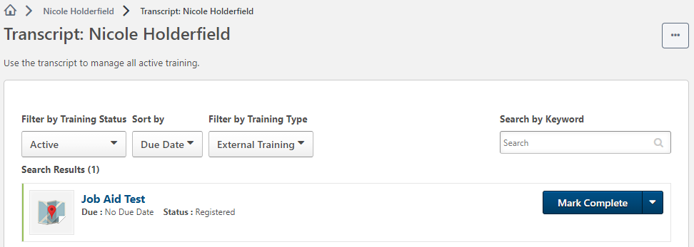

- A pop-up window will appear.
- Check the box stating you have submitted all relevant paperwork to the appropriate person in your organization.
- Click Submit.
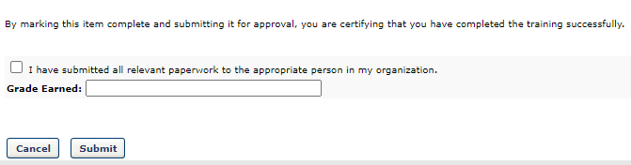
- If there is an approval workflow requirement, it is good practice to reach out to the approver.
- Once approval workflows are complete the training is listed on the Completed Transcript Page and is moved to the Archived Transcript page after a designated period of time.

- Select View Training Details if you need to access your certificate of completion.
