Supervisor: Learning Assignment

INTRODUCTION

This Job Aid will provide guidance for a supervisor to assign training within GSA’s new Online University which is utilizing the Cornerstone Learning Management System.
Table of Contents
INTRODUCTION 1
ASSIGNING A TRAINING FROM LEARNER HOME 1
ASSIGNING A TRAINING FROM UNIVERSAL PROFILE 4

ASSIGNING A TRAINING FROM LEARNER HOME

- After logging in to the Online University, in the top taskbar, select Learning, then Learner Home.
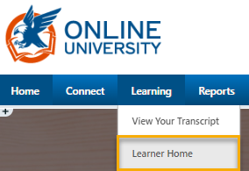
Alternatively, you can click Find Learning in the Welcome Page to access Learner Home.

- Find the Search for Learning box just below your greeting and “What would you like to learn today?” message.
- Enter a training title or keywords. Select the magnifying glass, or click enter on your keyboard.
- The results page will appear, and the number of results will be listed.

- If the list is too long, there are additional Filters (down the left side of the page) from which to choose.
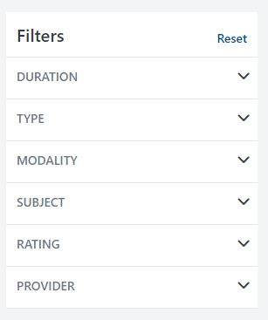
  - Duration – filter by the length of time in training
  - Type – filter by the training, i.e. Online Class, Event, Material, etc.
  - Modality – Watch, Read, Listen, Attend, Practice, etc.
  - Subject – filter by the list of options under this tab
  - Rating – filter by ratings 1-5 or Any Rating
  - Provider – filter by the list of options under this tab
  - Reset - Use the Reset option to clear all set filters and start again if needed.

- Under the results there are tiles with titles, training hours and a more options ellipsis.
  - Select the Event Title to review more details about the training to include the description.
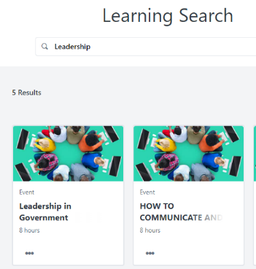
  - Select the more options Ellipsis to:
    - Launch
    - Assign
    - Save for Later
    - Add to Playlist (if you have permission)
    - Etc.

- Select Assign.

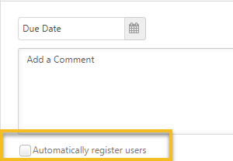
- Set the Due Date (leave blank if no due date is required) and add the desired commentary. It is recommended that Automatically register users be selected.

- Choose subordinates you wish to assign the training to by clicking the associated checkbox; if users already have the training in their transcript, their checkbox will be grayed out to indicate they cannot be included in the assignment.
  - If indirect subordinates need to be included, click the Select an Indirect Subordinate pop out to search associated subordinates.
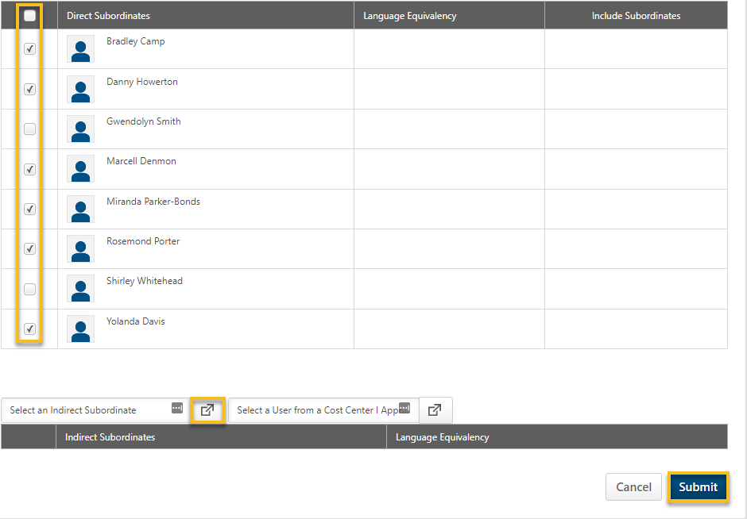

- Click Submit.

ASSIGNING A TRAINING FROM UNIVERSAL PROFILE

- Click the Universal Profile icon on the right of the top navigation.

- In your Bio page, click Actions; then select Actions.

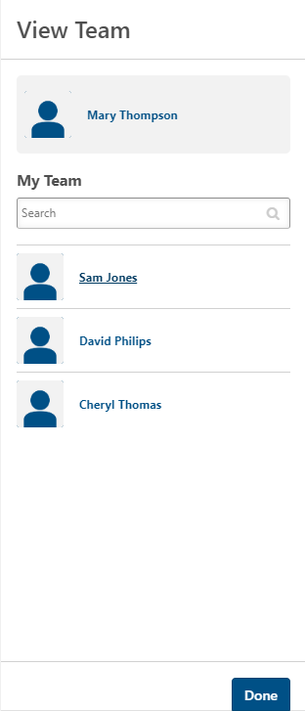

- In the Actions page, click View Team. 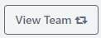
- Select a team member and click Done.
- Click the Ellipsis button to the right of the View Team button; then click Assign Training.
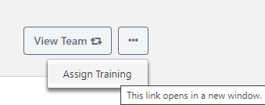

- In the pop up window, search for the training you wish to assign.
  - Select or unselect the training types you wish to search.
  - Search for the title or keyword by entering in the search bar; then click Search.
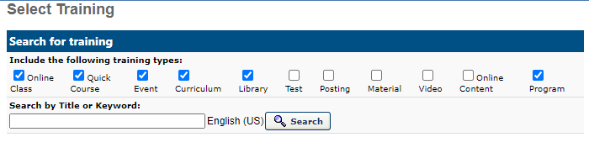
- Select the desired training by clicking the plus icon to the left of the training title.
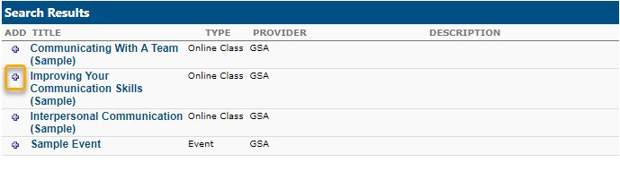

- In the Assign Training page, Set the Due Date (leave blank if no due date is required), and add comments. It is recommended that Automatically register users be selected.

- Choose subordinates to assign training by clicking the associated checkbox; if users already have the training in their transcripts, their checkbox will be grayed out to indicate they cannot be included in the assignment.
  - If indirect subordinates need to be included, click the Select an Indirect Subordinate pop out to search associated subordinates.

- Click Submit.

