NAVIGATING THROUGH BUSINESS OBJECTS
Dated for Reference: December 27, 2019

Table of Contents
Accessing Business Objects – CFO Platform
Accessing Business Objects – BIEDW Platform
Commonly Used Icons in Business Objects
Accessing Reports in your “My Favorites” or “Inbox”
Accessing Reports in Public Folders
Moving a Report from your “Inbox” to your “My Favorites” Folder Public Folders
Copying A Report from Public Folders to your “Favorites” Folder
Modifying a Report in your “My Favorites” Folder to Add an Object to the Results Pane
Modifying a Report in your “My Favorites” Folder to Add an Object to the Query Filter
Constant query filters vs Prompted query filters
Optional vs Mandatory prompts in a Query Filter and other Prompt properties
Multi vs Single Value Prompts in a Query Filter
Universe prompt vs Query Filter
Adding a Report Level Filter
Scheduling a Report
Determining the Universe a Report is Based On
Creating a New Ad-hoc Report
Sending a Report from your “My Favorites” Folder to another user’s BI Inbox
Creating Variables
Use of LEFT Statement in Variables
Use of Concatenation in Variables
Use of SUBSTRING in Variables
Use of IF Statement in Variables
Add a Query to a Document
Merging Queries in a Document

Accessing Business Objects – CFO Platform
The CFO Business Objects platform is accessible through the following link: https://corporateapps.gsa.gov/applications/financial-apps/business-intelligence/
Once at the Business Intelligence Screen, choose Login to access the BI Launch Pad.
- If you require a CFO business objects account, please access Enterprise Access Request System (EARS)https://ears.ocfo.gsa.gov/ears/faces/home.jsp.
- To reset your business objects password, please access use https://webappsreset.gsa.gov.

Accessing Business Objects – BIEDW Platform
https://corporateapps.gsa.gov/applications/financial-apps/other-financial-apps/
Once at the Other Financial Apps screen, choose FAS/WCF Business Objects BIEDW to access BI. (note: access to BIEDW is through single sign on so a separate log in screen will not appear.)
If you require access to the Business Objects BIEDW platform, please send an email to BIEDW Support BIEDWSupport@gsa.gov.
Now that you have successfully accessed Business Objects, here are some tips to get you started. As with many applications there can be more than one way to accomplish the same goal. The purpose of this document is to provide an initial introduction on navigating through the Business Objects R4 Environment.

Commonly Used Icons in Business Objects

Commonly used icons include “Save / Save As” 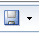 , Export Document to Excel , Send , and Refresh .
Accessing Reports in your “My Favorites” or “Inbox”

To access reports in your “My Favorites” folder or your “Inbox”, click Documents located in the upper left hand side of the home page displayed when you first opened the BI launch pad and then “My Favorites” or “Inbox” as appropriate.
Accessing Reports in Public Folders

To access Public Reports, click Documents from the home page displayed when you first opened the BI launch pad and then click “Folders” in the bottom left hand corner of your screen to open the Public Folders and then navigate to the appropriate sub – folder. Click on the “+” sign to expand the selection
As you click on the sub-folders containing reports, you will see the reports listed in the right pane of your screen in the block labeled “Title”.
Moving a Report from your “Inbox” to your “My Favorites” Folder Public Folders

After navigating to your “Inbox”, locate the report you want to move to your “My Favorites” Folder. Right click on the report and choose “Organize” then choose “Cut”. This will remove the report from your inbox. You can also use the copy command but it is preferred that you use the “Cut” function so that duplicates do not exist under your user name.
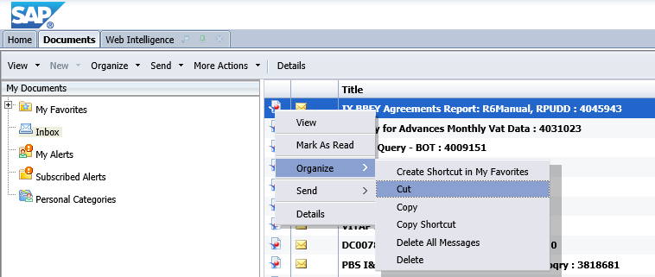

Navigate to your “My Favorites” folder, right click in the right pane containing your reports and choose “Organize” then choose “Paste”.
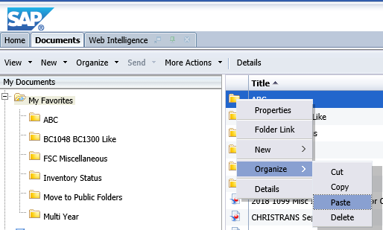
Note: If you wish to create sub folders within your “My Favorites” folderm from your “My Favorites” folder choose “New” and then “Folder”. You will be prompted for a new folder name after which choose “OK” to create.

Copying A Report from Public Folders to your “Favorites” Folder

After navigating to “Public Folders”, locate the report you want to move to your “My Favorites” Folder. Right click on the report and choose “Organize” then choose “Copy”.
Navigate to your “My Favorites” folder, right click in the right pane and then choose “Organize” then choose “Paste”. In the example below, a sub folder called “A Folder for Training” has been created.
It is recommended that you rename the report to distinguish it from the report in the public folders. To do this, from your “My Favorites” folder, right click the report and choose “Properties”.
Enter a Title of your choosing and if desired a Description. Be sure to choose “Save and Close” at bottom right of screen when complete.
The report in your “My Favorites” folder will now reflect the name change.

Modifying a Report in your “My Favorites” Folder to Add an Object to the Results Pane

After navigating to “Public Folders”, locate the report you want to move to your “My Favorites” Folder. Right click on the report and choose “Organize” then choose “Copy”. Navigate to your “My Favorites” folder, right click in the right pane and then choose “Organize” then choose “Paste”. (See Also “Copying A Report from Public Folders to your “Favorites” Folder”)
Locate the report in your “My Favorites” folder and right click on the report and choose “Modify”.
When the report opens, make sure Design, With Data is chosen. If it is not, click the desired options.
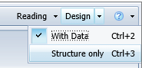
With the Design, With Data option open, click Data Access and the Edit
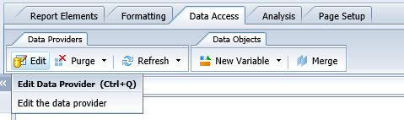
The Universe Outline View will appear. Please note in the upper left of your screen you can see the Universe on which the report was built, FMIS - Valid Accounting Transactions.
Also please note that sometimes reports are created through the use of multiple queries. An example of this is FMIS queries which can be created with two queries, “5 yr” and “Single year”. By clicking on the query name at the bottom of the query panel you can see the objects that make up each of the queries.
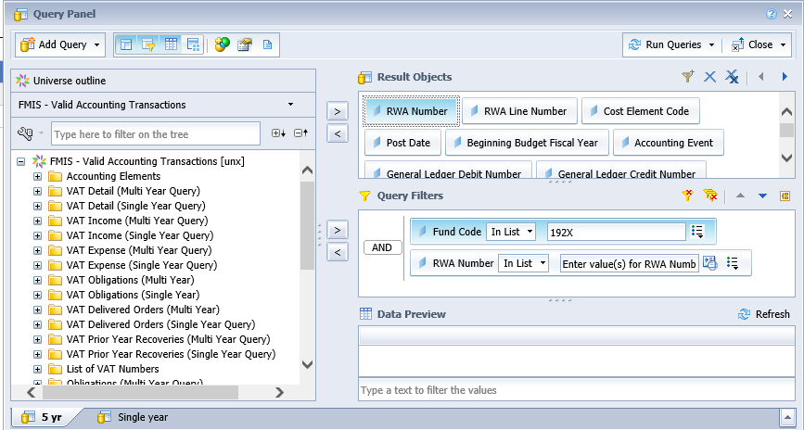
If you click on an object within the Results Object Pane, the class folder to which that object belongs will open.
In this example, if you click on RWA Number within the “5 yr query” you will see the VAT Detail (Multi Year Query) sub-folder expand and if you scroll down RWA is highlighted.
In the same way, if you click on RWA Number within the “Single Year” query” you will see the VAT Detail (Single Year Query) sub-folder expand and if you scroll down RWA is highlighted.
Note: When adding an object it is important to know the sub-folder from which the other objects originate. Objects are created based on source tables. Not all source tables are meant to be combined which is why in some instances you will not be able to add objects from other sub-folders.
For this example, we will be adding the object NARA Number to each query in this report.
With the Query Panel open in Data Access Edit Mode, locate the Object NARA Number in the sub-folder corresponding to the sub-folder from which the other objects in the query originated. Once located, drag the object over to the Results Objects Pane and release the object. In the example below NARA Number for the “5 yr query” was dragged over from the VAT Detail (Multi Year Query)
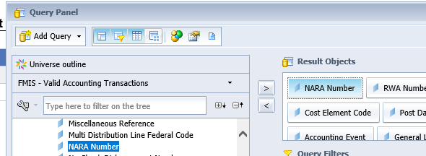
Repeat the process for the “Single Yr” query EXCEPT this time the object NARA Number should be from the VAT Detail (Single Year Query) sub-folder.
Once completed in the upper right hand corner of your screen, choose Close and then from the drop down menu chose “Apply Changes and Close”.
In the upper left hand corner choose the diskette icon and from the drop down choose “Save” to save the changes to the report of the same name or chose “Save As” to create a new file name. In this example “Save As” is chosen. Once the Save As window opens click on Favorites Folder and save your report to a new name such a 1 RWA VAT Query multi-year with NARA NUM.
Then click “Save” in the lower right hand corner of your screen.
Once saved, click on the “x” to the right of your query name in the menu bar to close the query.
Navigate back to your Favorites folder where you saved the renamed query, right click on the report and schedule the report to run.
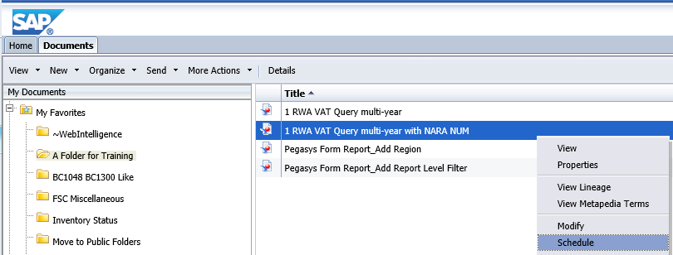
Note: For this particular report you will need to Modify the prompt values to Enter an RWA Number and a Fiscal Year.
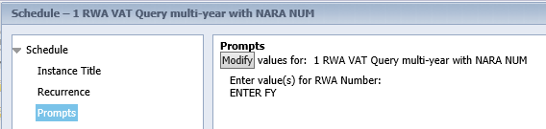
After applying prompt values, the chosen values will be present and you can choose Schedule in the lower right hand corner.
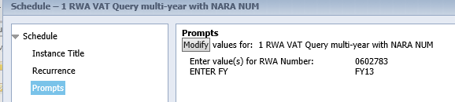
Note: In the above example, NARA Num will not be populated because the FMIS source table does not contain entries for NARA Num for RWA Number 0602783 at the time this was run.
Another example of prompt values is as follows. In this example, some of the transactions that appear on the report will have the NARA Num column populated. In these instances, the FMIS source table does contain entries for NARA Num for RWA Number 1728763.
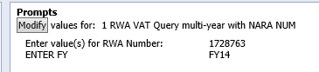
After scheduling, the History Pane will appear.
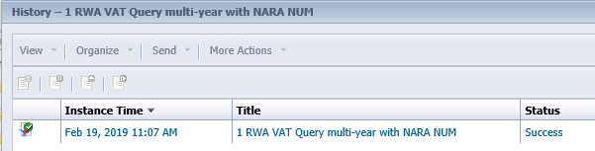
Once a Status of “Success” is returned, click on the report Instance Time to open the report.

In the event the column NARA Num does not appear on your report, go to the Design View’s “Design” then “Data Access” and then “Edit” mode.
If you click on the icon 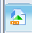 to the far left of your screen, available objects for the report will open up. You will then be able to drag over the NARA Number Object to the report output for the 5 Year and Single Year tabs. The snapshots below show the before and after of adding NARA Number (5 yr) to the report.
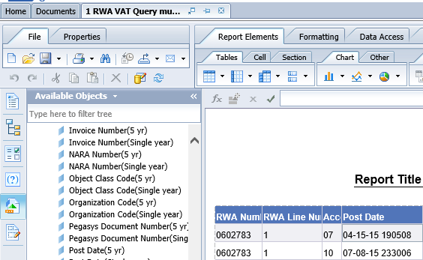
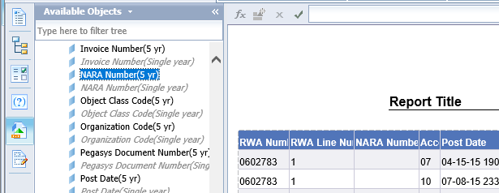
At this point you can choose “Save As” to save a report with the NARA Num column added.

Modifying a Report in your “My Favorites” Folder to Add an Object to the Query Filter

To modify a report, locate the report in your “My Favorites” folder you wish to modify. Right click on the report and choose “Modify”.
Under Modify there is a Reading View and a Design View. It is from the Design View that you can modify the objects in your report by clicking “Design” then “Data Access” and then “Edit”.
Access Reading or Design by clicking on the desired mode 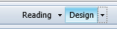

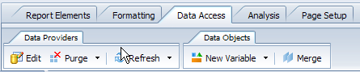
In this example, the object “Region” shall be added to a copy of the public report “Pegasys Form Report” that has been copied to a user’s “My Favorites” folder. To start, right click on the report and choose Modify.
The report will open up. If you will look to the far upper right of your screen you will see the report opened in Design Mode.

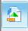 By clicking on this icon to the left of your screen the objects used on the report will be displayed.
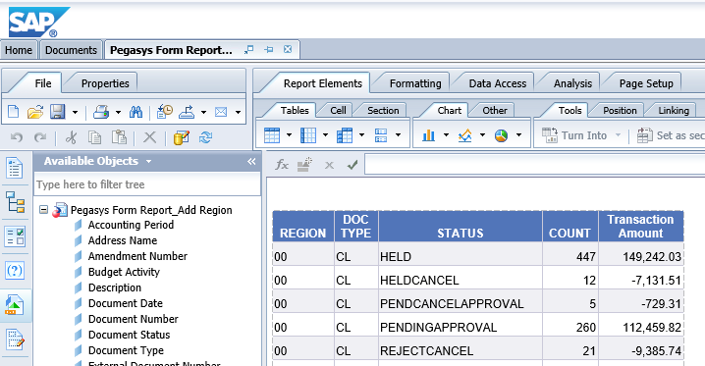
With the report open in “Design Mode” chose Data Access and then Edit.
The Universe Outline View will appear. Please note in the upper left of your screen you can see the Universe on which the report was built.
This particular report is created through the use of 2 Primary Queries, Query 1 and Query 2. Query 1 has series of combined queries.
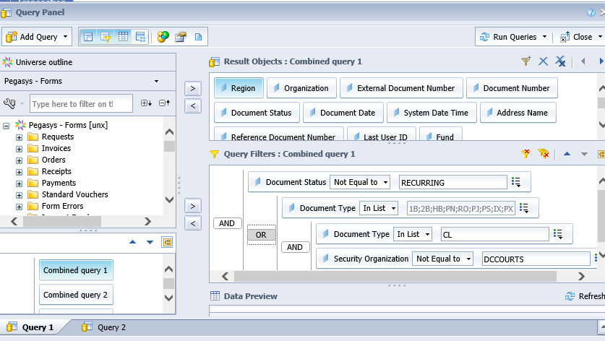
With the Data Access, Edit Screen Open, locate the Class Folder with the object you want to add.
Helpful Hint: If you click on an existing object in the Results Object Pane of the query, the class folder containing the object will display.
Drag the object Region to the Query Filter Panel and release. In this case we are choosing to limit the query to Regions 1, 2 and 3. 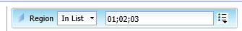
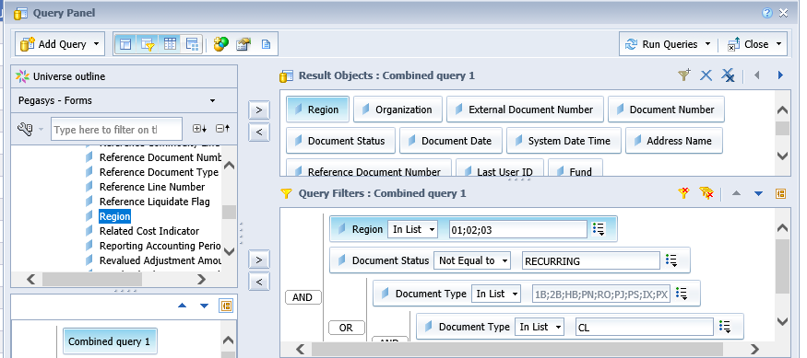
Click on Combined Query 2 and repeat the process.
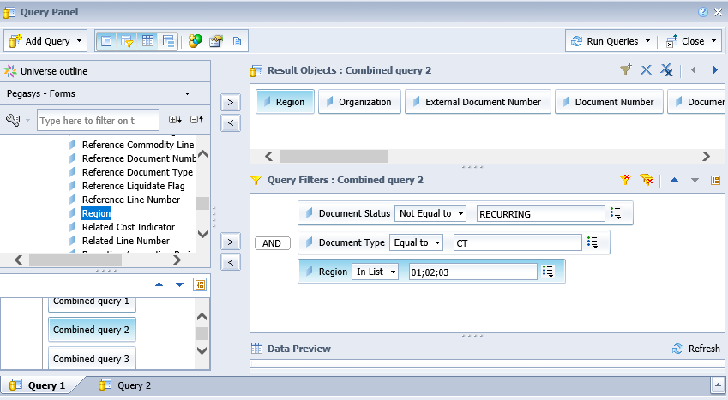
Repeat the process for Combined Queries 3-8. Once complete Chose “Close” and “Apply Changes and Close” in the upper right hand of your screen.
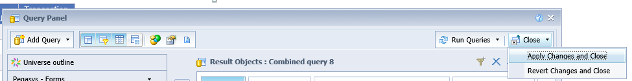
Save your changes by clicking the icon that looks like a diskette.
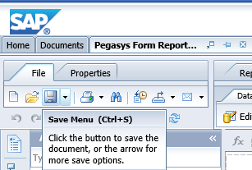
Close the report and schedule the report to run. Once complete, the report will be limited to Regions 1,2 and 3.

Query Filters - Constant vs Prompted
In the snapshot below the top three filters are constant (equal to a specified value) and the bottom two filters are prompted (user is prompted to enter a value(s)).
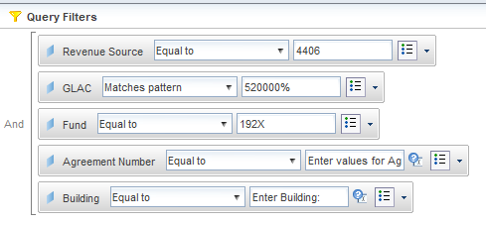
When a new query filter is added it defaults to “In list” with a blank for the value. “In list” allows for multiple values and the blank is for the specific constant values to be typed in.
When adding a filter to change the constant filter to a prompted filter click on the drop-down arrow to the right of the small box and select “Prompt”. The query filter now shows “Enter values for Region” and is a prompt filter.
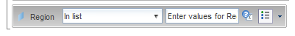
When the query is scheduled or refreshed the prompt window will include a prompt for Region.
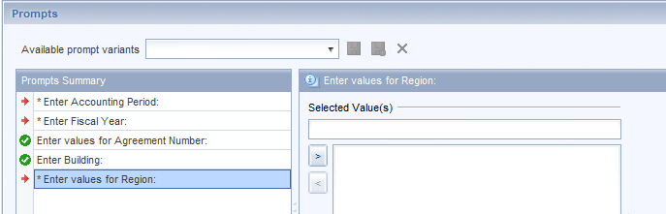
Optional vs Mandatory prompts in a Query Filter and other Prompt Properties
When a new query filter is added and changed to a prompt, it defaults to mandatory as evidenced by the red arrow to the left of the prompt in the Prompt Summary window.
The query filter can be modified from a mandatory to optional. In the query filter window click on the properties icon next to the filter. This properties icon did not display until the filter was changed from a constant filter to a prompted filter. This is the icon that contains a question mark.
The “Prompt Properties” window displays:
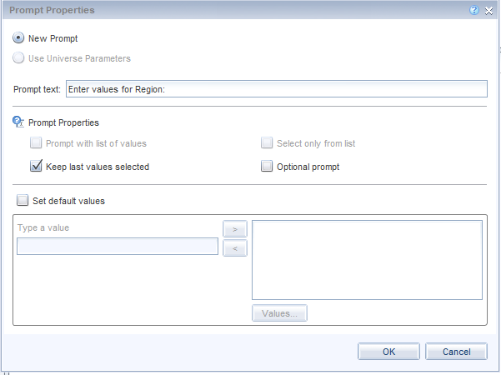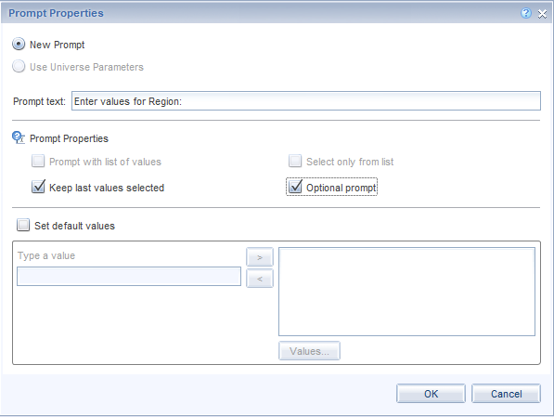
To change the filter from mandatory to optional, click inside the “Optional prompt” box and click “OK” in the bottom right. Now when the query is scheduled or refreshed the Prompts window shows a green checkmark next to the prompt.
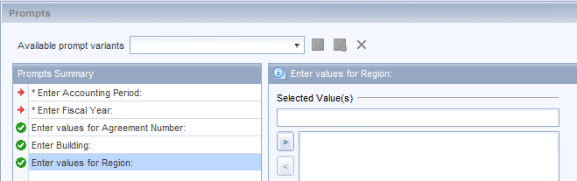
There are other properties that can be controlled via the Prompt Properties window.
You can change the text in the prompt box. The prompt defaults to show the last values used. You can change the prompt to show blank every time by unchecking the “Keep last values selected” box.
You can set the prompt to display a default value every time.
- click in the “Set default values” box
- enter the value(s) in the “Type a value” field; multiple values must be separated by “;”
- click the “>” button to move the values to the “Values” window
- click “OK” in the bottom right corner
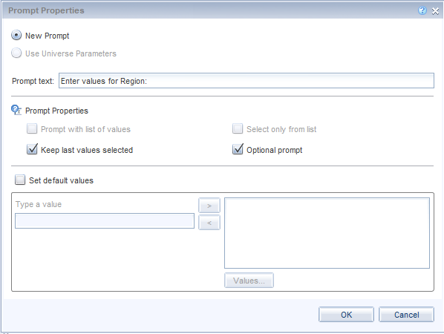

Multi vs Single Value prompts in a Query Filter
A new query filter will default to “In list”. This means that the filter will accommodate multiple values.
To change the filter from multi-value to single-value – click on the drop-down arrow next to “In list” and select “Equal to”.
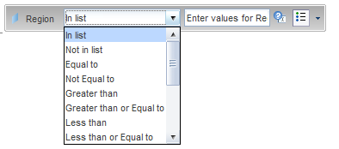
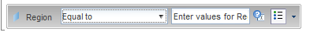
Universe prompt vs Query Filter
A Universe prompt is an embedded prompt built at the universe level. Universe-level prompts are built-in to avoid “runaway” queries which are queries that try to retrieve so much data that the system gets hung up. A universe-level prompt is seen when the Business Objects query is scheduled or refreshed.
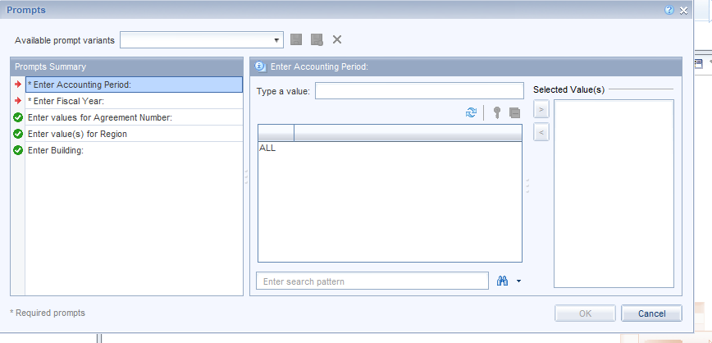
The “Accounting Period” and “Fiscal Year” prompts are universe-level prompts that will be applied to every query that accesses the universe. These prompts cannot be seen in the Query Filter window. The “Agreement Number”, “Region” and “Building” prompts are query filters that are applied at the query or report level and can be seen in the Query Filter window.
Adding a Report Level Filter
From Design you can add a Report Filter to a report.
With the report open in Design mode, choose Filter under the Analysis Tab
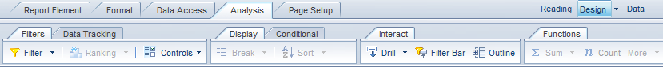
Then Chose Add Filter.
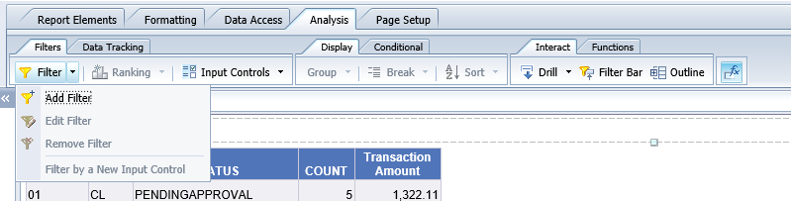
When the Report Filter Pane appears, choose Add Filter a second time. A list of Available Objects will appear.
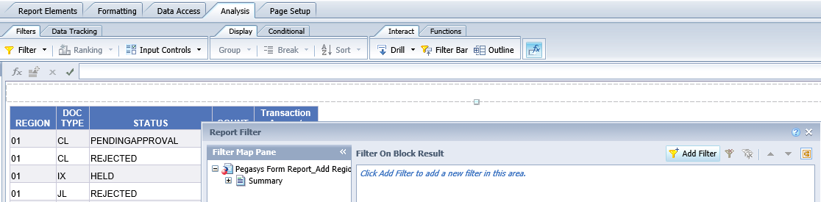
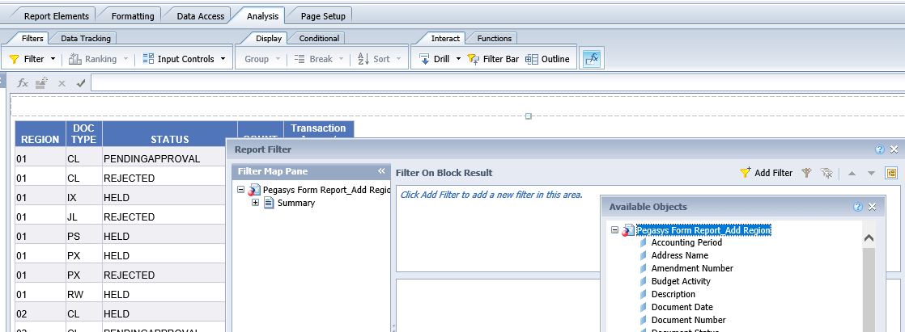
Scroll through the list of Available Objects to locate and highlight Region and click OK.
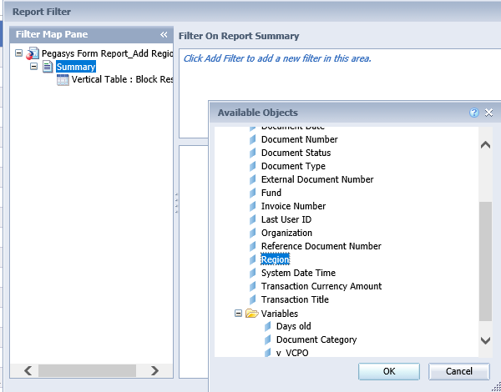
After you complete entering the filter criteria, click apply and then OK. The report should now be filtered to match your criteria. In this example, we are filtering the report tab for Region 02

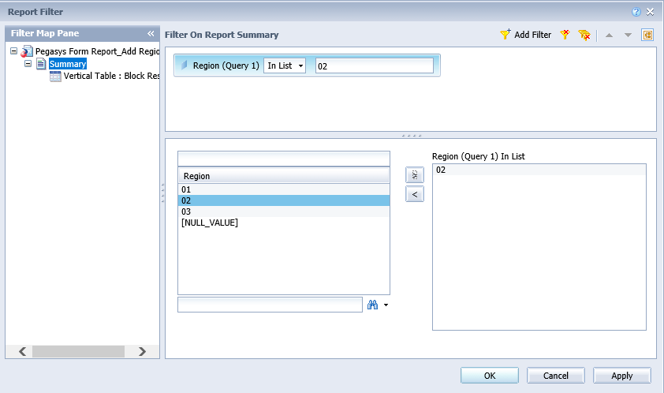
The report is now filtered for Region 2.

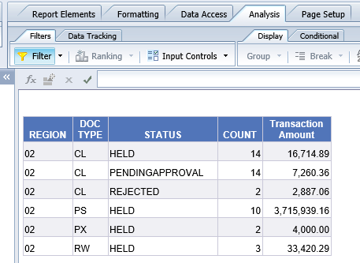

Once the filter has been applied, you will be able to edit and / or delete as needed.

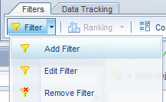

Repeat the process for each tab of the report on which you want to apply a report level filter.

Scheduling a Report

To schedule a report, locate the report name within the “Title” block.
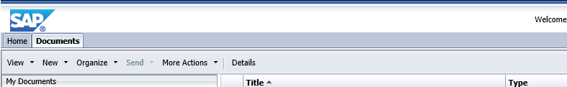
After the locating the report name, right click on the report and then click on schedule.
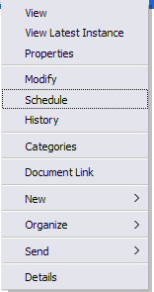

After choosing schedule, a screen will open that allows you to enter an instance title, recurrence, prompt value and format.
Instance Title: For example, if you want to change the Instance Title of the report “VAT Status Report (Updated)” you can click on the box within instance title and update the Instance Title to add a date.
Recurrence: The recurrence option defaults to “now” but for those reports that do not require user input when run, you have the ability to set the report to run at different time intervals.
Formats: The format option allows you to change the output format of a report. The Output Format will default to Web Intelligence. If the report is one you want to export in Excel, chose the Format Microsoft Excel.
Destinations: The Destination option allows you to set a destination for the output of the report. Destinations defaults to “Default Enterprise Location”. Although there are a few options listed based on software capability, the option may not have been enabled based on direction from GSA’s ISSO.
The below screenshots are for a report that does NOT contain Prompt values (prompts would be listed after Recurrence).
Caching, Events, Scheduling Server Group and Delivery Rules: These are not utilized and can be ignored.
For reports that do not contain prompt values select schedule in the bottom right hand corner of your screen.
Snapshot showing Instance Title, Recurrence, Formats, Destinations
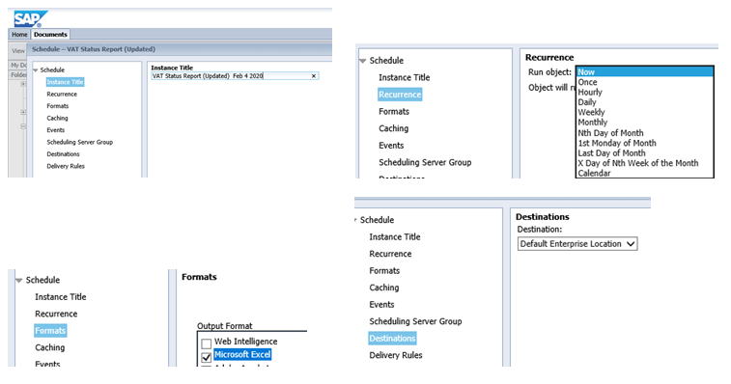

Prompts: Some reports contain user defined prompts which are required to be input before scheduling in order for the report to return data.
To Input Prompts click on Prompts and then Modify. Some input values are simply typed in an open block while others are chosen from a list of Refresh Values. Where < or > is present, the user is required to move the value to the open box on the right of the screen. After choosing prompt values be sure to choose Apply in the bottom right hand corner of your screen. 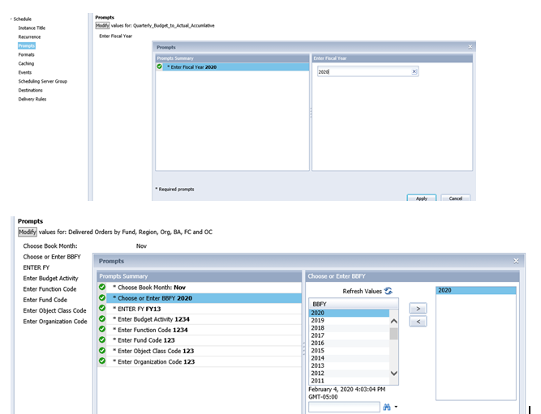

After inputting prompts and selecting apply, schedule should appear in the bottom right hand side of your screen and a new window will open up to show history of reports that are scheduled. The status of a scheduled report will change from Pending to Running and then to Success. Once Success appears as a status, click on the instance time to open the report.
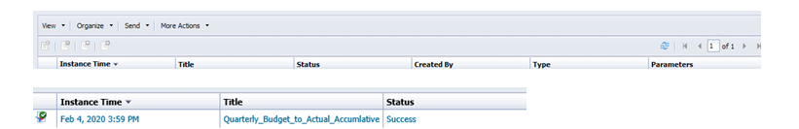

Determining the Universe a Report is Based On

Scenario: Another user sends a report to your Inbox and you copy it to your “My Favorites” Folder. Your boss asks you on what Universe the report is based. To determine this, right click on the report name that exists in your “My Favorites” folder and chose “Modify”.
Once the report is opens, go to the Design View’s, Design, With Data, Data Access and then Edit. Once in this mode, the Universe name will appear in the upper left hand corner.
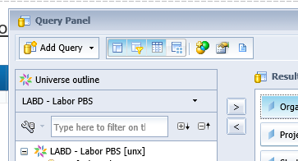

Creating a New Ad-hoc Report

To create a new report, from the Applications drop down menu in the upper right hand corner of the BI Launch Pad, click on Web Intelligence Application.

Once loading of the application is completed, click the icon that looks like a sheet of paper with the right upper corner folded.
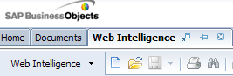
After clicking the icon, you will be prompted to “Create a new data provider”. Highlight Universe and click OK
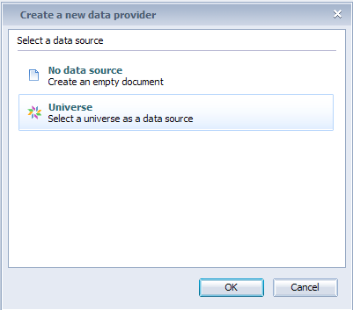
Select a Universe from the list of Available Universes and click OK which is located at the bottom right hand corner of your screen.
A query panel will open up from which you can create a report.
Drag the applicable objects to the Results Objects and Query Filters panels on the right hand side of your screen.
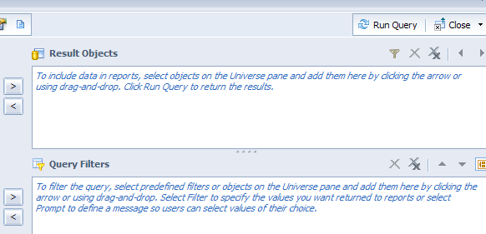
Sending a Report from your “My Favorites” Folder to another user’s BI Inbox

To send a report to another user’s BI Inbox, right click “Send” and then click “BI Inbox.”
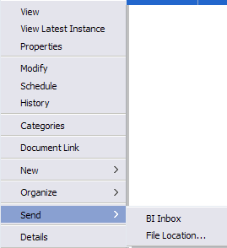
Search for the BI user you want to send the report to.
Highlight the user name and chose the right arrow to move the user to the Selected Recipients Box and click “Send” at the bottom right hand corner of your screen.

Creating Variables

A variable is a value that can change depending on conditions that are needed for a report. In business objects users have the ability to create variables at the report level to match specific reporting needs based on existing objects.
The snapshots presented as examples for this document come from a basic VAT Cash Query that is based on the below query filters.
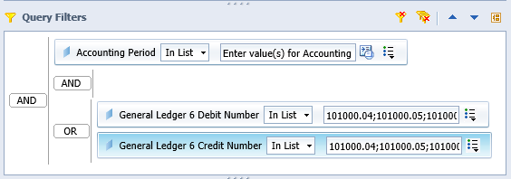

To begin, right click on the report within your “My Favorites” folder that you wish to add variables to and select modfy. Or right click on the report within your “My Favorites” folder, schedule report and then upon successful completion of the report, open the report in Design Mode.
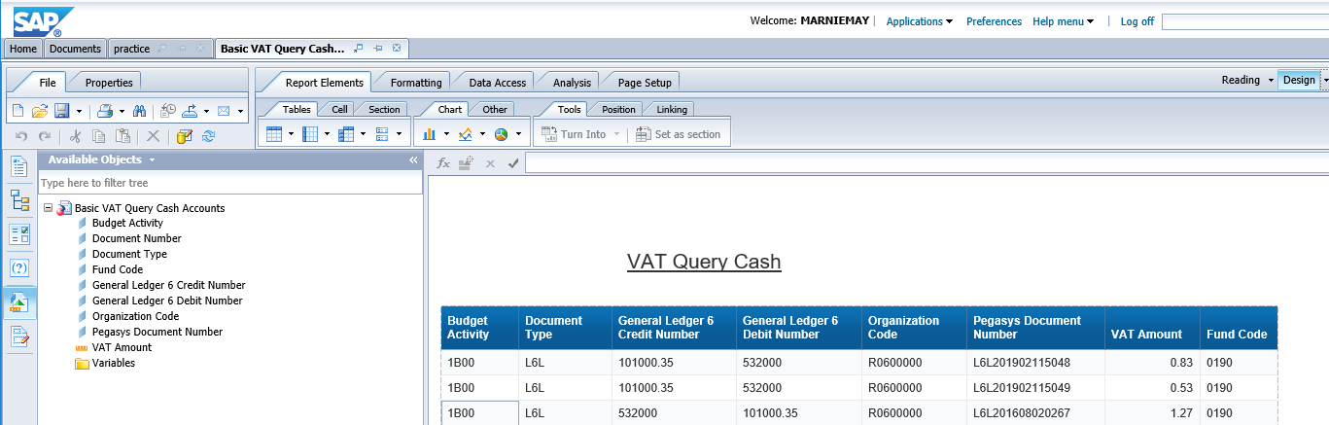

To add a variable, from within Design Mode With Data, chose Data Access, Data Objects, New Variable.
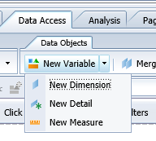
The type of variable will depend on what you are trying to create.
- Dimension objects typically retrieve information represented by characters or information such as dates
- Measure objects retrieve numeric data related to calculations.

After clicking on either Dimension of Measure the Create Variable Pane will open.
Within the Definition section, enter a name for your variable. When creating variable it is a good idea to place V_ or V. in front of the name to easily identify a variable. Make sure the Qualification accurately depicts either a Dimension or Measure and then enter the formula for your variable.
Section “Available Objects” provides you with the objects that exist within your specific query. Section “Available Functions” and “Available Operators” are available to guide you in creating the variables. When clicking on an Available Function a description of the function and example syntax will appear in the Description pane. Querying a subject via Google can also be helpful when creating variables with more complex syntax.
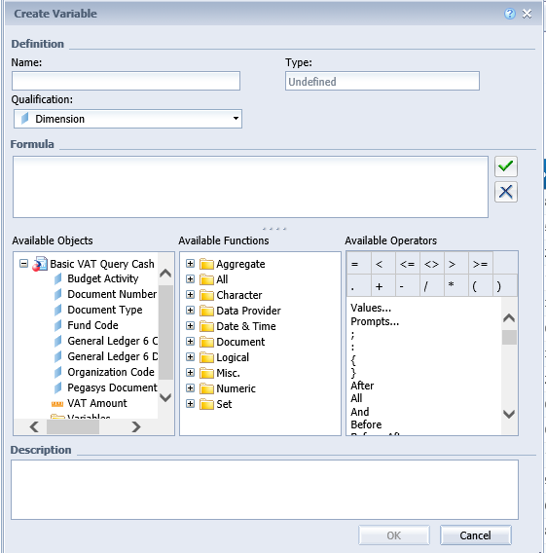.

Use of LEFT Statements in Variables
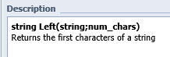

In the example below we are extracting the first two characters of the Budget Activity into a variable which we will call V_2 Digit BA
=Left([Budget Activity];2)
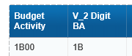

Use of CONCATENATION in Variables

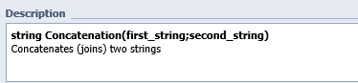
In the example below we are combining the variable V_2 Digit BA Budget Activity with the Organization Code.
=Concatenation(Concatenation([V_2 Digit BA];"-");[Organization Code])
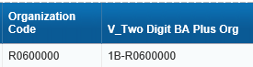

Use of SUBSTRING Statements in Variables
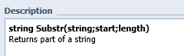

=If (Substr([Fund Code];1;1) = "0"; "Fund Group Zero";If (Substr([Fund Code];1;1) = "1"; "Fund Group One";If(Substr([Fund Code];1;1) = "2"; "Fund Group Two";"Other")))
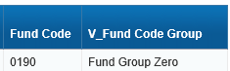

Use of IF Statements in Variables

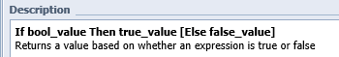
In the example below we are converting the VAT Amount to reflect the normal debit balance and normal credit balance for the Cash Accounts. In this case the Credit Accounts will be multiplied by negative 1.
=if([General Ledger 6 Debit Number] InList ("101000.04";"101000.05";"101000.06";"101000.06";"101000.20";"101000.35"); [VAT Amount]; If([General Ledger 6 Credit Number]InList("101000.04";"101000.05";"101000.06";"101000.06";"101000.20";"101000.35");[VAT Amount]*-1;[VAT Amount]))
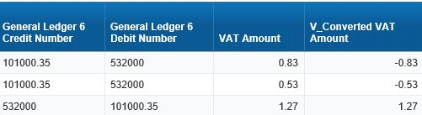

Add a Query to a Document
Report should be in user’s My Favorites folder – so it is an adhoc query built in the My Favorites folder or a report copied from Public Folders.
From My Favorites folder, right click on the report name and click “Modify” in the pop-up window. You should be able to see all the design tabs above the report. The report in this example is built using the FMIS – Valid Accounting Transactions universe and the VAT Income (Single Year Query) class.

Click on the “Data Access” tab, then the “Edit” icon
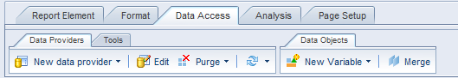
The Query Panel will open, click on the drop down arrow to the right of “Add Query”, then select “From Universe” from the drop down list
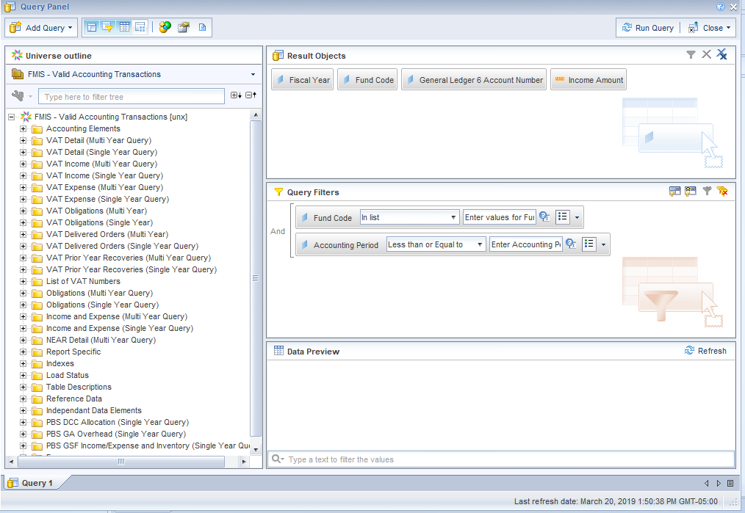
The Universe window will open – find the universe you want the new query to use and double-click the universe name in the bottom right corner of the window. This example is using the FMIS – Valid Accounting Transactions universe.
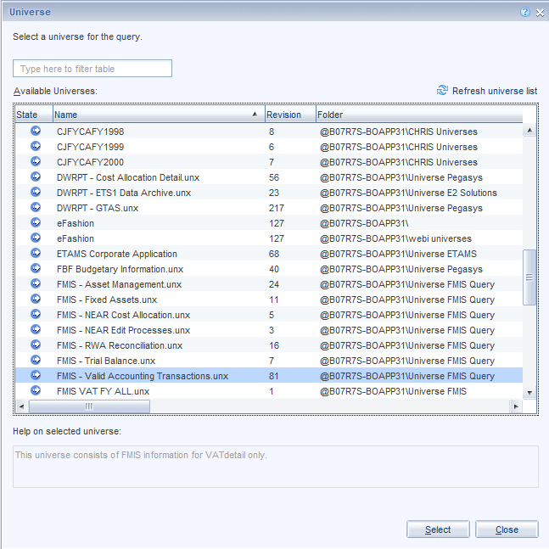
The Query Panel will open with a new empty “Query” tab
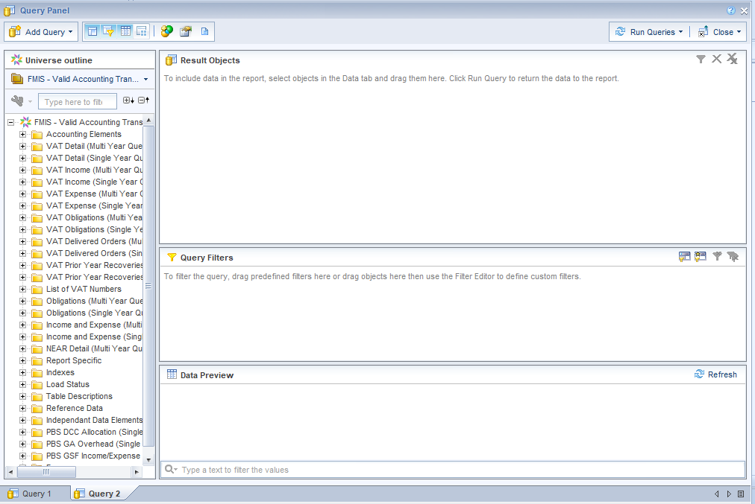
Build the new query – in this example the query will be built out of the VAT Expense (Single Year Query) using the same objects and filters as Query 1, but it does not have to be the same. If you want the Query Filters to show only once in the Prompt window – they must be built the same way.
You will notice that the “Run Query” button in the top right corner now says “Run Queries”. You can run all queries by clicking on “Run Queries” or individual queries by clicking the drop down arrow to the right of “Run Queries” and selecting which query to run.
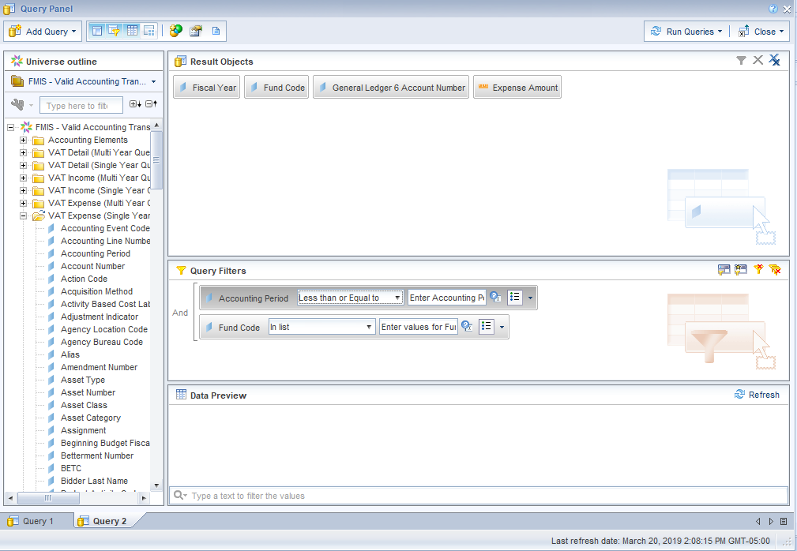
When the query finishes it will ask how you want to include the new data into the existing report:
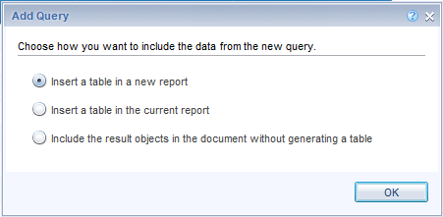
Selection 1 – Insert a table in a new report – the new query results will display on a new tab in the report
Selection 2 – Insert a table in the current report – the new query results will display on a new grid in the same tab as the first query
Selection 3 – Include the result objects in the document without generating a table – the data will be retrieved but not displayed anywhere on the report. This data can be pulled into the report at a later time.
For the purposes of this example we are staying with Selection 1 – Insert a table in a new report. The report now displays two tabs called “Report 1” and “Report 2”. You can rename the tabs to show “Income” and “Expense” or any other label.

Merge Queries in a Document
If a report has more than one query, the results from each query are displayed separate from each other. If you want the results to display in a combined report, you must first merge the data.
In this example the report has two queries – both queries have the same objects – Fiscal Year, Fund Code, General Ledger and Amount.
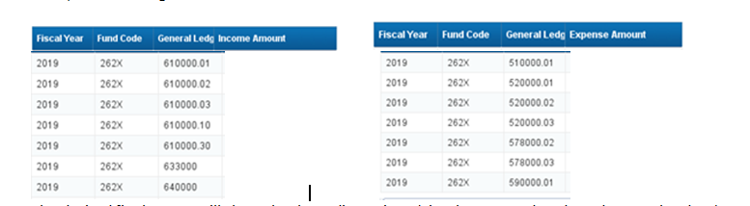

The desired final report will show the three dimensions (Fiscal Year, Fund Code and General Ledger) with Income and Expense side-by-side. Note: the amounts are not included in the snapshots.
Step 1: Merge the “like” dimensions. In “modify” or “edit” mode click on “Merge” on the “Data Access” tab under “Data Objects”.
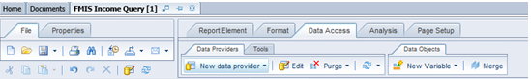
The “Available Objects” window will display asking which dimensions to merge. Holding the Control key down click on the objects to merge. In the example below we are merging Fiscal Year from Query 1 and Query 2. Click “OK”.
Repeat the process to merge Fund Code and General Ledger.
In the left window pane that shows available objects the merged objects display as merged objects. Compare the “before” snapshot on the left to the “after” snapshot on the right.
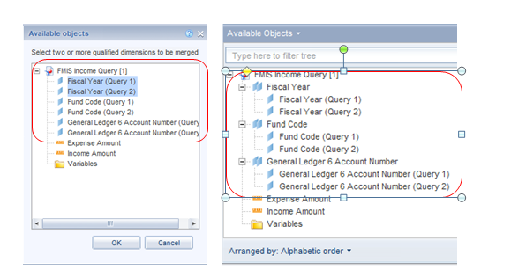

Step 2: Insert a new report by right-clicking on one of the existing tab labels and selecting “Add Report”. A new blank tab will display to the right of the last tab.
Step 3: Drag the merged dimensions and desired measures to the new report

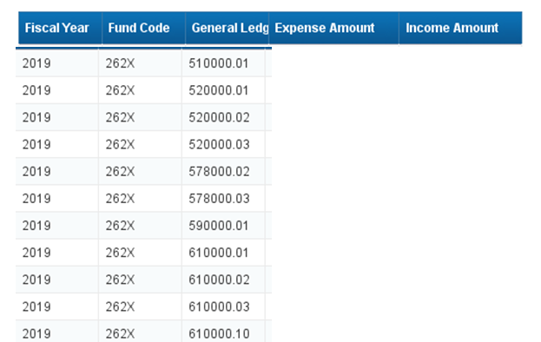

Note: the amounts are not included in the snapshots.

