NAVIGATING THROUGH BUSINESS OBJECTS - INTERMEDIATE
Dated for Reference: April 1, 2021

Table of Contents
Nested Filter Statement in a Query Filter
Creating Variables
Use of LEFT Statement in Variables
Use of Concatenation in Variables
Use of SUBSTRING in Variables
Use of IF Statement in Variables
Add a Query to a Document
Merging Queries in a Document

Nested Filter Statement in a Query Filter
Scenario: You have created an adhoc report as a basic VAT Cash report and have added objects for Accounting Period, General Ledger Credit Number and General Ledger Debit Number to the Query Filter Pane. Since the are all aligned at the same level this means all conditions shown in the filter will need to be true. Since we know the General Ledger Credit Number AND General Ledger Debit Number will not match the condition will not return any results. Therefore we will use the Nested IF to modify the condition to be General Ledger Credit Number OR General Ledger Debit Number.

Highlight General Ledger 6 Credit Number within the Query Filter pane and click “Add Nested Filter”. This is the last icon in this pane that looks like a folder with a plus sign in the lower right-hand corner. “OR” will now be inserted between General Ledger 6 Credit Number and General Ledger 6 Debit Number. There is a line to the right of OR. Drag and drop General Ledger 6 Credit Number and General Ledger 6 Debit Number to the right of this line. Your finished condition will then generate results based on a combination of an accounting period and either General Ledger 6 Credit Number or General Ledger 6 Debit Number matching the criteria entered in the filter.

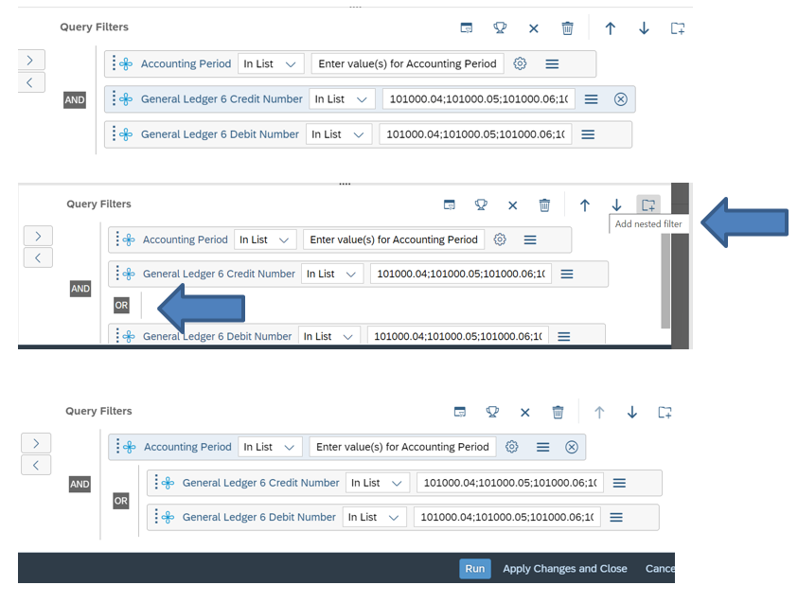

Creating Variables
A variable is a value that can change depending on conditions that are needed for a report. In business objects, users can create variables at the report level to match specific reporting needs based on existing objects.
As an example, we will add a variable to a user created basic VAT Cash report. To add a variable, you will need to be in Edit mode. From the Home Screen click on Folders and then Personal Folders and locate the report that you wish to add variables to. Once located, right click on the report and select modfy.
The Show Main Panel and Show property panels for current selection options are available when the report is open in Edit mode. Click on the Show Main Panel icon which is the icon that looks like clipboard to the left of the Edit button. Then click on Add Variable. The Create Variable panel will open.
Within the Name section, enter a name for your variable. When creating variables it is a good idea to place V_ or V. in front of the name to easily identify a variable. Add a description for the variable if desired. Make sure the Qualification accurately depicts either a Dimension or Measure and then enter the formula for your variable.
The qualification of the variable will depend on what you are trying to create which typically are one of two qualifications
- Dimension objects typically retrieve information represented by characters or information such as dates
- Measure objects retrieve numeric data related to calculations.
After clicking on either Dimension or Measure the Create Variable Pane will be expanded.
Section “Objects” provides you with the objects that exist within your specific query. Section “Functions” and “Operators” are available to guide you in creating the variables. Functions are categorized. You will need to click the arrow to expand the selection. When clicking on a Function within a particular category, a description of the function and example syntax will appear in bottom left of your screen. Querying a subject via Google can also be helpful when creating variables with more complex syntax.
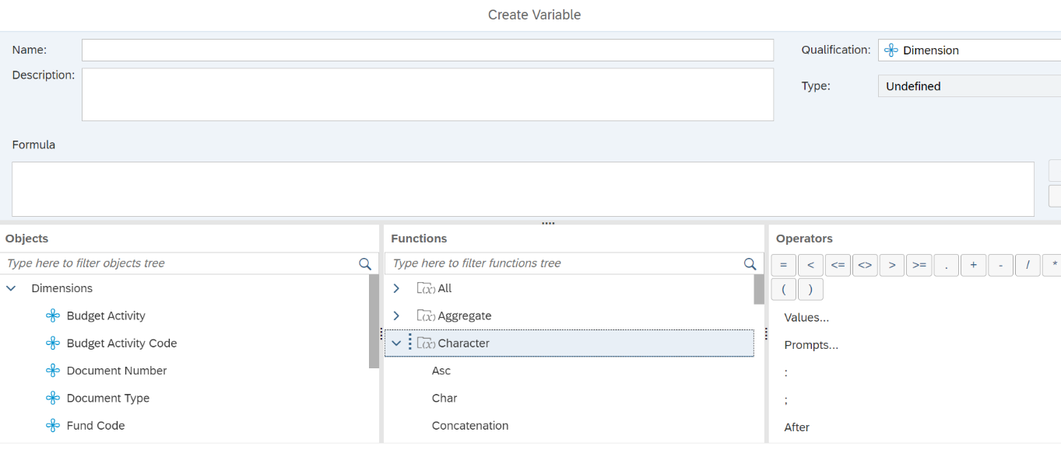.

Use of LEFT Statements in Variables
Use the LEFT command to extract the first characters of a string.
For example, the LEFT Command can be used to extract the first two characters of the Budget Activity into a variable we create called V_2 Digit
=Left([Budget Activity];2)

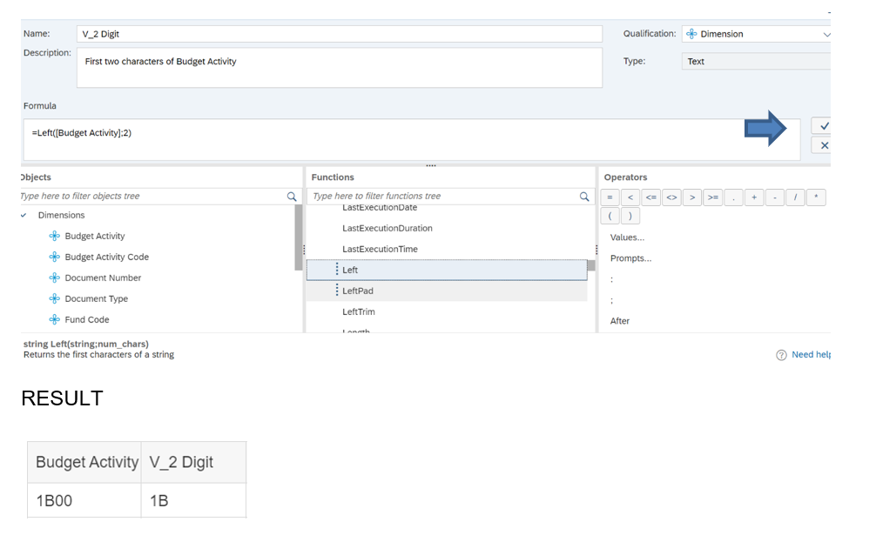

Use of CONCATENATION in Variables
Use the CONCATENATION command to join two strings.
For example, the CONCATENATION Command can be used to concatenate or join the Two Digit Budget Activity variable with the Organization Code into a variable we create called V_Two Digit BA Plus Org
=Concatenation(Concatenation([V_2 Digit];"-");[Organization Code])
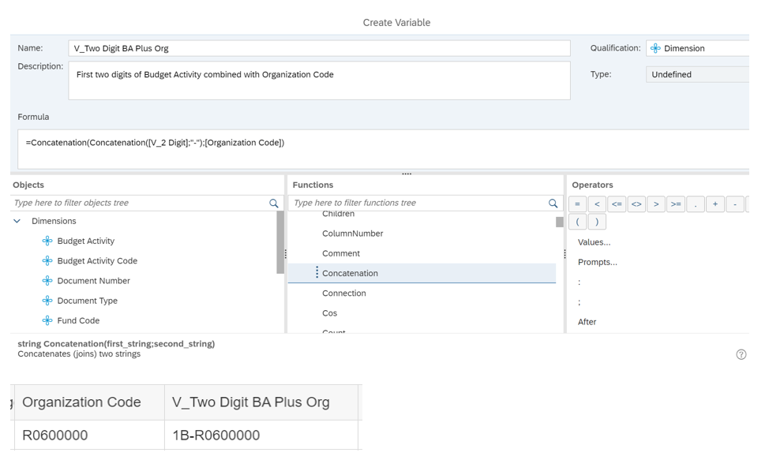

Use of SUBSTRING Statements in Variables
Use the SUBSTRING command to return part of string.
For example, the SUBSTRING Command can be used to create variable V_Fund Group Code to categorize/group specific funds
=If (Substr([Fund Code];1;1) = "0"; "Fund Group Zero";If (Substr([Fund Code];1;1) = "1"; "Fund Group One";If(Substr([Fund Code];1;1) = "2"; "Fund Group Two";"Other")))
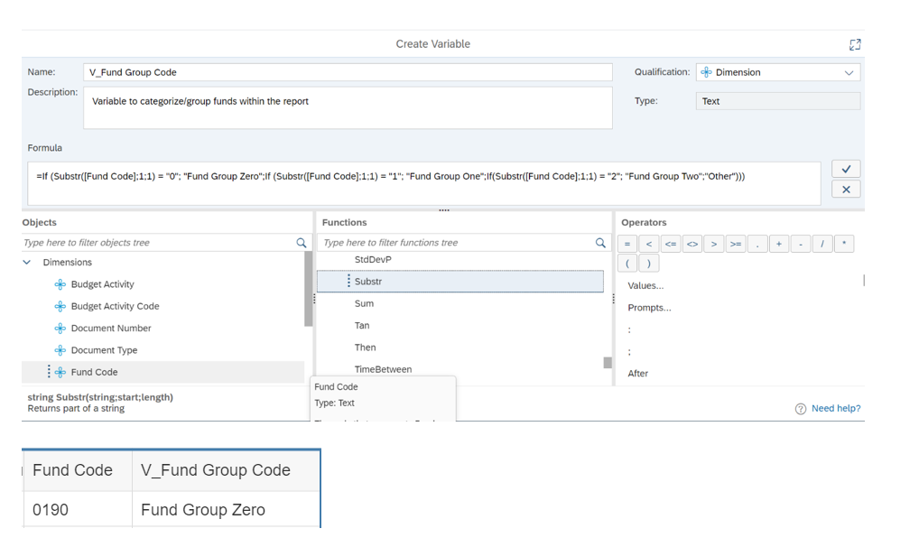
Use of IF Statements in Variables
The IF, THEN statement will return a value based true vs false criteria.
You can use the IF, THEN statement to create a variable called V_Converted VAT Amount to converting the VAT Amount to reflect the normal debit balance and normal credit balance for the Cash Accounts. In this case the Credit Accounts will be multiplied by negative 1.
=if([General Ledger 6 Debit Number] InList ("101000.04";"101000.05";"101000.06";"101000.06";"101000.20";"101000.35"); [VAT Amount]; If([General Ledger 6 Credit Number]InList("101000.04";"101000.05";"101000.06";"101000.06";"101000.20";"101000.35");[VAT Amount]*-1;[VAT Amount]))
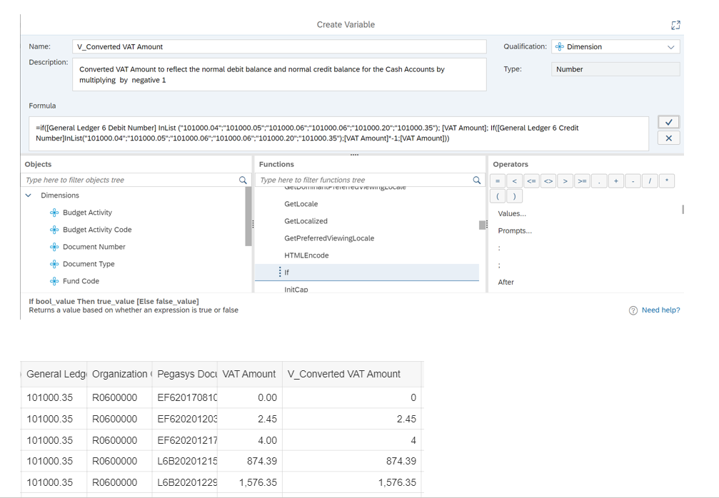

Add a Query to a Document
REVISIT FOR 4.3
Locate the report in your “Personal folder”. Right click on the report name and choose “Modify”. When you choose Modify from your Personal Folder, this allows you to edit your report to add a query. To display the query panel, click on the first icon under Data which looks like a little grid with a circle in the lower right-hand corner. When you hover over the icon it will display the word Edit. A window should open displaying the query panel.
The report in this example is built using the FMIS – Valid Accounting Transactions universe and the VAT Income (Single Year Query) class.
With the query panel for the report open, locate “Add Query” at the upper left of the query panel screen. Click on the drop down arrow to the right of “Add Query” and then select “Universe” from the drop down list.
The Universe window will open – find the universe you want the new query to use and double-click the universe name and click OK in the bottom right-hand corner of the window. This example is using the FMIS – Valid Accounting Transactions universe.
After clicking the Universe, a blank query panel will display a tab for Query 2 in the upper left hand corner of your screen. You are now ready to add objects.
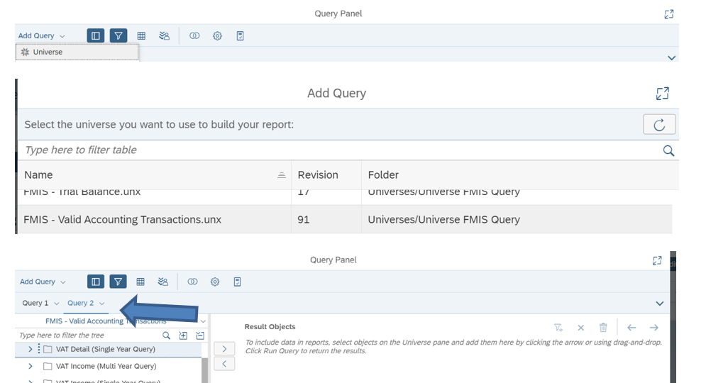

The Query Panel will open with a new empty “Query” tab
Build the new query –Add objects to the newly created query by adding objects to the Results Objects and Query Filters pane. In this example, the query will be built out of the VAT Expense (Single Year Query) using the same objects and filters as Query 1 which was built form VAT Income (Single Year Query). Objects do not have to be the same. However, in order that the Query Filters only show once in the Prompt window – the queries must be built the same way. The only exception is that the object chosen for amount will be expense amount from VAT Expense and income amount from Income Expense. The below snapshot shows this.
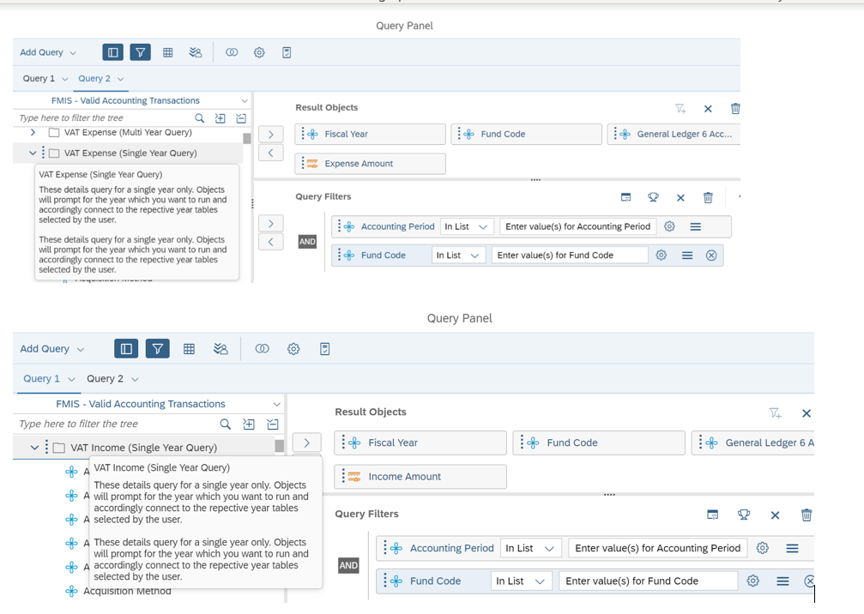
You are now able to run the queries. As part of the query, you will be prompted to “Choose how you want to include the data from the new query”.
Selection 1 – Insert a table in a new report – the new query results will display on a new tab in the report
Selection 2 – Insert a table in the current report – the new query results will display on a new grid in the same tab as the first query
Selection 3 – Include the result objects in the document without generating a table – the data will be retrieved but not displayed anywhere on the report. This data can be pulled into the report at a later time.
For the purposes of this example we are staying with Selection 1 – Insert a table in a new report.
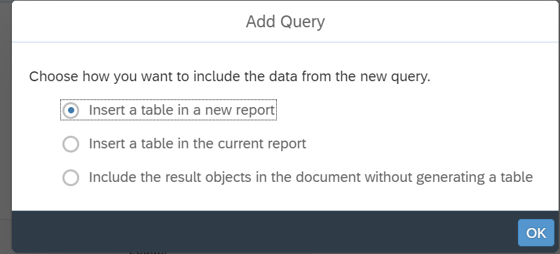
Once the query completes, the report now displays two tabs called “Report 1” and “Report 2”. You can rename the tabs to show “Income” and “Expense” or any other label by right clicking on Report 1 or Report 2 and choosing Rename.
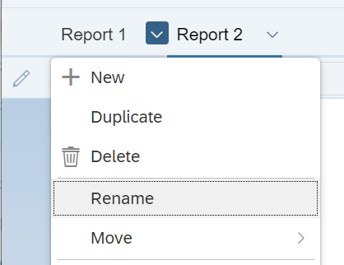

Merge Queries in a Document
If a report has more than one query, the results from each query are displayed separately from each other. If you want the results to display in a combined report, you must first merge the data.
In this example the report has two queries – both queries have the same objects – Fiscal Year, Fund Code, General Ledger and Amount.

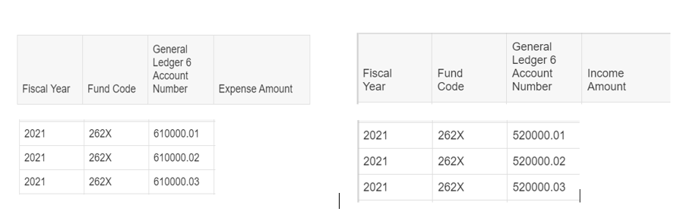

The desired final report will show the three dimensions (Fiscal Year, Fund Code and General Ledger) with Income and Expense side-by-side. Note: the amounts are not included in the snapshots.
Step 1: Merge the “like” dimensions. For this report the “like” dimensions are Fiscal Year, Fund Code and General Ledger Account Number, meaning all three objects are used in each of the queries. With the report open in Edit Mode, click on the Clip Board Icon next to Edit button (far upper right of your screen) which is the Show Main Panel option. Then click on the first icon that looks like a cube which is Show Document Objects view.
The objects used in your query will be displayed. In the event the Dimensions or Measures drop down is not open click the carrot object to the left of the word Dimensions or Measures to expand. Holding the Shift key down, click on the first object from Query 1 that you want to merge and then click on that same object from Query 2. The objects will then be displayed as grayed out. Click on the three dots to the right of the object you are merging and click merge. Repeat the process for Fund Code and again for General Ledger 6 Account Number.
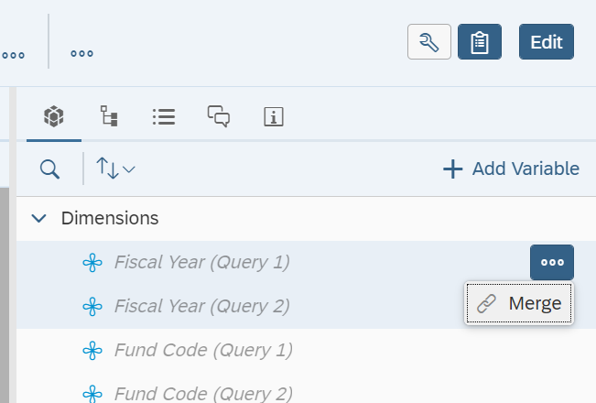

The objects will then appear grouped. Compare the “before” snapshot on the left to the “after” snapshot on the right.

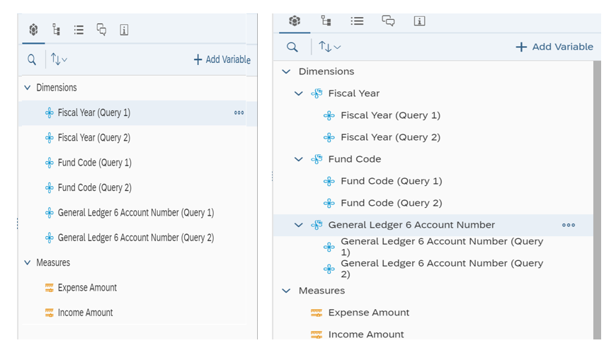

Step 2: Insert a new report by right-clicking on one of the existing tab labels and selecting “Add Report”. A new blank tab will display to the right of the last tab.
Step 3: Drag the merged dimensions and desired measures to the new report
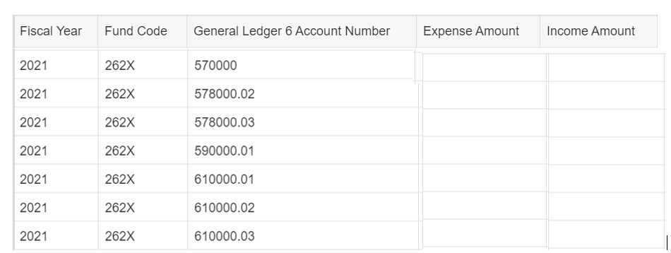

Note: the amounts are not included in the snapshots.

