NAVIGATING THROUGH BUSINESS OBJECTS – BEGINNER BASICS
Dated for Reference: March 3, 2023
Note: This document is in the process of being updated to capture changes in the updated Business Objects version introduced on March 4, 2023. Notations have been made in the sections that are not yet updated.
Table of Contents
Welcome
For Users of Versions Prior to SAP’s 4.3 Software Release
Requesting Access to the FDRS Business Objects Platform
Accessing FDRS Business Objects Platform
General Messages and/or Error Messages
FDRS Business Objects Home Page
Icons in Business Objects
Public, Personal and BI Inbox Folders
Accessing Reports in Public Folders
Accessing Reports in your Personal Folder
Creating A Shortcut to A Report; Marking a Report as a Favorite Report
Accessing Reports in Your BI Inbox; Moving a Report from your “BI Inbox” to your Personal Folder
Copying A Report from Public Folders to your “Personal” Folder
Modifying a Report in your “Personal” Folder to Add an Object to the Results Pane
Scheduling a Report
Scheduling a Report Using Example Report
Scenario: I added an object to my query but it did not show up on my report
Refreshing a Report
Modifying a Report in your “Personal” Folder to Add an Object to the Query Filter
Query Filters – Constant vs Prompted
Query Filter Conditions: In List vs Wildcard Use in Matches Pattern; Multi vs Single Value prompts Optional vs Mandatory prompts
Universe prompt vs Query Filter
Determining the Universe that a Report is Based On
Adding a Report Level Filter
Adding an Input Control Filter to a Report
Determining the Universe That a Report is Based On
Creating a New Ad-hoc Report
Sending a Report from your “Personal” Folder to another user’s BI Inbox

Welcome
Welcome to Financial Data Reporting System Business Objects (FDRS BO) Training. FDRS Business Objects (Business Objects for short) is a reporting tool offered by the software vendor SAP. FDRS is the chosen nomenclature for GSA’s Business Objects platform. For those of you who have used FDRS Business Objects prior to 2021, please note that with SAP’s 4.3 software release a new look and feel was implemented. As SAP’s 4.3 software evolves, new service packs are released which can result in changes to the look and feel. This guide is intended to help both the new user and user’s of previous upgrades navigate through some of the more commonly used features and functionality of the new versions.

****** We have found that the SAP version 4.3 tends to work best when launched from the Chrome or Edge browser.****

For Users of Versions Prior to SAP’s 4.3 Software Release
For those of you who have used FDRS Business Objects prior to 2021, not only will you instantly recognize the new look and feel, you may also notice the following:
- There are both familiar and new icons.
- My Favorites is now Favorites and Personal Folders.
- The Refresh Button often plays an important role when selecting report level prompts to apply when scheduling and/or refreshing the report.
- Additional clicks are required to apply prompts values when scheduling and/or refreshing the report. As of March 4, 2023 with the latest upgrade there are now less clicks involved in applying prompts.
- Objects contained in your report now appear on the right-hand side of your screen rather than the left.
- For reports with multiple tabs, tabs are now shown above the report rather than below.
- If you have more than one report open, you will need to use a drop-down to toggle between reports and likewise to close each report. The drop-down to display the reports open is in the middle of the Welcome Bar.
- Filtering is now located under Analyze but rather under a Show properties panel for current selection while in Edit Mode
- Likewise, variables included in Intermediate Documentation are now created by accessing the Show properties panel for current selection while in Edit Mode
- Edit Mode has some additional icons to navigate to show the main panel on which objects used on the report are made visible and variables can be created and to navigate to show the properties panel where some of the layout features can be set and report level features can be applied. As of March 4, 2023 with the latest upgrade Edit Mode is now labeled Design which contains a drop down menu to be able to select a Reading Mode, a Design Mode, a Structure Mode or a Data Mode. For those of you that modify queries in your Personal Folder, from the drop-down menu choose Design and the first icon in the Query section of the top tool bar, i.e. the icon that looks like a graph with the sun in the lower right hand corner.

Requesting Access to the FDRS Business Objects Platform
If you require access to FDRS Business Objects platform, please access Enterprise Access Request System (EARS) https://ears.ocfo.gsa.gov/ears/faces/home.jsp. Instructions can be found under the Getting Stared section at the Corporate Webpage link https://corporateapps.gsa.gov/applications/financial-apps/business-intelligence/

Accessing FDRS Business Objects Platform
Once you have been granted access to the FDRS Business Objects platform, the platform is accessible through the following link: https://corporateapps.gsa.gov/applications/financial-apps/business-intelligence/

Once at the Corporate Apps site, the Business Intelligence Screen is accessible through either the FDRS Login or FDRS PII Login.
As a general rule, if you are running Financial Reports, please choose the FDRS Login. For example, this would be reports utilizing Pegasys or FMIS Data. If you are running reports that do / potentially can contain PII and/or sensitive data, choose the FDRS PII Login. This is for access to reports utilizing Labor, HR, Credit Card or Payroll data.
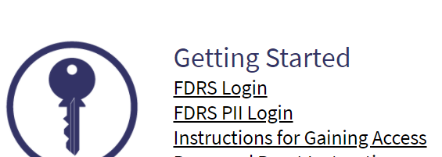
For individuals with a GSA ENT ID, the FDRS login is via Single Sign On. In the event single sign on is not available you may be presented with a login screen. The first line of the login screen will auto-populate with the System Name. As a user make sure the Authentication Type shows Windows AD (use the drop down arrow to change) and enter your ENT User Name and ENT Password.
For users of the FDRS PII login, you will need to enter your GSA ENT ID and ENT Password for access.
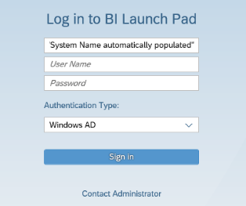
If you encounter a message such as Data Protection, please respond accordingly.
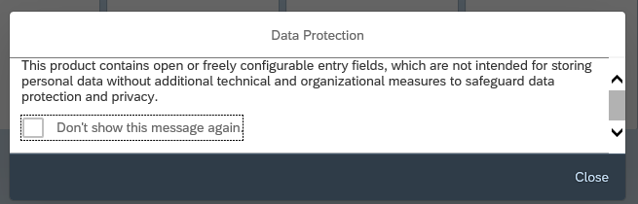
Now that you have successfully accessed Business Objects, here are some tips to get you started. As with many applications there can be more than one way to accomplish the same goal. The purpose of this document is to provide an initial introduction on navigating through the FDRS Business Objects Environment.

General Messages and/or Error Messages
In the event the following messages appear, click the “x” to the right of the message
A data source of this document has been updated. We recommend saving the document to improve its performance next time you refresh it.
This document has been migrated. We recommend saving the document to improve its performance next time you open it.

FDRS Business Objects Home Page
With SAP’s 4.3 software release, a new look and feel was implemented beginning with the Welcome Screen.
NOTE: In the event the “Recently Run” section is not populated, navigate to the folder containing the report and schedule or refresh the report and the report will re-populate in the Recently Run section.

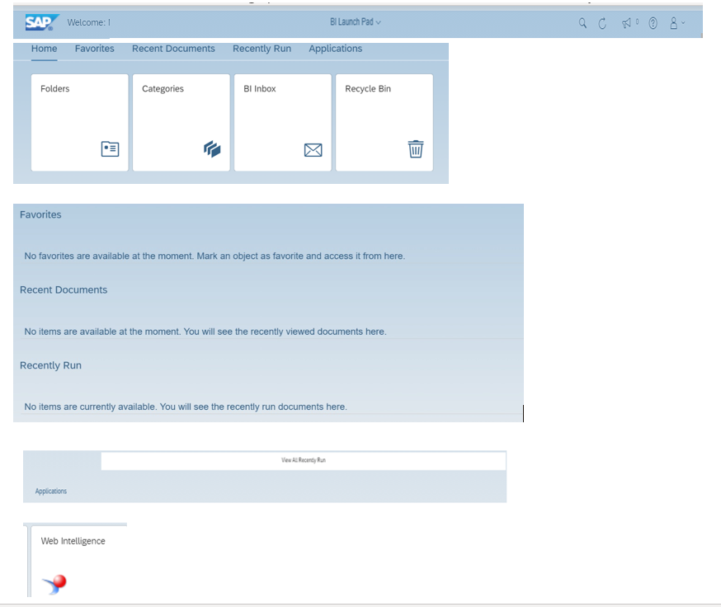

Icons in Business Objects

Below is an overview of ICONs. As of March 4, 2023, what was previously referred to as the View Mode is now referred to as the Reading Mode and what was previously referred to as Edit Mode is now referred to as Design Mode.

The Reading (View) Mode tool bar consists of icons in sections labeled File, Query, Analyze and Display. This replaces what was labeled File, Data and Analyze.

When in the Reading Mode in a report in your Personal Folders you can switch to Modify/Design (Edit) Mode by clicking the drop-down arrow to the right of Reading and choosing Design. This will result in the top tool bar now displaying additional icons and a new section labelled “Insert” which among other features allows you to insert crosstab tables as well as charts.

Reading (View) Mode: While in Reading (View) Mode, from left to right there are 4 categories of Icons. As of March 4, 2023 you have additional options available to you. Please note that not all options are available and are most likely grayed out.

- File
  - New and Open Icons
    - allow you to open another report without navigating back to the home page
  - Save As
  - Undo
  - Redo
  - Mark as Favorite
  - More (which includes Export and Send to BI Inbox)
- Query (formerly Data)
  - Refresh
- Analyze
  - Show Filter Bar
  - Enable Navigation
  - Show Changes (not available)
  - Track Data Changes
- Display
  - Hide Main Tool Bar
  - Freeze All Table Headers
  - Enable Folding/Unfolding Breaks and Sections
  - Start Presentation Mode

Modify/Design (Edit) Mode: When in Modify/Design (Edit) Mode, additional Icons are displayed.

From left to right there are now 5 categories of Icons
- File
  - New and Open Icons
    - allow you to open another report without navigating back to the home page
    - allows you to access files from other folders
  - Save is allowable in Design (Edit) Mode in addition to Save As
  - Undo
  - Redo
  - Mark as Favorite
  - More (which includes Export and Send to BI Inbox)
- Query (formerly Data)
  - Edit
  - Refresh
  - More (includes Change Source and Purge Data)
- Insert
  - Insert Table which allows you to insert a cross tab/pivot table
  - Insert Chart which contains a number of visualization options
  - Insert Cell
  - Insert Section
- Analyze
  - Show Filter Bar
  - Enable Navigation
  - Show / Hide Filter Bar
  - Show / Hide Formula Bar
  - More (including Drill, Track Data Changes and Formatting Rule)
- Display
  - Hide Main Tool Bar
  - Zoom
  - Show Print Layout
  - Freeze All Table Headers
  - More: Enable Folding/Unfolding, Fit to Width, Fit to Page, Presentation Mode
- Unlabeled Section (three dots)
  - Navigation from Page to Page

Public, Personal and BI Inbox Folders

- Public Folders
  - Public Folders, sometimes referred to as Corporate Folders, are reports typically created by a developer on the IDEAA team for use by a group of individuals. These reports are often complex.
- Personal Folders
  - Personal Folders, historically referred to as My Favorites, contains reports created by the user.
- BI Inbox
  - The BI Inbox is meant to be a temporary holding place for a report.
  - BI Inbox is for the receipt of reports from another business objects user. The recipient should use the ‘Save As” command after opening the report.
    - Prior to March 4, 2023, this was accomplished via the copy command to copy/paste the report to his/her Personal Folder and then delete the report from the BI Inbox or the recipient usedthe cut command to cut/remove the report from the BI Inbox paste the report to his/her Personal Folder. Instructions are contained within this document.
  - Where scheduling is permitted a user can also send the output of a report to his/her BI Inbox from which the report should then be downloaded.

Accessing Reports in Public Folders
To access Public Reports, from the home page click “Folders” and then navigate to the appropriate sub – folder. Click on the marker to the left of the words Public Folders to expand the selection.
As you click on the sub-folders containing reports, you will see the reports listed in the right pane of your screen in the block labeled “Title”.

Accessing Reports in your Personal Folder
The “My Favorites” Folder from previous versions has been renamed Personal Folder.
To access your Personal Folder, from the Home page click on Folders to display Personal Folders. Click on the marker to the left of the words Personal Folders to expand the selection.
Let’s get acclimated to the icons in you “Personal Folder” in the upper right of your screen. 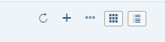
From left to right, (1) Refresh, (2) Add, (3) Export Listed Table Items as Excel, (4) toggle between Grid View (Default) and List View.

Creating A Shortcut to A Report; Marking a Report as a Favorite Report
The Home Page contains a block called Favorites. This is where you can create a short cut to your favorite or most often used reports by “marking” the report as a favorite and accessing it from this block. To do so, navigate to the report and click in the open space in the favorites column next to the report name. The report will be marked with a star and will appear on the Home Page within the Favorites block. To remove/un-tag a report as a favorite, navigate back to the report origin and click on the star to the right of the report name. You will be prompted to confirm removing from favorites.

Accessing Reports in Your BI Inbox; Moving a Report from your “BI Inbox” to your Personal Folder
The Inbox Folder from previous versions has been renamed “BI Inbox. To access the BI Inbox, from the home page, click on BI Inbox to display the reports in what is now labelled “My Inbox”.
Navigate to your “BI Inbox/My Inbox” and locate the report you want to move to your “Personal” Folder. Click the envelope which will open the report. Then chose Save As.
Navigate to your “Personal” folder to access the report. You may need to click the WebIntelligence SubFolder.
Titles of reports in your Personal Folders can still be renamed at either during Save As or by right clicking the report in your Personal Folder and choosing Properties.
Once the report is successfully in your Personal folder, navigate back to your BI Inbox and delete the report. To do so right click on the report and chose Delete.
Note: If you wish to create sub folders within your “Personal” folder from your “Personal” folder, click the plus + sign to the far right of the Personal Folders pane to display a drop down. Then click “New Folder”. “Create Folder” should appear as a second window for you to populate a New Folder Name and if desired to enter a Description and Keywords for the folder. One completed chose Save at the bottom of of the Create Folder Window and choose “OK” to create.

Copying A Report from Public Folders to your “Personal” Folder
After navigating to “Public Folders”, locate the report you want to move to your “Personal” Folder. Right click on the report and choose “Organize” then choose “Copy”.
Navigate to your “Personal” folder. In the upper right-hand corner you will see a series of icons. Click on the icon that looks like 3 dots which represents Click Here for More Actions and choose Organize and Paste.
It is recommended that you rename the report to distinguish it from the report in the public folders. To do this, from your Personal” folder, right click the report and choose “Properties”.
Enter a Title of your choosing and if desired a Description. Be sure to choose “Save” at bottom right of screen when complete.
The report in your “Personal” folder will now reflect the name change.
Practice:
Navigate to Public folders and then to FMIS Query > Misc and copy the report “1 RWA VAT Query multi-year to your Personal Folder. Once copied rename the report “Copy Of 1 RWA VAT Query multi-year”.

Modifying a Report in your “Personal” Folder to Add an Object to the Results Pane

Locate the report in your “Personal” folder and right click on the report and choose “Modify”. A prompt window may appear for you to Run the report. You can either run the report of choose “Cancel”. Your report should display but may or may not contain data at this point.
Please note that sometimes reports are created using multiple queries. These will appear as tabs at the top of your screen. An example of when multiple queries are used is for FMIS queries where the first tab is a query created to pull data for the most recent 5 years and a second query to pull in a single year.
When you choose Modify from your Personal Folder, this allows you to edit your report to add and /or delete objects, as well as add/delete/edit Query Filters.
To display the query panel, click on the first icon under Query (formerly Data) which looks like a little grid with a circle in the lower right-hand corner. When you hover over the icon it will display the word Edit. A window should open displaying the query panel.
In the upper left of your screen, you can see the Universe on which the report was built.
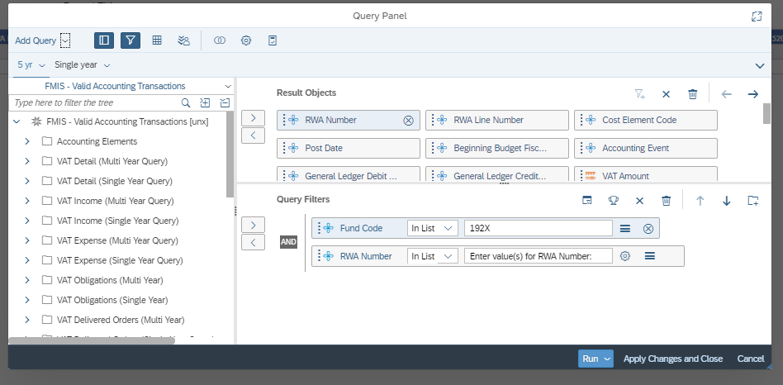
The above snapshot is from the report “Copy Of 1 RWA VAT Query multi-year” that was suggested for practice in the Copying A Report from Public Folders to your “Personal” Folder section of this guide.
When adding an object to a report it is important to know the sub-folder from which the other objects originate. Objects are created based on source tables. Not all source tables are meant to be combined which is why in some instances you will not be able to add objects from other sub-folders.
An easy way to determine what class folder an object currently in the report resides in is to click on the object within the Results Object Pane and the class folder to which that object belongs will open.
In the report example shown, if you click on RWA Number within the “5 yr” query tab you will see the VAT Detail (Multi Year Query) sub-folder expand and RWA highlighted. You may need to scroll up or down to see the sub-folder name. and if you scroll down RWA is highlighted.
In the same way, if you click on RWA Number within the “Single Year” query” you will see the VAT Detail (Single Year Query) sub-folder expand and the RWA is highlighted.
Using the practice example, we will be adding the object NARA Number to each query in this report.
With the Query Panel open in Design(Edit) Mode, locate the Object NARA Number in the sub-folder corresponding to the sub-folder from which the other objects in the query originated. Once located, drag the object over to the Results Objects Pane and release the object. In the example below NARA Number for the “5 yr query” was dragged over from the VAT Detail (Multi Year Query) sub-folder.
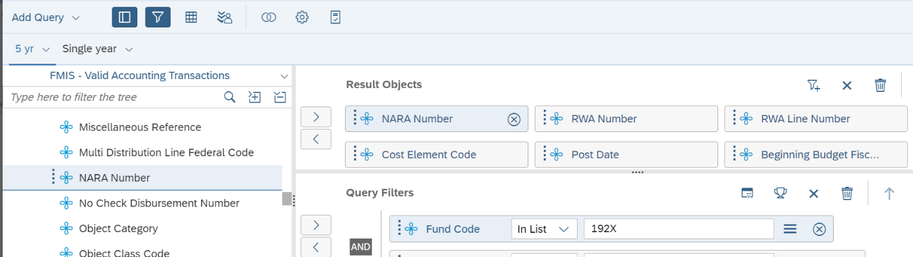
Repeat the process for the “Single Yr” query EXCEPT this time the object NARA Number should be from the VAT Detail (Single Year Query) sub-folder.
Once completed, in the lower right-hand corner of your screen, choose “Apply Changes and Close”.
In the upper left-hand corner choose the diskette icon and from the drop down choose “Save” to save the changes to the report of the same name or chose “Save As” to create a new file name. In this example “Save As” is chosen. Once the Save Document window open, click on Personal Folders and save your report to a new name such a Copy of 1 RWA VAT Query multi-year with NARA NUM. Note: If you do not want to save this report in the root folder, choose the marker to the left of Personal Folders to choose the sub-folder you would like to save the report to.
Then click “Save” in the lower right-hand corner of your screen.
Once saved, click on the drop-down marker of your query name that appears in the Welcome menu bar and then the x to the right of the query name to close the query.
Navigate back to your Personal Folders where you saved the renamed query, right click on the report and schedule the report to run.
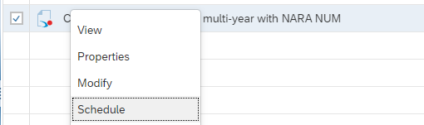

See Scheduling a Report for general instructions followed by specific instructions for the report used in this example, i.e. Copy of 1 RWA VAT Query multi-year with NARA NUM

Scheduling a Report
Please note that with the March 4, 2023 Installation of SAP’s 4.3 updated software release schedule option looks different and has LESS clicks than earlier 4.3 versions. Note: For reports that reside on the FDRS PII Server, the Schedule Option is not available. Rather you must refresh the report.
To schedule a report, locate the report name within the “Title” block of the folder in which the report resides. You can either right click on the name of the report or click the three dots to the far right of the line containing the report name to display a menu with the Schedule Option.
After choosing schedule, a screen will open that contains two tabs with drop down menus (1) General and (2) Report Features. Click on each tab to display the options.
General Tab
Instance Title: The Instance Title allows you to change the name of the report instance while maintaining the name of the report itself. For example, if you want to change the Instance Title of the report “VAT Status Report (Updated)” you can click on the box within instance title and update the Instance Title to add a date such as VAT Status Report as of February 17, 2020. The name of the report “VAT Status Report (Updated)” will remain intact. The benefit of renaming an instance is if you are downloading the report, this can add clarity to the report title.
Destinations: The Destination option allows you to set a destination for the output of the report. Destinations default to “Default Enterprise Location”. Although there are a few options listed that are available with the software, the option may not have been enabled based on direction from GSA’s ISSO. One item that has been disabled in the Email Functionality.
Recurrence: The recurrence option defaults to “now” but for those reports that do not require user input when run, you have the option to set the report to run at different time intervals. To do so, use the drop-down menu to choose Recurring which in turn gives you options on intervals.
Note: Calendar is a custom feature and is currently not available.
Allow Retries should remain as defaulted to Off.
Events: This is for system use only.
Scheduling Server Group: This is for system use only.
Notification: This is for system use only.
Report Features
Formats: The format option allows you to change the output format of a report. The Output Format will default to Web Intelligence. If the report is one you want to export in Excel, chose the Format Microsoft Excel-Reports. Prior to the March 4, 2023 upgrade this was labeled Microsoft Excel.
Prompts: The prompt section contains the prompt values that need to be populated to generate results. See Scheduling a Report Using Example Report for the “how to” on entering prompt values using an example.
Delivery Rules: These are not utilized and can be ignored.
For reports that do not contain prompt values select schedule in the bottom right-hand corner of your screen.

Scheduling a Report

Navigate to the report you want to schedule. You can either right click on the name of the report or click the three dots to the far right of the line containing the report name to display a menu with the Schedule Option.
Prompts: To populate the prompt values, choose Edit Prompt Values in the upper right-hand corner of the Prompt box from the Report Features screen to open the Prompt Box for entry.
As of March 4, 2023 Optional and Mandatory Prompts are now displayed on one page so that you can remain on one page to navigate through each prompt. Once you have completed prompt entry, choose apply at the right hand bottom of the screen.
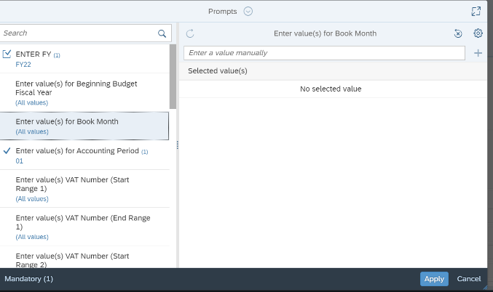

Reports can contain Mandatory and Optional Prompts. Mandatory prompts are designated by a number in parens to the right of the prompt name.
Mandatory Prompts must be populated for a report to run successfully. Optional prompts are those designed to be used at the discretion of the user but are not required for the report to run successfully.
As you click through the verbiage for each prompt value the right side of the prompt box will automatically update to be applicable for the prompt values needed.
After clicking on the line to add a value as a manual entry or after selecting a value from a list of values, your choices will appear automatically with no need to apply each change.
Once completed with all prompt choices, choose Apply in the bottom right hand of your screen to apply all entries and then Schedule. A History Window should appear that reflects the status of your report which goes from Pending to Running to Success.
Note: if you are refreshing choose Run to run the report.
Once a Status of “Success” is returned, click on the report Instance Time to open the report.
In the event you encounter a status of Failed, click the three dots to the far right of the line containing the Report name and click Details from the menu to open information about generation of the report. Failed reports will contain verbiage next to Status Detail that provides insight as to why the report failed to generate

Scenario: I added an object to my query but it did not show up on my report
Using the practice example from the section “Copying A Report from Public Folders to your “Personal” Folder”, when you added NARA number to the report “Copy of 1 RWA VAT Query multi-year with NARA NUM and scheduled the report to run, NARA Num may not have automatically appeared on your report.
To add a column to the report to pick up the NARA NUM data, the report will need to be in Edit View except in this case, after clicking the Edit Icon, rather than selecting the Data, Edit option in the tool bar to open the Query Panel, click on the Clip Board Icon next to Edit button (far upper right of your screen) which is the Show Main Panel Option. Then click on the first icon that looks like a cube which is Show Document Objects view. Locate NARA NUM and drag the object to the location on the report you want the data to appear. You will then need to save the report.

Refreshing a Report
Refreshing a report is very similar to scheduling. Unlike scheduling which produces and instance that is saved in History, a refreshed report does not generate a saved instance but rather as user if you would like to retain the data generated on a refreshed report, you will need to download the report to your hard drive.
To refresh a report, locate the report name within the “Title” block of the folder in which the report resides. You can either right click on the name of the report or click the three dots to the far right of the line containing the report name to display a menu with the View Option. Some reports will refresh upon opening while others will require you to manually choose the refresh button in the tool bar in the upper left of your business objects screen under the Welcome Banner. After clicking the refresh button, a refresh document box will appear. If the report requires prompt values to be entered, the Prompt box will open. Refer to the instructions for updating prompt values in the Scheduling a Report Using Example Report section of this document. The one caveat is that once you are done updating the prompts when refreshing a report, you will need to choose “Run” in the bottom right of your business objects screen rather than Schedule.

Modifying a Report in your “Personal” Folder to Add an Object to the Query Filter
Note: Steps may have changed slightly with the updated version introduced on March 4, 2023. Future versions will capture the changes.
The beginning steps to add and/or modify a Query Filter are basically the same as adding an object to the Results Pane.
Locate the report in your “Personal” folder and right click on the report and choose “Modify”. A prompt window may appear for you to Run the report. You can either run the report of choose “Cancel”. Your report should display but may or may not contain data at this point.
When you choose Modify from your Personal Folder, this allows you to edit your report to add and /or delete objects as well as to add/delete/edit Query Filters. To display the query panel, click on the first icon under Query (formerly Data) which looks like a little grid with a circle in the lower right-hand corner. When you hover over the icon it will display the word Edit. A window should open displaying the query panel.
In the upper left of your screen, you can see the Universe on which the report was built.
The Query Filters block is below the Results Objects block of the Query Panel.
In this example, a copy of the public report “Pegasys Form Report” has been copied to a user’s “Personal” folder and opened from the user’s Personal Folder by right clicking on the report and choosing Modify and then accessing the Data Panel as described above.
The Pegasys Forms Report is created through use of 2 Primary Queries, Query 1 and Query 2. Query 1 has series of combined queries.
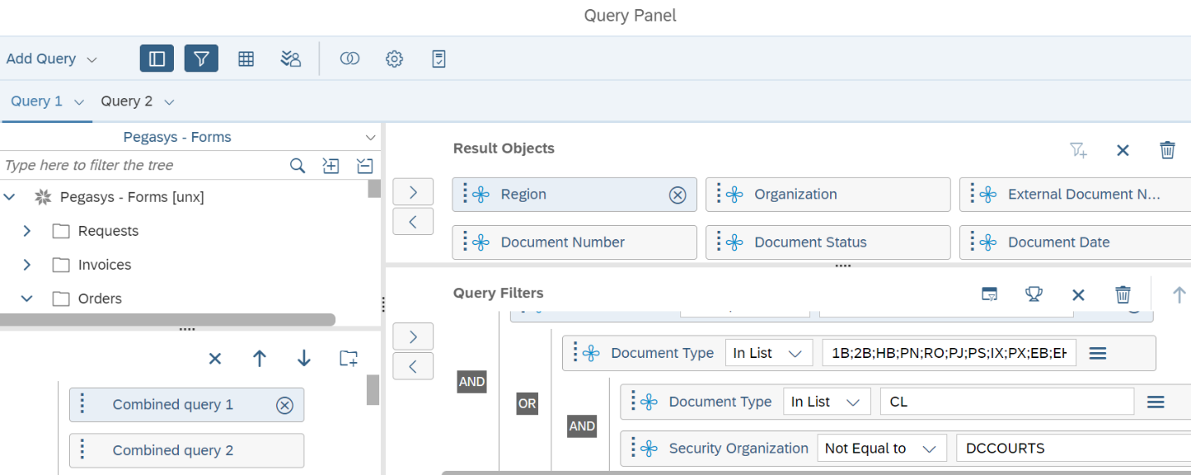
If you click on an existing object in the Results Object Pane of the query, the class folder containing the object will display. From this class folder click on Region and use the right arrow under Query Filters to move the Region to the Query Filters panel. Note: If you need to move the object up and down within the query panel you can do so by clicking and dragging the object.
Now that the object has been added to the Query Filter Panel you will need to define its use. In this case we are choosing to limit the query to Regions 01, 02 and 03. In List which is default for newly added objects allows you to enter multiple values and the blank is for the specific constant values to be typed in. A constant indicates that each time you run the query the values entered will not change and are equal to the specified value. Be sure to type in each value separated by a semicolon.
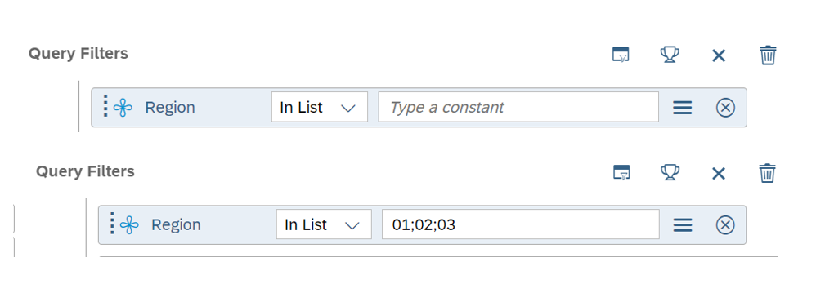

Click on Combined Query 2 and repeat the process.
Repeat the process for Combined Queries 3-8. Once complete, choose “Apply Changes and Close” in the lower right of your screen.
Save your changes by clicking the icon that looks like a diskette.
Close the report and schedule the report to run. Once complete, the report will be limited to Regions 1,2 and 3.

Query Filters - Constant vs Prompted
Note: Steps may have changed slightly with the updated version introduced on March 4, 2023. Future versions will capture the changes.
When establishing a query filter, the filter can be hard coded as a query filter constant (equal to a specified value) or can be set as a prompt (user is prompted to enter a value(s) each time the report is run).
When a new query filter is added it defaults to “In list” with a blank for the value. “In list” allows for multiple values and the blank is for the specific constant values to be typed in.
When adding a filter to change the constant filter to a prompted filter, click on the three lines to the right of the Query Filter Object which allows you to Define Query Type by choosing Prompt. The query filter now shows “Enter value or X% for Function Code as a prompt filter and an and icon that looks like a wheel that if you hover over it reveals it is used to show prompt properties appears to the Define Filter Type icon.

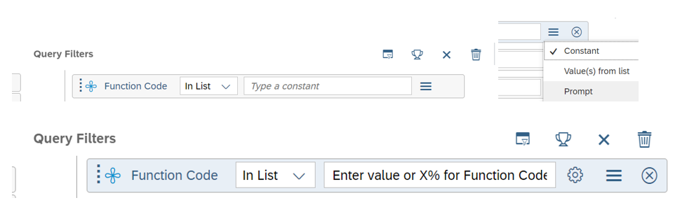
When the query is scheduled or refreshed the prompt window will now include a prompt for Function Code
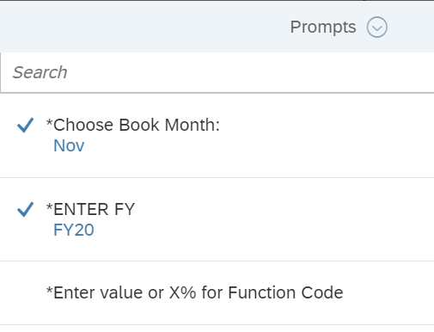

Query Filter Conditions: In List vs Wildcard Use in Matches Pattern and Multi vs Single Value prompts
Note: Steps may have changed slightly with the updated version introduced on March 4, 2023. Future versions will capture the changes.
When a new query filter is added it defaults to “In list” with a blank for the value. However, you can update the filter for a report in your Personal Folder choose other options such as Matches Pattern which allows the user to enter partial characters as a wildcard. To choose other options click the drop down arrow next to the object name in the query filter window which when howevered over states “Click here to access options”.
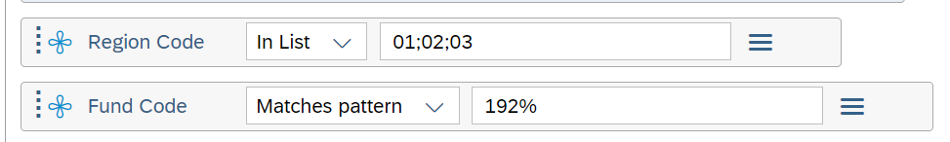
Similar to how you update the filter for a report in your Personal Folder to choose other options such as Matches Pattern, you can also change the filter from multi-value to single-value – click on the drop-down arrow next to “In list” and select “Equal to”.

Optional vs Mandatory prompts in a Query Filter and other Prompt Properties
Note: Steps may have changed slightly with the updated version introduced on March 4, 2023. Future versions will capture the changes.
When a new query filter is added and changed to a prompt, it defaults to mandatory as evidenced by the asterisk to the left of the prompt in the Prompt window
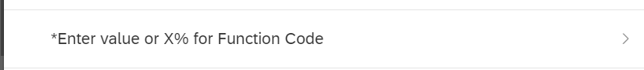
The query filter can be modified from a mandatory to optional. In the query filter window click on the Show Prompt Properties icon next to the filter
The “Prompt Properties” window displays. To change the filter from mandatory to optional, click inside the “Optional prompt” box and click “OK” in the bottom right. Now when the query is scheduled or refreshed the Prompts window will display the prompt without the asterisk to the left of the prompt. You may also see a notation at the bottom left of the window indicated the number of mandatory prompts the report contains.

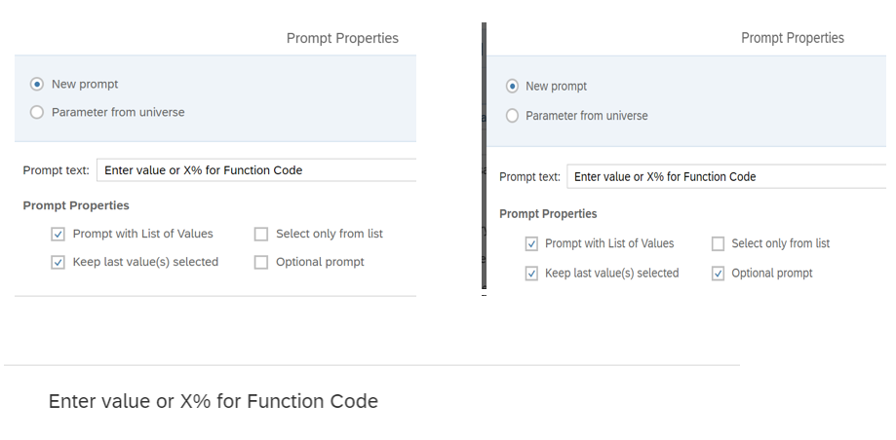

There are other properties that can be controlled via the Prompt Properties window.
You can change the text in the Prompt Text Box. The prompt defaults to show the last values used. You can change the prompt to show blank every time by unchecking the “Keep last values selected” box.
You can set the prompt to display a default value every time.
- click in the “Set default values” box
- enter the value(s) in the “Type a value” field; multiple values must be separated by “;”
- click the “>” button to move the values to the “Values” window
- click “OK” in the bottom right corner
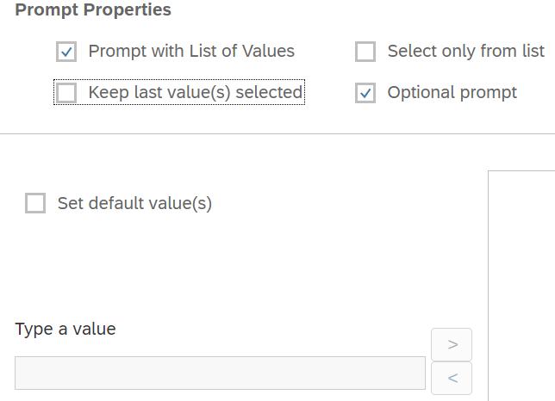

Universe prompt vs Query Filter
Note: Steps may have changed slightly with the updated version introduced on March 4, 2023. Future versions will capture the changes.
A Universe prompt is an embedded prompt built at the universe level. Universe-level prompts are built-in to avoid “runaway” queries which are queries that try to retrieve so much data that the system gets hung up. Unlike other prompts, these cannot be seen in the Query Filter window and will present themselves when the Business Objects query is scheduled or refreshed.
Examples of Universe Prompts that can appear are “Accounting Period” and “Fiscal Year” that will be applied to every query that accesses a specific universe.

Determining the Universe that a Report is Based On
Note: Steps may have changed slightly with the updated version introduced on March 4, 2023. Future versions will capture the changes.
Scenario: Another user sends a report to your Inbox and you copy it to your Personal Folder. Your boss asks you on what Universe the report is based. To determine this, right click on the report name that exists in your “Personal” folder and chose “Modify”.
To display the query panel, click on the first icon under Data which looks like a little grid with a circle in the lower right-hand corner. When you hover over the icon it will display the word Edit. A window should open displaying the query panel.
In the upper left of your screen, you can see the Universe on which the report was built.
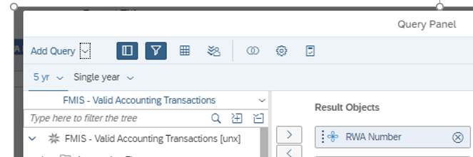

Adding a Report Level Filter
Note: Steps may have changed slightly with the updated version introduced on March 4, 2023. Future versions will capture the changes.
You limit the data returned to the document by applying filters when you define the query.
For this example, we copied the VAT Query (Updated v3) report from the Public folders > FMIS Query > VAT folder and are going to apply a filter to our report.
To add a Report Level Filter to a report, with the report open, click on Edit in the upper right-hand corner and then click on the Show property panels for current selection which is the icon that looks like a wrench two to the left of the Edit button. Then click on Show report element data which is the icon that looks like an “x” formed by a wrench and a screwdriver.
Click on the icon with 3 dots which is Manage Filters
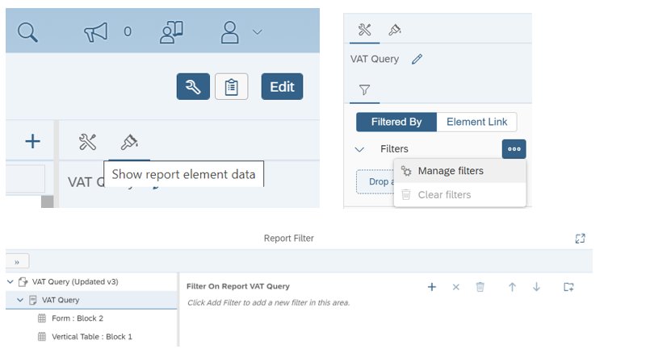
After clicking on Manage Filters in the Report Filter box, click on the plus sign to display a list of Available Objects to use as a filter. Select the desired object by clicking on it and then OK at the bottom of list. The object you selected will now appear in the Report filter box with a drop-down option to the right of the object. Use the drop-down to select the criteria for the filter. In this example we are choosing to filter the report on VAT Numbers 275 and 276 so we will choose In List which allows us to select two values. After selecting VAT Numbers 275 and 276 click OK at the bottom of your screen. Your report will now be limited to display lines for VAT Numbers 275 and 276 as reflected in box shown under Filtered By. To Edit Filters in the report simply click on the dots under Element Link to open Manage Filters.
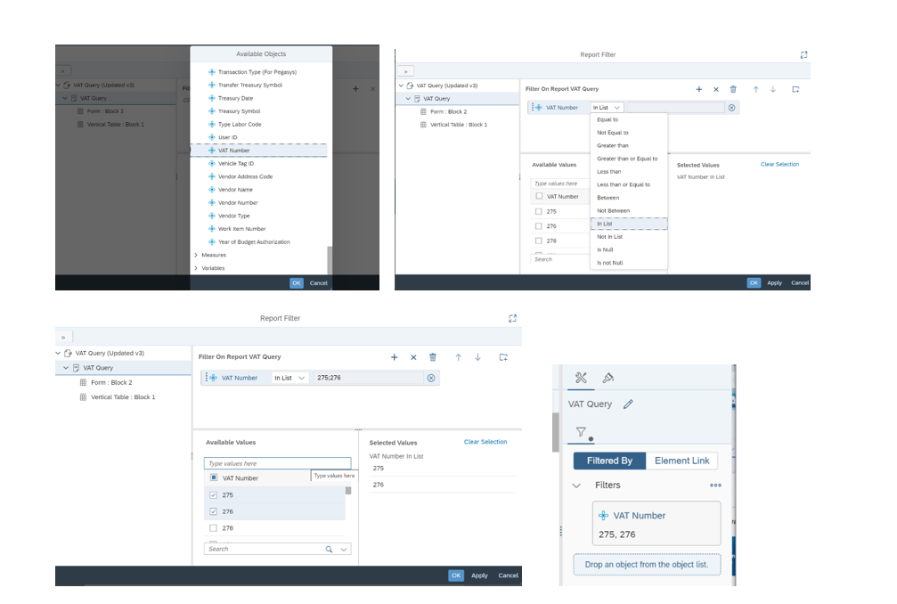

Adding an Input Control Filter to a Report
Note: Steps may have changed slightly with the updated version introduced on March 4, 2023. Future versions will capture the changes.

Input controls are similar too filters but are more interactive. With input controls, there will be radio buttons by the values you set up that by clicking the values you select will limit your data.
To add an Input Control Filter to a report, with the report open, click on Edit in the upper right-hand corner and click on Show Filter Bar function which is the icon that looks like a funnel under Analyze in the tool bar. If you hover over this icon, the verbiage Show Filter Bar appears. This will bring up an icon to the left of your screen under the toolbar that is filter with a plus sign and a drop-down menu. If you hover over it will show Manage Filters.
From the drop-down menu under Manage Filters, choose New Input Control to open the New Control Window where you will select the object to use as a filter. Once the object is chosen, you will be able to apply criteria to the object filter to limit the data.
For example, in the VAT Query report if you want to filter the report for a particular VAT Number(s), the object you would choose as your filter is VAT Number. You would then use the drop-down menu to next to Type to choose In List and the drop-down next to Operator to choose Equal if you are choosing a single VAT number or Type to Multi-List and Operator to In List if you are filtering on more than one VAT Number. In either case you will then click on Select Values to select the specific value(s) desired. On the Select values screen, highlight the VAT Number and using the arrow to move the value over the to Selected Values pane and once completed click OK on the bottom right lower hand corner of your screen which will then bring you back to the New Control Window where you will need to click OK on the bottom right lower hand corner of this screen to apply the filters to your report. Once applied, your report will be limited to the values chosen and your filter will appear in the ribbon bar above the report.
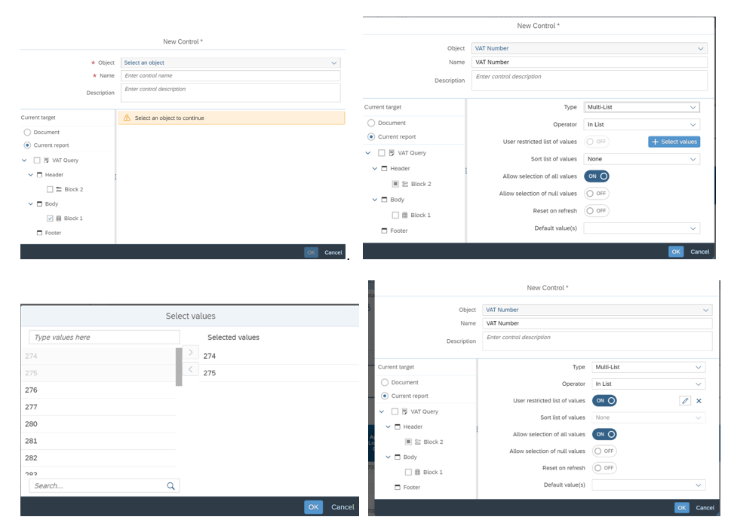

Creating a New Ad-hoc Report
Note: Steps may have changed slightly with the updated version introduced on March 4, 2023. Future versions will capture the changes.

To create a new report, from the Home Screen click on Applications and then Web Intelligence
After clicking the icon, highlight Universe and click OK
Select a Universe from the list of Available Universes and click OK
A Query Panel will open up from which you can create a report.
Drag the applicable objects to the Results Objects and Query Filters panels on the right-hand side of your screen.
Click Apply Changes and Close and then Save to save your work.

Sending a Report from your “Personal” Folder to another user’s BI Inbox
Note: Steps may have changed slightly with the updated version introduced on March 4, 2023. Future versions will capture the changes.

To send a report to another user’s BI Inbox, locate the report in your Personal Folder that you would like to send to another BI User. Right Click the name of the report Click the three dots to the far right of the row containing the report name “click here for actions on the row” and click on Send To and then BI Inbox.
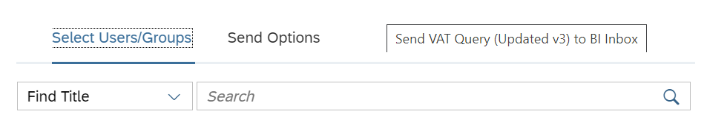
Enter a username or partial name in the Search Box next to Find Title. When the name appears click inside the check box and click Send at the bottom of your screen. If you wish to send to more than one user, search for the additional user(s) and click inside the check box and then once all are selected click Send.

