# United States Department of Agriculture Purchasing Pegasys 7.5.1 User Guide



Contract: # HHSN316201200011W

Order # AG-3144-D-16-0278

Version 2.00

1 of 5

May 2018

## Table of Contents

Table of Contents 1

Table of Figures 5

Table of Tables 8

Revision Log 9

Guide Summary 11

1 How do I use This Guide? 12

1.1 What Information is Included in the Purchasing User’s Guide? 12

1.2 What is the Structure of the Purchasing User’s Guide? 12

1.3 What Terminology and Conventions Are Used in the Purchasing User’s Guide? 13

1.3.1 Window Elements 13

1.3.1.1 What Are The Data Field Types In The Purchasing Subsystem? 16

1.3.2 What Terminology is used in the Pegasys User’s Guide? 17

2 Pegasys Homepage & Navigation 19

2.1 What is Pegasys? 19

2.1.1 How Do I Access Pegasys? 19

2.1.2 How Do I Obtain A Pegasys User ID? 19

2.1.3 How Do I Obtain A Pegasys Password? 19

2.1.4 When Does My Temporary Password Expire? 19

2.1.5 How Do I Set My Security Questions And Answers? 19

2.1.6 What Do I Do When I Forget My Password Or I Fail To Change My Temporary Password? 20

2.1.7 How do I Sign In to Pegasys? 21

2.1.8 How Do I Exit/Sign Out Of Pegasys? 21

2.1.9 How Do I Change My Pegasys Password? 22

2.2 What Elements Do I See On The Pegasys Homepage? 24

2.3 What Elements Do I See On Pegasys Pages? 25

2.3.1 How Are Pegasys Pages Displayed? 25

2.3.2 Where Are System Messages And Buttons Displayed? 25

2.3.3 Where Are Summary Lines Displayed On A Form? 25

2.3.4 How Do I Know When A Field Is Required? 28

2.3.5 What Are Reference Field Hyperlinks? 28

2.3.6 What Are The Common Icons? 28

2.3.7 How Do I Search In Pegasys? 29

2.3.8 What Do I Need To Remember About Navigating In Pegasys? 29

2.4 Why Does Pegasys Log Me Out After 15 Minutes Of Inactivity? 29

2.5 How Can I Create and Use A Favorite? 29

2.6 For What Purpose May I Use The Menu Bar? 32

2.6.1 How Can I Create and Organize Bookmarks? 33

2.6.2 How Are Submenu Options Displayed In Pegasys? 34

2.6.3 What Are The Transactions Menu Options and Their Descriptions? 34

2.6.4 What are the Queries Menu Options and their Descriptions? 35

2.6.5 What Are the Reference Menu Options and Their Descriptions? 36

2.6.6 What Are The System Administration Menu Options and Their Descriptions? 36

2.6.7 What Are the Utilities Menu Options and Their Descriptions? 37

2.6.8 What Are the Reports Menu Options and Their Descriptions? 37

2.6.9 What Are the Batch Execution Options and Their Descriptions? 38

2.7 For What Purpose May I Use The Link Strip? 38

2.7.1 What User Settings may I change in Settings? 40

2.7.2 How Are Document And Office Defaults Helpful To Me? 40

2.7.3 How Do I Assign Alternate Assignees And Groups? 41

2.7.4 How Do I Indicate That I Am Unavailable? 42

2.7.5 How can I Create and Organize Shortcuts? 42

2.7.6 How Is The Open New Window Feature Helpful To Me? 43

2.7.7 How Do I Access Pegasys On-Line Help Topics? 43

2.8 For What Purpose May I Use The Breadcrumbs Track? 44

2.9 For What Purpose May I Use The Inbox? 44

2.9.1 How Do I Open A Workflow Task From My Inbox? 44

2.9.2 How Do I View Completed Tasks? 45

2.10 What Is Workflow? 45

2.10.1 How Does Pegasys Process Forms? 46

2.10.2 What Can I Do With A Form Reserved In Workflow? 46

2.10.3 Approvals Required After Form Correction 47

2.10.4 What are Alternate Assignees? 47

2.11 How Do I Create A Custom Routing List? 47

2.12 How Do I Ad-Hoc Route A Form Or Document In Pegasys? 49

2.13 How Do I Add Or View A Memo On My Form Or Document? 50

2.14 What Can Be Printed From The Reports Menu? 51

2.14.1 How Do I Print And Display Forms Using The Reports Menu? 52

3 Pegasys Purchasing Overview 54

3.1 What are the Pegasys Purchasing Document Types? 54

3.2 What are the Pegasys Purchasing Models? 55

3.2.1 What is the GSA Standard Purchasing Model? 56

3.2.1.1 What is the Standard Purchasing Model Workflow? 57

3.2.2 What are the GSA Training Models? 60

3.2.2.1 What is the GSA Training Model Workflow? 62

3.2.3 What is the GSA Direct Pay Model? 64

3.2.3.1 What is the GSA Direct Pay Model Workflow? 64

3.3 What is Pegasys Automated Match? 65

3.4 What Are the Pegasys Purchasing Forms? 66

3.4.1 How do I Create Purchasing Forms? 67

3.4.1.1 What is the Referencing feature in Pegasys? 68

3.4.1.2 What are the Date Formats in Pegasys? 70

3.4.1.3 What are Accounting Templates? 71

3.4.1.4 What are the Accounting Lines Action Buttons? 72

3.4.1.5 What is the Action Button Bar on a Pegasys Form? 72

3.4.1.6 What are the Edits on Purchasing Transactions? 73

3.5 What Are the Pegasys Security Organizations? 74

3.5.1 What is the GSA Standard Security Policy? 76

3.6 Purchase Query Enhancement Overview 76

4 Working With Purchasing Forms and Documents 78

4.1 How to Search for a Form or Document 78

4.1.1 How Do I Search for a Form? 78

4.1.2 How Do I Search for a Document? 81

4.2 How Do I Add An Attachment? 83

4.3 How Do I Correct a Form or Document? 86

4.4 How Do I Amend a Purchase Order Document? 89

4.5 How Do I Delete a Form? 92

4.6 How Do I Cancel a Document? 93

4.7 How Can I Query a Document Using the References Button? 94

4.8 What Are the Common System Messages in Pegasys? 99

4.8.1 What Are Informational Messages in Pegasys? 99

4.8.2 What Are Overrideable Errors in Pegasys? 100

4.8.3 What Are Hard Errors in Pegasys? 100

5 Reservations & Requests 102

5.1 What is a Reservation in Pegasys? 102

5.1.1 How Can I Complete a Reservation in Pegasys? 102

5.2 What is a Purchase Request in Pegasys? 105

5.2.1 How Do I Complete a Purchase Request in Pegasys? 106

5.2.2 How Can I Complete a Request with Itemized Lines in Pegasys? 110

5.3 What Are Training Requests in Pegasys? 117

5.3.1 How Do I Complete a Training Request in Pegasys? 117

## Table of Figures

Figure 1: Purchasing Document Window 14

Figure 2: Action Button Bar 15

Figure 3: Accounting Line Window 16

Figure 4: Security Question and Answer Page 20

Figure 5: Pegasys Sign In 20

Figure 6: Pegasys Sign Out 22

Figure 7: Account Maintenance 23

Figure 8: User Information Tab 23

Figure 9: Pegasys Homepage 24

Figure 10: Summary Tab 26

Figure 11: Adding to the Header Accounting Line 26

Figure 12: Summary Tab Sort 27

Figure 13: Expand or Contract Column 27

Figure 14: Header Tab Corrected Document 30

Figure 15: Header Vendor Information 30

Figure 16: Favorites Look-up Box 30

Figure 17: Reference Data Search page 31

Figure 18: Pegasys Menu Bar 32

Figure 19: Bookmarks tab 33

Figure 20: Pegasys Link Strip 39

Figure 21: Document Default page 41

Figure 22: Search Routing List page 48

Figure 23: Search - Security Organization page 48

Figure 24: Memos 51

Figure 25: Run Reports page 52

Figure 26: Purchasing Overview 54

Figure 27: Standard Purchasing Model 56

Figure 28: Standard Training Model 60

Figure 29: Prepayment Training Model 61

Figure 30: Direct Pay Model 64

Figure 31: Purchasing Document Window 67

Figure 32: New Form tab (Order) 68

Figure 33: Copy Forward Function 69

Figure 34: Header Accounting Line Copy Forward 70

Figure 35: Copy Forward 70

Figure 36: Date Fields and Formats 71

Figure 37: Accounting Templates 72

Figure 38: Accounting Line Action Buttons 72

Figure 39: Action Button Bar Continued 72

Figure 40: Security Organization Hierarchy Example 74

Figure 41: Purchase Order Header Page 76

Figure 42: View page 79

Figure 43: Searching to view documents 80

Figure 44: Header Tab Purchase Order 80

Figure 45: Review P6 Document page 81

Figure 46: Document Matching Search Criteria 82

Figure 47: Header 2B Document page 83

Figure 48: Header Processed 2B Page 84

Figure 49: Attachments 84

Figure 50: Import local file 85

Figure 51: Attachment Access 85

Figure 52: Adding a user 86

Figure 53: Correct page 87

Figure 54: Header OP Document page 88

Figure 55: New Amendment page 89

Figure 56: Header OP Document page 90

Figure 57: Amendment Justification 90

Figure 58: Delete page 92

Figure 59: Cancel page 93

Figure 60: Review P6 Document page 94

Figure 61: Document Reference Tree page 95

Figure 62: Header RK document page 96

Figure 63: Line Level Detail page 97

Figure 64: Exportable View Button 97

Figure 65: GL Account Detail Query 98

Figure 66: Transactional Detail 99

Figure 67: Informational Message 100

Figure 68: Overrideable Error Message 100

Figure 69: Hard Error Message 100

Figure 70: New Reservation page 102

Figure 71: Header RS Document page 103

Figure 72: Header Accounting Lines page 104

Figure 73: New Request page 106

Figure 74: Header PR Document page 107

Figure 75: Header Accounting Lines page Continued 108

Figure 76: New Request page Continued 110

Figure 77: Itemized Request Header page 111

Figure 78: Header / Footer Information 111

Figure 79: Office Addresses page 112

Figure 80: Itemized Lines page 113

Figure 81: Supplemental Information 113

Figure 83: Pricing Options 114

Figure 84: Accounting Line page 115

Figure 85: New Training Request page 118

Figure 86: Training Request Header page 119

Figure 87: Training Request Contracts section 119

Figure 88: Training Request Description section 120

Figure 89: Training Request Office Addresses page 120

Figure 90: Training Request Employees page 121

Figure 91: Training Request Accounting Lines page 122

Figure 92: Training Request Course Information page 123

## Table of Tables

Table 1: Window Element Descriptions 14

Table 2: Action Button Bar Field Descriptions 15

Table 3: Accounting Lines Window Field Descriptions 16

Table 4: General Terminology and Conventions 17

Table 5: Inbox Icons 28

Table 6: Transaction Menu Option Descriptions 34

Table 7: Query Menu Option Descriptions 35

Table 8: Reference Menu Option Descriptions 36

Table 9: System Administration Menu Option Description 37

Table 10: Utilities Menu Option Descriptions 37

Table 11: Reports Menu Option Descriptions 38

Table 12: Batch Execution Menu Option Descriptions 38

Table 13: Pegasys Document Categories and Document Types 55

Table 14: Standard Purchasing Model 57

Table 15: Training Model 62

Table 16: Direct Pay Purchasing Model 64

Table 17: Action Button Bar Descriptions 73

Table 18: Security Organization Document Access Table 75

Table 19: Security Organization Scenarios 75

Table 20: GSA Standard Security Policy Table 76

## Revision Log

| **Date** | **Version No.** | **Description** | **Author** | **Reviewer** | **Review Date** |
| --- | --- | --- | --- | --- | --- |
| 02/2011 | Draft/Version .1 | Original Draft | Danielle Becker | Jenna Stegmann | 1/21/2011 |
| 11/2014 | Draft/Version 2 | Draft- 7.1.2 upgrade enhancements | Karin Keswani, Matthew Leeson, and Matthew Randall | Karin Keswani, Matthew Leeson, and Matthew Randall | 11/2014 |
| 1/2015 | Final | No updates per GSA- finalized | Karin Keswani | Karin Keswani | 1/2015 |
| 2/21/2018 | Revision 1.0 | Updated to reflect the following changes for Pegasys 7.5.1 Upgrade:   * Applied 508 standards and performed testing. * Updated screen shots and provided Alternate Text. * Added Section for System Administration menu * Added additional wording for complex figures * Adjust wording for new menus and buttons * Adjusted tables to account for new sections/removed old sections no longer valid | Jason Pfaff | Jenny Lewis, Marice Grissom | 2/2018 |
| 5/2018 | Final | Updated Docment 1to reflect the following changes for Pegasys 7.5.1 Upgrade:  Updated **Table 20** point of contact to IT Service Desk.  Added **Section 3.6** to account for Purchase Query Enhancement information and ACDOCRVS batch job parameter and instance. | Peter Timmins | Jenny Lewis, Marice Grissom | 5/2018 |

## Guide Summary

The Purchasing User Guide is divided into 5 documents, which contains the following sections. This is Document 1.

**Document 1**

* **Section 1: How to Use this Guide**
* **Section 2: Pegasys Homepage & Navigation**
* **Section 3: Pegasys Purchasing Overview**
* **Section 4: Working With Purchasing Forms and Documents**
* **Section 5: Reservations & Requests**

Document 2

* Section 6: Orders
* Section 7: Receipts
* Section 8: Estimated Accruals
* Section 9: Recurring Profiles

Document 3

* Section 10: Approvals & Vendors
* Section 11: Standard Purchasing Reports
* Section 12: Blanket Purchase Agreements
* Section 13.5: Training Order

Document 4

* Section 13.6: Direct Payments

Document 5

* Section 14: Appendix B: Form Mappings
* Section 15: Appendix C: External Procurements
* Section 16: Appendix D: Document Types
* Section 17: Appendix E:Transaction Types

## How do I use This Guide?

This section serves as a guide for understanding the layout of the Pegasys Purchasing User’s Guide. It is important that all users read and understand the concepts explained in this section.

### What Information is Included in the Purchasing User’s Guide?

Pegasys is a comprehensive financial management system. The system provides extensive functionality to record purchasing and budgeting activities.

The Purchasing User’s Guide details the concepts and functions of the Pegasys Purchasing subsystem. The User’s guide is separated into the following twelve chapters. Each chapter is self-standing to allow users to become proficient in a functional area quickly.

* **Chapter 1** - How to Use this Guide
* **Chapter 2 -** Pegasys Desktop
* **Chapter 3** - Pegasys Purchasing Overview
* **Chapter 4** - Working with Purchasing Forms and Documents
* **Chapter 5** - Reservations & Requests
* **Chapter 6** - Orders
* **Chapter 7** - Receipts
* **Chapter 8** - Estimated Accruals
* **Chapter 9** - Recurring Profiles
* **Chapter 10** - Approvals & Vendors
* **Chapter 11** - Purchasing Reports
* **Chapter 12** - Blanket Purchase Agreements
* **Chapter 13** - Novations
* **Chapter 14 -** Replace Values

### What is the Structure of the Purchasing User’s Guide?

To assist users in locating specific information, each chapter follows the same structure described below.

* **Chapter Overview:** Provides a brief synopsis of the chapter and outlines the topics that are to be covered.
* **Topic Specific Headings:** Discusses specific purchasing functions, such as, requests, direct pay, or approval types.
* **Step-by-Step Instructions:** Provides instructional steps on how to enter data into the system and guides users through a transaction; GSA policy is included where applicable.

In addition to the functional chapters, the Purchasing User’s Guide includes the following appendices, which augment the information provided in each chapter.

* **Appendix A** - Field Descriptions: Provides screen shots and field definitions for the Pegasys Purchasing Subsystem windows and dialog boxes.
* **Appendix B** - Form Mappings: Provides form mappings of GSA Forms to Pegasys forms and documents.
* **Appendix C** - External Procurements: Provides a detailed listing of the types of procurement activities that will occur outside of the Purchasing Subsystem.
* **Appendix D** - Document Types Usage and Definitions: Provides a listing and definition for all Purchasing Subsystem Document Types, as well as guidelines for using them.
* **Appendix E** - Transaction Types: Provides a listing of the Transaction Types used by the Purchasing Subsystem.

### What Terminology and Conventions Are Used in the Purchasing User’s Guide?

This section identifies special terminology and conventions that are used throughout the Purchasing User’s Guide.

#### Window Elements

**Figure 1** displays a typical window in Pegasys.

Figure 1: Purchasing Document Window

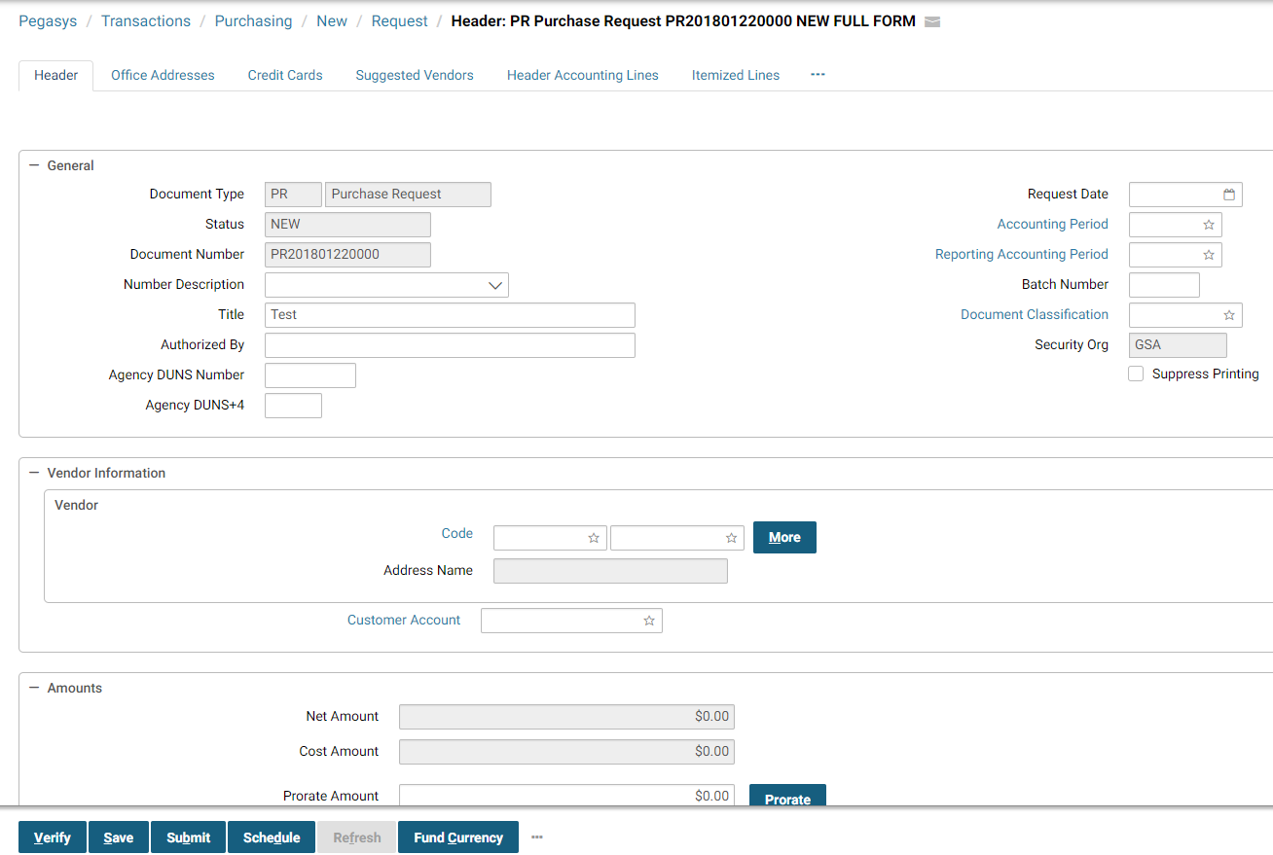

Remember, not all Pegasys screens will have the same window elements. For instance, some windows may have only one page; therefore, these windows will have no tabs displayed.

**Table 1** describes the window elements shown in **Figure 1**.

Table 1: Window Element Descriptions

| **Window Element** | **Description** | **How to Access** |
| --- | --- | --- |
| Title bar | Displays the name of the current window. | Automatically displayed when a window is opened. |
| Menu bar | Displays a list of commands. | Select a menu item to display its pull-down menu (list of commands). |
| Tab | Designates each page in a window. | Automatically displayed if more than one page of fields and buttons exist. |
| Page | Displays fields and buttons. When a page is displayed, it is considered to be the “current” page. For example, in **Figure 1**, Accounting Line 1 is the current page of the Accounting Lines. | Select the tab to access the desired page. |
| Minor tabs | Identifies that multiple entries exist for the current page. For example, in Figure 1, each minor tab represents a different accounting line. | Select the minor tab to access the desired entry for the current page. |
| Drop-down list arrow | Displays a drop-down list box that contains valid values for the current field. Only values listed in the drop-down list box can be selected. | Select the arrow to display the drop-down list box and select the desired option to select it. |
| Action buttons | Controls changes made to the entire window. For example, the Process button in **Figure 1** processes a form. | Select desired button. |
| Check box | If checked, indicates the field is true. | Select to check. If already checked, select to uncheck. |

**Figure 2** illustrates Pegasys Action buttons.

Figure 2: Action Button Bar

The action buttons are located below the document information. They become active based on the status of the document you are entering. The actions are: Verify, Save, Submit, Schedule, Refresh, Fund Currency, and additional buttons can be found by selecting the three small dots at the end of the last visable action button.

All Pegasys forms display a set of action buttons at the top of the form window. **Table 2** describes the common Action buttons.

Table 2: Action Button Bar Field Descriptions

| **Field Name** | **Description** | **Features** |
| --- | --- | --- |
| Verify | Populates all defaulted fields. Performs validity, relationship and funding edits. Checks the form for errors, such as invalid codes or blank required fields. | N/A |
| Schedule | Schedules form to process during nightly offline processing. | GSA currently not using. |
| Submit | Performs Verify functions. Updates the general ledger and relevant budgets, plans, and projects (based on the accounting implications of the form being processed). | N/A |
| Save | Enables the form to be saved as a draft. Does not check for errors or update other subsystems. Typically, forms will be placed on Hold while awaiting approvals. | N/A |
| Refresh | Clears the form window. Restores form to last saved state.  Caution: When creating new forms, this button will delete the form and all related information. | N/A |
| Add Shortcut | Select to add the query, notebook, form or document as a shortcut. | N/A |
| Attachments | Select to add attachments to the document. | N/A |
| Route | Select to route the document. | N/A |

##### What Are The Data Field Types In The Purchasing Subsystem?

**Figure 3** displays typical data fields in the Purchasing Subsystem.

Figure 3: Accounting Line Window

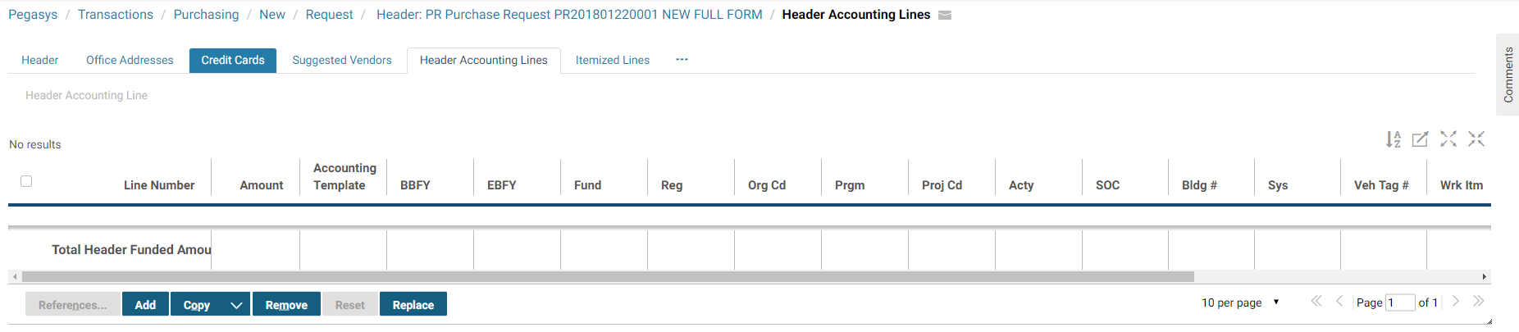

**Table 3** provides a description of the terms introduced in the Accounting Lines Window displayed in **Figure 3**.

Table 3: Accounting Lines Window Field Descriptions

| **Field Type** | **Designated By** | **Descriptions** |
| --- | --- | --- |
| Group box | Fields grouped together with a single group box name. | Groups related fields within a window or page. |
| Required field | Field names in blue lettering are system-required fields. GSA requires that additional fields be completed to properly process and record spending transactions in Pegasys. Please refer to **Purchasing User Guide 5 of 5, Section 14,** for detailed information on transitioning GSA forms to their Pegasys counterparts. | Fields that must be completed. |
| Defaulted field | Field that automatically displays a value when a window is opened. | Fields that can be changed but automatically display a value. |
| Optional field | Field names in black lettering. | Fields that do not require a value. |
| System- maintained field | Fields shaded in gray. | Fields that are automatically displayed but cannot be changed. |

#### What Terminology is used in the Pegasys User’s Guide?

**Table 4** describes general terminology and conventions used throughout the User’s Guide.

Table 4: General Terminology and Conventions

| **Terminology or Convention** | **Descriptions** | **Where Typically Found** |
| --- | --- | --- |
| Bolded text | Text that represent the following:  Button names  Field names  Window titles  Menu names  Check box names  Form names  Document names  Table names | Instructional steps.  Titles of screen shots.  Text used to describe a topic.  Bolding is not used in any Field and Button Description tables. |
| Please refer to Section X.X | Indicates that additional information can be found regarding a topic in another section of the manual. The number to the left of the decimal point represents the chapter number, and the number(s) to the right of the decimal place represents the chapter section. | Text used to describe a topic.  Instructional steps. |
| Select | Use the left mouse button to select a menu option or tab in a window. | Instructional steps. |
| Select | Use the left mouse button to select a button in a window. | Instructional steps. |
| Enter ‘Normal’ | User is to type the value between the single quotes in the identified field. | Instructional steps. |
| Select Applications - Purchasing - New Form | Sequentially identifies menu commands users are to select. For example, Select Applications - Purchasing - New Form indicates a user should select Applications from the menu bar, select Purchasing from the subsequent pull-down menu, and select New Form from the next pull-down menu in that order. | Instructional steps. |

## Pegasys Homepage & Navigation

### What is Pegasys?

Pegasys is GSA’s integrated financial management system that provides extensive functionality to record purchasing and budgeting activities.

#### How Do I Access Pegasys?

Access to Pegasys is restricted to employees of the General Services Administration (GSA) and other select, authorized persons. Initially, you will be provided with a URL to access Pegasys from your Internet Explorer or Netscape Navigator web browser. In order to login to Pegasys, you must exist in the system as a valid user and must be assigned the authority to perform specific tasks, such as viewing vendor data, creating purchase orders, and applying approvals; therefore, you must obtain a unique User ID and an associated password to gain access to the system. The following section addresses the procedures for obtaining a GSA user ID and password to logon to Pegasys.

#### How Do I Obtain A Pegasys User ID?

Your Functional Coordinator or Service Representative may obtain a User ID (lowercase not to exceed 30 characters) from the Pegasys Security Administrator through a request. The User ID and password determine your rights within the system for creating and processing forms and accessing tables and queries.

#### How Do I Obtain A Pegasys Password?

An initial password may be obtained from the Pegasys Security Administrator. You must enter the password exactly as it has been established to successfully login to Pegasys. Passwords are case sensitive and have a minimum length of eight characters that may be alphanumeric.

#### When Does My Temporary Password Expire?

The initial password will expire after three logins. If you do not change your temporary password, you will be prevented from accessing the system.

#### How Do I Set My Security Questions And Answers?

In order to use the “Forgot your password?” link, your security questions and answers must be set up. To set up your security questions and answers, navigate to the Preferences Menu and select on the Security Question and Answer Page tab. Enter your current password and select a question from the Questions drop down box. Enter your answer for the question in the Answer text box.

Figure 4: Security Question and Answer Page

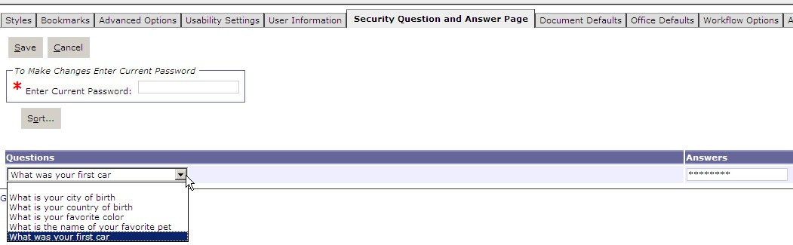

#### What Do I Do When I Forget My Password Or I Fail To Change My Temporary Password?

If you have forgotten your password please select the "Forgot your password?" link on the Pegasys homepage. After setting your security questions and answers in the Preferences menu, once you select the forgot password link, you will be prompted to answer one or more of your security questions. After correctly answering the security questions, you will receive a message stating that your password reset link has been sent via email. Upon receiving an email from Pegasys, select the link which will open a new page where you can change their password prior to logging into Pegasys.

Figure 5: Pegasys Sign In

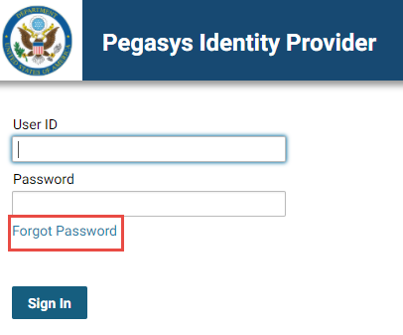

#### How do I Sign In to Pegasys?

The following steps describe how to sign in to Pegasys. Only one Pegasys session is permitted per Login ID (you cannot initiate multiple sessions at the same time). After logging in, the user id is displayed in the top right hand corner and is present on every page. This is particularly useful for users who have multiple user ids.

1. Open your web browser and enter the designated URL address.

The Pegasys Sign In page will be displayed.

1. Enter your Pegasys User ID in the User Name field.

**NOTE:** Login is lowercase.

1. Enter your Pegasys password in the **Password** field.

**NOTE:** Passwords are case sensitive.

1. Select the **Sign In** button.

The Pegasys Homepage will be displayed.

1. If Pegasys finds an existing session logged in for your User ID, then select the **Continue** button to login.

**NOTE:** Any information not saved in this previous session will be lost.

#### How Do I Exit/Sign Out Of Pegasys?

When signing out of Pegasys, it is extremely important to exit the system properly. The following procedure describes the only correct way to exit Pegasys.

1. In the **Link Strip**, select the Sign Out hyperlink.

Figure 6: Pegasys Sign Out

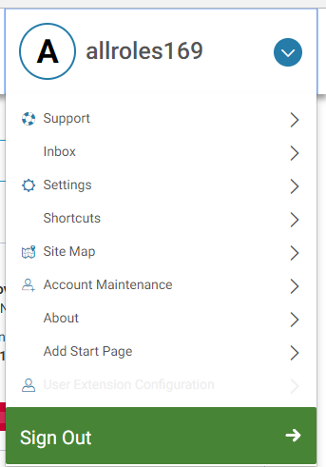

The Pegasys Sign Out page will be displayed.

1. Do not select the **‘X’** in your web browser to log off Pegasys. This will not log your session out of the application.

#### How Do I Change My Pegasys Password?

After the initial login, the user must change his/her password. The following steps describe how to change your Pegasys password.

1. In the Drop down menu by your user name, select the **Account Maintenance** hyperlink.

The user preferences tabs will be displayed.

Figure 7: Account Maintenance

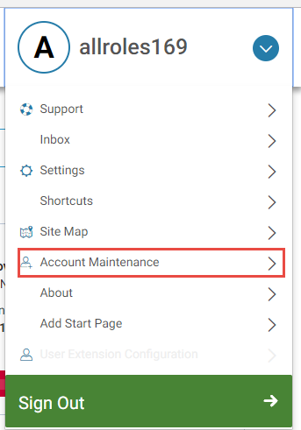

1. Select the User Information tab.

The User Information tab will be displayed.

Figure 8: User Information Tab

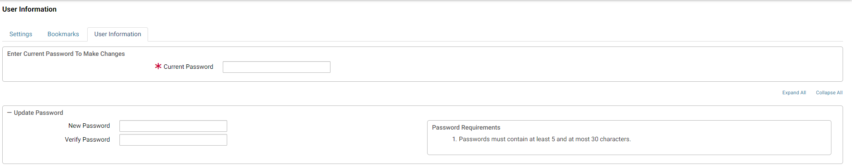

1. Type the initial password in the Current Password field.
2. Type the new password in the New Password field.

**NOTE***:* Passwords can be alphanumeric and must be at least eight characters long.

1. Type the new password again in the Verify Password field.

**NOTE**: Remember that passwords are case sensitive and must be entered in the Verify Password field exactly as they were entered in the New Password field.

1. Select the **Save** button to change your password.

**NOTE**: A system message will state that the password change succeeded.

### What Elements Do I See On The Pegasys Homepage?

When users initially login to the application and access the homepage, the elements that they see depend on the setup their system administrator has chosen for their site. Users will see their last successfully log in time, the number of login attempts since the user’s last successfully login, and the number of unsuccessful attempts. A typical user will also see the following items:

* Menu Bar
* Link Strip
* Breadcrumbs Track
* Navigation Panel
* Inbox

The Menu Bar, Link Strip, and the Breadcrumbs Track appear on almost every page in Pegasys. These elements provide the primary basis of navigation in Pegasys.

**Figure 9** displays the Pegasys homepage.

Figure 9: Pegasys Homepage

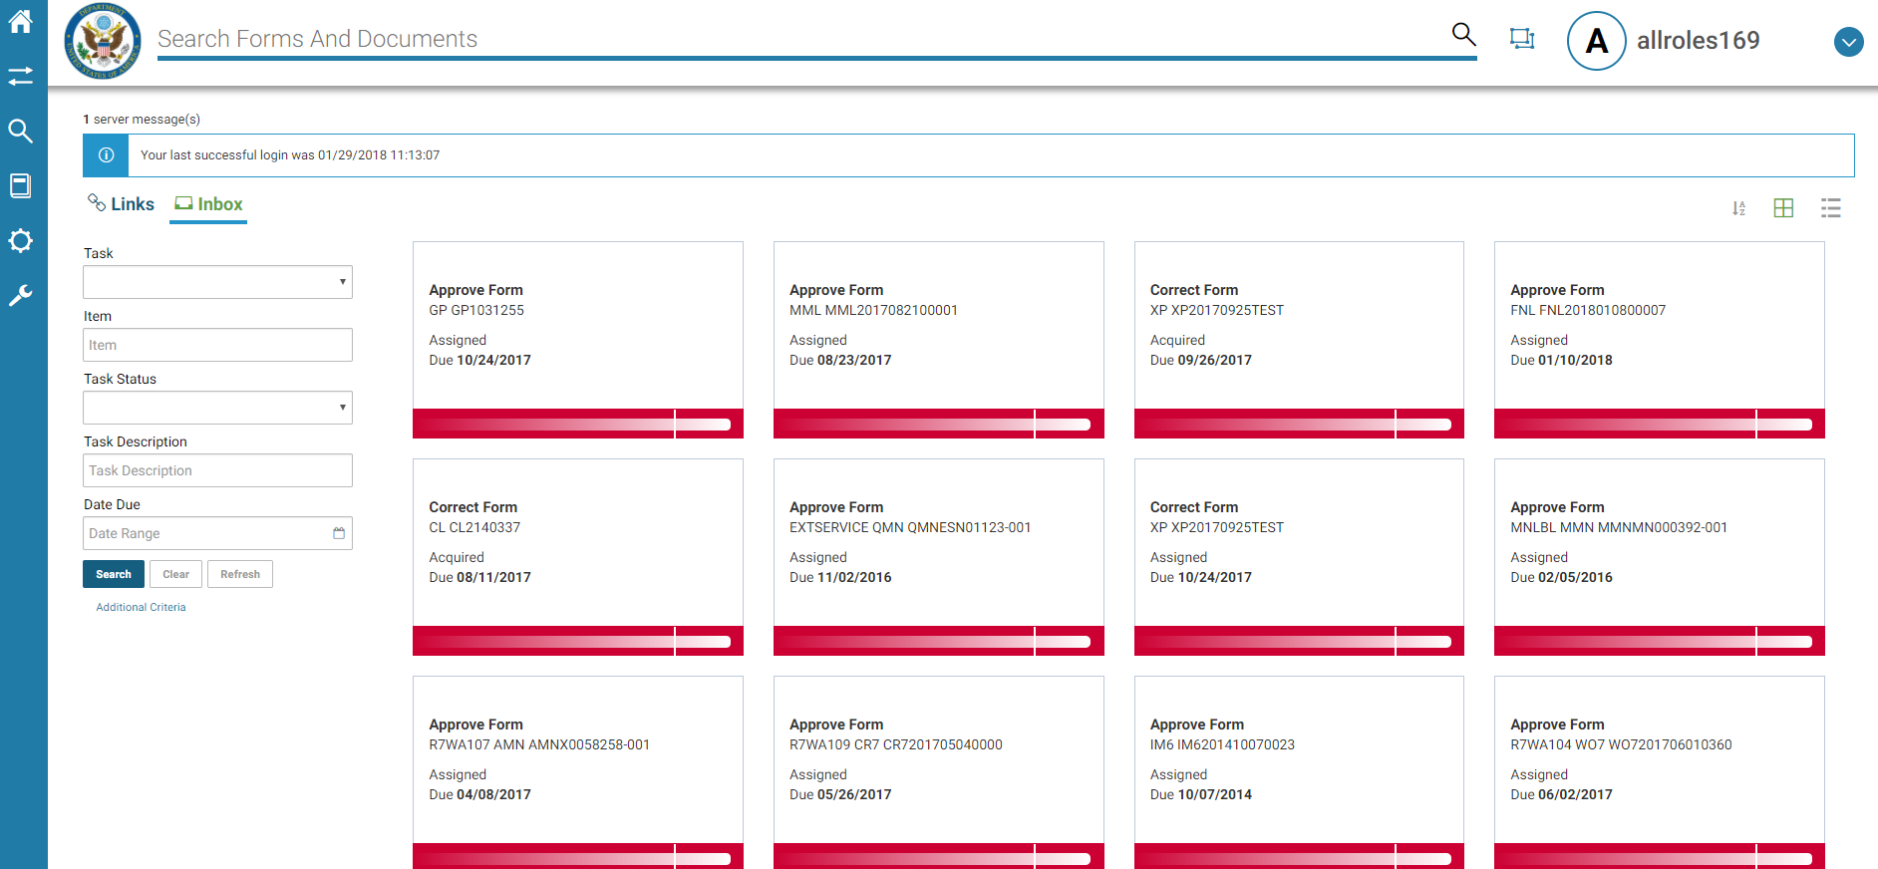

### What Elements Do I See On Pegasys Pages?

#### How Are Pegasys Pages Displayed?

Multiple pages are displayed as tabs in a notebook style. For instance, the different pages on a form or query can be accessed by selecting the appropriate tab on the current page. Pages are divided into sections that can be expanded or collapsed. Many of the sections contain information that was entered on a separate page via a button link in previous versions of Pegasys. Using the web browser scroll bar, users may scroll up or down to view all the sections on a page.

#### Where Are System Messages And Buttons Displayed?

System messages are displayed at the top of the page underneath the Breadcrumbs Track. These system messages never obscure other features on the page. All navigational elements and the remaining page content are always visible to the user in the web browser window.

System messages may be informational, warning, or error messages that must be corrected before processing or updates can occur. If Pegasys returns an error message, the user needs to make the appropriate corrections, and then attempt again the action that previously prompted the error message. It is highly recommended that forms are verified successfully before users submit them for approval or processing. Pegasys provides a selectable message functionality that enables the user to select on system messages reported during form verification and be taken to the field on the page that is related to that error message

Action buttons are also located at the top left corner of the page, just above the notebook style tabs of forms and reference tables, and on some queries.

#### Where Are Summary Lines Displayed On A Form?

Summary lines allow users to view the line amount, transaction type, accounting dimension information, and, if it exists, the commodity information of all the lines on the form or document at the same time. There are two ways to view summary lines. The first way is by selecting either the Header Accounting Lines tab or the Itemized Lines tab on a transaction. From those tabs, users may highlight a specific line, and select either the Header Accounting Lines or Itemized Lines hyperlink to view line information. Users have the ability to view the Total Funded Amount and Total Cost Amount at the line level of the page (in addition to showing totals at the header). The transaction’s total header funding and total cost/itemized funding will be available from the Header Accounting Lines, Itemized Lines, and Itemized Accounting Line pages. The Funded Amount and Cost Amount will also be displayed on the Summary tab to allow users to use a single tab to review the impact of all lines of the transaction.

The second way to view summary information is by selecting the Summary tab on the transaction. From this tab users can view a summary of all lines, make changes to existing lines, and add new accounting lines. The Summary tab also allows a user to select on a column heading and drag it to a preferred location as well as expand or contract a column width. **Figure 10** displays the Summary Tab.

Figure 10: Summary Tab

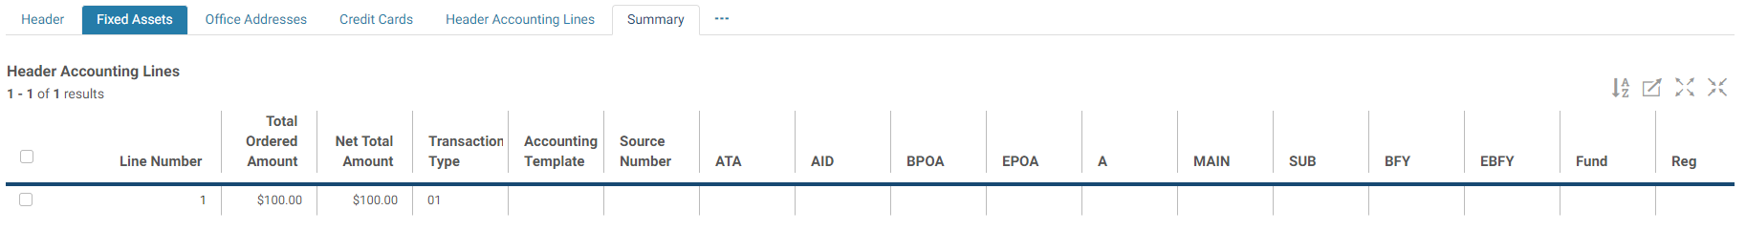

The following steps describe how to use the Summary tab. These steps refer to header accounting lines but the same steps can be used for the Item Lines section on the Summary tab.

1. To add a new line, select the **Add** button. A new line will be displayed.
2. To add information to the new line, select inside the cell and type in the information.

Figure 11: Adding to the Header Accounting Line

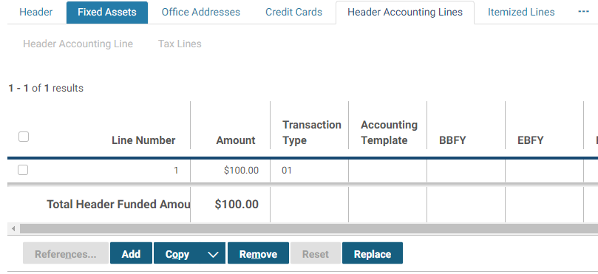

1. To default an accounting template, enter an accounting template in the Template cell, and select the **Default Accounting Template** button.
2. To default information from a referenced line, enter a Referenced Document Type and Document Number in the cells provided, and select the **Default from Referenced Line** button.
3. To update an existing line, select the desired line, select inside the desired cell(s) for the field that should be updated, and make the change.
4. To copy an existing line, select the desired line and select the **Copy** button. A new line will be created.
5. To remove an existing line, select the desired line and select the **Remove** button.
6. To see the header accounting line for a specific line, select the line, and select the **Details** button. The header accounting line will be displayed.
7. To sort accounting lines, select the **Sort** button. Choose the Sort criteria and select **OK**.

Figure 12: Summary Tab Sort

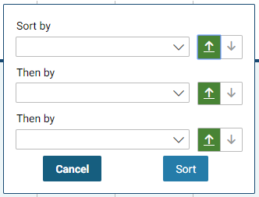

1. To view the accounting lines as a CSV, select the **View as CSV** button.
2. To move a column heading, select on a column heading and drag it to the desired location.
3. To expand or contract the column width, select on the vertical line before or after the column heading and drag outwards to increase the width or drag inwards to decrease the width size.

Figure 13: Expand or Contract Column

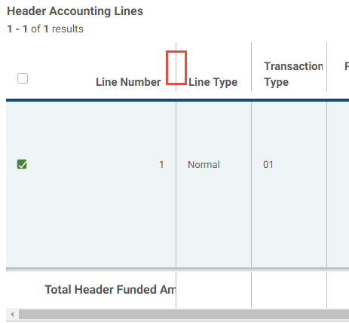

#### How Do I Know When A Field Is Required?

Required fields are indicated by a red asterisk (*). Pegasys returns a hard error at the top of the page if a required field isn’t filled in when a user attempts to submit his or her form for processing, or save updates within Pegasys.

#### What Are Reference Field Hyperlinks?

Fields that have references to other data within Pegasys are underlined in blue. By selecting these hyperlinks, users are taken to a reference data search page. From this page, they may search for and select the appropriate reference item. Selecting a value from this page will populate the corresponding reference fields on the original page.

#### What Are The Common Icons?

Inbox icons are also found on many other tables, forms/documents, and queries throughout Pegasys:

Table 5: Inbox Icons

| **Icon Name** | **Icon Image** | **Icon Description** |
| --- | --- | --- |
| Checkbox | This checkbox is also known as a flag and when checked, has a value of true. | Selecting the **Checkbox** icon on column headings selects all records; on a line it selects only that record. |
| Bubble Help | The bubble help icon is a small icon that describes relevant information. It looks like a dialog bubble with an exclamation point in the center. | Selecting the **Bubble Help** icon displays topic information |
| Toggle | The new window icon is a blue background box with two overlapping white squares inside of it. | Selecting the **Toggle** icon maximizes or minimizes the search results area on the page. |
| Go to Top of Page | The go to top of page hyperlink can be selected to bring the user to the top of the current page. | Selecting the **Go to Top of Page** hyperlink takes user to the top of the current page. |
| Envelope | The envelope icon is represented by an envelope. | Selecting the **Envelope** icon will generate a new email containing a link to the current transaction or entity. |
| Start Page | start page icon is represented by a house with a sheet of paper behind it, aka start page or 'Home' page. | Selecting the **Start Page** icon will save the current page as the first page a user will see when logging into Pegasys. |

#### How Do I Search In Pegasys?

The asterisk (*) can be used as a wild card value. More than one wildcard can be used when searching. Reference field hyperlinks are indicated by blue underlined text, and will take the user to a search page for reference data. Selecting a value from this page will populate the corresponding reference fields on the original page. When searching for a date to enter in a reference field, the user can select the hyperlink to bring up a calendar of days, from which he or she may select the date. Upon selection this date is populated in the corresponding reference field.

#### What Do I Need To Remember About Navigating In Pegasys?

Users should not use the web browser buttons to navigate in Pegasys; this will result in an error. For instance, if the web browser Back button is selected, then the following message will appear: “You are about to end your session. Select to logout or return to the current page.” At this point, the user would select to return to the current page if he or she did not want to end the login session.

### Why Does Pegasys Log Me Out After 15 Minutes Of Inactivity?

If a user has been inactive in the system for more than fifteen minutes, then Pegasys will timeout. The user will be unable to keep working in the application in his or her existing login session. Any unsaved information will be lost. For this reason, it is recommended that users save their forms often, especially if they will be idle in the application for any period of time.

Inactivity is defined as staying on the same HTML page. For instance, if it takes the user longer than 15 minutes to enter information on a funding line, then he or she will be timed out. If however it takes less than 15 minutes to enter the line information, and the user moves on to enter information on another funding line, then the 15 minute clock is reset.

If a user has multiple windows open in the same session, then he or she only needs to be active on one window to not be timed out in Pegasys.

### How Can I Create and Use A Favorite?

The Favorites feature allows users to designate and quickly access frequently-used reference data in Pegasys. For reference fields with blue hyperlinks, selecting the Favorites icon The favorite’s icon appears as a small tag. This can be selected to display the users saved favorites.  will drop down a list of favorites from which users may select a value to populate that reference field. For instance, instead of having to type in or search for a vendor code or an accounting template, the user may simply select the Favorites icon to select that reference code. From the Favorites icon next to a reference field, users may select from a list of existing favorites, as well as add or remove values from the list. There is no limit to the number of favorites a user may select. The following steps describe how to create, use, and delete a favorite.

1. Create a new form.

The Header page of a new form will be displayed.

Figure 14: Header Tab Corrected Document

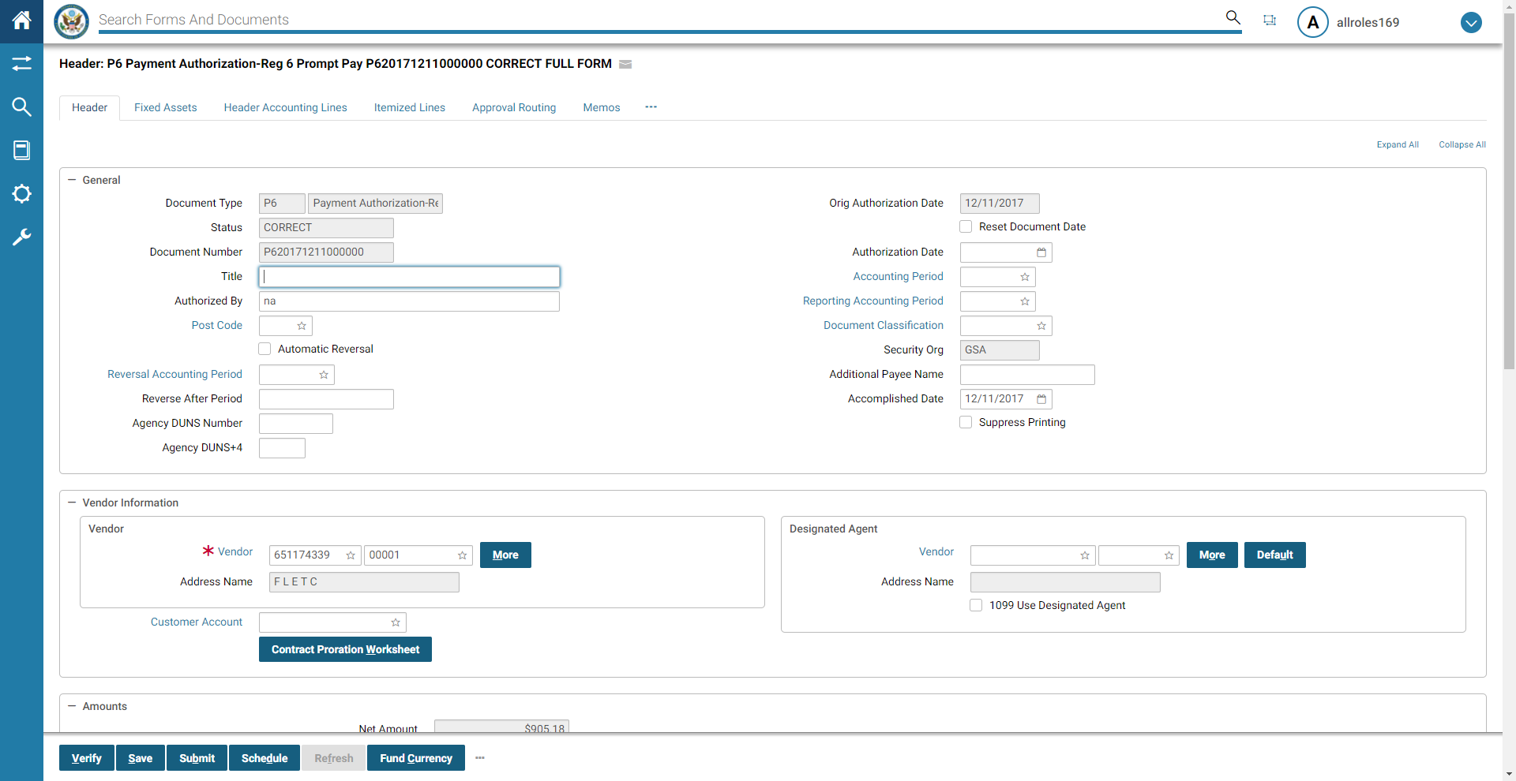

1. Find a reference field with a hyperlink (e.g. a blue underlined field).

One example is the **Vendor Code** in the **Vendor Info** section on the **Header** page.

Figure 15: Header Vendor Information

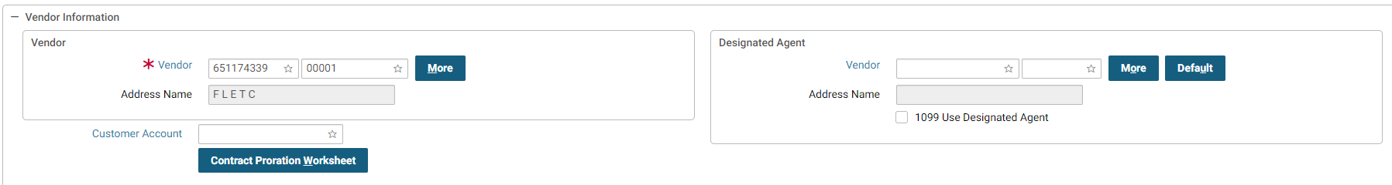

1. Select the Favorites icon next to the reference field.

The Favorites look-up box will be displayed.

Figure 16: Favorites Look-up Box

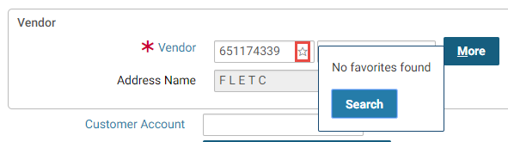

1. **To add a favorite**, select the **Search** hyperlink button in the Favorites look-up box.

The reference data search page will be displayed.

Figure 17: Reference Data Search page

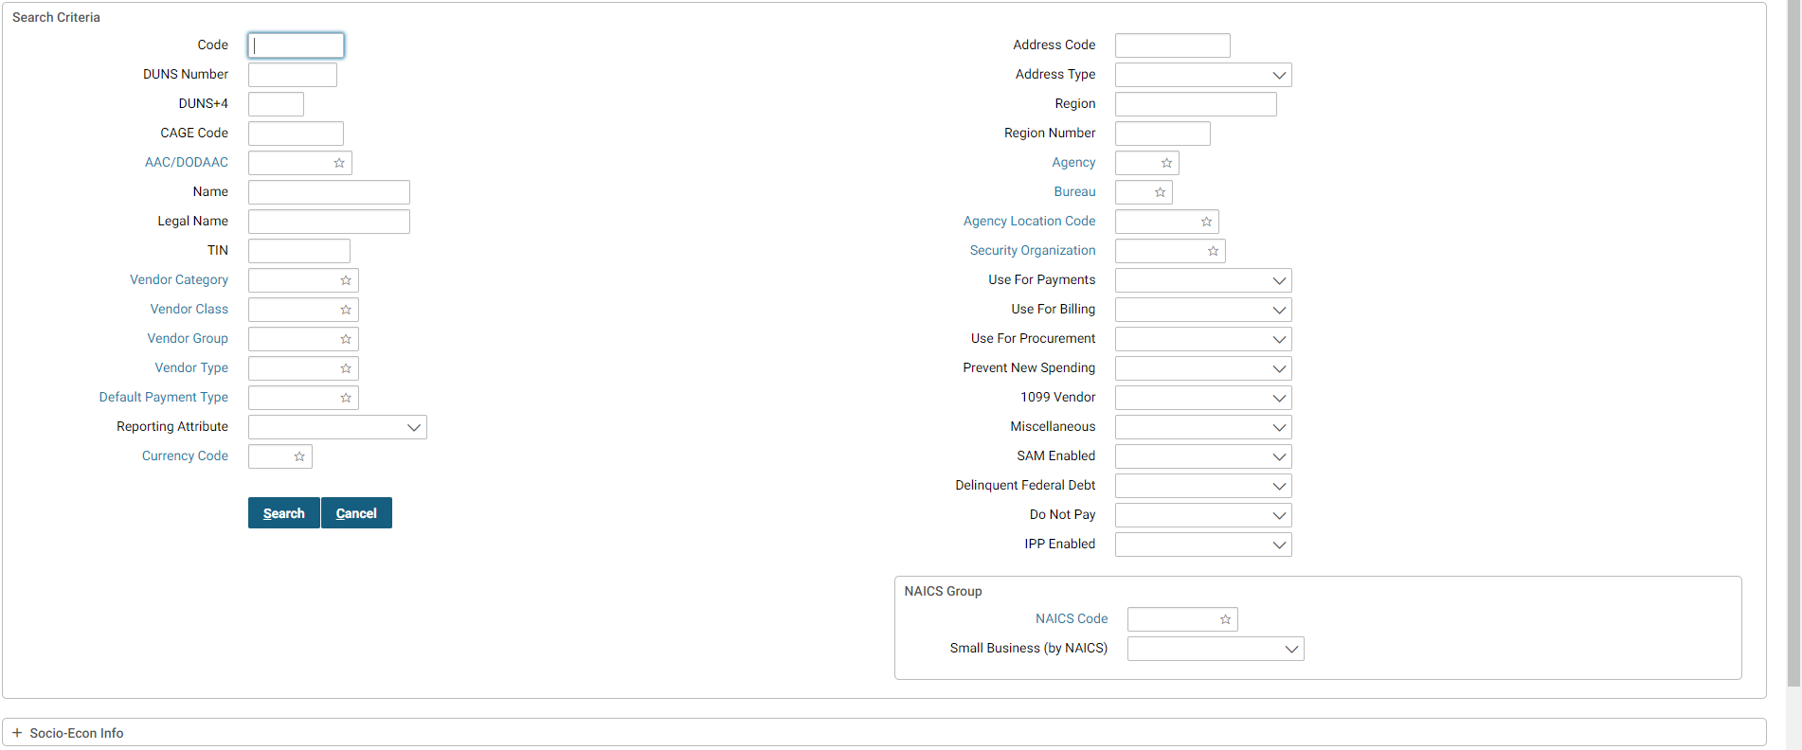

1. Enter the search criteria, and select on the **Search** button.

**NOTE:** If you do not know the full value, enter a partial value and the * wildcard symbol before or after the value entered.

The search results will be displayed in the bottom portion of the page.

1. For the desired reference data record, select the **Favorites** icon The favorite’s icon appears as a small tag. This can be selected to display the users saved favorites. .
2. Select the **Cancel** button.

You are returned to the form page where you left off.

1. To select a favorite, select the **Favorites** icon As previously stated, the favorite’s icon appears as a small tag. This can be selected to display the users saved favorites. next to the reference data field from step 2 (e.g., **Vendor Code**).

The Favorites look-up box will be displayed. The reference data code added in step 6 appears in the list of Favorites.

1. From the list of **favorites**, select the desired reference data record.

The reference data information will be populated in the corresponding data entry fields.

1. To delete a favorite, select the **Favorites** icon As previously stated, the favorite’s icon appears as a small tag. This can be selected to display the users saved favorites. next to reference data field from step 2 (e.g., **Vendor Code**).

The Favorites look-up box will be displayed. The reference data code added in step 6 appears in the list of Favorites.

1. Select the **recycling bin** icon The recycling bin icon can be selected to delete the record.  next to the **favorite** record you wish to delete.

The Favorites look-up box is closed, and you are returned to the form page where you left off.

1. Select the **Favorites** icon The recycling bin icon can be selected to delete the record.  next to the reference data field from step 2 (e.g., **Vendor Code**).

The Favorites look-up box will be displayed. The Favorite reference data code deleted in step 10 no longer appears in the list of Favorites.

### For What Purpose May I Use The Menu Bar?

Located beneath the Pegasys image, the Menu Bar displays the menu options available on the Pegasys Homepage. Users can choose to expand menu items by either hovering over the menu item or by selecting on it. Users can also choose the speed at which the menu item displays. Both of these settings can be found by selecting on the Preferences link in the top right corner and then selecting the Usability Settings tab. Instructions on how to set your menu settings can be found in **Section 2.6.2**.

**Figure 18** displays the Pegasys menu bar found on the Homepage.

Figure 18: Pegasys Menu Bar

The Pegasys Menu Bar is located to the left of the screen and contains the following menu icons for the following sections: At the top is the House shaped Home icon, second is the Transactions icon which is represented by one arrow pointing to the left and another to the right. Third is Queries, which is a magnifying glass shape, fourth is the Reference icon which is shaped like a book. Fifth is the System Administration icon in the shape of a wheel, and finally  the Utilities icon, in the shape of a wrench tool.

The Menu Bar consists of the following options:

* **Transactions** - Allows users to create, amend, correct, view, delete, review, and cancel forms and documents, grouped by subsystem. Only the available Pegasys subsystems are displayed. Security rights determine which subsystem users can access.

Form/Document Selection also appears here, and provides access to forms and documents in all subsystems. Security rights determine what documents users can access

* **Queries** - Allows users to perform queries. Only the available queries are displayed, and are grouped by category. Security rights determine which queries users can access.

The Reference Query is available at the document level, the accounting line level, and the itemized line level. Additional information is available from the tree section, which can also be exported to a comma delimited (CSV) file. More information will be displayed in the Reference Query tree so that users will not have to select individual records to view details such as the Invoice Number. The View Unprocessed Transactions Added to Reference Query provides users with the ability to view unprocessed transactions in the Reference Query.

* **Reference** - Provides access to the Pegasys reference data tables. These reference tables store all the valid values in the system and provide Pegasys the means to verify data prior to forms being processed. The data tables are grouped by category in this menu.
* **System Administration** - Provides acces to various administrative tasks within Pegasys. The available menu items are: Audit Log Query, Asynchronous Messages Maintenance, Current Logins, Forms in Progress, Report Administration, Task Administration and WorkFlow Reservations.
* **Utilities** - Provides access for users to create reports and setup, monitor, and execute batch jobs. Security rights determine which utilities users can access.

#### How Can I Create and Organize Bookmarks?

Bookmarks allow users to create a custom menu that can be used for easy access to a Pegasys new form creation page, query, reference data search page, or to any of the Report or Batch Execution pages. Bookmarks can be established for pages by selecting on the drop down menu located next to your user name, selecting settings, and then the second tab. The following steps describe how to create, access, and organize Bookmarks.

1. From any page in Pegasys, select the drop down menu next to your user name and select settings. The Bookmarks tab is the second tab available.
2. Select the **Bookmarks** tab.
3. To open a bookmark, select the Pegasys page you bookmarked from the **Bookmarks** menu.

The correct bookmarked page appears.

1. To organize your bookmarks, select **Organize Bookmarks** from the **Bookmarks** menu.

The Bookmarks tab on your User Preferences page will be displayed.

Figure 19: Bookmarks tab

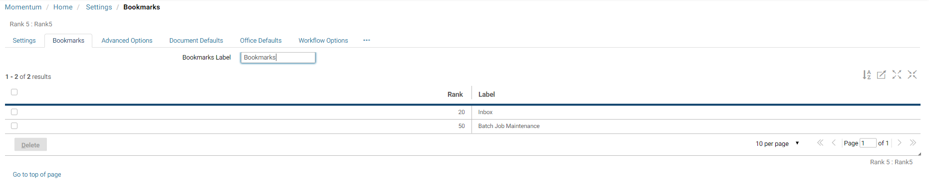

1. **To change the Bookmarks menu name**, enter a new name in the **Bookmarks Label**. Select the **Save** button.

The name of the Bookmarks menu on the menu bar has now changed.

1. To change the order in which your bookmarks are **displayed in the Bookmarks menu**, highlight a bookmark record. Change the rank to a numeral either above or below your other bookmarks. Select the **Save** button.

System message will state that the action was successful.

1. From the menu bar, select the **Bookmarks** menu.

The bookmarked items are re-ordered based on the change in rank.

1. Return to the **Bookmarks** tab. **To delete a bookmark**, highlight a bookmark record. Select the **Delete** button. Then select the **Save** button.

The bookmark is deleted.

#### How Are Submenu Options Displayed In Pegasys?

If the symbol “+” (plus mark) is displayed before a menu option, then a submenu exists for that option. To view the submenu, select the “+” option. User Interface Improvements provides menu usability improvements in the Queries and Reference menus, by grouping items more logically and using submenus more often. As mentioned in **Section 2.6**, users can choose to expand menu or sub menu items by selecting on it.

#### What Are The Transactions Menu Options and Their Descriptions?

**Table 6** describes the options available from the **Transactions** menu.

Table 6: Transaction Menu Option Descriptions

| **Option** | **Description** |
| --- | --- |
| Accounts Payable | Provides access to Accounts Payable forms and documents. |
| Accounts Receivable | Provides access to Accounts Receivable forms and documents. |
| Automated Disbursements | Provides access to Automated Disbursement transactions. |
| Budget Execution | Provides access to the Budgeting transactions. |
| Credit Card | Provides access to Credit Card Reconciliation Notebook. |
| Fixed Assets | Provides access to Fixed Asset forms and documents. |
| General Ledger | Provides access to General Ledger forms and documents. |
| General System | Provides access to General System forms and documents. |
| Planning | Provides access to Planning notebooks. |
| Project Cost Accounting | Provides access to Project Cost Accounting (PCAS) transactions. |
| Purchasing | Provides access to the Purchasing transactions. |
| Travel Accounting | Provides access to the Travel Accounting transactions. |
| Reference Data | Provides access to Vendor documents. |
| Form/Document Selection | Provides access to all forms and documents in Pegasys that the individual user has the authority to view. |
| Faceted Search | Provides access to advanced search features o |

#### What are the Queries Menu Options and their Descriptions?

**Table 7**describes the options available from the **Queries** menu.

Table 7: Query Menu Option Descriptions

| **Option** | **Description** |
| --- | --- |
| Accounts Receivable | Provides access to Automated Receivable queries. |
| Automated Disbursements | Provides access to Automated Disbursement queries. |
| Budget Execution | Provides access to the Budgeting queries. |
| Document | Provides access to the Recurring Profile queries. |
| External Reports | Provides access to the External Reports queries. |
| Fixed Assets | Provides access to the Fixed Assets queries. |
| General Ledger | Provides access to General Ledger queries. |
| General System | Provides access to General System queries. |
| GPRA | Provides access to Workcount/PMI Definition query. |
| Planning | Provides access to Planning queries. |
| Project Cost Accounting | Provides access to Project Cost Accounting (PCAS) queries. |
| Purchasing | Provides access to the Purchasing queries. |
| Vendor | Allows users to query Vendor related information. |
| Workflow | Provides access to the Workflow queries. |
| Workload | Provides access to all Workload assignments. |

#### What Are the Reference Menu Options and Their Descriptions?

**Table 8** describes the options available from the **Reference** menu.

Table 8: Reference Menu Option Descriptions

| **Option** | **Description** |
| --- | --- |
| Accounts Payable | Provides access to the Accounts Payable reference data. |
| Accounts Receivable | Provides access to Automated Receivable reference data. |
| Automated Disbursements | Provides access to the Automated Disbursements reference data. |
| Budget Execution | Provides access to the Budget Execution reference data. |
| Cost Allocation | Provides access to the Cost Allocation reference data. |
| Credit Card | Provides access to the Credit Card reference data. |
| Date | Provides access to date-related reference data. |
| Dimensions | Provides access to accounting dimension reference data. |
| Document | Provides access to Document reference data. |
| Employee | Provides access to Employee reference data and Routing Lists set up. |
| External Reports | Provides access to External Reports setup and definitions. |
| Fixed Assets | Provides access to Fixed Assets reference data. |
| General Ledger | Provides access to the General Ledger reference data. |
| General System | Provides access to the General System reference data. |
| GPRA | Provides access to GPRA measurements and goals. |
| Project Cost Accounting | Provides access to PCAS reference data. |
| Purchasing | Provides access to the Purchasing reference data. |
| Travel Accounting | Provides access to the Travel Accounting reference data. |
| Vendor | Provides access to Vendor related reference data. |
| Workload | Provides access to Workload setup data. |

#### What Are The System Administration Menu Options and Their Descriptions?

**Table 9** describes the options available from the System Administration menu.

Table 9: System Administration Menu Option Description

| **Option** | **Description** |
| --- | --- |
| Administration | Provides access to current logins and forms in process. |
| Approvals | Provides access to approval setup and logs. |
| Batch Setup | Provides access to batch process setup. |
| Configuration | Provides access to system settings and relationship edits. |
| Reference | Provides access to referential integrity and problem definitions. System administrator may suppress error messages and successfully process a correction or amendment even if an unchanged piece of data is no longer valid (e.g., a reference data has an expired end date). |
| Security | Provides access to Pegasys’ security setup. |
| Workflow | Provides access to standard workflow process information. |

#### What Are the Utilities Menu Options and Their Descriptions?

**Table 10** describes the options available from the **Utilities** menu.

Table 10: Utilities Menu Option Descriptions

| **Option** | **Description** |
| --- | --- |
| Reports | Provides access to various standard reports, as well as the ability to print certain GSA forms, documents, and reports. Users can View Reports and check Report Status. |
| Batch Execution | Provides access to offline processing through various batch processes. Users will be able to access this menu only if they have the appropriate security role. |
| Manage External Documents | Provides access to external documents. |
| External Applications | Provides access to external applications |
| Business Intelligence | Provides access to the Business Dashboard/Monitor |

#### What Are the Reports Menu Options and Their Descriptions?

**Table 11** describes the options available from the **Reports** menu.

Table 11: Reports Menu Option Descriptions

| **Option** | **Description** |
| --- | --- |
| View Reports | Allows users to view the available reports and to submit for printing various GSA forms and documents. |

#### What Are the Batch Execution Options and Their Descriptions?

**Table 12** describes the options available on the **Batch Execution** menu.

Table 12: Batch Execution Menu Option Descriptions

| **Option** | **Description** |
| --- | --- |
| Batch Job | Allows user to create and maintain batch jobs. |
| Batch Job Executions | Allows the user to receive a status on any executed batch job. |
| Batch Job Monitor | Allows the user to monitor when a batch job is run. |
| Batch Job Automatic Report Generation Monitoring | Allows the user to set automatic report generation monitoring |
| Batch Job Scheduler | Allow the user to view the batch job scheduler |
| Disbursement Parameter Setup | Allows the user to set the parameters for the four main disbursement jobs. |
| Overseas 1166 Mapping | Allows the user to view overseas 1166 mapping. |

### For What Purpose May I Use The Link Strip?

The Link Strip is located at the top, right-hand corner of the page. The link strip consists of static hyperlinks the Inbox, user preferences, informational, and navigational pages. **Figure 20** displays the Pegasys Link Strip found on the homepage.

Figure 20: Pegasys Link Strip

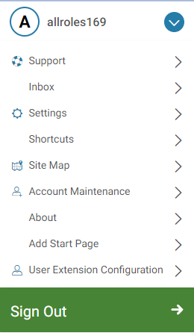

The Link Strip contains the following hyperlinks:

* **Support -** Access to Momentum Support page
* **Inbox -** Returns users to their Inbox.
* **Settings -** Allows users access to various settings within Pegasys
* **Shortcuts** **-** Allows users direct access to forms and documents.
* **Site Map -** Provides an alternative way to view menus and their contents.
* **Account Maintenance** **-** Allows access to a user’s account settings.
* **About** **-** The About link pops up a window with technical and legal information about this version of Pegasys.
* **Add Start Page** **-** Allows a user to update their start page.
* **User Extension Configuration -** Allows a user to manage display configuration.
* **Sign Out -** Allows users to exit Pegasys.

#### What User Settings may I change in Settings?

The **Settings** link allows users to set Pegasys settings, bookmarks, advanced options, and document and office defaults.

* **Settings**: The menu and display options used by Pegasys:
* **Bookmarks:** Bookmarks allow for easy access to a user’s favorite new form creation pages, queries and reference data tables. On this tab, users can organize in what order their established bookmarks are listed in the Bookmarks menu in the menu bar, re-name a bookmark, or delete any bookmark. A bookmark is added to the list by selecting the book icon at the end of the Breadcrumbs Track when accessing a query or reference data search page in Pegasys. Please see 2.6.1: How Can I Create and Organize Bookmarks?
* **Advanced Options:**
  + Enable Offline Email Notification: This option enables the GSOFFLINE batch job to send out email notifications to the user once the batch job is complete. When email notification is on, the last user to modify a document receives an email from GSOFFLINE stating the process status of the document.
  + Search Limit: This option allows users to specify the maximum number of records to be returned when searching. For example, if the user specifies 90 for a search limit and initiates a vendor search that generates a list of 200 records, Pegasys will ask the user to narrow the search criteria. Lowering the search limit speeds up searching, while increasing the search limit returns more records.
* **Document Defaults**: Allows users to set defaults for the Vendor, Accounting Template, and Currency to be used when forms are created. Establishing a default value here results in that value automatically populating applicable areas in forms. For example, if the value the user specifies for the Vendor Code is “ABC” for the GP document type, when the user creates a new GP form, the Vendor Code field will be populated with “ABC”.
* **Office Defaults**: The Office Defaults tab works similarly to the Document Defaults tab. It allows users to set default location code values for multiple offices.
* **Workflow Options:** On this tab, users can view their workflow options
* **Availability:** On this tab, users can change their availability status.

#### How Are Document And Office Defaults Helpful To Me?

Setting your Document Defaults saves users time and eliminate repetitive data entry by automatically filling in vendor codes and accounting templates with the same information each time a user creates a new Pegasys transaction for your specified document type. Office Defaults populate in the appropriate office addresses for all documents the user creates. The following steps describe how to create, access, and organize Document and Office Defaults:

1. In the **Drop Down menu,** select the **Settings** hyperlink and then select the **Document Defaults** tab.
2. Select the **Add** button.

The Document Default page will be displayed.

Figure 21: Document Default page

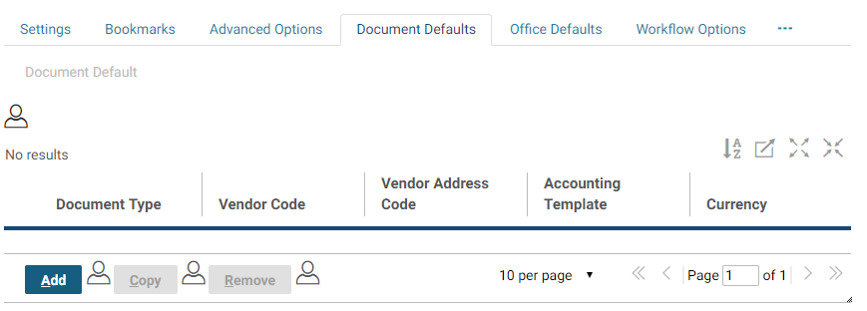

1. Enter the appropriate information in the **Document Type**, **Vendor**, and **Accounting Template** fields. Type **USD** in the **Currency** field.

**NOTE:** If necessary, utilize the reference field hyperlink or Favorites icon to make your selections. You may enter as few or as many fields as necessary.

1. Select the **Save** button.

System message will state that the action was successful; the document default was saved.

1. Select the **Office Defaults** hyperlink and repeat steps 2-4 to save any **Office Defaults**.

System message will state that the action was successful; the office default was saved.

#### How Do I Assign Alternate Assignees And Groups?

Alternate Assignees will receive tasks when the user is unavailable. Assignees will not inherit the security of the unavailable user, so in order to complete the task the alternate assignees must have valid security permission themselves. Upon returning to an available status, incomplete or non-acquired tasks will be removed from the Inbox of the alternate assignees and future tasks will only be assigned to the original Pegasys user.

1. In the **Drop Down Menu,** select the **Settings** hyperlink and then select the **Availability** tab.
   1. Go to step 2 to select alternates individually.
   2. Go to step 5 to select alternate groups.
2. In the **Alternate Assignees/Groups** group box, select the **Alternate Assignee** hyperlink.
3. Select the **Add** button and search for the appropriate User ID of your backup.

**NOTE:** If you do not know the full value, enter a partial value and the * wildcard symbol before or after the value entered.

1. Select the **Select** button to select the User ID, and select the **Save** button.
2. To select an Alternate Group, select the **Alternate Groups** hyperlink.
3. Select the **Add** button and search for the Code.

**NOTE:** If you do not know the full value, enter a partial value and the * wildcard symbol before or after the value entered.

1. Select the **Select** button to select the Code, and select the **Save** button.

#### How Do I Indicate That I Am Unavailable?

1. In the **Drop Down Menu,** select the **Settings** hyperlink and then select the **Availability** tab.
2. In the **Main Participant Details** group box, uncheck the **Available** checkbox.
3. Select the **Supervisor** hyperlink.
4. Search for the User ID, choose the User ID, and select the
5. **Select** button.

**NOTE:** If you do not know the full value, enter a partial value and the * wildcard symbol before or after the value entered.

1. Select the **Save** button.

#### How can I Create and Organize Shortcuts?

Shortcuts are a convenient way to directly access saved forms or processed documents, eliminating the need to use the Menu Bar to perform a search. From the Drop Down Menu, users can access their list of shortcuts and jump straight to a form or document. Hierarchical folders can be employed to assist in organizing shortcuts. The following steps describe how to create, access, and organize shortcuts:

1. If adding a shortcut to a previously saved form or processed document, first open the form or document in **Correct, View,** or **Amend** mode. Skip to Step 3.
2. On a new form, select the **Save** button.

**NOTE:** Forms must first be saved successfully before users may add a shortcut to them.

1. Select the **Add Shortcut** button.

A system message will indicate that the action was successful; a shortcut to the form or document has been created.

1. To access your **shortcuts,** select the **Shortcuts** hyperlink in the **Link Strip**.

The Shortcuts page will be displayed listing all your previously saved shortcuts.

1. Double-select the hyperlink corresponding to your document number.

The form or document will be displayed in read-only or an editable mode, respectively.

1. **To create a new folder** in your list of shortcuts, select the **Shortcuts** link in the **Link Strip**. Then select the folder labeled **Shortcuts**.

The Shortcuts folder is highlighted.

1. Select the **New Folder** button. In the **Shortcut Detail Information** section, enter a name for your new folder in the **Label** field. Select the **Save** button.

A new folder is listed within the Shortcuts folder.

1. To **move a shortcut** to a different folder, select once on the hyperlink corresponding to your document number. Then, select the **Cut** icon.

The form or document that has been cut is italicized.

1. Select the **folder** to which you wish to add your shortcut. Then select the **Paste** icon.

The form or document has been moved into the selected folder.

1. Select the **Save** button.
2. To **delete a shortcut**, select once on the hyperlink corresponding to your document number. Then select the **Delete** button.

The form or document is crossed out.

1. Select the **Save** button.

The form or document is removed.

1. To **delete a folder**, select once on any folder except the Shortcuts folder. Then select the **Delete** button.

The folder is crossed out.

1. Select the **Save** button.

The folder is removed.

#### How Is The Open New Window Feature Helpful To Me?

The double cascading box icon The New Window icon is visually represented by two square boxes, one slightly off center in front of the other. found next to your user name at the top of the screen, allows users to open a new window in the same Pegasys session. This feature is useful when the user wishes to look up additional information, but does not want to lose the page on which he or she is currently working. For instance, if the user is filling out a purchase order form, but needs to look up information in a reference table, then he or she may open a new window and navigate to that reference table, while the purchase form is still open.

**NOTE:** It is advisable that users save their forms often. If users are idle in Pegasys for more than fifteen minutes, then the application will timeout. Any unsaved work will be lost.

#### How Do I Access Pegasys On-Line Help Topics?

1. In the **Drop Down Menu,** select the **Support** hyperlink.

Pegasys’ expanded On-line Help window appears in a new window.

1. Using the scroll bar, scroll down to the new **How-To’s** to select one to review.
2. When finished, close the On-Line Help window by selecting the **‘X’** in your web browser.

### For What Purpose May I Use The Breadcrumbs Track?

The Breadcrumbs Track appears directly beneath the Menu Bar. The Breadcrumbs Track traces the user’s path as he or she navigates through Pegasys. The current page is the right-most breadcrumb. Breadcrumbs provide a path that links users back to previous locations accessed in Pegasys. Each breadcrumb is a hyperlink. Users will select these hyperlinks to navigate through Pegasys in lieu of the Internet Explorer or Netscape Navigator Back button.

### For What Purpose May I Use The Inbox?

The Inbox will be displayed on the Homepage after logging in to Pegasys. It is also accessible by selecting the Inbox hyperlink in the Drop Down Menu. The Inbox contains forms that require the user’s approval or correction, and also forms or documents that have been manually routed to the user for his or her review. Tasks will remain in the Inbox until the assignment is completed or terminated. The completed tasks are listed under the Completed Tasks tab.

Users may filter through the Inbox task list using any of the Inbox column headers found in the Search Criteria group box. For a complete discussion of approving a form from the Inbox, please refer to **Purchasing User Guide 3 of 5, Section 10**.

#### How Do I Open A Workflow Task From My Inbox?

The following steps describe how to open a workflow task from the Inbox.

**NOTE:** A Lotus Notes e-mail notification will be sent to the Pegasys user advising them of the arrival of a workflow task in their Inbox.

1. View the **Inbox**. Users may have **Approve Form**, **Correct Form**, or **Ad-Hoc Routing Task** records in their Inboxes.
2. Select the workflow task record you wish to open.
3. Select the **Open and Acquire** button.

The form will be displayed in read-only mode for approvals and in an editable mode for corrections.

1. If opening an Ad-Hoc Routing task, then the **Notification of Ad Hoc Mailing Router Workflow Task** page will be displayed.

Select the **View** button to review the form or document in read- only mode.

1. If the ad-hoc routed item is a form, select the **Correct** button to open the form in an editable mode.
2. The **Ad-Hoc Routing Task** will remain in the Inbox until the assignment is manually completed. Therefore, on the **Notification of Ad Hoc Mailing Router Workflow Task** page, select the **Complete** button.
3. **Approve Form** and **Correct Form** tasks will be removed automatically from the Inbox after the user has either approved or resubmitted the corrected form.

#### How Do I View Completed Tasks?

The following steps describe how to view a completed task from the Inbox.

1. View the **Inbox**, then select the **Completed Tasks** tab.
2. If necessary, enter the appropriate search parameters and select the **Search** button to search for the completed task.

Information regarding the completed tasks will be displayed.

### What Is Workflow?

Workflow is the automation of a business process, in whole or part, during which documents, information, or tasks, are passed from one participant to another for action according to a procedural set of rules. In Pegasys, Workflow handles the correction, approval, and ad-hoc or manual routing of forms and documents. Workflow has a Task Email Notification functionality to provide agencies with the ability to: enable more extensive email notification content configuration, establish a link within the email notification that leads to the actual task as opposed to the inbox, and extend the new logic to supported tasks for mobile applications. There is also the ability to include a Universal Resource Locator (URL) link in the Task Email Notification message.

Pegasys automatically routes forms for approval based on a list of approvers selected on the form’s Approval Routing tab in combination with the approval template and type associated with the document type. The form appears as an Approve Form task in the approving official’s Inbox. As with all workflow tasks, a Lotus Notes e-mail notification will be sent to the Pegasys user advising them of the existence of a new task in their Inbox.

Workflow provides the ability for a user to view an inbox task without acquiring it, as well as provide a means for the user to acquire and complete the task that is being viewed without having to return to the Inbox. This will allow users to review detailed task information before acquiring it and removing the task from the inboxes of other assignees. Search criteria have been expanded and add new fields to the result set for the Inbox and Completed Tasks query pages. The additional search criteria give users flexibility and efficiency in search for their for their workflow tasks. These additional values allow users to sort the Inbox task by the desired column. Users can quickly determine which tasks are assigned to them and need prompt attention.

#### How Does Pegasys Process Forms?

After a user selects the Submit button on a form, and the system indicates that it was submitted successfully for processing, the form is now reserved in Workflow. On form submission, the following logic occurs in Pegasys: the application first checks for hard or non-overridden errors on the form. If there are hard or non-overridden errors, then the form is returned to the submitter’s Inbox as a Correct Form task. The user may open the form from the Inbox to correct it. Please refer to **Section 2.9.1**. After correcting re resubmitting the form, it is removed from the user’s Inbox.

If there are no hard or non-overridden errors on the form, Pegasys next checks for applicable approval templates based on the document type and document amount. If the form doesn’t require approvals, then Pegasys will process it.

If the form does require approvals, Pegasys next determines the order of the approval types, if multiple. For example, on a purchase request, the Manager approval must be applied first, followed by the Account Classification approval, and finally the Funds Authorization approval. This approval order is determined by GSA Policy. Users will not need to add approvers to the form in any specific order; Pegasys will automatically route the forms for approval in the correct order. In combination with the approvers listed on the form’s Approval Routing tab, the application will then send an Approve Form task to the appropriate users.

After the first approval is applied, Pegasys will then automatically route the form to the second approver, and so on and so forth. After the final approval is applied, Pegasys automatically processes the form.

If the Prohibit Duplicate Approver checkbox is checked on the Document Type table, users who have already applied approvals on a form (and have the ability to apply multiple approval levels) will not receive tasks for later approvals on the same transaction.

For a complete discussion of approving a form from the Inbox, please refer to **Purchasing User Guide 3 of 5, Section 10**.

#### What Can I Do With A Form Reserved In Workflow?

Normal document actions (e.g., Correct, Delete) are restricted on forms reserved in Workflow. If a user tries to correct or delete a form in workflow, the system displays an error message that the form is reserved in workflow. The user then has the option to unreserve the form, if he or she has the appropriate security permission. If the user unreserves the form, then the form is removed from workflow. For instance, the form will be removed from any user’s Inbox in which it currently resides. This applies to both Approve Form and Correct Form tasks. The form is then available for correction or deletion. Please refer to **Section 2.10.3** below for additional information on how corrections and amendments on form and documents affect approvals.

#### Approvals Required After Form Correction

When a form is approved, certain key information recorded on the document, such as the vendor information, full accounting distribution, and dollar amount on each line of the form, cannot be changed without approval from the appropriate approving officials. When users correct or amend a form or document to change this information, and approvals have already been applied, Pegasys will automatically drop all pre-existing approvals. On submission, the form must route through the entire approval chain again. If the changes do not impact key information recorded on the form, such as the information listed above, then the form or document will retain all the previous approvals and return to the Inbox of the approving official who needs to approve it next. In the case of a document, it will remain in a processed state.

#### What are Alternate Assignees?

Users can assign tasks to alternates during a period of inactivity. A Pegasys user or an administrator may specify alternate assignees (user IDs) that will receive tasks when the user is unavailable, as described in **Section 2.7.3.** During that period, tasks assigned to the unavailable user will be sent to the Inbox of that user and the Inboxes of all assignees. Assignees will not inherit the security of the unavailable user, so in order to complete the task the alternate assignees must have valid security permission themselves. Upon returning to an available status, incomplete or non- acquired tasks will be removed from the Inbox of the alternate assignees and future tasks will only be assigned to the original Pegasys user.

Users have the ability to individually setup their availability options on the Availability tab through the User Preferences, as described in **Section 2.7.4**. The Principal Availability table tracks users out of office preferences, including alternate assignees.

### How Do I Create A Custom Routing List?

Custom Routing Lists are lists of user-defined addressees. Routing Lists allow Pegasys users to add multiple approvers to a form at once, or allow users to ad-hoc or manually route forms or documents to others for review. The following steps describe how to create a custom routing list.

1. From the **Reference** menu, select **Employee - Routing Lists** from the menu bar.

Figure 22: Search Routing List page

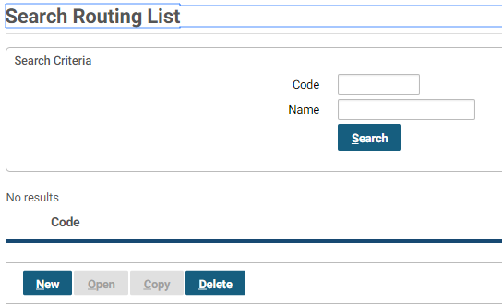

The Search Routing List page will be displayed.

1. Select the **New** button.
   1. The Routing List page will be displayed.
   2. On the Routing List tab, enter all appropriate information.

**NOTE:** The Code field is required. The routing list’s codes naming convention is: the user’s correspondence symbol followed by text that describes the purpose of the routing list, e.g., 4BB-Trng. The **Code** field cannot exceed ten characters.

1. Enter a name that describes the routing list in the **Name** field.

**NOTE**: The Name cannot contain spaces, quotes, apostrophes, or any other special characters.

1. Select the **Security Org** reference field hyperlink.

The Search - Security Organization page will be displayed.

Figure 23: Search - Security Organization page

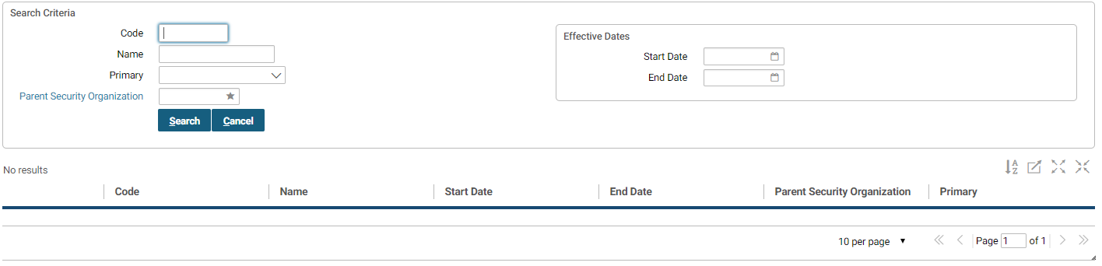

1. Enter your search criteria in the appropriate fields. Select the **Search** button.

**NOTE:** If you do not know the full value, enter a partial value and the * wildcard symbol before or after the value entered.

The search results will be displayed in the bottom portion of the page.

1. Highlight the security organization record. Then select the **Select** button. Select **GSA** to make the routing list available to all employees.

The selected security organization will be populated in the corresponding reference field.

1. Select the **Mail Stop** tab.

The Mail Stop page will be displayed.

1. Select the **Add** button.

The Add User page will be displayed.

1. Enter your search criteria in the appropriate fields. Select the **Search** button.

**NOTE:** If you do not know the full value, enter a partial value and the * wildcard symbol before or after the value entered.

The search results will be displayed in the bottom portion of the page.

1. Highlight the record for the user to be added to the routing list. Then select the **Select** button.

The selected user will be added to the routing list.

1. Repeat steps 7-10 to add additional users to the routing list. When all users have been added to the routing list, select the **Save** button.

System message will state that the save action was successful.

1. The top-down order of users in the routing lists does not affect the order in which Workflow will route the form for approval. However, the order of users in routing lists does affect the order in which ad-hoc routed forms and documents will be sent to other users for review. In an ad-hoc route, the first user in the routing list will receive the routed item first. The second user listed will receive the routed item second.

### How Do I Ad-Hoc Route A Form Or Document In Pegasys?

The following steps describe how to manually send a form or document in Pegasys.

**NOTE*:*** A Lotus Notes e-mail notification will be sent to the Pegasys user advising them of the existence of a new workflow task in their Inbox.

1. From the **Form/Document Selection** page, search for a previously saved form or processed document. Highlight the document record and select the **Route** button. Skip to Step 4.
2. On a new form, select the **Save** button.

**NOTE:** Forms must first be saved successfully before users may route them to other for review.

1. Select the **Route** button.

The Route page will be displayed.

1. Edit the **Subject** and **Description** fields, as necessary.

**NOTE:** Information entered in the Description field will appear in the Inbox’s Description field*.*

1. Select the **Mail Stop** tab.
   1. Go to step 6 to select recipients one by one.
   2. Go to step 9 to select multiple recipients saved in a routing list.
2. To select recipients one by one, select the **Add User/Group** button.

**NOTE:** The User Search page will be displayed.

1. Enter your search criteria in the appropriate fields. Select the **Search** button.

**NOTE:** If you do not know the full value, enter a partial value and the * wildcard symbol before or after the value entered.

The search results will be displayed in the bottom portion of the page.

1. Highlight the record for the recipient of the form or document. Then select the **Select** button.

**NOTE:** The selected user is added to the list on the Mail Stop tab.

1. To select multiple recipients saved in a routing list, select the **Add Routing List** button.
2. Repeat steps 6-8 to search for and select a routing list to add as mail stops.
3. Review the list of recipients. Then select the **Previous** button.

**NOTE:** The form or document will be sent to the recipients in the order listed on the **Mail Stops** tab.

1. Select the **Send** button.

A system message will state that the ‘submit’ action was successful.

### How Do I Add Or View A Memo On My Form Or Document?

A memo is a message that users can add to a form or document to provide additional information or direction for the originator or recipient. For instance, when applying an approval or disapproval to a form, approving officials may include their comments. These comments appear on the form or document as a memo. Memos are accessible by selecting the Memos tab on the form or document. The following steps describe how to add or view a memo on a form or document.

1. If adding a memo to a previously saved form or processed document, first open the form or document in **Correct** or **Amend** mode. Skip to Step 3.
2. Create a new form.
3. Select the **Memos** tab.

The Memos tab will be displayed and lists any memos previously added to the form or document.

1. To add a new memo, select the **Add** button.

A new memo is added to the form; the Subject and Message Text fields become editable.

Figure 24: Memos

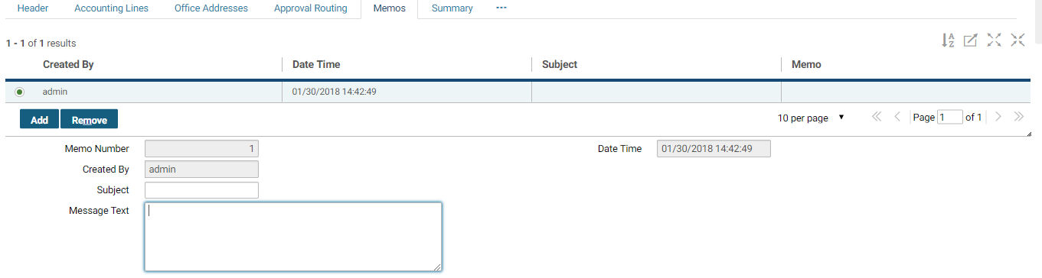

1. Type your memo **Subject**.

**NOTE:** The Subject is limited to nineteen characters. The text in the Subject field is entered in the memo record.

1. Type your Message Text.

**NOTE**: The Message Text is limited to 255 characters. The text in the Message Text field is entered in the memo record.

1. Select the **Save** button.

System message will state that the form was saved successfully.

1. To delete a memo, highlight the memo record and select the **Remove** button.

The memo record will be crossed out.

1. Select the **Save** button.

System message will state that the form was saved successfully; the memo record has been removed.

### What Can Be Printed From The Reports Menu?

The **Reports** menu provides access to various standard reports, as well as the ability to print certain GSA forms, such as GSA Form 300 and GSA 49.

To view the reports available through Pegasys and to print various GSA forms and documents, select **Run View Reports** from the **Reports** pull-down menu. Use **Report Status** from the **Reports** pull-down to access a report that was previously generated. Forms will be displayed in a web browser with the option of printing using **Adobe Acrobat**. For a complete discussion of available reports and printing procedures, please refer to **Purchasing User Guide 3 of 5, Section 11**.

#### How Do I Print And Display Forms Using The Reports Menu?

The following steps describe how to print and display purchasing forms using the **Reports** menu in Pegasys. Please refer to **Purchasing User Guide 3 of 5, Section 11,**for additional details on printing forms.

1. From the **Utilities** menu, select **Reports** - **Run Reports**.

The **Run Reports** page will be displayed.

Figure 25: Run Reports page

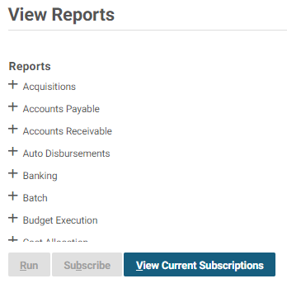

1. Select the **Expand** icon for the **Purchasing** folder to view the available reports.
2. Highlight the desired form.
3. Select the **Select Report** button.

The report Parameters and Options page will be displayed.

1. In the **Parameters** section, enter the appropriate information.

The number and type of fields in the **Parameters** group box may vary depending upon what form or report is being selected from the available reports.

Parameter information is case-sensitive.

1. In the **Options** section, select the Saved Output Format.

The user can select HTML and PDF.

1. Select the **Run** button.

System message will state that the report has been submitted successfully.

1. From the **Utilities** menu, select **Reports** - **Report Status**.

The **Report Status Maintenance** page will be displayed.

1. Select **Purchasing** from the **Report Subsystem** drop-down box. In the **Logon ID** field, type your User ID. Enter any additional search criteria.
2. Select the **Search** button.
3. Highlight the General System report record. Then select the **Details** button.
4. Highlight the latest execution record. Ensure the **Report Status** is **Complete.** Then select the **Output** button.

The report appears onscreen in the specified report output format.

1. To print the form, select on the **Print** button in Adobe Acrobat.

The form will be sent to the user’s default printer.

## Pegasys Purchasing Overview

The Pegasys Purchasing subsystem is used as a system for the entry of purchasing transactions and enables GSA to incur costs against its budgets by recording these spending transactions. Pegasys accommodates the full range of purchases including goods, services, and training. The sequence of events involved in recoding transactions is called a “purchasing chain” and includes the following activities:

Figure 26: Purchasing Overview

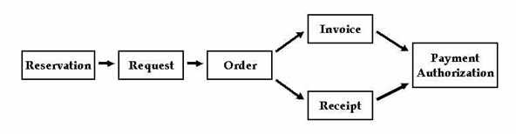

**Figure 26: Purchasing Overview** lists the type of documents to complete the purchasing chain. The chain starts with a reservation. After the reseveration is procesesd, the next document in the chain is the request. Once the request is processed, an order is created. After an order is processed, there is either an invoice and receipt are created. The final step to complete the purchasing chain is the payment authorization.

Not every purchasing transaction will include all of these steps; however, the relative sequence of steps must be followed. For example, a purchasing chain can begin with an order (skipping both the reservation and request) but the order cannot be followed by a request.

### What are the Pegasys Purchasing Document Types?

Purchasing transactions are recorded in Pegasys through the use of documents. There are three basic types of purchasing documents: documents that contain itemized lines, documents that do not contain itemized lines, and training documents. Some document types, such as reservations, requests, training requests, and receipts are used by all GSA Services and authorized agencies. Purchase Orders and Training Orders, however, are service specific document types. Also, other document categories such as direct pay and matched invoice have service or region specific document type codes. **Table 13** defines the document categories, document types, and budgetary impact of Pegasys purchasing documents. Please refer to **Purchasing User Guide 5 of 5, Section 16,** for additional detail on document types.

Table 13: Pegasys Document Categories and Document Types

| **Pegasys Document Categories** | **Budgetary Impact** | **Pegasys Document Types** |
| --- | --- | --- |
| Reservation | Pre-commitment | RS |
| Purchase Request | Commitment | PR, BL, BP, IM, LO, RR, IQ, ER, RQ |
| Intra Agency Purchase Request | Commitment | IG, RR |
| Training Request | Commitment | TR |
| Purchase Order | Obligation | FP, TP, GP, PP, XP, NP, OP*, ZP, PJ, 1B, 2B, BW, CF, CL, HB, NR, PN, PS, CO, RO, EO, CT 2I, PJ, PP, ZP, FW, GW, EO, FC, FO, FX, FZ, GO, GZ, NO, NR, NT, OZ, PO, PZ, QO, QP, QX, QZ, TP, TZ, XO, XZ |
| Intra Agency Purchase Order | Obligation | IX, HX, IT, LT, FX, GX, PX, TX, OX, XX, NX, ‘*’, ZX, FZ, GZ, IZ, IY |
| Training Order | Obligation | FW, TW, GW, PW, XW, OW*, CT |
| Prepaid Training Order | Obligation | FY, TY, GY, PY, XY, OY, NY*,CY |
| Direct Pay | Expenditure | D6, D7, DC, DF, DK, DW, DX**, IL, IR, IS |
| Receipt | Accrual | RC, RK, RW, 1C, 2C, HC, RD, RM, RT, 2R |
| Match Invoice | Expenditure (once payment is generated) | M6, M7, MJ, MK, MM, MW, IK, IW (Finance only), MC, MF, MT, 5I, NI, NK, 2M, UI, FE, 6V, 8B, 8I, 9F, 9I, 9M, 9V, CD, CN, DC, DF, E1- E8 |

*Purchase Orders are Service-specific. The *first* character of the two-character code is the Service indicator: **F**-FSS, **T**-FTS, **G**-GM&A, **P**-PBS, **X**-CLIENT, **N**-NARA, **C**- DC Courts, O- OTHER. The *second* character indicates the type of document: **P**- non-itemized or itemized,   
**X**- Inter-agency, **W**-Training, **Y**-Prepaid Training.

**For Finance Centers use only: DK and DW; External Clients use DX; Disbursements to TX - use D7 or DF; and Disbursements to KC - use D6 or DC.

### What are the Pegasys Purchasing Models?

GSA purchasing transactions follow one of three purchasing models:

* **Standard Purchasing Model** - Includes most purchases for goods and services made from within the procurement office.
* **Training Model (Standard and Prepayment -** Includes all purchases for training services.
* **Direct Pay Model** - Includes purchases that require only an invoice for payment.

This section includes a discussion of each of these purchasing models. All spending transactions must follow one of these purchasing models to ensure that the transaction is properly recorded in the Pegasys Purchasing subsystem.

#### What is the GSA Standard Purchasing Model?

The GSA Standard Purchasing model is used to record all requests, orders, receipts, and invoices associated with a purchase, except those purchases made with a credit card or related to training. **Figure 27** outlines the steps of the Standard Purchasing model from the initial entry of a request through the payment authorization. Reservations (pre-commitments) are not typically used by GSA; however, if used, the reservation will not draw down the budget.

Figure 27: Standard Purchasing Model

**Optional Workflow**

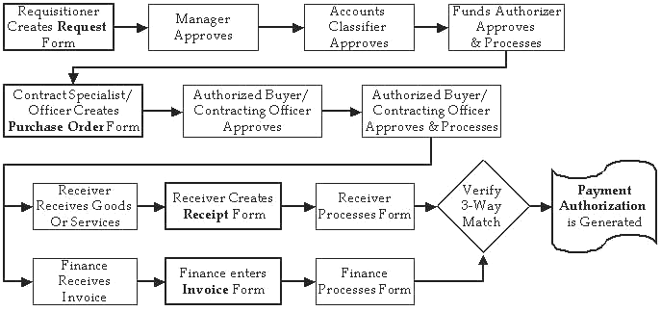

**Figure 27: Standard Purchasing Model** optional workflow outlines in more detail the optional steps needed to complete the purchasing chain. The optional steps are as follows:

1. Requisitioner creates Request form
2. Manager approves
3. Accounts Classifier approves
4. Funds Authorizer approves and processes
5. Contract Specialist / Officer creates Purchase Order form
6. Authorized buyer / contracting officer approves
7. Authorized buyer / contracting officer approves and processes
8. Receiver receives Goods / Services OR Finance receives invoice
9. Receiver creates receipt form OR Finance enters invoice form
10. Receiver processes form OR Finance processes form
11. Verify 3-way match
12. Payment Authorization is generated

##### What is the Standard Purchasing Model Workflow?

**Table 14** defines the document types, user groups, and approving officials associated with the steps of the Standard Purchasing model.

Table 14: Standard Purchasing Model

| **Pegasys Document** | **Document Type** | **Entered By** | **Approved By** |
| --- | --- | --- | --- |
| Reservation | RS | Funds Manager | None |
| Request | PR, IQ | Requisitioner | Manager  Accounting Classification  Funds Authorizer |
| Intra Agency Request | IG | Requisitioner | Manager  Accounting Classification  Funds Authorizer |
| Purchase Order | FP, TP, GP, PP, XP, OP, NP, FO, TO, GO, PO, XO, NO, OO | Authorized Buyer/ Contract Specialist/ Contract Officer | Authorized Buyer/Contracting Officer |
| Intra Agency Purchase Order | IX, IT | Authorized Buyer/ Contract Specialist/ Contract Officer | Authorized Buyer/Contracting Officer |
| Interagency Purchase Order | FX, GX, OX, PX, TX, XX, NX, FZ, GZ, OZ, PZ, TZ, XZ | Authorized Buyer/ Contract Specialist/ Contract Officer | Authorized Buyer/Contracting Officer |
| Receipt | RC, RK, RW, IC, IF | Receiver | None |
| Match Invoice | M6, M7, MJ, MK, MM, MW, I6, I7, IK, IW | Finance | None |

**Reservations**

A reservation is a pre-commitment of funds for a projected purchase. Typically, a pre- commitment will set aside funding for a specific purpose that may entail multiple purchases. The **Reservation (RS)** is an optional step in the purchasing chain and will usually be entered into Pegasys by a Funds Manager. No approvals are required. Most Pegasys users will not use reservations to begin the purchasing cycle; however, when a reservation is recorded, it can be referenced by future requests, orders, receipts, invoices and payments. Reservations will not decrease available budget amounts, but will decrease available plan amounts.

**Requests**

To begin the Standard Purchasing model, a Requisitioner generates a request. The request is completed using the **Purchase Request (PR** or **IQ)** form. A **Purchase Request** may or may not contain itemized lines. A request may contain multiple lines of funding, regardless of whether or not it contains itemized lines.

Once complete, the request must be approved. All purchase requests require Manager, Accounting Classification, and Funds Authorization approvals. After all approvals have been applied, the request must be processed to commit the funding. Typically, users who applied the last approval to the request will process the form. Once processed, the form becomes an official document, which is then forwarded to the procurement office.

Please refer to **Section 5.2.1** and **Section 5.2.2** for detailed information on completing a purchasing request.

**Purchase Orders**

Typically, a Contract Specialist or Contracting Officer creates a **Purchase Order** form in Pegasys. A **Purchase Order (FP, TP, GP, PP, XP, NP, OP, FO, TO, GO, PO, XO, NO,** and **OO)** may or may not contain itemized lines. An order may contain multiple lines of funding, regardless of whether or not it contains itemized lines.

The completed order must be approved by an Authorized Buyer or Contracting Officer. An Authorized Buyer’s approval is required on orders equal to or under $3000, and a Contracting Officer’s approval is required on any order greater than $3000. Once approved, the order is processed to obligate the funds. The order is then printed and sent to the vendor.

Because a purchase request is an optional step, the purchasing chain can begin with the creation of an order. However, if a request has been recorded in Pegasys, GSA requires that the order reference the request by using the copy forward function when creating the order. Copying the information forward from the request to the order eliminates redundant data entry. Referencing will also liquidate the request for the amount of the order.

Please refer to **Purchasing User Guide 2 of 5, Section 6.1** and **Purchasing User Guide 2 of 5, Section 6.13**for detailed information on creating a purchase order.

**Oral Procurements (Certified Invoice)**

Another way to facilitate a purchase is through an oral procurement, sometimes referred to as a certified invoice. All oral procurements must be captured in Pegasys to record the obligation. Oral procurements can be recorded by generating either a Purchase Order or Direct Pay form. A complete discussion of oral procurements can be found in **Purchasing User Guide 2 of 5, Section 6.1**,**Purchasing User Guide 2 of 5, Section 6.13**, **Purchasing User Guide 2 of 5, Section 6.14** and **Section 3.2.3.**

**Inter/Intra Agency Purchase Orders**

GSA procurements include interagency (government agencies external to GSA) and intra- agency (services internal to GSA) purchases. Interagency purchases (formerly recorded on GSA Form 3669) and Intra-agency purchases (formerly recorded on GSA Form 2957) are recorded in Pegasys as purchase orders. A complete discussion of interagency and intra- agency purchase orders can be found in**Purchasing User Guide 2 of 5, Section 6.11** and **Purchasing User Guide 2 of 5, Section 6.12***.*

**Blanket Purchase Agreements**

Blanket Purchase Agreements (BPAs), pre-negotiated agreements between the agency and a vendor, can also be established and monitored in the Pegasys Purchasing subsystem. A BPA is typically established at the beginning of the fiscal year and will track purchasing activity against an authorized limit and within a specified time frame. BPAs can be referenced on requests, orders, receipts, and invoice forms.

**Receipts**

When ordered goods or services are received, a Receiver completes a **Receipt (RC, RK, RW**, **IC,** and **IF)** form. A **Receipt** may or may not contain itemized lines.

Receipts must reference a purchase order. To create the receipt, copy forward from the order (this applies to oral procurements as well). Using copy forward functionality eliminates redundant data entry and ensures that the receipt contains accounting line information associated with the original order. Receipts do not have to be approved; however, they must be processed to record the delivery and acceptance of the ordered goods or services. Please refer to **Purchasing User Guide 2 of 5, Section 7.1** and **Purchasing User Guide 2 of 5, Section 7.3** for detailed information on completing a receipt in Pegasys.

**Invoices**

The vendor invoice is typically sent to a regional Finance center. There, a Regional Accounting Technician is responsible for recording the invoice in Pegasys. Once the purchase order, receipt, and vendor invoice have been entered, the automated match payment process will be initiated. When the matching process is complete, a payment authorization will be generated (please refer to **Section 3.3** for additional information).

#### What are the GSA Training Models?

The GSA Training Purchasing models used in Pegasys record both Standard and Prepaid training purchases. **Training Request (TR)** and **Training Order (FW, TW, GW, PW, XW,** and **OW)** forms are used to track training purchases. Because the training request is an optional step in the purchasing chain, the process can begin with the creation of a training order. However, if a training request has been recorded in Pegasys, the request must be referenced by the training order by using the copy forward function. **Figure 28**and **Figure 29** outlines the steps in the Standard Training model and Prepayment Training model.

**NOTE:** The Standard Training model contains a receipt step; however, the Prepayment Training model does not.

Figure 28: Standard Training Model

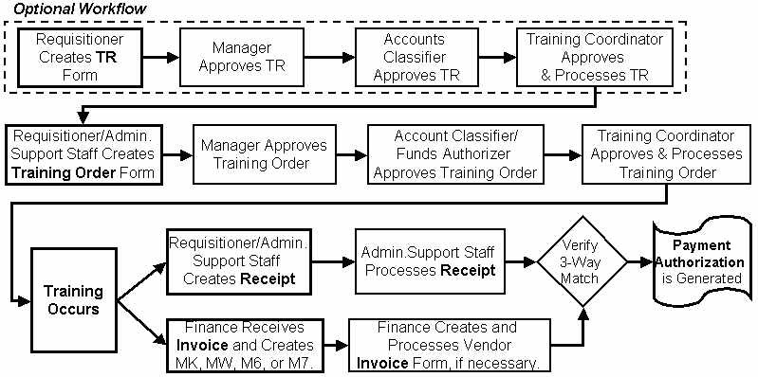

**Figure 28: Standard Training Model** outlines the optional workflow steps needed to process a 3 way match purchasing document in Pegasys. Those steps include:

1. Requisitioner Creates TR Form
2. Manager Approves TR
3. Accounts Classifier Approves TR
4. Training Coordinator Approves & Processes TR
5. Requisitioner / Admin Support Staff creates Training Order Form
6. Manager approves training order form
7. Account Classifier / Funds Authorizer approves training order
8. Training Coordinator Approves & Processes Training Order
9. Training Occurs
10. Requisitioner / Admin Support Staff creates Receipt Or Finance Receives Invoice and Creates MK, MW, M6, or M7
11. Admin Support Staff Processes Receipt Or Finance Creates and Processes Vendor Invoice Form (if necessary)
12. Verify 3-Way match
13. Payment Authorization is generated

Figure 29: Prepayment Training Model

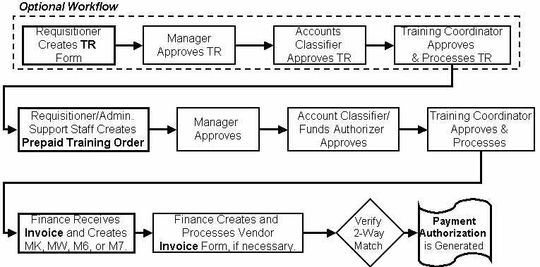

**Figure 29: Prepayment Training Model** outlines the steps required to process prepayments for training. The steps are:

1. Requisitioner creates TR From
2. Manager Approves TR
3. Accounts Classifier Approves TR
4. Training Coordinator Approves & Processes TR
5. Requisitioner / Admin. Support Staff Creates Prepaid Training Order
6. Manager Approves
7. Account Classifier / Funds Authorizer Approves
8. Training Coordinator Approves & Processes
9. Finance Receives Invoice & Creates MK, MW, M6, or M7
10. Finance Creates and Processes Vendor Invoice Form, if necessary
11. Verify 2-way match
12. Payment Authorization is Generated

##### What is the GSA Training Model Workflow?

**Table 15** defines the document types, user groups, and approving officials associated with the steps in the Training Purchasing models.

Table 15: Training Model

| **Pegasys Document** | **Document Type** | **Entered By** | **Approved By** |
| --- | --- | --- | --- |
| Training Request | TR | Requisitioner | Manager  Accounting Classification  Funds Authorizer  Training Coordinator |
| Training Order (Standard Model) | FW, TW, GW, PW, XW, OW, CT | Requisitioner  Administrative Support | Manager  Accounting Classification  Funds Authorizer  Training Coordinator |
| Training Order (Prepayment Model) | FY, TY, GY, PY, XY, OY, NY, CY | Requisitioner  Administrative Support | Manager  Accounting Classification  Funds Authorizer  Training Coordinator |
| Receipt (Standard Model Only) | RC, RK, RW | Requisitioner  Administrative Support | None |
| Match Invoice | M6, M7, MK, MW | Regional Accounting Technician (Finance) | None |

**Training Requests**

To begin either type of Training Purchasing model or the Prepaid Training Purchasing model, the Requisitioner (i.e.*,* the person who wants the training or the person responsible for completing training requests) generates a **Training Request (TR)** form in Pegasys. Detailed information such as the requester’s name, request date, and the training class are recorded on the form. Follow the steps in **Section 5.3.1** for detailed information on completing a training request in Pegasys.

Once complete, the training request must be approved. All training requests require Manager, Accounting Classification, Funds Authorization, and Training Coordinator approvals. To receive the necessary approvals, the request must be routed within Pegasys to the appropriate approvers. Follow the steps in **Purchasing User Guide 3 of 5, Section 10.1**for detailed information on approving a form.

After the training request has received all four approvals, it must be processed to commit the funding. Typically, the last approver processes the request, and routes it to the person responsible for generating the training order. Usually, the Requisitioner or a member of the Administrative Support Staff completes the training order.

**Training Orders**

The training order phase begins with the creation of a **Training Order (FW/FY, GW/GY, PW/PY, TW/TY, XW/XY, OW/OY,** and **NY)** form in Pegasys. Because the Training Request is not a required step in the Standard or Prepayment Training models, either training model may begin with the training order.

If a training request has been recorded in Pegasys, however, GSA requires that the training order reference the request by using the copy forward function when creating the order. Copying the information forward from the request to the order eliminates redundant data entry. Referencing the purchase request on the order also liquidates the request. Follow the steps in **Purchasing User Guide 2 of 5, Section 6.9**for detailed information on completing a training order.

Oral procurements for training must also be captured in Pegasys to record the obligation. An oral procurement of this type is recorded using the training order form.

The completed training order requires four approvals: Manager, Accounting Classification, Funds Authorization, and Training Coordinator. An approver may have the authority to apply one or more approval types. Follow the steps in **Purchasing User Guide 3 of 5, Section 10.1** for detailed information on approving a form within Pegasys.

Once approved, the training order is processed to obligate the funds. Typically, the Training Coordinator or Budget/Funds Analyst who applied the last approval will also process the order.

**Receipts (Standard Training Model Only)**

When following the Standard Training Model, the **Receipt (RC, RK,** or **RW)** form is entered in Pegasys and processed by the training class participant. Receipts must reference the training order. When creating the receipt, the information on the associated training order is copied forward from the order to the receipt. Receipts do not have to be approved; however, they must be processed to record the delivery and acceptance of the training. Follow the steps in **Purchasing User Guide 2 of 5, Section 7.1** for detailed information on completing a receipt.

**Invoices**

Invoices for training are entered and processed in Pegasys by a Regional Accounting Technician. The invoices are then matched to the appropriate training order via the automated match process and a payment authorization is generated (please refer to **Section 3.3** for additional information).

#### What is the GSA Direct Pay Model?

This model is used when only an approved Pegasys direct payment form is required to initiate payment to the vendor. Oral procurements (certified invoices) will follow the Direct Pay Model. Other examples of direct pay include local telephone service or uniform allowances. **Figure 30**outlines the steps of the Direct Pay model.

Figure 30: Direct Pay Model

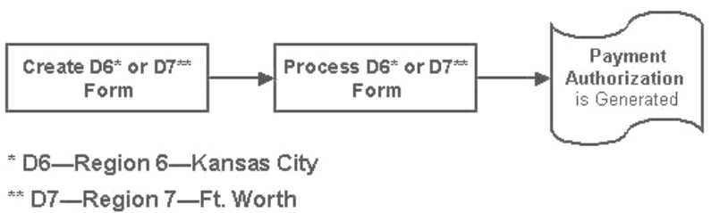

**Figure 30: Direct Pay Model** outlines the steps required to initiate payment to the vendor. The steps are:

1. Create D6 (Region 6-Kansas City) or D7 (Region 7-Ft. Worth) Form
2. Process D6 or D7 Form
3. Payment Authorization is generated.

##### What is the GSA Direct Pay Model Workflow?

**Table 16** defines the document category, document types, user groups, and approving officials associated with the steps in the Direct Pay Purchasing model.

Table 16: Direct Pay Purchasing Model

| **Pegasys Document** | **Document Type** | **Entered By** | **Approved By** |
| --- | --- | --- | --- |
| Direct Pay under or equal to $3000 (<=$3000) | D6  D7 | Service personnel using either Region 6 or Region 7 Finance Center | Direct Pay Approver  Accounting Classification  Funds Authorizer |
| Direct Pay over $3000(>$3000) | DC  DF | Service personnel using either Region 6 or Region 7 Finance Center Finance (for approval) | Direct Pay Approver  Accounting Classification  Funds Authorizer  Finance Direct Payment Approval |
| Direct Pay less than $100000 | DK - Region 6**  DW- Region 7** | Finance | Finance Direct Payment Approval |
| Direct Pay equal to or over $100000 | DK - Region 6**  DW- Region 7** | Finance | Finance Direct Payment Approval Senior |
| Direct Pay over $3000(>$3000) | DX - External Clients** | Finance | Finance Direct Payment Approval Official |

**For Finance Center use only: DK, DW, DX. Disbursements to TX - use D7 or DF, Disbursements to KC - use D6 or DC.

**Direct Pay**

Typically, a direct payment purchase is a reimbursement for work-related telephone charges or other type of purchase where only the vendor invoice is required for payment. After the direct pay form has been entered, it must be routed for approval. Direct payment created by the Services that are $3000 or less require three approvals: Direct Pay Approver, Accounting Classification, and Funds Authorization. Direct payment forms created by Services that are greater than $3000 also require the approval of a Finance Direct Pay Approver.

Direct payments created by Finance that are less than $100,000 require the approval of a Finance Direct Pay Approver. Direct payments created by Finance that are $100,000 or greater require the approval of a Finance Direct Pay Approver Senior. Once the approvals have been applied and the form has been processed, the automated match process will be initiated, a one- way match will occur, and a payment authorization will be generated (see **Section 3.3** for additional information).

### What is Pegasys Automated Match?

Before payment is made to a vendor, the documents used to record the spending transaction are grouped together to create a complete purchasing chain. The process of grouping the purchasing documents together is called Automated Match. The Automated Match process ensures that orders are matched to their associated receipts and to the appropriate vendor invoices. GSA uses three Automated Match models for purchasing transactions. While the automated match process occurs behind the scenes, every purchasing transaction will be sent through one of these three automated matching processes:

* **One-Way** (Direct Pay Model)
* **Two-Way** (Prepayment Training Model, Interagency Model)
* **Three-Way** (Standard Purchasing Model, Standard Training Model)
* **Four-Way** (Separate receipt and acceptance).

**One Way Match** - A one-way match occurs when a document is processed for which payment can be generated immediately. For example, a direct pay does not reference a purchase order and does not require a corresponding receipt. In transactions designated as one-way match, Pegasys will automatically generate a payment authorization after the direct pay document is approved and processed.

**Two Way Match** - A two-way match occurs when an invoice referencing a purchase order is processed. Interagency purchase orders and prepaid training orders are examples of a two-way match. When an invoice references the appropriate purchase order, the match is completed as soon as the invoice is processed. Pegasys will generate a payment authorization automatically after an invoice designated as a two-way match transaction is processed.

**Three/Four Way Match** - A three-way and four-way match occur when both a receipt and an invoice have been processed for a given purchase order. Once receipts and invoices have been matched, Pegasys will automatically generate a payment authorization.

### What Are the Pegasys Purchasing Forms?

In Pegasys, purchasing forms are used to record each transaction in the purchasing chain. There are three basic types of purchasing documents: documents that contain itemized lines, documents that do not contain itemized lines, and training documents. Forms without itemized lines are used to record and track purchases where detailed unit and quantity information is not required. Forms with itemized lines are used to record purchases for items where detailed unit and quantity information is required. Training forms are used to facilitate the purchase of employee training classes. Once the appropriate purchasing form has been completed and approved, it is processed. Processing the form turns it into a document, which then updates all appropriate budgets and plans. Please refer to **Figure** **3.1: What are the Pegasys Purchasing Document Types?** for detailed information on Pegasys forms and documents.

The **Header** pages are common to all purchasing forms. Other purchasing forms will have different pages, such as Office Addresses or Itemized Lines to record information specific to that purchasing form. **Figure 31** displays a typical purchasing document window.

Figure 31: Purchasing Document Window

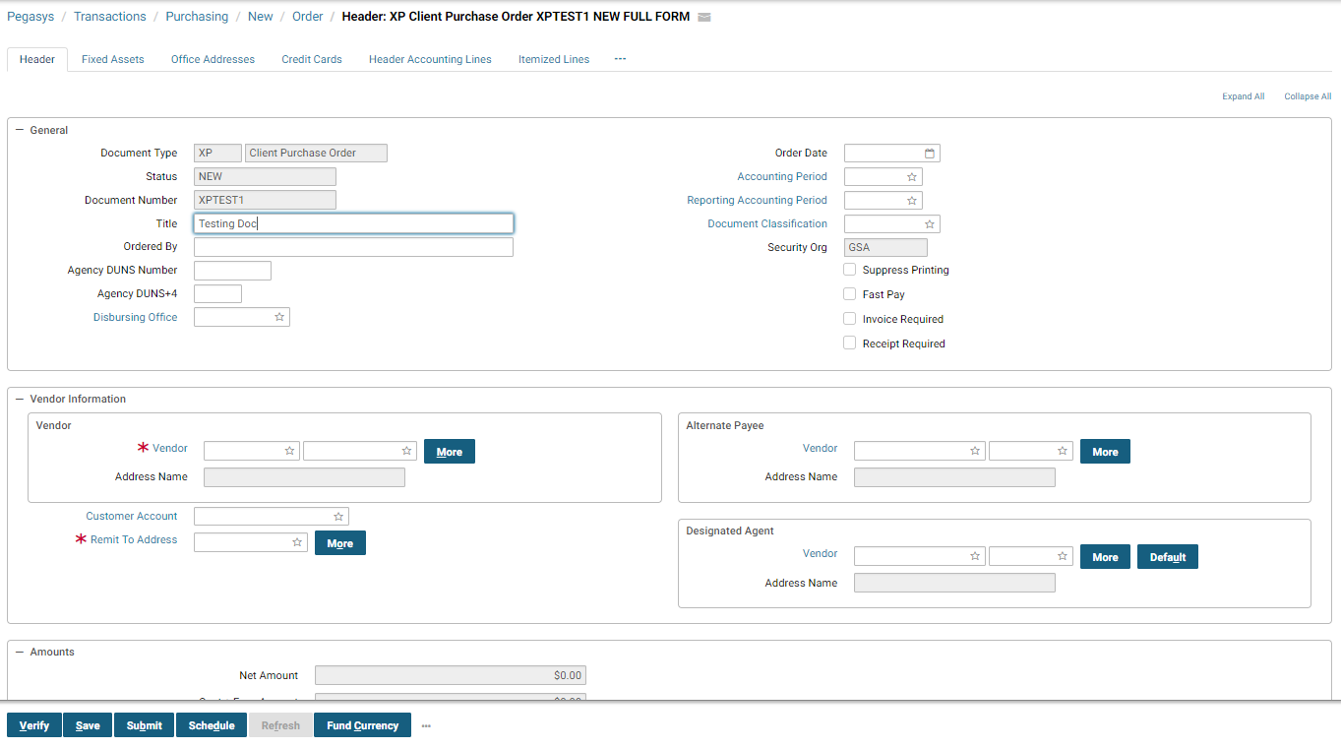

#### How do I Create Purchasing Forms?

To create any Pegasys purchasing form, a user must first select **Transactions - Purchasing - New** and then select the appropriate category (i.e. Order) from the **Pegasys** menu bar. **Figure 32** is displayed.

Figure 32: New Form tab (Order)

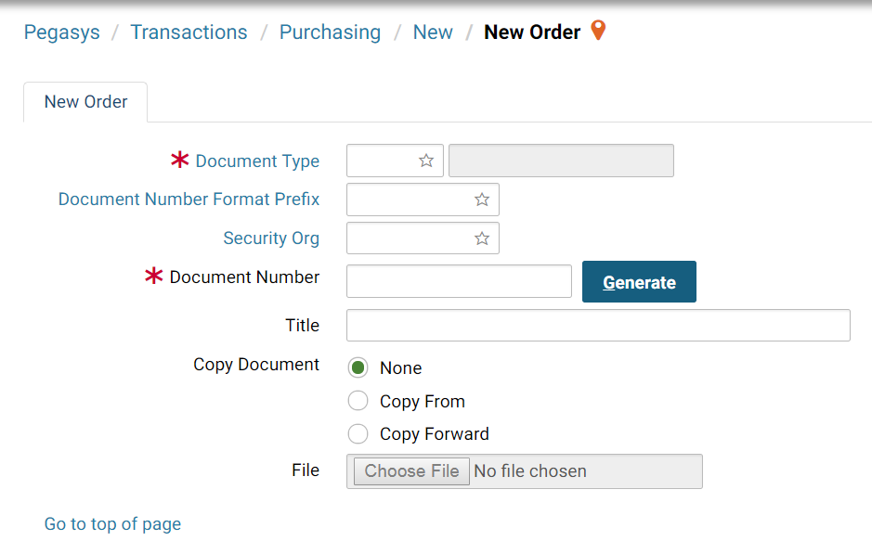

**NOTE:** Fields labeled with a red asterisk* are system-required. On the **New Form** tab, both **Document Type** and **Document Number** are required.

**Document Type** refers to the type of purchasing document being created (i.e., request, order, receipt, or invoice). **Document Number** refers to the system-generated number that uniquely identifies the purchasing document being created. Please refer to **Figure 3-1: Pegasys****Document Categories and Document** Types or **Purchasing User Guide 5 of 5, Section 16,** for a complete listing of Pegasys document types.

##### What is the Referencing feature in Pegasys?

**Referencing** is a feature that allows purchasing activities to be linked together to form a purchasing chain. Through referencing, a purchase order can be linked to its associated request and any subsequent receipts and invoices. When referencing is used, Pegasys will automatically liquidate the referenced document. For example, if a $100 purchase order references a purchase request, Pegasys will automatically reduce the outstanding amount of the request by $100. **Figure 33** displays the **New Form** tab from which the **Copy Forward** function is accessed.

Figure 33: Copy Forward Function

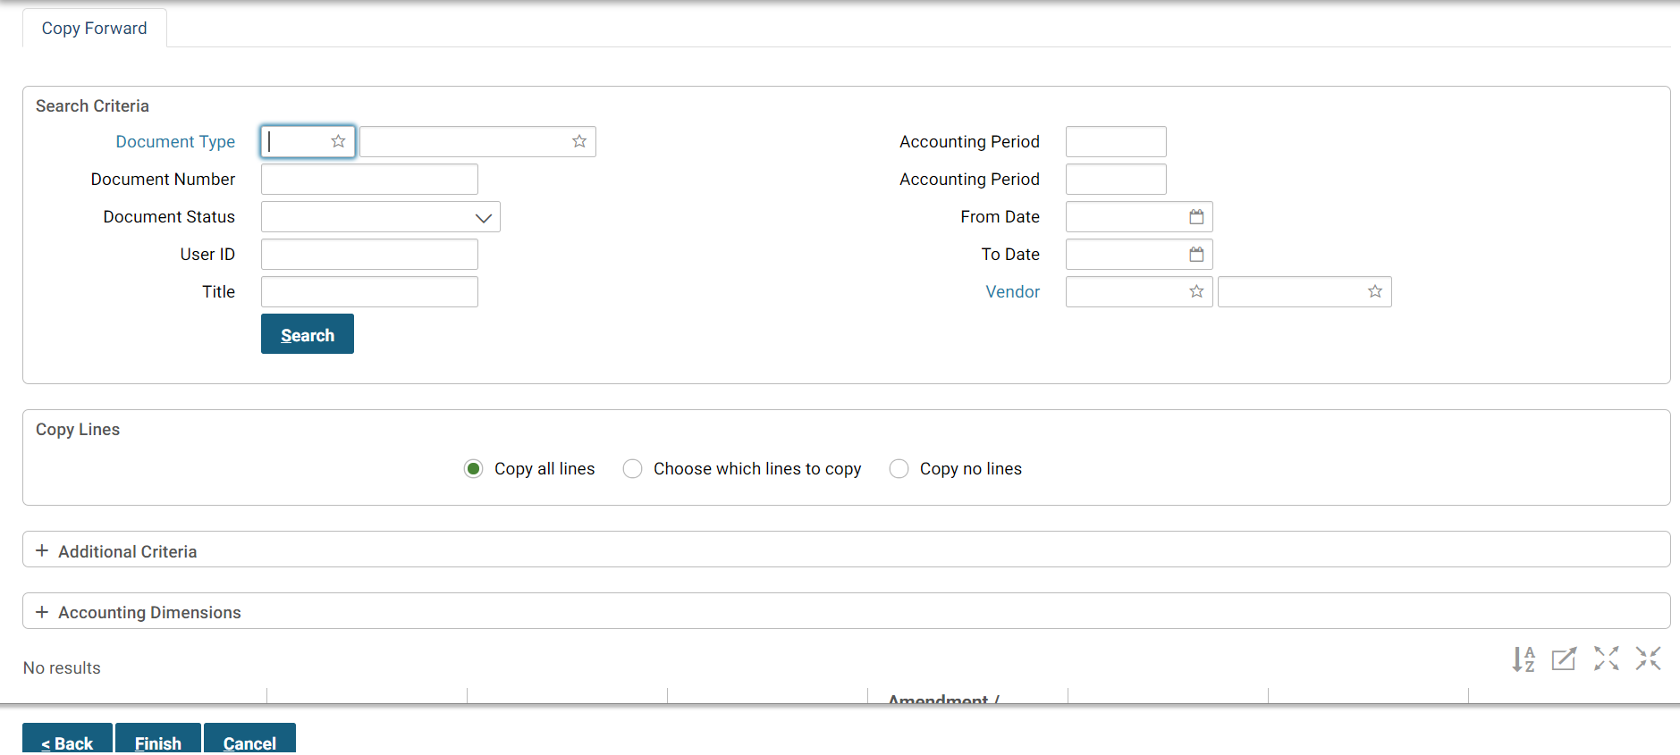

Document referencing is accomplished by using the **Copy Forward** function. When creating a new purchasing form that will be linked to a previous transaction, select the **Copy Forward** radio button, and then select the **Next** button. Specify the document type and the document number to be referenced, select the **Search** button, then select the appropriate document. The **Copy Forward** function reduces data entry when creating new purchasing forms and ensures that vital information is maintained from one transaction to the next in the purchasing chain. GSA requires the use of the copy forward function when creating receipts and invoices. When creating new purchase orders, GSA requires the use of the copy forward if an associated purchase request already exists. The Copy Forward functionality for invoice (IV) to payable (IP) scenarios has been updated, so that the invoice’s references are also copied forward to all itemized (product/service) lines, in addition to all accounting or funding lines.

Another way to reference accounting information from another document is to manually reference the accounting information on the accounting line itself. The steps below describe how to use the Copy Forward button the Header Accounting line tab however these steps can also be followed when using the Itemized Lines tab.

1. Select on the **Header Accounting Lines** tab and then select the **Copy Forward** button.

Figure 34: Header Accounting Line Copy Forward

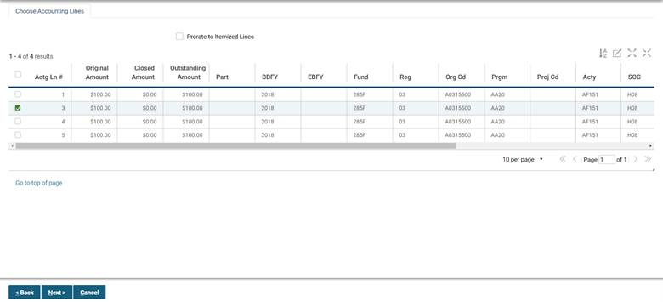

1. The Copy Forward New Line Document Selection window will open. Enter in criteria to search for a document, select a document, and select the **Finish** button.

Figure 35: Copy Forward



1. The new line(s) will be added to the Header Accounting Lines tab.

##### What are the Date Formats in Pegasys?

Calendar dates on Pegasys forms are generally displayed in the following format: MM/DD/YYYY. In addition to the calendar date on which the form is created, the Accounting Period and the Reporting Accounting Period must also be entered. These are entered into the **Accounting Period** and **Reporting Accounting Period** fields and refer to the fiscal month and fiscal year in the following format: MM/YYYY.

The dates on the **Header** page will default to the current date when the form is held, verified, or processed. **Figure 36**display the date fields and formats on the **Header** page.

Figure 36: Date Fields and Formats

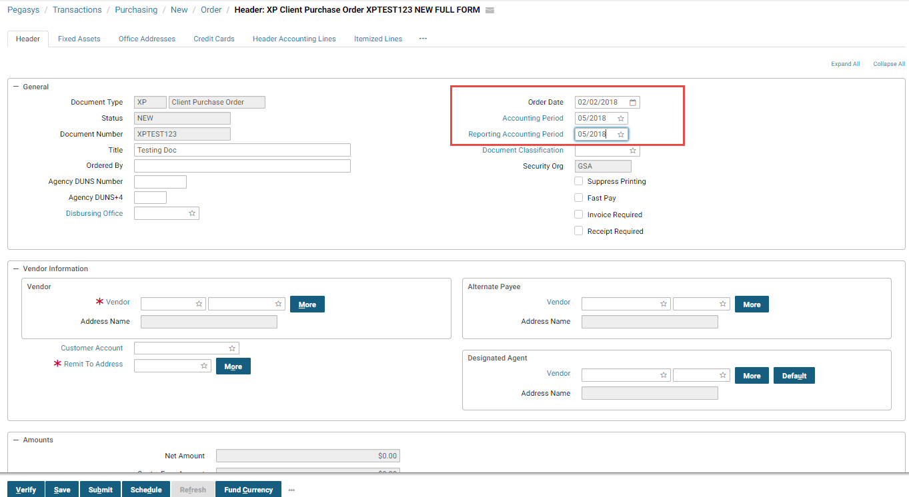

Additionally there are Period of Performance dates which can be entered on a header accounting or itemized line. When a referenced transaction is processed citing a contract, edit checks are performed to ensure that (1) the period of performance cited on the referencing transaction is within the period of performance on the contract and (2) the document date on the referencing transaction is within the effective dates of the contract. If a referenced transaction is outside of the contract dates, an overrideable error is displayed for those with override permission.

##### What are Accounting Templates?

In Pegasys, accounting data has been organized into **Accounting Templates**. A template corresponds to the accounting strip funding the spending transaction. **Figure 37** displays a typical purchasing form **Accounting Template**.

Figure 37: Accounting Templates

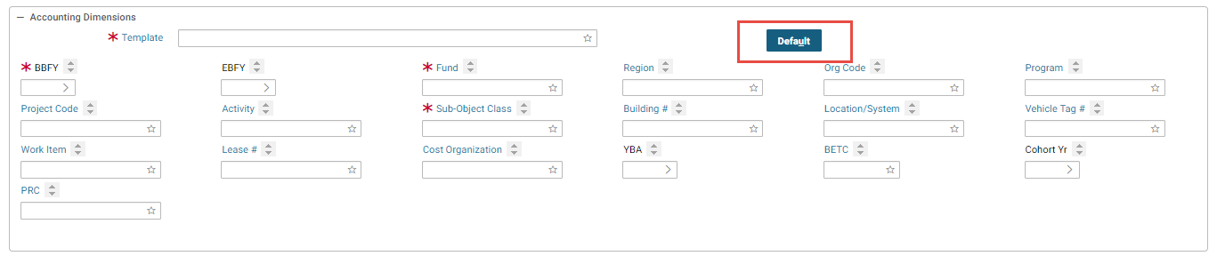

All GSA purchasing transactions require an **Accounting Template**. Once the appropriate template has been selected, most of the remaining template fields will populate when the Default button is selected. Depending on the accounting template selected, however, some fields may require entries to be made by the user.

**NOTE:** Accounting Templates should not be manually typed in Pegasys; users should always **Search** by selecting the Template link, or select the **Favorites** icon and select from pre-existing Favorites.

##### What are the Accounting Lines Action Buttons?

On the **Accounting Lines** page there are buttons that enable users to add an accounting line or copy, remove, reset, or replace previously entered accounting information. **Figure 38** displays the **Accounting Lines** Action buttons. The **Add** button creates a new accounting line. The **Copy** button will add an exact copy of an existing line to the form. The **Copy Forward** button allows the user to search for a form or document to copy forward one or more lines to the form. The **Remove** button will delete the accounting line from the form. The **Reset** button will remove any changes and return the information which was last saved. The **Replace** button allows the user to create a new accounting line to replace an existing line.

Figure 38: Accounting Line Action Buttons

The Accounting line action buttons are located on the Header Accounting Line tab below the accounting lines, if any. The buttons are as follows: References (grayed out), Add, Copy, Remove, Reset, Replace.

##### What is the Action Button Bar on a Pegasys Form?

All Pegasys forms display a set of action buttons at the top of the form window. **Figure 39**displays common Action buttons.

Figure 39: Action Button Bar Continued

The Document Action buttons are located below all of the form information of a document. They are the action buttons used to process a completed document. The buttons are: Verify, Save, Submit, Schedule, Refresh, Fund Currency, and Dot Dot Dot. The 3 dots, open an additional drop down with additional document action buttons.

**Table 17** describes the Action button bar.

Table 17: Action Button Bar Descriptions

| **Field Name** | **Description** |
| --- | --- |
| Verify | Populates all defaulted fields. Performs validity, relationship, and funding edits. Checks form for errors such as invalid codes or blank required fields. |
| Save | Enables the form to be saved as a draft. Does not check for errors or update other subsystems. Typically, forms will be placed on Hold while awaiting approvals. |
| Submit | Performs verify functions. Updates the general ledger and relevant budgets, plans, and projects (based on the accounting implication of the form being processed). |
| Schedule | Not in use by GSA. |
| Refresh | Clears the form window. Restores form to last saved state. Caution: When creating new forms, this button will delete the form and all related information. |
| Fund Currency | Not in use by GSA |

##### What are the Edits on Purchasing Transactions?

After the appropriate information has been entered on the purchasing form, it must be processed. The first step in processing the purchasing form is verifying that the information entered is valid and correct. Pegasys performs a series of edits to ensure that the entered information is correct by applying these edits to the spending transaction:

* **Spending Edits** - Transaction amounts are checked against available budget amounts.
* **Validity Edits** - All codes (*e.g.,* commodity codes, vendor codes) are checked against the appropriate reference table data.
* **Relationship Edits** - Accounting Templates are compared to Pegasys accounting elements to ensure compatibility. Edits can be created on the Document Reference Consistency table for any transaction field in the system, including fields that have been added through extensibility. Relationship Edits have the capability to configure the triggers for edits for reference data creation and modification, including the Accounting Dimensions and Vendor reference tables, the Vendor form, the Accounting Template, and for the Dimension and Vendor Rollups. Additionally, the system allows the ability to associate unique Problem Definitions with Relationship Edits.
* **Tolerance Edits** - Pegasys will perform tolerance edits when you reference purchasing activities. Tolerance edits prohibit the original accounting line amount of one purchasing transaction from exceeding or falling below the referenced purchasing transaction net line amount by more than a predetermined amount. For example, a receipt may not be more than 10% or $100 dollars more than the referenced purchase order.
* **Document Reference Consistency** - Pegasys will perform document reference consistency edits to check the consistency between a source and referencing document for the fields defined on the Document Reference Consistency table and will issue the appropriate error based on the control level defined for the fields.

### What Are the Pegasys Security Organizations?

Security organizations allow users to be put into logical groups. Organizations can be as simple as divisions within an organization or as specific as departments within divisions. Users are only able to view documents associated with the security organization(s) to which they belong. When an organization is part of a larger organization, the child organization inherits the right of the parent. This allows users to gain access to general data of the parent organization, as well as the specific data for the child organization. A parent organization is established for all of GSA and child organizations are established for each of the Services. Each service organization has several two-digit correspondence symbol child organizations. Users are grouped under these organizations based on their functional roles at GSA and their system needs.

Establishing security organizations ensures that individuals outside of a given organization cannot view data. In Pegasys, the security organization is established at the document level. If a user does not select a Security Organization when creating a new document, it will default to the user’s “default security organization.” **Figure 40** displays GMA and PBS security organizations will be called “Service Levels” and AC, AD, 1P and 2P security organizations will be called “Correspondence Symbols”.

Figure 40: Security Organization Hierarchy Example

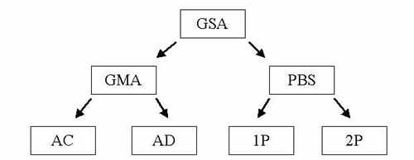

**Figure 40: Security Organization Hierarchy Example** shows an example of how the parent GSA security organization can be broken down into children security organizations under it. It starts with GSA. This GMA and PBS are sibling organizations to GSA. Finally, AC and AD are siblings of GMA and 1P and 2P are siblings to PBS.

Security organization is established at the document level. It is important to realize that users in other security organizations may require document access. Therefore, when creating a new document, users must select the security organization that will enable appropriate document access. Please refer to **Table 18*.***

Table 18: Security Organization Document Access Table

| **Security Organization** | **Document Access** |
| --- | --- |
| The user selects the correspondence level symbol security organization (*e.g.,* 2P, TI, 9F). | Only users within the correspondence symbol security organization can view, reference, approve, and process the document. |
| The user selects the Service security level organization (*e.g.,* FTS, FSS, PBS, GMA). | All users within the Service can view, reference, approve, and process the document. |
| The user selects the GSA security organization. | All users within GSA can view, reference, approve, and process the document. |

Security levels are established as a hierarchy with the highest level (Pegasys) containing the most document and reference data access and the lowest level (correspondence symbol) contains the least document and reference data access.

**NOTE:** When creating a document that must be viewed, approved, or processed by another Service, the user must select GSA as the security organization.

**Table 19** discusses various scenarios and the results of the Security Organization selection associated with each scenario.

Table 19: Security Organization Scenarios

| **Scenario** | **Security Organization Selection** |
| --- | --- |
| Susie User belongs to Security Organization ‘AC’. She is creating a request, which will subsequently be referenced and approved by another user in the ‘AC’ Security Organization. | Susie User will select the ‘AC’ Security Organization. |
| Joe User belongs to Security Organization ‘1P’. He is creating an order, which will subsequently be approved by a user in the ‘2P’ Security Organization. | Joe User will select the ‘PBS’ Security Organization. |
| Jill User belongs to Security Organization ‘AD’. She is creating a request, which will subsequently be referenced by another user in the ‘PBS’ Security Organization. | Jill User will select the ‘GSA’ Security Organization. |

Once the Security Organization is selected, it is system maintained on the **Header** page and cannot be changed. Please refer to **Figure 41**.

Figure 41: Purchase Order Header Page

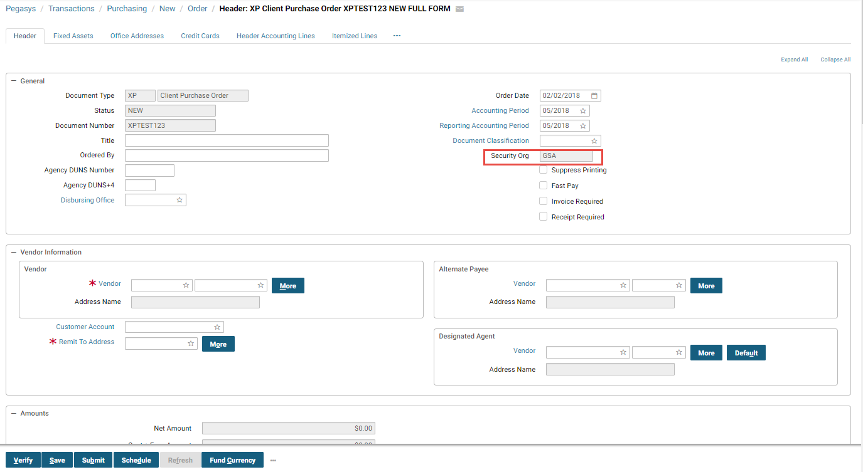

#### What is the GSA Standard Security Policy?

Table 20: GSA Standard Security Policy Table

| **Policy** | **Rules** |
| --- | --- |
| GSA Standard Pegasys Policy | Passwords are valid for 90 days.  Grace logins for new and expired passwords will be set to 3.  Verify logged on user after 15 minutes of inactivity.  Login attempts permitted are 3.  **NOTE**: If a user is locked out after three attempts, please call the IT Service Desk at (866) 450-6588 or email [businessapps@gsa.gov](mailto:businessapps@gsa.gov).  Passwords may be reused after 5 iterations.  Expired passwords will be stored for 90 days. |

### Purchase Query Enhancement Overview

This enhancement includes updates to the Purchase Query to allow a Pegasys user to enable and/or approve accounting lines for automated document reversal, as well as allowing users to search by and view automated document reversal status for Obligations, Commitments, Receipts, and Reservations. This enhancement includes a new simple parameter on the Document Reversal batch process (ACDOCRVS) in support of selecting approved records from the Purchase Query and sending failure email notifications if an approved PurchaseQuery record fails during ACDOCRVS execution. Additionally, new complex parameters that will allow specification of a particular accounting line were added to ACDOCRVS.

A new instance of the ACDOCRVS batch process specific to the accounting line reversal enhancement will be configured. The “Use Approved Purchase Query Records” parameter will be set to True.

## Working With Purchasing Forms and Documents

In Pegasys, purchasing forms are used to record transactions in the purchasing chain. There are three types of purchasing forms: forms with Header Accounting Lines, forms with Itemized Lines, and training forms.

* **Forms with Header Accounting Lines** - Used to record and track purchases where detailed unit and quantity information is not required.
* **Forms with Itemized Lines** - Used to record purchases for items where detailed unit and quantity information is required.
* **Training Forms** - Used to facilitate the purchase of employee training classes.

Once the appropriate purchasing form has been selected, completed, and approved, the form can be processed. Processing the form turns it into a document, which then updates all appropriate budgets and plans. During the course of the purchasing cycle, it may be necessary to view, correct, amend, delete, or cancel a purchasing transaction and its corresponding Pegasys form or document.

### How to Search for a Form or Document

There are several ways to search for a form or document in Pegasys. The type of search method depends on whether you are looking for a *form* or a *document*.

* **Forms** - Refer to transaction items such as purchase requests, purchase orders, receipts, etc., that have been created in Pegasys but are *not yet processed.*
* **Documents** - Refer to transaction items such as purchase requests, purchase orders, receipts, etc., that have been processed (ergo, capable of drawing down plans, budgets, or referenced documents, if applicable).

To retrieve and view a form, follow the steps outlined in **Section 4.1.1*.*** To retrieve a document, follow the steps outlined in **Section 4.1.2.**

#### How Do I Search for a Form?

The Pegasys **View Form** option allows users to view purchasing forms in **Held**, **Pending Approval** or **Rejected** status. The following steps describe how to search for, retrieve, and view a form.

1. Select **Transactions** - **Purchasing** - **View** from the menu bar.

The **View** page will be displayed.

Figure 42: View page

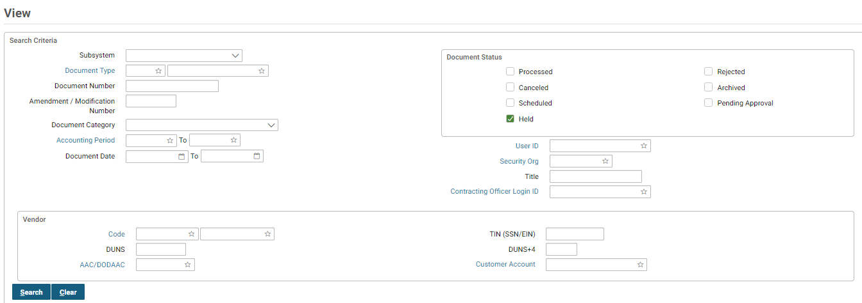

The **Held** check box in the **Document Status** group box will default to checked.

1. Enter a document type in the **Document Type** box.
2. Select the **Document Type** hyperlink to open the **Search Document Type** page.
3. In the **Document Search Criteria** group box, enter one or more of the following search criteria:
   1. **Document Category** (document type).
   2. **Document Number** (document number).
   3. **Subsystem** (will default to Purchasing)
   4. **User ID** (login ID of the person who *created* the form).
   5. **From Date** (date on which the form was created or prior).
   6. **To Date** (date on which form was created or later).
   7. **From Accounting Period** (accounting period on which the form would post or prior).
   8. **To Accounting Period** (accounting period on which the form would post or later).
   9. **Amendment Number**
   10. **Vendor Code** (code that represents a vendor in Pegasys).
   11. **DUNS** (DUNS for the vendor)
   12. **TIN (SSN/EIN)** (TIN for the vendor)
   13. **DUNS+4** (DUNS+4 for the vendor)
   14. **Customer Account** ( customer account for the vendor)
   15. **Additional Criteria** (can further search by Amount From Amount, Amount to Amount, Alternate Payee, Designated Agent, Currency or Open/Closed).
   16. **Accounting** (can further search by accounting dimensions)

For example, user John Doe wants to search for all purchase requests he created for the month of December 2010. The search criteria would be:   
**USER ID** = johndoe, **From Date** = 12/01/2010, **To Date** = 12/31/2010.

1. Select the **Search** button.

The forms matching the search criteria will be displayed.

Figure 43: Searching to view documents

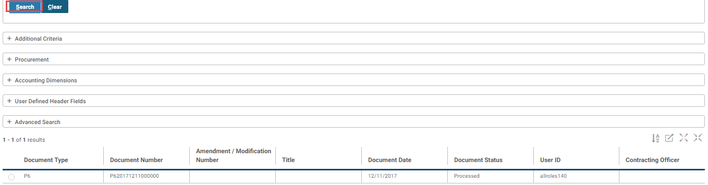

1. Select the document desired and select the **View** button to open the document in read only status.

The **Header** page of the selected form will be displayed in a read-only format. All fields will be protected.

Figure 44: Header Tab Purchase Order



1. To view another form return to step 1. The form will close when you perform a new action.

#### How Do I Search for a Document?

The Pegasys **Review** option allows users to retrieve processed purchasing documents in a “read-only” format in which all fields are protected. The following steps describe how to review a document.

1. Select **Transaction** - **Purchasing** - **Review** from the menu bar.

The **Review** page will be displayed.

Figure 45: Review P6 Document page

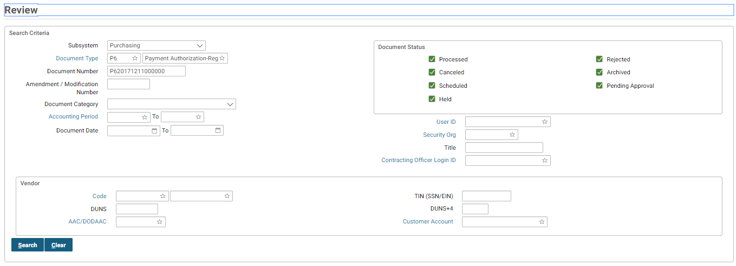

The **Processed** check box in the **Document Status** group box will default to checked.

1. Enter a particular Pegasys form in the **Document Type** field.
   1. To search for a document type, select the **Document Type** link to open the **Search Document Type** page:
   2. Enter the appropriate values in the **Search Criteria** box for your document.
   3. Select the **Search** button
   4. Select the **Select** button to copy the appropriate selection. The **View** page’s **Search Criteria**.
2. Enter the document number of document in the **Document Number** field. If the document number is unknown, continue with Step 4. If the doc number is known proceed to Step 5.
3. In the **Document Search Criteria** group box, enter one or more of the following search criteria:
   1. **Document Category** (document type).
   2. **Document Number** (document number).
   3. **Subsystem** (will default to Purchasing)
   4. **User ID** (login ID of the person who *created* the form).
   5. **From Date** (date on which the form was created or prior).
   6. **To Date** (date on which form was created or later).
   7. **From Accounting Period** (accounting period on which the form would post or prior).
   8. **To Accounting Period** (accounting period on which the form would post or later).
   9. **Amendment Number**
   10. **Vendor Code** (code that represents a vendor in Pegasys).
   11. **DUNS** (DUNS for the vendor)
   12. **TIN (SSN/EIN)** (TIN for the vendor)
   13. **DUNS+4** (DUNS+4 for the vendor)
   14. **Customer Account** ( customer account for the vendor)
   15. **Additional Criteria** (can further search by Amount From Amount, Amount to Amount, Alternate Payee, Designated Agent, Currency or Open/Closed).

For example, user John Doe wants to search for all purchase requests he created for the month of December 2003. The search criteria would be:   
**USER ID** = johndoe, **From Date** = 12/01/2010, **To Date** = 12/31/2010.

1. Select the **Search** button.

The documents matching the search criteria will be displayed.

Figure 46: Document Matching Search Criteria

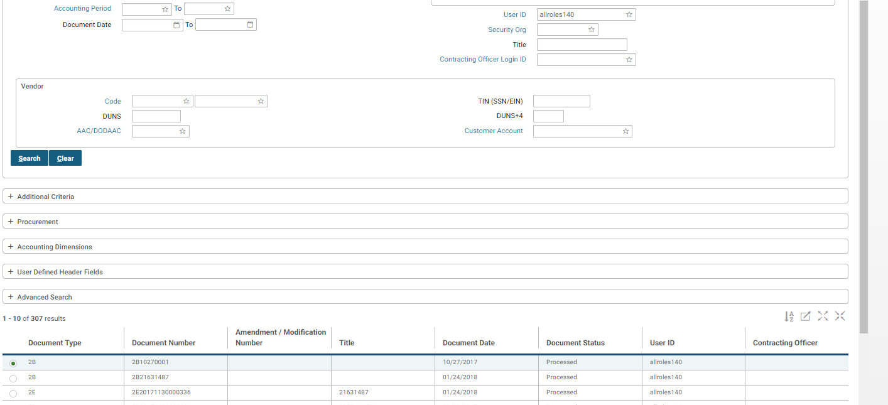

1. Select the desired document and select the **Reference Query** button to view all referenced documents, the **GL Detail** button to view the GL information, or select the **View Document** button to view the document.

The **Header** page of the selected document will be displayed in a read-only format. All fields will be protected.

Figure 47: Header 2B Document page

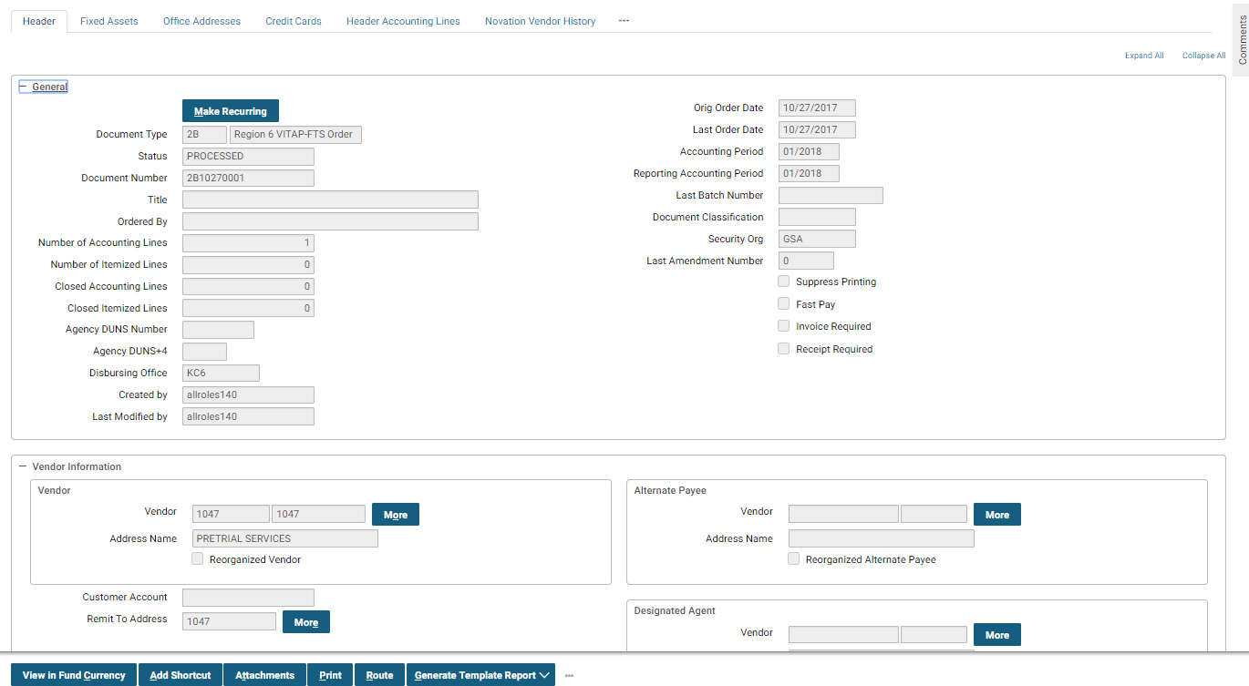

1. To view another form return to step 1. The form will close when you perform a new action.

### How Do I Add An Attachment?

Pegasys allows users to add attachments and supporting documents to forms. The attachments and supporting documents can be marked as sensitive which enables the system to restrict view, check in, check out, unlock and delete access to designated users. This attachment functionality has been extended to various notebooks and queries; this functionality will allow users to view and manage attachments at notebook and query level, therefore users will no longer need to navigate to the form/document level to add an attachment. Attachments associated with forms/documents will not be visible from the Notebooks or Queries; and vice versa.

1. Open an existing form and select the **Attachment** button.

Figure 48: Header Processed 2B Page



1. Select the **Import Local File** button

Figure 49: Attachments

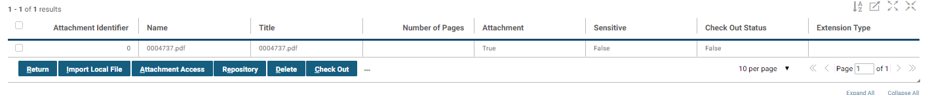

1. Enter a Title, select the **Browse** button to find the document to attach.

Figure 50: Import local file

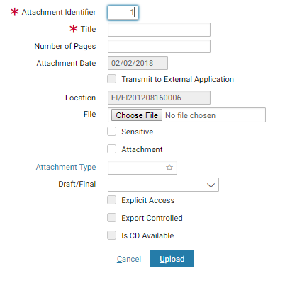

* 1. Select the Sensitive checkbox if you want to limit the document to only designated users. The user uploading the document is automatically granted Attachment Manager permissions on the specific attachment and also receives the ability to view, edit and delete the file. The Attachment Manager is able to grant view, edit or delete access for the attached file to other users.
  2. Select the Attachment checkbox if you do not want this document to be a supporting document.

1. Select the **Upload** button.
2. If the Sensitive checkbox in the Upload Document screen was checked, select the **Attachment Access** button.

Figure 51: Attachment Access

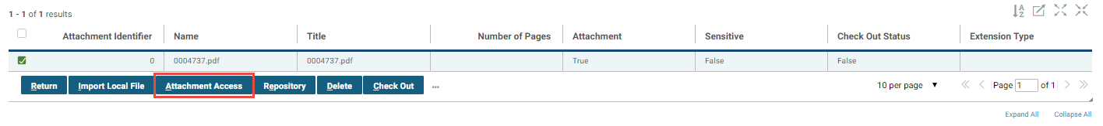

1. Select **Add** to add a user with attachment access.

Figure 52: Adding a user

To add a principal id to view an attachment can be done by entering the principle ID in the Principle ID file and clicking any/or View, Edit, Delete check boxes. There are two tabs in this window. The Attachment Access tab and the External Attachment Access tab. The Previous returns the user to the previous screen.


1. Enter or search for a Principal ID and check View, Edit, and /or Delete checkboxes.
2. Select the Previous button to return to the Attachment screen, Select the Copy button to copy the permissions for another user, and select the Remove button to remove a user.
3. Select Return on the Manage Attachments and Supporting Documents screen.

### How Do I Correct a Form or Document?

Pegasys users can correct forms or documents. The difference between correcting a form and correcting a document is the status. All *forms* have a status of **Held**, **Pending Approval** or **Rejected** while all *documents* have the status of **Processed**.

**NOTE:** Purchase Orders can only be corrected if they have not been sent to the vendor. Once the purchase order has been sent to the vendor, changes must be made by amending the original purchase order.

The following steps describe how to correct a form or a document.

1. Select **Transactions** - **Purchasing** - **Correct** from the menu bar.

The **Correct** page will be displayed.

Figure 53: Correct page

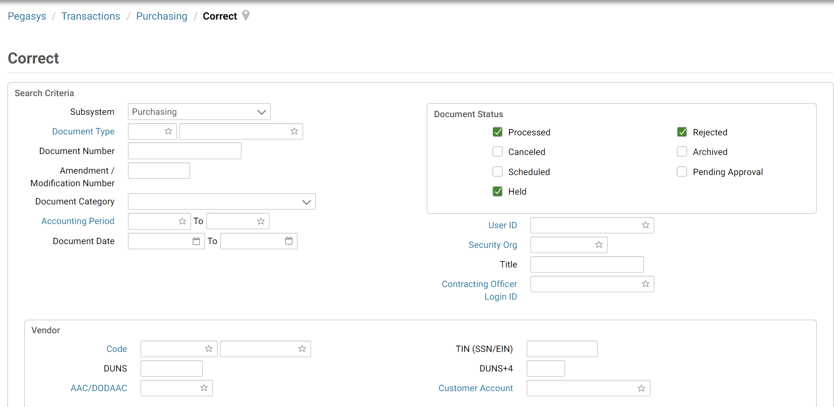

1. Check the desired document status check box (or boxes) from the **Document Status** group box.
2. Select the Document Type link to open the Search Document Type page:
   1. Enter the appropriate values in the **Search Criteria** box for your document.
   2. Select the **Search** button
   3. Select the **Select** button to copy the appropriate selection. The View page’s **Search Criteria**.
3. Enter the document number of the form or document in the Document Number field.
4. If the document number is unknown, please refer to How to Search for a Form or Document for instructions on how to search for a form or document.
5. Select the **GL Detail** button to view GL information for the document or select the **Correct** button.

The **Header** page of the selected form or document will be displayed.

Figure 54: Header OP Document page

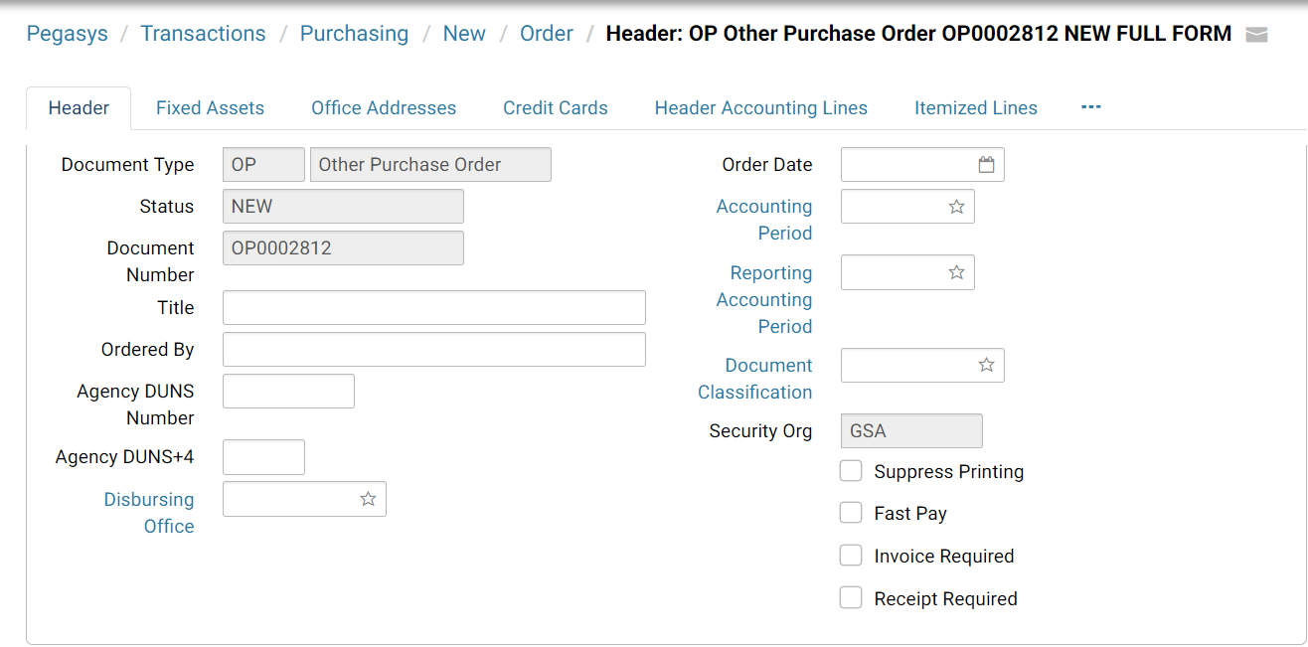

1. Enter the desired changes.

If the form requires approvals, you must add the approver(s) to the form. Please refer to **Purchasing User Guide 3 of 5, Section 10.1.8**. If no approvals are required, proceed to Step 16 (Select the Verify button step). To add approvers to the form, select the Approval Routing tab. The Approval Routing page will be displayed. Since the form’s creator has not yet added approvers, none will be listed.

1. To add approvers one by one to the form, select the **Approval Routing** tab, select the **Add User** button. The **User Search** page will be displayed.

**NOTE:** To add multiple approvers that are stored in a routing list, please view **Step11.**

1. Enter the **User ID** or **Name** of the form’s approver in the appropriate search fields, and select the **Search** button. If users do not know the specific **User ID** or **Name** of the approver, then they may use the asterisk (*) as a wildcard in the search. The search results listing the form’s approver will appear.
2. Highlight the appropriate **Principal ID** record for the approver of the form. Then select the **Select** button.
3. The selected user will be added to the approvers list on the **Approval Routing** tab. Repeat **Steps 7-9** to add additional approvers to the form.

**NOTE:** Users are required to add all approvers to a form, even if one of the approvers is the form’s creator.

1. To add multiple approvers to the form that are stored in a routing list, select the **Add Routing List** button. The **Routing List Search** page will be displayed.
2. Enter the **Routing List Code** or **Routing List Name** in the appropriate search fields, and select the **Search** button. If users do not know the specific **Routing List Code** or **Routing List Name**, then they may use the asterisk (*) as a wildcard in the search. The search results will appear.
3. Highlight the appropriate **Routing List** record. Then select the **Select** button.
4. The users saved in the routing list will be added to the approvers list on the **Approval Routing** tab. Repeat **steps 11-13** to add additional routing lists to the form.

**NOTE:** Users may add multiple users and/or routing lists to the Approvers list on a form. In addition, users will be required to add all approvers to a form, even if one of the approvers is the form’s creator and submitter.

1. Select the **Verify** button.

If error messages are displayed, review the messages, and correct the form accordingly.

1. Select the **Submit** button to submit the form for approval or processing.

### How Do I Amend a Purchase Order Document?

Amendments are made to change information on processed purchase orders and requests. The Sequential Amendment Number Generation functionality improves the generation of amendment numbers; it changes the Amendment Number generation logic to increment the Amendment Number from the last saved form rather than from the last generated number. When a purchase order document is amended, an **Amendment Number** and a **Justification** for the change must be recorded. The following steps describe how to amend a document.

1. Select **Transactions - Purchasing - Amend -** and then choose the appropriate Document Category: Request, Training Requests, Non-Accounting Training Request, Order or Training Order from the menu bar.

The **New Amendment** page will be displayed.

Figure 55: New Amendment page

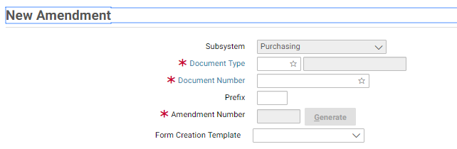

1. Enter a document type in the **Document Type** box.
2. Enter the document number of the document in the **Document Number** field.

If the document number is unknown, please refer to **How to****Search for a Form or Document** for instructions on how to search for a document.

1. Enter a number for the amendment in the **Amendment Number** field or if the **Generate** button is active, select the **Generate** button to generate the next amendment number.

**NOTE:** Amendment numbers will follow the current naming conventions of the user’s service.

1. Select the **OK** button.

The **Header** page of the selected document will be displayed.

Figure 56: Header OP Document page



1. Enter the desired changes.
2. In the Amendment Information group box, enter the reason for the modification in the **Justification** text box.

Figure 57: Amendment Justification

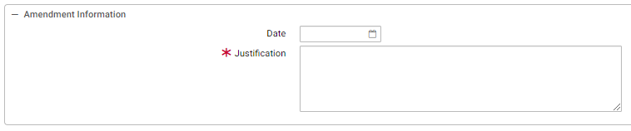

1. If the form requires different approvers than those who previously approved the document, you must add these new approver(s) to the form and remove the others. Please refer to **Purchasing User Guide 3 of 5, Section 10.1.8**.
2. To add approvers to the form, select the Approval Routing tab. The Approval Routing page will be displayed.
3. To delete approvers from the form, select the approver record and select the **Remove** button.

**NOTE:** The approver will be removed on form verification.

1. To add approvers one by one to the form, select the **Add User** button. The **User Search** page will be displayed.

**NOTE:** To add multiple approvers that are stored in a routing list, please view **Step 14.**

1. Enter the **User ID** or **Name** of the form’s approver in the appropriate search fields, and select the **Search** button. If users do not know the specific **User ID** or **Name** of the approver, then they may use the asterisk (*) as a wildcard in the search. The search results listing the form’s approver will appear.
2. Highlight the appropriate **Principal ID** record for the approver of the form. Then select the **Select** button.
3. The selected user will be added to the approvers list on the **Approval Routing** tab. Repeat **steps 10-12** to add additional approvers to the form.

**NOTE:** Users are required to add all approvers to a form, even if one of the approvers is the form’s creator.

1. To add multiple approvers to the form that are stored in a routing list, select the **Add Routing List** button. The **Routing List Search** page will be displayed.
2. Enter the **Routing List Code** or **Routing List Name** in the appropriate search fields, and select the **Search** button. If users do not know the specific **Routing List Code** or **Routing List Name**, then they may use the asterisk (*) as a wildcard in the search. The search results will appear.
3. Highlight the appropriate **Routing List** record. Then select the **Select** button.
4. The users saved in the routing list will be added to the approvers list on the **Approval Routing** tab. Repeat **steps 14-16** to add additional routing lists to the form.

**NOTE**: Users may add multiple users and/or routing lists to the Approvers list on a form. In addition, users will be required to add all approvers to a form, even if one of the approvers is the form’s creator and submitter.

1. If the document requires approvals, **Save** it and route it to the appropriate approver(s). Please refer to **Purchasing User Guide 3 of 5, Section 10.1.8**. If no approvals are required, proceed to   
   **Step 20**.
2. Select the **Verify** button and correct any errors returned.
3. Select the **Submit** button to submit the amendment for approval or processing to the Purchase Order form.

### How Do I Delete a Form?

Purchasing forms with the status of **Held**, **Pending Approval** or **Rejected** can be deleted from Pegasys. Only users with the proper security permissions can delete a form. The following steps describe how to delete a form.

**NOTE:** Only forms can be deleted; documents cannot be deleted.

1. Select **Transactions** - **Purchasing** - **Delete** from the menu bar.

The **Delete** page will be displayed.

Figure 58: Delete page

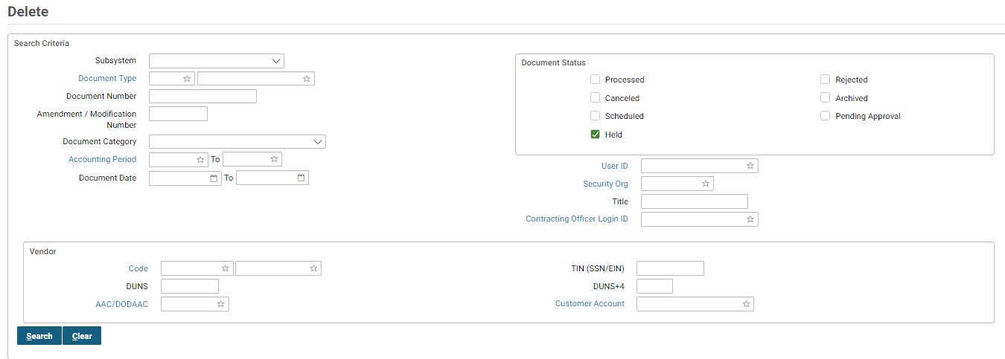

The **Held** check box in the **Document Status** group box will default to checked.

1. Select the **Document Type** link to open the **Search Document Type** page:
   1. Enter the appropriate values in the **Search Criteria** box for your document.
   2. Select the **Search** button.
   3. Select the **Select** button to copy the appropriate selection. The **View** page’s **Search Criteria**.
2. Enter the document number of the form in the **Document Number** field.

If the document number is unknown, please refer to **Section 4.1** for procedures on how to search for a form.

1. Select the **Search** button.
2. Select the document from the generated list.
3. Select the **Delete** button.

A confirmation page will display.

1. Select the **Yes** button to delete the form or the **No** button to cancel the deletion process.

Once the form has been successfully deleted, user will receive a dialog box indicating, “Successful Action”.

### How Do I Cancel a Document?

Spending transactions recorded in Pegasys can be canceled by canceling the related purchasing documents. Only processed documents can be canceled. The following steps describe how to cancel a document.

**NOTE:** Purchasing documents that have been referenced by other documents cannot be canceled unless all referencing documents are canceled first. For example, if a purchase request is referenced by a purchase order, then the purchase order must first be canceled before the purchase request can be canceled.

1. Select **Transactions** - **Purchasing** - **Cancel** from the menu bar.

The **Cancel** page will be displayed.

Figure 59: Cancel page

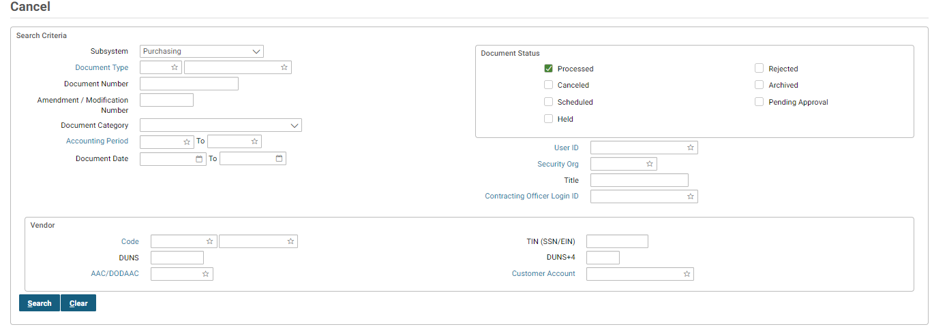

The **Processed** checkbox in the **Document Status** group box will default to checked. No other check boxes will be available.

1. Select the **Document Type** link to open the **Search Document Type** page:
   1. Enter the appropriate values in the **Search Criteria** box for your document.
   2. Select the **Search** button
   3. Select the **Select** button to copy the appropriate selection. The **View** page’s **Search Criteria**.
2. Enter the document number you wish to cancel in the **Document Number** field.

If the document number is unknown, please refer to **Section 4.1** for instructions on how to search for a document.

1. Select the **Search** button.
2. Select the appropriate document from the generated list. Select the **GL Detail** button to view GL information or select the **Cancel** button to cancel the document.

The **Header** page of the document to be canceled will be displayed with the status of, “PENDING CANCELLATION”.

1. Enter an **Amendment Number**.

**NOTE**: Amendment numbers will only be required for documents that are allowed to be amended per the document type table.

1. Select the **Submit** button.

The document is canceled; however, no confirmation dialog box will be displayed.

### How Can I Query a Document Using the References Button?

Referencing allows purchasing transactions to be linked together to form a purchasing chain. To view documents that have been linked together, simply select the **References** button available on all purchasing documents displayed in the read-only format. By selecting the **References** button, linked documents are displayed in a **Document Chain** dialog box. If, for example, a purchase order is queried, the related request, receipt(s), invoice(s), and payment authorization(s) documents are displayed. Only those documents that have been referenced using the copy forward function will be displayed.

The following steps describe how to query a document using the **References** button.

1. Select **Transactions** - **Purchasing** - **Review** from the menu bar.

The **Review** page will be displayed.

Figure 60: Review P6 Document page



The **Processed** check box in the **Document Status** group box will default to checked.

1. Select the **Document Type** link to open the **Search Document Type** page:
   1. Enter the appropriate values in the **Search Criteria** box for your document.
   2. Select the **Search** button.
   3. Select the **Select** button to copy the appropriate selection. The **View** page’s **Search Criteria**.
2. Enter the document number of the document in the **Document Number** field.

If the document number is unknown, please refer to **How to****Search for a Form or Document** for procedures on how to search for a document.

1. Select the **Search** button, select the document, and select the **View** button.

The **Header** page of the selected document will be displayed in a read-only format. All fields will be protected.

1. Select the **References** button.

The **Document Reference Tree** page will be displayed.

Figure 61: Document Reference Tree page

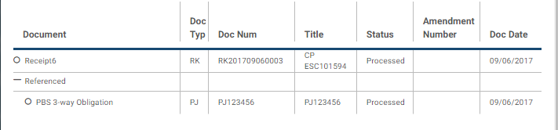

1. Select on a “O” or “-“ icon to expand the Reference Tree*.*
2. To view a specific document in the chain, select it by selecting the appropriate document number.

When the document is selected, the **Document Type**, **Document Number**, **Document Total**, **Document Cost**, and **Document Date** fields are displayed.

1. Select the **View** button to view the selected document.

The **Header** page of the selected document will be displayed in a read-only format. All fields will be protected.

Figure 62: Header RK document page

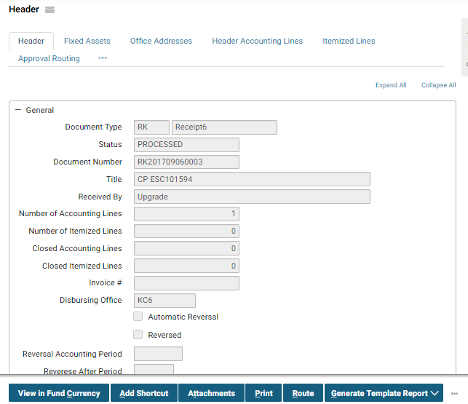

1. Select the **Close Window** link. Select the **View Line Level Detail** button of the **Document Chain** window to view a specific accounting line on the selected document.

**Line Level Detail** page will be displayed.

Figure 63: Line Level Detail page

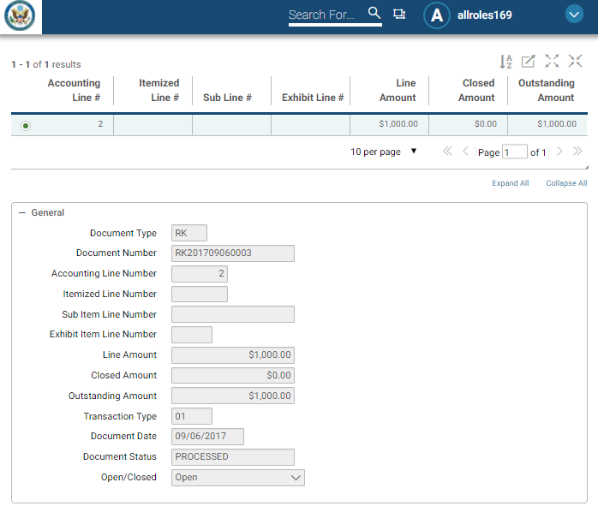

1. The **Line Selection** dialog box lists all lines included on the selected document. Select the **OK** button.
2. Select the **Exportable View** button to export the reference tree.

Figure 64: Exportable View Button

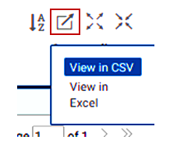

1. Select the **View GL Detail** button to view the GL Account Detail Query.

Figure 65: GL Account Detail Query

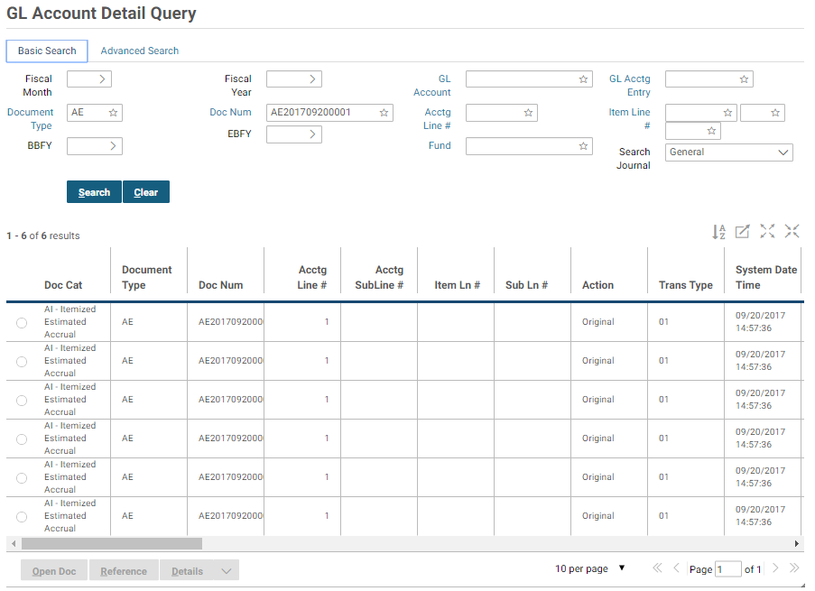

1. Select the **View Transaction Detail** button to view the Transaction Journal Detail Query.

Figure 66: Transactional Detail

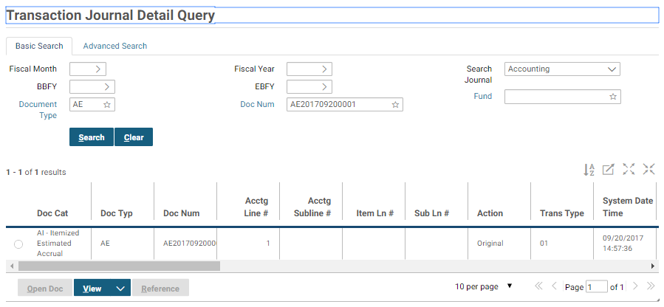

### What Are the Common System Messages in Pegasys?

This section will help the user interpret the Pegasys system messages. Pegasys provides three levels of warning and error messages: Informational, Warning or Overrideable, and Hard. Each level will be discussed in this section. All Pegasys error messages share a similar structure. The first line of the error message displays an error code, followed by the name of the form or table where the error occurred, including the specific line or field. The message concludes with a brief description of the error.

Error messages appear at the top of the page and include the following key elements:

* Error symbol - identifies the type of error as **i** (informational message), **!** (warning or overrideable error), or a red stop sign (hard error).
* Error code - displays a seven-digit error. The first two characters represent the subsystem that issued the error (e.g., **PE** - the Purchasing subsystem). The last character designates the severity (e.g., **I** - informational)
* Page title - identifies the location on the form where the error occurred.
* Error description - gives a detailed explanation of the problem that occurred.
* Error counter - identifies the total number of errors Pegasys encountered while trying to verify or process a transaction.

#### What Are Informational Messages in Pegasys?

An informational message is accompanied by a blue box, containing the letter “**i**”. Informational messages are intended to notify users of situations that may require further attention; however, they do not prevent a form from being processed. When informational messages appear, evaluate the impact of the problem, and continue processing the form, if appropriate. **Figure 67** displays an example of an informational message.

Figure 67: Informational Message

Informational messages information or notify the user of issues within a document that require further attention. The informational message is surrounded by a blue border and a blue box with the letter 'i' in the center. This message states the following: Automated Match Invoice/Itemized Match Invoice Header Accounting Line 1
A valid BETC must be entered if the Agency location code on the Disbursing Office is a CARS GWA reporter.

#### What Are Overrideable Errors in Pegasys?

Overrideable errors notify users of situations that require special attention and will prevent a form from being processed; however, an individual with the appropriate authority can override them. An overrideable error is accompanied by a yellow triangle containing a “**!**” until it is overridden.

If a user with Override authority wishes to override the error message, the message must first be selected with a mouse-select. The user then selects the **Override** link. After the error has been overridden, the error will be accompanied by the informational symbol (a blue circle, containing the letter “**i**”).

If the user does not want to override the error or if other errors exist on the form, make the necessary changes. **Figure 68** displays an example of an overrideable error message that warns about spending against an expired fund.

Figure 68: Overrideable Error Message

Similar to Informational Errors, Overrideable errors inform a user of issues within document. These errors tell the user that there is an error within the document, however, that error can be overridden and the document can still be processed. The message is surrounded by an orange border with an orange box and a white triangle and orange exclamation point within it.

#### What Are Hard Errors in Pegasys?

A hard error message is accompanied by a red circle (stop sign). Hard error messages are NOT overrideable and must be corrected before the transaction can be processed. The user should select the error message link to be directed to the area where the error is located. **Figure 69** displays an example of a hard error message.

Figure 69: Hard Error Message

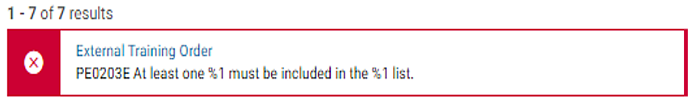

The Configurable Problem Definition Control Level modifies Problem Definitions so that GSA can modify the severity level of edits that are initially informational or overridable to be stronger or weaker. Informational or overridable errors can either be weakened or strengthened. However, hard errors cannot have their severity level changed, as hard errors are integral to Pegasys processing and/or ensure that data integrity is not compromised.

## Reservations & Requests

### What is a Reservation in Pegasys?

A reservation is a pre-commitment of funds for a projected purchase. Typically, a pre- commitment will set aside funding for a specific purpose that may entail multiple purchases. The reservation (**RS**) is an optional step in the purchasing chain and will typically be entered into Pegasys by a Funds Manager. Reservation forms are used across all GSA Services and can be used to record the pre-commitment of funds for itemized and non-itemized purchases. No approvals are required. Most Pegasys users will not use reservations to begin the purchasing cycle; however, when a reservation is recorded, it can be referenced to subsequent requests, orders, receipts, invoices and payments. Reservations will not decrease available budget amounts, but will decrease available plan amounts.

Please refer to the following additional information related to completing a reservation in Pegasys:

* **Section 3.4: What Are the Pegasys Purchasing Forms?** for a complete discussion of Purchasing subsystem forms.
* **Section 13: Appendix A: Field Descriptions**, which is located in Document 3 and Document 4 of the Purchasing User Guidefor screen prints and accompanying field descriptions.

#### How Can I Complete a Reservation in Pegasys?

The following steps describe how to complete the **Reservation** form in Pegasys.

1. Select **Transactions** - **Purchasing** - **New** - **Reservations** from the Pegasys menu bar.

The **New Reservation** page will be displayed.

Figure 70: New Reservation page

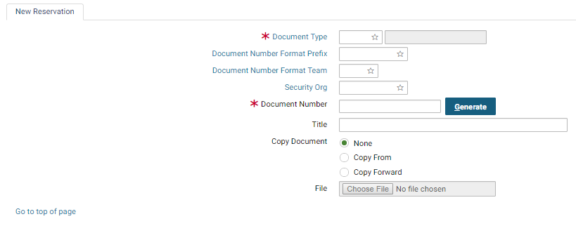

1. In the Document Type field, enter RS - Reservation.

A unique document number will be generated in the **Document Number** field after selecting the **Generate** button.

1. In the **Security Org.** field, enter the appropriate Security Organization.

If left blank the **Security Org** field will default to the user’s default Security Organization (please refer to **Section 3.5**).

1. Select the **Finish** button.

The **Header** page of the Reservation form will be displayed.

Figure 71: Header RS Document page

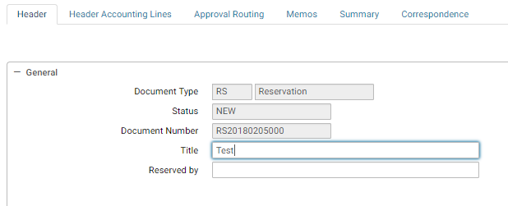

1. In the **Reserved By** field, enter the name of the person making the reservation.

**Reservation Date**, **Accounting Period**, and **Reporting Accounting Period** will default to the current date, when the form is verified or processed.

1. In the **Vendor Information** group box, enter the vendor’s Taxpayer Identification Number (TIN) and address code into the **Code** fields (if applicable).
2. Select the **Header Accounting Lines** tab.

The **Header Accounting Lines** page will be displayed.

1. To add a new line, select the **Add** button.

Figure 72: Header Accounting Lines page

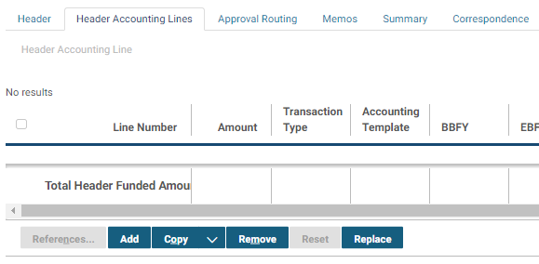

1. In the **Line Amounts** group box, enter the dollar amount of the accounting line in the Amount field.
2. In the **Accounting Dimensions** group box, enter or search for the **Template** field.

Complete any other required accounting elements that were not populated by the accounting template.

1. In the **Agreement** group box, enter associated RWA or IBAA Agreement number (PBS only).
2. In the **Description** field enter any descriptive information up to 255 characters long in the **Description** text box. The **Extended Description** field can be used if more than 255 characters are needed up to 60,000 characters.

**NOTE:** Depending on the room left on the form, the extended description field may not print in its entirety.

Information entered in this field will copy forward to the Request.

1. Return to the **Header Accounting Lines** page by selecting the **Header Accounting Lines** link.
   1. Additional accounting lines may be added by repeating Steps 7-12.
   2. To delete an existing line, select the line and select the **Remove** button.
   3. To change a line’s information, select the line, select the **Header Accounting Lines** link and make the necessary updates.
   4. To copy an existing line, select the line you wish to copy, select the **Copy** button and change the necessary information.
2. Go to the **Summary** tab to view a summary of the accounting lines. To update an existing line, select the line, select in the text box for the field you would like to update, and make the update.
   1. To add a new line, select the **Add** button and follow the instructions above on how to enter a header accounting line. To delete a line, select the line and select the **Remove** button. (Refer to **Section 2.3.3** for more information about the Summary tab.).
3. Select the **Verify** button.

If error messages are displayed, review the messages, and correct the form accordingly.

1. Select the **Submit** button.

The form becomes a document capable of affecting related plans within Pegasys.

### What is a Purchase Request in Pegasys?

A purchase request records the intent to buy goods, services, or training. It is usually the first step in the purchasing cycle (unless a reservation has been created). While the request is not legally binding, it commits funds for a future purchase. Therefore, a request will reduce available funds for plans and obligation-based budgets.

In Pegasys, there are Purchase Request forms that fill the function of GSA Form 49. However, the type of request form used depends on whether the intended purchase uses itemized lines (to record commodity information) or header accounting lines (where commodity information is not available). For requests with header accounting lines, a **Purchase Request (PR)** form is used. For itemized requests (those containing quantity and unit price information), an **IQ** form can be used. A request may contain multiple lines of funding. Also, both **PR** and **IQ** documents will print as the GSA Form 49.

Requests can be referenced to existing reservations and may be connected to subsequent Orders, Receipts, Invoices, and Payments. Information relevant to the request can be imported into Pegasys and affixed to the request as an external attachment.

Once complete the request must be approved. All purchase requests require a Manager’s approval, an Accounting Classification approval, and a Funds Authorization approval. (An approver may have the authority to apply one or more approval types.) To receive the necessary approvals, the request is routed, within Pegasys, to the appropriate approval levels. Follow the steps in **Purchasing User Guide 3 of 5, Section 10.1**for detailed information on approving a form.

Please refer to the following for additional information related to completing a purchase request in Pegasys:

* **Section 3.4: What Are the Pegasys Purchasing Forms?** for a complete discussion of Purchasing subsystem forms.
* **Section 13: Appendix A: Field Descriptions,** which is located in Document 3 and Document 4 of the Purchasing User Guidefor screen prints and detailed field descriptions.
* **Section 14: Appendix B: Form Mappings,** which is located in Document 4 of the Purchasing User Guidefor detailed information on transitioning GSA forms to their Pegasys counterparts.

**NOTE:** A request is an optional step in the purchasing chain and the purchasing process can begin with an order.

#### How Do I Complete a Purchase Request in Pegasys?

The following steps outline how to complete a Purchase Request form within Pegasys.

1. Select **Transactions** - **Purchasing** - **New** - **Request** from the Pegasys menu bar.

The **New Request** page will be displayed.

Figure 73: New Request page

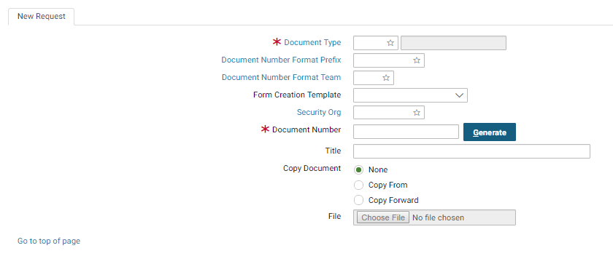

1. In the **Document Type field**, enter **PR - Purchase Request**.

A unique document number will be generated in the **Document Number** field after selecting the **Generate** button.

1. In the **Security Org**. field, enter the appropriate Security Organization.

If left blank the Security Org will default to the user’s default Security Org (please refer to **Section 3.5**).

1. Select the **Finish** button.

The **Header** page of the Purchase Request form will be displayed.

Figure 74: Header PR Document page

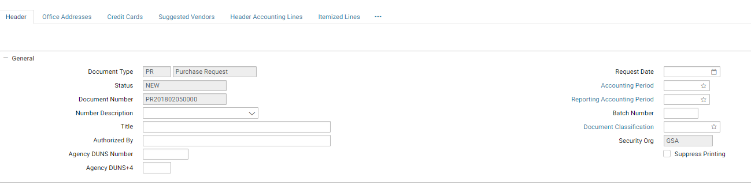

1. In the **Authorized By** field, enter the name of the person requesting the purchase of goods or services.

**Request Date**, **Accounting Period**, and **Reporting Accounting Period** will default to the current date, when the form is verified or processed.

1. In the **Vendor Information** group box, enter the vendor’s Taxpayer Identification Number (TIN) and address code into the **Code** fields (if applicable).

A vendor is not required at the request phase. Therefore, these fields are optional. If several vendors can be considered for the procurement, proceed to Step 20 **Suggested Vendors**.

1. Use the **Contracts** group box, to specify the information from a contract or delivery order (if applicable).

Blanket Purchase Agreement information can be entered on the purchase request along with the FSS schedule number in the **Blanket Agreement #** field. The appropriate procurement action type may also be selected. Information on the request can update a blanket purchase agreement by selecting the **Update Blanket Agreement** option.

1. In the **Description** field enter descriptive information about the requested purchase. The **Extended Description** field can be used if more than 255 characters are needed up to 60,000 characters.

**NOTE:** Depending on the room left on the form, the extended description field may not print in its entirety.

1. Select the **Office Addresses** tab.

The **Office Addresses** page of the request will be displayed.

1. Select the appropriate **Office Type** and select the **Office Address** link to enter Requesting, Issuing, or COTR office (procurement office) address information.
2. Enter or search for an Address Code and select the **Get Address button**. Select the **Office Address** hyperlink to return to the main **Office Addresses** tab. Select the **Clear Address** button to clear address information.
3. Select the **Suggested Vendors** link.

The **Suggested Vendors** page will display.

* 1. Add a new line by selecting the **Add** button.
  2. Once a line has been created, the line may be modified by selecting the line on the **Suggested Vendors** page, selecting the **Suggested Vendors** link and making the appropriate changes.
  3. A line can be copied by selecting the line, selecting the **Copy** button and making any appropriate changes.
  4. A line may be deleted by selecting the line and selecting the **Remove** button.

1. Select the **Header Accounting Lines** tab.

The **Header Accounting Lines** page will be displayed.

* 1. Add a new line by selecting the **Add** button.
  2. Once a line has been created, the line may be modified by selecting the line on the **Header Accounting Lines** page, selecting the **Header Accounting Line** link and making the appropriate changes.
  3. A line can be copied by selecting the line, selecting the **Copy** button and making any appropriate changes.
  4. A line may be deleted by selecting the line and selecting the **Remove** button.

Figure 75: Header Accounting Lines page Continued



1. In the **Period of Performance** group box, enter the **Start Date** and **End Date** (if applicable).
2. In the **Line Amounts** group box, enter the dollar amount for the accounting line in the **Requested** field.
3. In the **Accounting Dimensions** group box, enter or search for an accounting template for the accounting line in the **Template** field,

Complete any other required accounting elements that were not populated by the accounting template.

1. In the **Agreement** group box, use the **Agreement** field to enter a Work Authorization number or IBAA number (PBS only).
2. In the **Contract Line Info** group box, enter any info associated with an existing contract.

Specify the contract line item number or sub-contract line item number referenced by the request.

1. Use the **Description** field to enter descriptive information specific to this accounting line. If the description is more than 255 characters, the extended description field can be used.

Information entered in this field will print on the processed purchase request and also copy forward to the subsequent purchase order(s).

**NOTE:** Depending on the room left on the form, the extended description field may not print in its entirety.

1. Select the **Header Accounting Lines** link to return to the **Header Accounting Lines** page. Additional accounting lines may be added by repeating **Steps 13-19.**
2. Go to the **Approval Routing** tab. The **Approval Routing** page will display. Since the form’s creator has not yet added approvers, none will be listed.
3. To add approvers one by one to the form, select the **Add User** button. The **User Search** page will be displayed.
   1. Enter the **User ID** or **Name** of the form’s approver in the appropriate search fields, and select the **Search** button.
   2. Highlight the **Principal ID** record for the approver of the form. Then select the **Select** button.
   3. The selected user will be added to the approvers list on the **Approval Routing** tab.
4. To add to the form multiple approvers that are stored in a routing list, select the **Add Routing List** button. The **Routing List Search** page will display.
   1. Enter the **Routing List Code** or **Routing List Name** in the appropriate search fields, and select the **Search** button.
   2. Highlight the appropriate **Routing List** record and select the **Select** button.
   3. The users saved in the routing list will be added to the approvers list on the **Approval Routing** tab.
5. Go to the **Summary** tab to view a summary of the accounting lines. To update an existing line, select the line, put your cursor in the text box for the field you would like to update, and make the update.
   1. To add a new line, select the **Add** button and follow the instructions above on how to enter a header accounting line. To delete a line, select the line and select the **Remove** button. (Refer to **Section 2.3.3** for more information about the Summary tab.).
6. Select the **Verify** button.

If error messages are displayed, review the messages, and correct the form accordingly.

1. Select the **Submit** button.

The form becomes a document capable of affecting related plans and budgets within Pegasys.

#### How Can I Complete a Request with Itemized Lines in Pegasys?

The following steps outline how to complete an Itemized Request.

1. Select **Transactions** - **Purchasing** - **New** - **Request** from the Pegasys menu bar.

The **New Request** page will be displayed.

Figure 76: New Request page Continued



1. In the **Document Type** field, enter **IQ - Request**.

A unique document number will be generated in the **Document Number** field after selecting the **Generate** button.

1. In the **Security Org**. field, enter the appropriate Security Organization.

If left blank the Security Org will default to the user’s default Security Org (please refer to **Section 3.5**).

1. Select the **Finish** button.

The **Header** page of the Itemized Request form will be displayed.

Figure 77: Itemized Request Header page

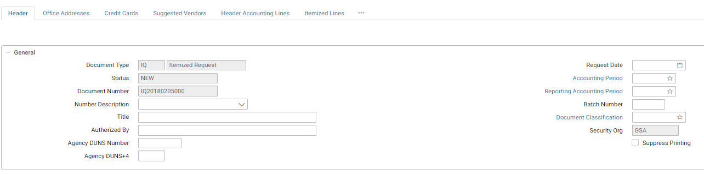

1. In the **Authorized By** field, enter the name of the person requesting the purchase of goods or services.

**Request Date**, **Accounting Period**, and **Reporting Accounting Period** will default to the current date, when the form is verified or processed.

1. In the **Vendor Information** group box, enter the vendor’s Taxpayer Identification Number (TIN) and address code into the **Code** fields (if applicable).
2. Use the **Contracts** group box to specify the information from a contract or delivery order (if applicable).

Blanket Purchase Agreement information can be entered on the purchase request along with the FSS schedule number in the **Blanket Agreement #** field. The appropriate procurement action type may also be selected. Information on the request can update a blanket purchase agreement by checking the **Update Blanket Agreement** checkbox.

1. In the **Shipping Information** group box, record delivery information applicable to the entire itemized request.

Shipping information can be entered on a line-by-line basis on the **Itemized Line** pages.

1. Use the **Header/Footer** group box to add information to the header or footer on the form.

Figure 78: Header / Footer Information

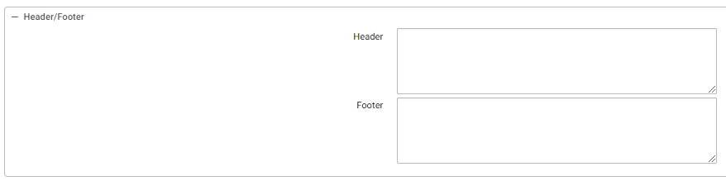

1. In the **Description** field enter descriptive information about the requested purchase. The **Extended Description** field can be used if more than 255 characters are needed up to 60,000 characters.

**NOTE:** Depending on the room left on the form, the extended description field may not print in its entirety.

1. Select the **Office Addresses** tab.

The **Office Addresses** page will be displayed.

Figure 79: Office Addresses page

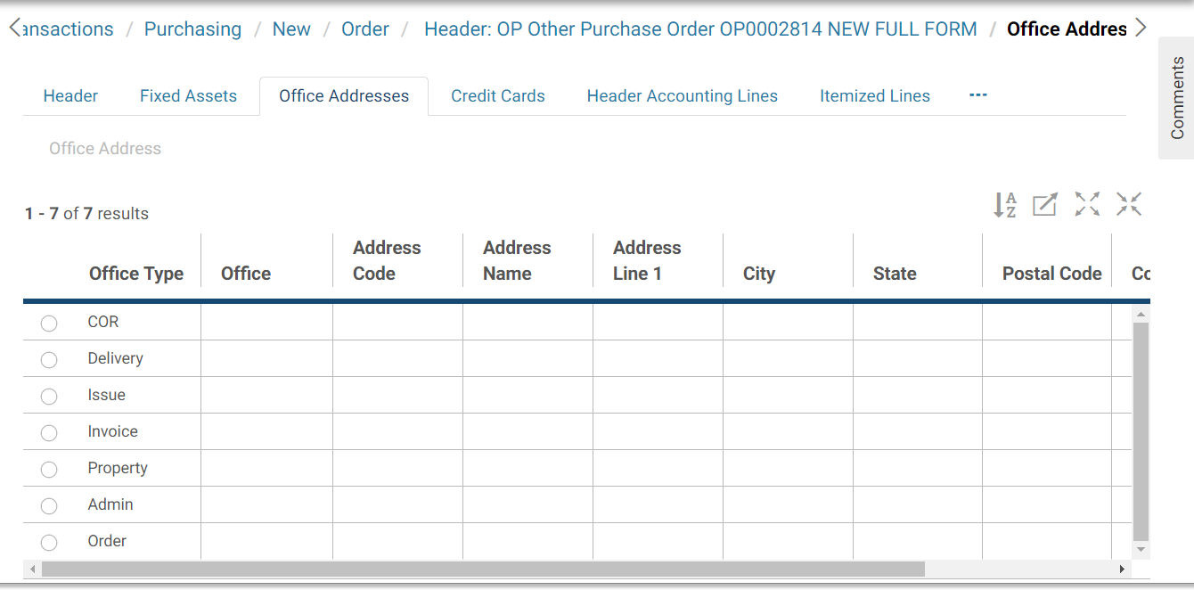

1. Select the appropriate **Office Type** and select the **Office Address** link to enter the Requesting, Delivery, Issuing office (procurement office), Invoice To, Property, and COTR address information.
   1. Enter or search for an address code and select the **Get Address** button. Select the **Clear Address** button to clear the address information.
2. Select the **Suggested Vendors** tab.

The **Suggested Vendors** page will display.

* 1. Add a new line by selecting the **Add** button.
  2. Once a line has been created, the line may be modified by selecting the line on the **Suggested Vendors** page, selecting the **Suggested Vendors** link and making the appropriate changes.
  3. A line can be copied by selecting the line, selecting the **Copy** button and making any appropriate changes.
  4. A line may be deleted by selecting the line and selecting the **Remove** button.

1. Select the **Itemized Lines** tab.

The **Itemized Lines** page will be displayed.

Figure 80: Itemized Lines page

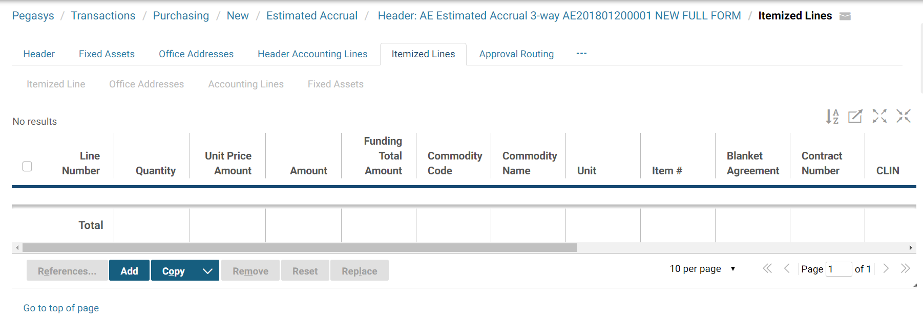

1. Add a new line by selecting the **Add** button.
   1. Once a line has been created, the line may be modified by selecting the line on the **Itemized Lines** page, selecting the **Itemized Line** link and making the appropriate changes.
   2. A line can be copied by selecting the line, selecting the **Copy** button and making any appropriate changes.
   3. A line may be deleted by selecting the line and selecting the **Remove** button.
2. In the **General** group box, enter the appropriate **Commodity Code.**

The **Commodity Name** and **Unit** will default based on the **Commodity Code** entered.

1. In the **Line Amounts** group box, enter the **Quantity** and **Unit Price**.
2. In the **Supplemental Info** group box, enter additional descriptive information about the line item.

Figure 81: Supplemental Information

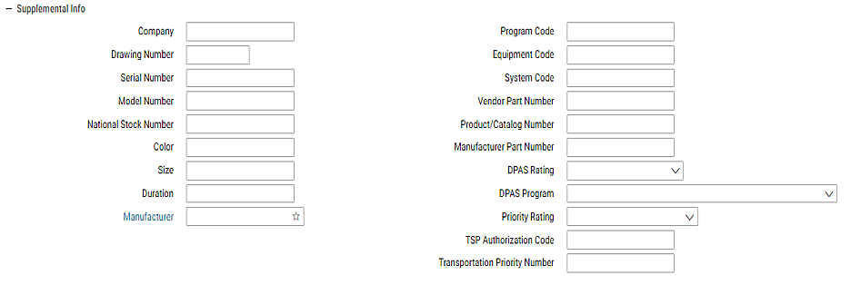

This information will not print on any form. If this information is needed on a printed form, enter the information in the **Description** field on the **Header** page.

1. Use the **Pricing Options** group box to enter contract related line options, such as specifying the line as a base or option period line, a base or option quantity line, and the contract type for the line.

Figure 83: Pricing Options

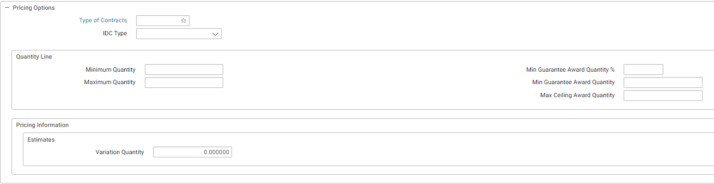

1. Select the **Deliveries Instances** tab. The Delivery Instances page will display.
2. Select the **Add** button.

The **Delivery Instance** page will display.

Enter the appropriate information on this page.

1. Select the **Intermediate Deliveries** tab. Selecting the **Add** button will allow users to enter a Delivery name and number. To copy or remove an **Intermediate Delivery** select the **Intermediate Delivery** link, select a **Delivery Name,** and select the **Remove** or **Copy** button as appropriate.
2. Select the **Itemized Line** link to return to the **Itemized Lines** page. Select the appropriate line and select to the **Itemized Line** link to access the appropriate line.
3. Use the **Contract Line** fields if the request is to be associated with an existing contract.

Specify the contract line item number or sub-contract line item number referenced by the request.

1. In the **Description** field enter a detailed line item description up to 255 characters long. The **Extended Description** field can be used if more than 255 characters are needed up to 60,000 characters.

**NOTE:** Depending on the room left on the form, the extended description field may not print in its entirety.

1. Select the **Accounting Lines** tab to add funding information for the itemized line.

To create a new Accounting Line, select the **Add** button.

The **Accounting Line** page will be displayed.

Figure 84: Accounting Line page

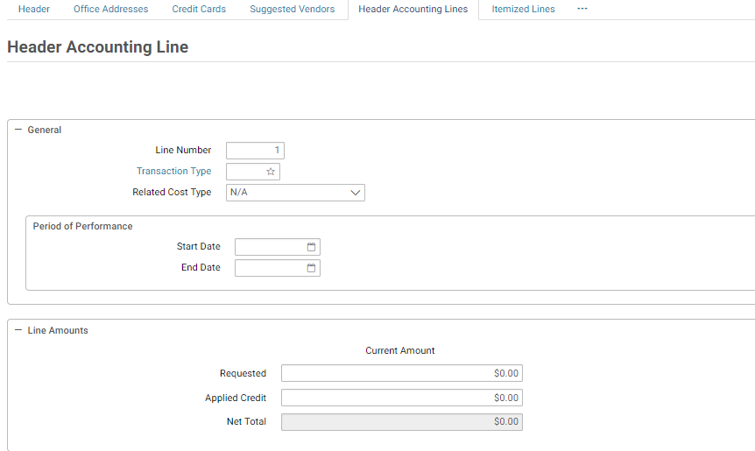

The **Transaction Type** will default when the itemized purchase request form is Verified or Processed.

1. In the **Line Amount** group box, enter the dollar amount of the accounting line in the **Total Amount** field.

The line amount is the total dollar amount that will be charged to this accounting strip. For each itemized line, the sum of the line amounts on the associated accounting lines must equal the itemized line amount.

1. In the **Accounting Dimensions** group box, enter or search for an accounting template for the accounting line in the **Template** field

Complete any other required accounting elements that were not populated by the accounting template.

1. In the **Agreement** field enter a Work Authorization number or IBAA number (PBS only).
2. In the **Description** field enter descriptive information specific to this accounting line. If the description is more than 255 characters, the extended description field can be used.
3. To return to the **Accounting Lines** tab, select the **Accounting Lines** link.

The accounting line will be displayed in the table on the **Accounting Lines** page.

* 1. To delete an existing line, select the line by highlighting its tab and select the **Remove** button.
  2. To change a line’s information, select the line, select the Accounting Line link and make the necessary updates.
  3. To copy an existing line, select the line you wish to copy, select the **Copy** button and change the necessary information.

1. Additional accounting lines may be added by repeating **Steps 26-31**.
2. Select the **Itemized lines** tab to view the summary lines.
   1. One line summary represents one itemized line.
   2. An itemized line can be associated with multiple lines of funding.
   3. If the itemized line total amount and the accounting line total amount are different, you will receive an error message when verifying or processing the request.
   4. Additional line items may be added by selecting the add button and repeating **Steps 15-33**.
3. Go to the **Summary** tab to view a summary of the accounting lines. To update an existing line, select the line, select in the text box for the field you would like to update, and make the update.
   1. To add a new line, select the **Add** button and follow the instructions above on how to enter an itemized line. To delete a line, select the line and select the **Remove** button. (Refer to **Section 2.3.3** for more information about the Summary tab.).
4. Go to the **Approval Routing** tab. The **Approval Routing** page will display. Since the form’s creator has not yet added approvers, none will be listed.
5. To add approvers one by one to the form, select the **Add User** button. The **User Search** page will be displayed.
   1. Enter the **User ID** or **Name** of the form’s approver in the appropriate search fields, and select the **Search** button.
   2. Highlight the **Principal ID** record for the approver of the form. Then select the **Select** button.
   3. The selected user will be added to the approvers list on the **Approval Routing** tab.
6. To add to the form multiple approvers that are stored in a routing list, select the **Add Routing List** button. The **Routing List Search** page will display.
   1. Enter the **Routing List Code** or **Routing List Name** in the appropriate search fields, and select the **Search** button.
   2. Highlight the appropriate **Routing List** record and select the **Select** button.
   3. The users saved in the routing list will be added to the approvers list on the **Approval Routing** tab.
7. Select the **Verify** button.

If error messages are displayed, review the messages, and correct the form accordingly.

1. Select the **Submit** button.

The form becomes a document capable of affecting related plans and budgets within Pegasys.

### What Are Training Requests in Pegasys?

The **Training Request (TR)** form is used to commit funds for employee training. It is typically the first step in the training purchasing cycle (unless a reservation has been created) and can be used to facilitate the Standard and Prepaid Training purchasing model. (The **TR** creates a GSA Form 3076.) Because a request is a commitment of funds, it will reduce available funds for plans and obligation-based budgets.

The training request form looks and functions just like other Pegasys request forms. The **TR** has a **Header** page and **Header Accounting Lines** page, and a **Summary** page. Because the training request is recording the intent to purchase employee training, it also has a **Course Information** page. In addition to the required funding information, this page enables employee and training course information to be captured.

Training requests can contain multiple lines of funding, can be referenced to existing reservations and may be connected to future orders, receipts, invoices, and payments. Information relevant to the training request can be imported into Pegasys and affixed to the request as an external attachment.

Once complete the training request must be approved. Training requests require four approvals: a Manager’s approval, an Accounting Classification approval, a Funds Authorization approval, and the approval of a Training Coordinator. To receive the necessary approvals, the request is routed, within Pegasys, to the appropriate approval levels. Follow the steps in **Purchasing User Guide 2 of 5, Section 10.1** for detailed information on approving a form.

Please refer to the following for additional information related to completing a Training request in Pegasys:

* **Section 3.4: What Are the Pegasys Purchasing Forms?** for a complete discussion of Purchasing subsystem forms/
* **Section 13: Appendix A: Field Descriptions**, which is located in Document 3 and Document 4 of the Purchasing User Guide for screen prints and accompanying field descriptions.
* **Section 14: Appendix B: Form Mappings,** which is located in Document 5 of the Purchasing User Guidefor detailed information on converting a 3076 to a training request form.

#### How Do I Complete a Training Request in Pegasys?

The following steps outline how to complete a **Training Request** in Pegasys.

1. Select **Transactions** - **Purchasing** - **New** - **Training** **Request** from the Pegasys menu bar.

The **New Training Request** page will be displayed.

Figure 85: New Training Request page

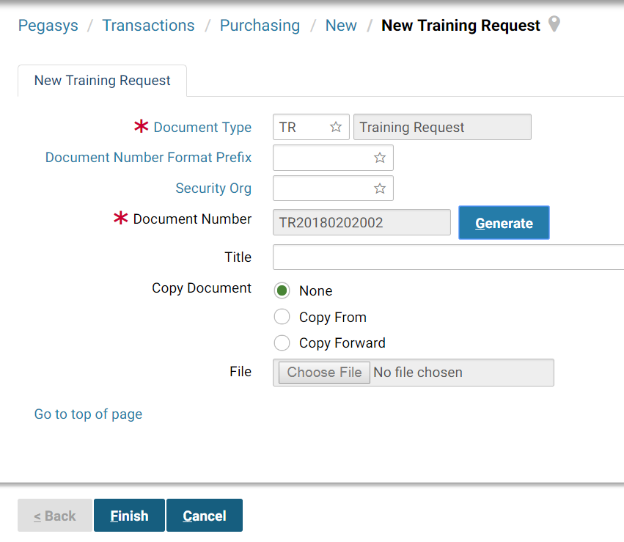

1. In the Document Type field, enter TR - Training Request.

A unique document number will be generated in the **Document Number** field after selecting the **Generate** button.

1. In the **Security Org**. field, enter the appropriate Security Organization.

If left blank the Security Org will default to the user’s default Security Org (please refer to **Section 3.5**).

1. Select the **Finish** button.

The **Header** page of the Training Request form will be displayed.

Figure 86: Training Request Header page

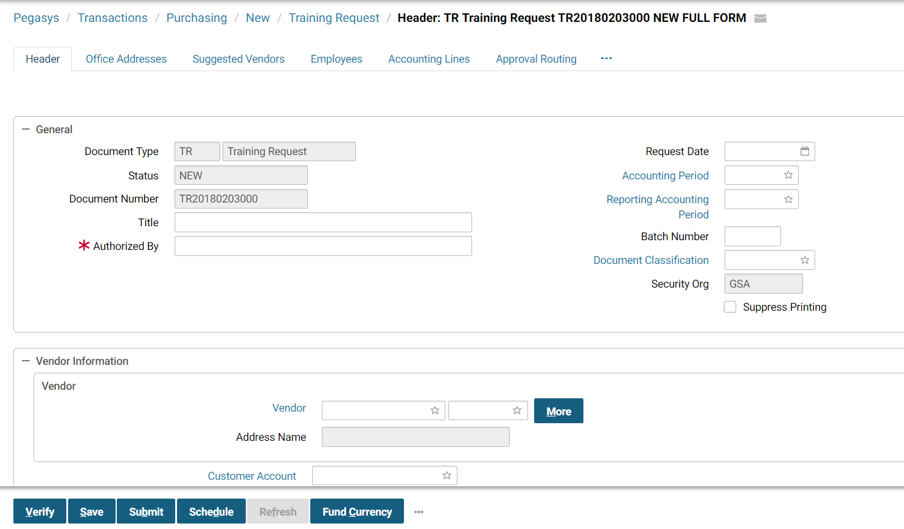

1. In the **Authorized By** field, enter the name of the person requesting the purchase of goods or services.

**Request Date**, **Accounting Period**, and **Reporting Accounting Period** will default to current, when the form is verified or processed.

1. In the **Vendor Information** group box, enter the vendor’s Taxpayer Identification Number (TIN) and address code into the **Code** fields (if applicable).
2. In the **Contract** group box specify the information from a contract or delivery order (if applicable).

Figure 87: Training Request Contracts section

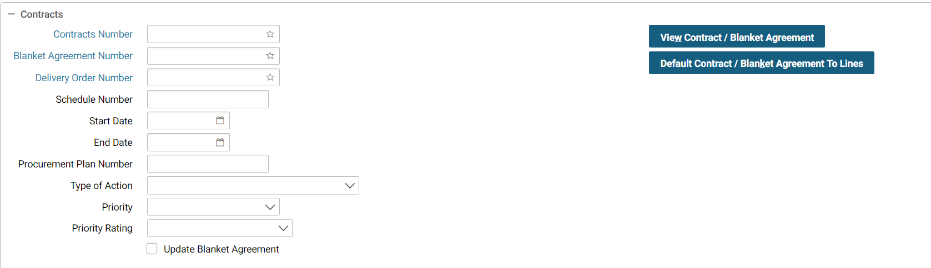

Blanket purchase agreement information can be entered on the request, along with an FSS schedule number (in the **Blanket Agreement #** field). The appropriate procurement action type may also be selected on the request. The information on the request can update a blanket purchase agreement by checking the **Update Blanket Agreement** checkbox.

1. In the **Description** group box enter descriptive information about the requested purchase. If the description is more than 255 characters, the extended description field can be used.

Figure 88: Training Request Description section

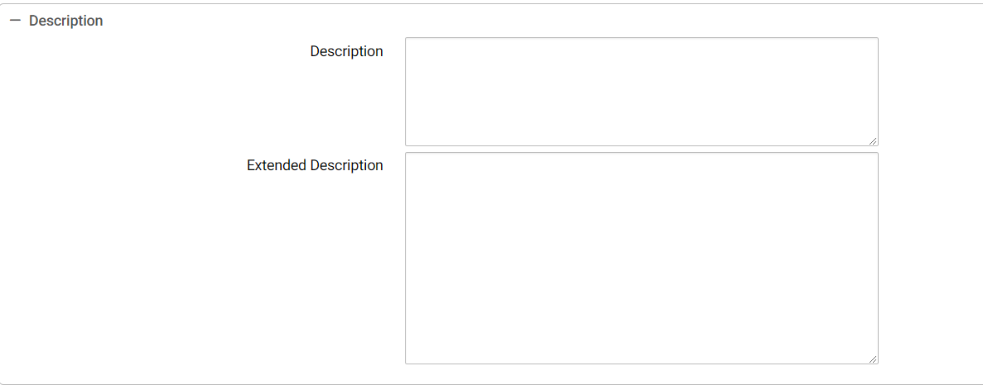

Select the **Office Addresses** tab. The **Office Addresses** page will be displayed.

Figure 89: Training Request Office Addresses page

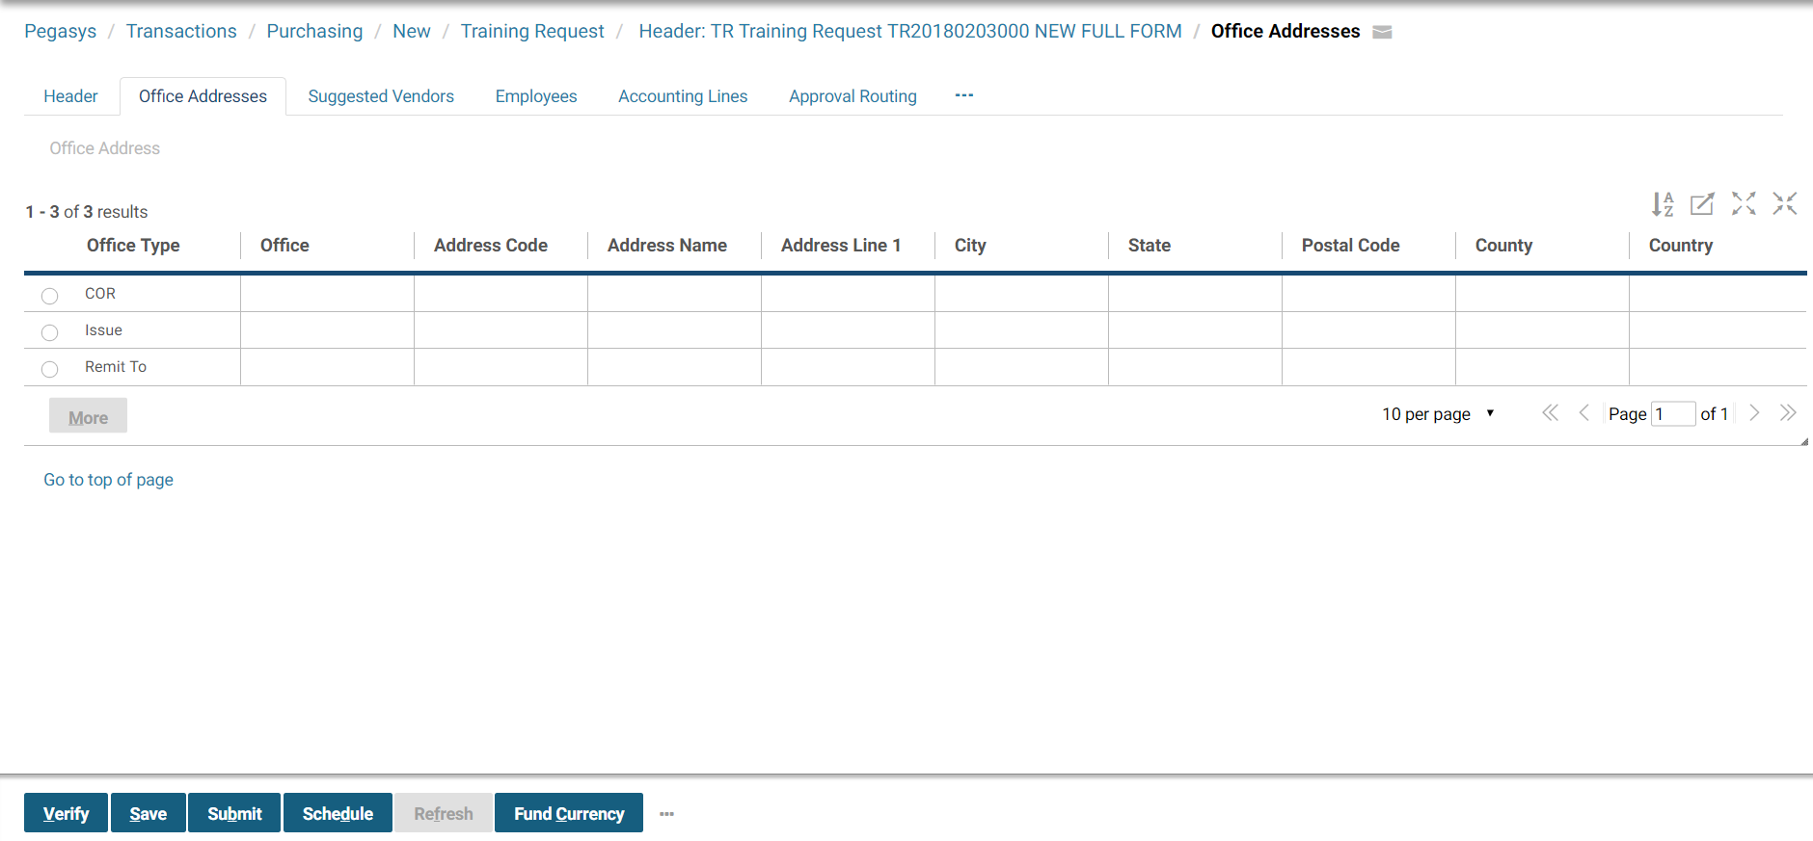

1. Select the appropriate **Office Type** to enter the Requesting, Issuing, and COTR (procurement office) address information.
2. Enter or search for an Address code and select the **Get Address** button. Select the **Clear Address** button to clear the address information.
3. Select the Suggested Vendors tab.
   1. The **Suggested Vendors** page will display.
   2. Add a new line by selecting the **Add** button.
   3. Once a line has been created, the line may be modified by selecting the line on the **Suggested Vendors** page, selecting the **Suggested Vendors** link, and making the appropriate changes.
   4. A line can be copied by selecting the line, selecting the **Copy** button and making any appropriate changes.
   5. A line may be deleted by selecting the line and selecting the **Remove** button.
4. Select the **Employees** link to enter the names of employees who will attend the training class. The **Employee Selection** page will be displayed.
5. Use the Add button to add employee information.
6. After selecting the Add button enter the appropriate information in the Search criteria group box, Select Search and select the appropriate employee from the generated list.

Figure 90: Training Request Employees page

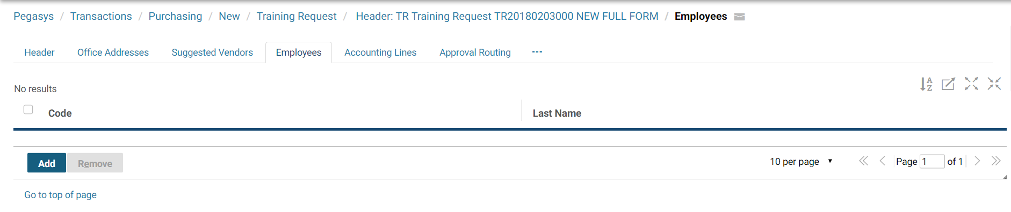

1. Select an employee from the **Employees** search page and select the **Select** button to move that individual to the **Employees** list.
2. Select the Accounting Lines tab. The **Accounting Lines** page will be displayed.
   1. To add a new line, select the Add button. The **Accounting Line** page will display.

Figure 91: Training Request Accounting Lines page

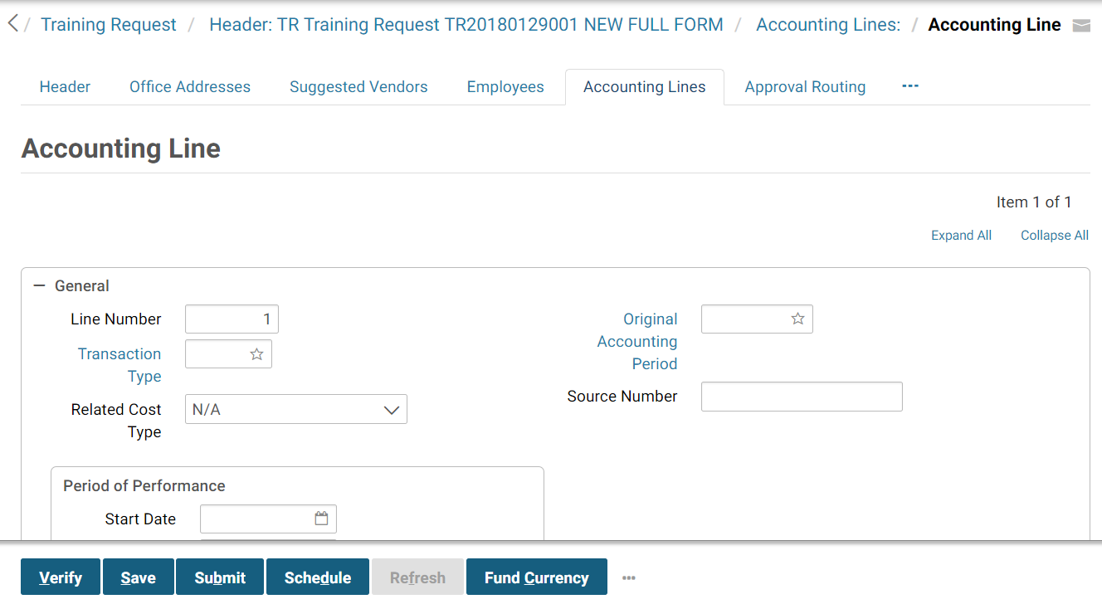

1. In the **Period of Performance** group box, enter the **Start Date** and **End Date** (if applicable).
2. In the **Line Amounts** group box, enter the dollar amount for the accounting line in the **Requested** field.
3. In the **Accounting Dimensions** group box, enter or search for a **Template** for the accounting line.
   1. Complete any other required accounting elements that were not populated by the accounting template.
4. In the **Agreement** field enter referenced RWA or IBAA Agreement information (PBS only).
5. Use the **Contract Line Info** group box if the request is to be associated with an existing contract.
   1. Specify the contract line item number or sub-contract line item number referenced by the request.
6. In the **Description** field enter descriptive information specific to this accounting line. If the description is more than 255 characters, the extended description field can be used.
7. Select the **Accounting Lines** link to return to the **Accounting Lines** page.
   1. Additional accounting lines may be added by repeating **Steps 14-22**.
   2. To delete an existing line, select the line and select the **Remove** button.
   3. To change a line’s information, select the line, select the Accounting Line link and make the necessary updates.
   4. To copy an existing line, select the line you wish to copy, select the **Copy** button and change the necessary information.
8. Go to the **Approval Routing** tab. The **Approval Routing** page will display. Since the form’s creator has not yet added approvers, none will be listed.
   1. To add approvers one by one to the form, select the **Add User** button. The **User Search** page will be displayed.
   2. Enter the **User ID** or **Name** of the form’s approver in the appropriate search fields, and select the **Search** button.
   3. Highlight the **Principal ID** record for the approver of the form. Then select the **Select** button.
   4. The selected user will be added to the approvers list on the **Approval Routing** tab.
   5. To add to the form multiple approvers that are stored in a routing list, select the **Add Routing List** button. The **Routing List Search** page will display.
9. Enter the **Routing List Code** or **Routing List Name** in the appropriate search fields, and select the **Search** button.
   1. Highlight the appropriate **Routing List** record and select the **Select** button.
   2. The users saved in the routing list will be added to the approvers list on the **Approval Routing** tab.
10. Select the **Course Information** tab.

The **Course Information** page will be displayed.

Figure 92: Training Request Course Information page

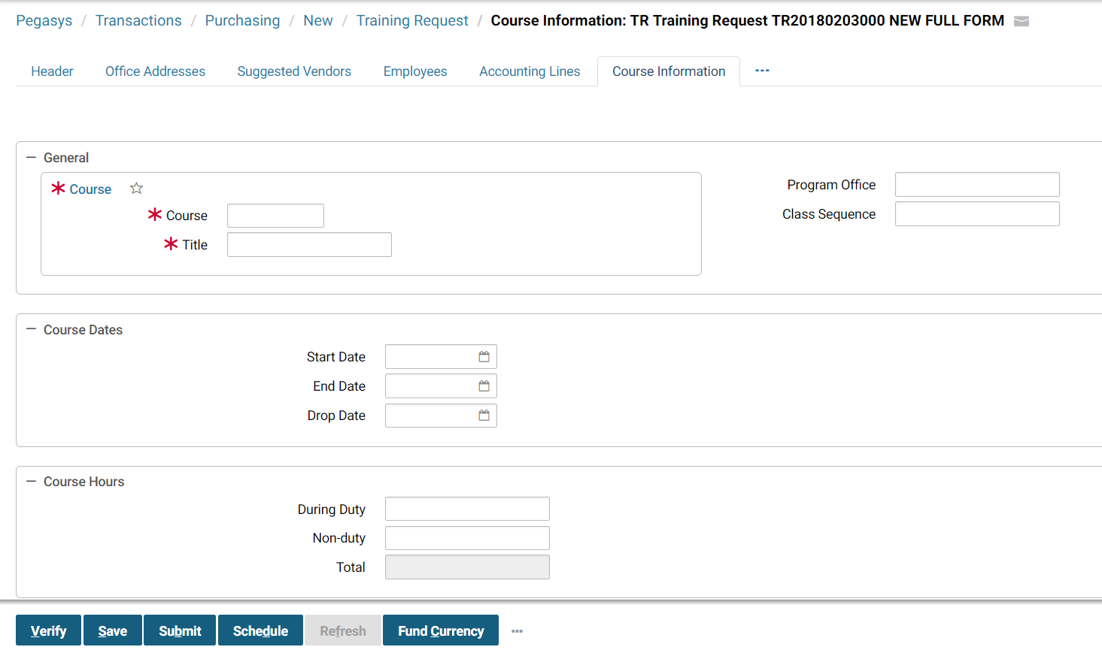

1. In the **General** group box, enter or search for the **Course** and **Title.**
2. Enter the **Program Office** and **Class Sequence**.
3. In the **Course Dates** group box, enter or select on the link to choose a **Start Date, End Date, and Drop Date** (if one exists).
4. In the **Course Hours** group box, enter the number of both **During Duty** and **Non-Duty** course hours.

The **Total** field is system maintained and represents the total of duty and non-duty hours entered by the user.

1. In the **Training Address** group box, enter the training address or select the **Address Same As Vendor** checkbox.
2. In the Objectives and Benefits group box, enter a description for the **Objective and Benefits.**
3. Go to the **Summary** tab to view a summary of the accounting lines. To update an existing line, select the line, select in the text box for the field you would like to update, and make the update.
   1. To add a new line, select the **Add** button and follow the instructions above on how to enter an accounting line. To delete a line, select the line and select the **Remove** button. (Refer to **Section 2.3.3** for more information about the Summary tab.).
4. Select the **Verify** button.

If error messages are displayed, review the messages, and correct the form accordingly.

1. Select the **Submit** button.

The form becomes a document capable of affecting related plans and budgets within Pegasys.