United States Department of Agriculture
Document Level Reorganization Pegasys 7.5.1
User Guide
Contract: # HHSN316201200011W
Order # AG-3144-D-16-0278
Version 03.00
May 2018

Table of Contents
United States Department of Agriculture Document Level Reorganization Pegasys 7.5.1 User Guide 1
Table of Contents 1
Table of Figures 3
Table of Tables 4
Revision Log 5
1 Introduction 6
2 Document Level Reorganization 7
2.1 How Do I Create A Document Level Reorganization? 7
2.2 How Do I Review The Status Of A Reorganization Notebook? 10
2.3 How Do I Review A Document That Has Been Reorganized? 12
2.3.1 How Do I Review A Document Through The Purchasing Subsystem? 12
2.3.2 How Do I Review A Payment Document Through The Accounts Payable Subsystem? 13
3 Reports 15
3.1 Reorganization Reports 15
3.1.1 What Types Of Reorganization Reports Are Available In Pegasys? 15
3.1.2 How Do I Generate And Print Reorganization Reports From The Reports Menu? 15
3.1.3 What Type Of Information Do Each Of The Reports Provide Me? 16
4 Document Level Reorganization Batch Jobs 18
4.1 What Are The Batch Jobs For The Document Level Reorganization? 18
4.2 What is the Setup for the Document Level Reorganization Batch Jobs? 18
4.3 What Are The Common Reorganization Errors? 21
A Appendix A - Document Level Reorganization Field Definitions 23
A.1 General Page 23
A.1.1 Batch Errors Button 27
A.2 Reorganization Lines Page 27
A.2.1 Agreement Group Box 29
A.2.2 Spending Adjustment Recovery Options 30
A.2.3 Debt Account 31
A.2.4 Contract 32
A.2.5 From Accounting Group Box 33
A.2.6 To Accounting Group Box 36

Table of Figures
Figure 1: Document Level Reorganization Notebook - Search Page 8
Figure 2: Document Level Reorganization Notebook - Lines Page 9
Figure 3: Document Level Reorganization Notebook - Search Page 10
Figure 4: Document Level Reorganization Notebook - Lines Page 12
Figure 5: Purchasing Subsystem Document Review page 12
Figure 6: Accounts Payable Subsystem Document Review page 13
Figure 7: Document Level Reorganization Notebook Header Accounting Line Reorganization Information Page 14
Figure 8: View Reports Page 16
Figure 9: General Page 23
Figure 10: Batch Errors Group Box 27
Figure 11: Reorganization Lines Page 27
Figure 12: Agreement Number Dialog Box 29
Figure 13: Spending Adjustment Recovery Options Group Box 30
Figure 14: Debt Account Group Box 31
Figure 15: Contract Group Box 32
Figure 16: From Accounting Strip 33
Figure 17: To Accounting Strip 36

Table of Tables
Table 1: Reorganization Reports 15
Table 2: Document Level Reorganization Batch Jobs 18
Table 3: Document Level Reorganization Batch Job Setup - General 18
Table 4: Document Level Reorganization Batch Job Setup - Parameters 19
Table 5: Document Level Reorganization Batch Job Parameter Descriptions 19
Table 6: Document Level Reorganization Recoveries Batch Job Setup - General 21
Table 7: Document Level Reorganization Recoveries Batch Job Setup - Parameters 21
Table 8: Common Reorganization Errors 22
Table 9: General Page Field and Button Descriptions 23
Table 10: General Page Field and Button Descriptions - Processing Rules (Group Box) 25
Table 11: General Page Field and Button Descriptions – Properties (Group Box) 26
Table 12: Reorganization Lines Page Field and Button Descriptions 28
Table 13: Reorganization Lines Page Field and Button Descriptions – Reference Document (Group Box) 28
Table 14: Agreement Number Dialog Box Field Descriptions – From Agreement (Group Box) 30
Table 15: Agreement Number Dialog Box Field Descriptions – To Agreement (Group Box) 30
Table 16: Spending Adjustments/Recovery Options Group Box Field Descriptions 31
Table 17: From Debt Account Group Box Field Descriptions 32
Table 18: To Debt Account Group Box Field Descriptions 32
Table 19: Contract Group Box Field Descriptions 33
Table 20: From Accounting Strip Field Descriptions 34
Table 21: To Accounting Strip Field Descriptions 36

Revision Log
Date | Version | Description | Author | Reviewer | Review Date
2/2011 | Draft/ Version .1 | Original Draft | Danielle Becker | Jenna Stegmann | 1/20/2011
4/2011 | Final Version 1.0 | Final - No comments on Draft |  | Jennifer Ritchey | 4/14/2011
1/2018 | Final Version 2.0 | Revision 1.0 - Updated to reflect the following changes for Pegasys 7.5.1 Upgrade:  - Applied 508 standards and performed testing.  - Updated screen shots and provided Alternate Text. | Veronica Braxton | Richard Bowman, Marice Grissom, Jenny Lewis | 9/2017  10/2017
5/2018 | Final Version 3.0 | Final Version 3.0 - Applied the following changes:  - Section 1: Updated Pegasys website link.  - Section 2: Updated (GSA) Finance Centers to USDA Pegasys Financial Services.  - Separated tables (by subheadings) to comply with 508 guidelines:  - #9 became tables 9, 10, and 11  - #10 became tables 12 and 13  - #11 became tables 14 and 15  - #13 became tables 17 and 18 | Marice Grissom | Jenny Lewis | 5/2018

Introduction
Document Level Reorganization in Pegasys will allow users to change document level accounting information throughout an entire spending chain. This user guide provides step-by-step procedures for creating a document level reorganization, executing the reorganization reports and running the document level reorganization batch jobs.
There are several Pegasys resources available on the Pegasys website: https://pegasys.gsa.gov/index.htm. Resources include the Purchasing User’s Guide, the Finance User Guide, and the Automated Disbursements User Guide.

Document Level Reorganization
Document Level Reorganization will allow GSA to move a particular chain in the system from one accounting dimension to another by performing the following:
- Journal Entries
- Budget Updates
- Entity (Plan/Agreement) Updates
- Accounting Line Updates
- Other table (e.g., Credit Card) Updates
Document Level Reorganization will NOT create new budgets, modify reference data, or modify held or rejected forms.
Pegasys will allow the user to specify the reorganization record code, name, justification and the date when the reorganization record is to be processed. The user will be able to specify which open accounting period should be used by the Reorganization batch job for the back out and repost journal entries. The user will be able to enter multiple reorganization line records under a single reorganization code. This will allow GSA to perform multiple reorganization actions under a single main reorganization, so these actions can update the system together. For each line record, the Document Level Reorganization Notebook will require the user to enter an accounting line in the chain to be reorganized and the changes to be made to the accounting distribution or agreement information of that chain.
Requests for a document level reorganization are sent from the Regions to USDA Pegasys Financial Services (PFS) in Kansas City and Ft. Worth. The Regions will send an email to PFS requesting the document level reorganization.
The Document Level Reorganization Notebook will allow an approving official to search for and approve reorganization records. PFS will create the document level reorganizations. The person who is creating the document level reorganization notebook will also apply the approval. The only exception is if the person is new to the process, they must have their supervisor approve the document level reorganization. The notebook will save and display the user ID of the user who last modified the reorganization record and the date when the modification occurred as well as the user ID of the approving official and the date of the approval.

How Do I Create A Document Level Reorganization?
The following steps describe how to create a document level reorganization record in Pegasys.
- Select Reference - Document - Reorganization - Document Level Reorganization Notebooks. The Document Level Reorganization Notebooks page will be displayed.
Figure 1: Document Level Reorganization Notebook - Search Page
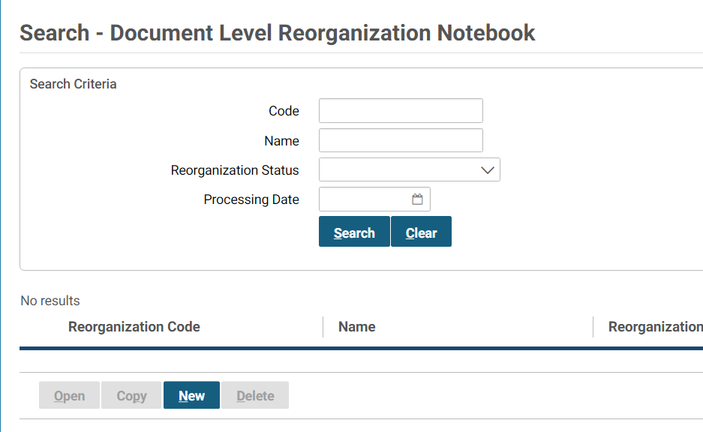
- Select the New button.
- In the General group box, enter the code for this reorganization in the Code field on the Document Level Reorganization Notebooks page.
NOTE: The Reorganization Code format is the first document number in the chain to be reorganized. If multiple reorganizations need to be made to this chain, a letter of the alphabet will be added after the document number beginning with A.
- Enter your User ID in the Name field.
- Enter the current date in the Processing Date field.
NOTE: If using another date other than the current date for the processing date, a justification must be noted in the Justification field.
- In the Accounting Period Options group box, allow the Use Current Accounting Period option in the Accounting Period Options box to default.
NOTE:
  - The accounting period must be open in order for the document level reorganization to process.
  - The Use Specified Accounting Period option in the Accounting Period Options group box can be selected but the accounting period entered must be open.
- In the Processing Rules group box, select the Reorganize Miscellaneous References check box.
NOTE:
  - This will allow any miscellaneous reference in the chain to be reorganized.
  - This option must be selected each time a new document level reorganization notebook is created.
- No Spending Control Options are to be selected for a document level reorganization.
- In the Justification group box, enter the current date, name of the person requesting the action and any other descriptive information for this document reorganization in the Justification field.
NOTE: Entering the current date is essential since the Processing Date does not appear in the Reorganization Information dialog box after selecting the Reorg Info button of a document that has been reorganized.
10. Select the reorganization Lines tab. The Lines page will be displayed.
Figure 2: Document Level Reorganization Notebook - Lines Page
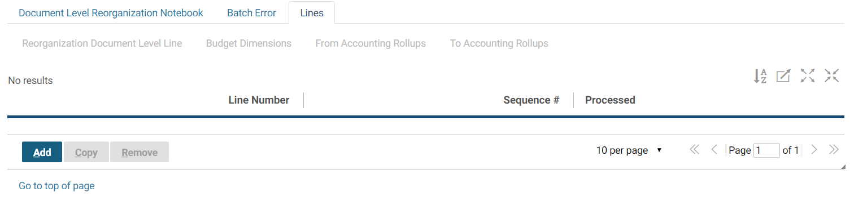
- Add a new line by selecting the Add button. The Reorganization Document Level line page will display.
- In the Referenced Document group box, enter the document type of the first document in the chain to be reorganized in the Type field.
- In the Document field, enter the document number of the first document in the chain to be reorganized.
- Enter the appropriate line number of the document to be reorganized.
NOTE: If this is a multi-line document and several lines need to be reorganized, a new line must be created in the document level notebook for each line in the document to be reorganized.
- Select the Default button.
NOTE: The From Accounting and To Accounting fields default with the accounting template information from the document accounting line that was selected.
- In the To Accounting strip group box, enter the dimension(s) to change for the document chain or a different accounting template for the chain.
NOTE: If multiple lines on an order are being reorganized and an invoice miscellaneously references the order, the last To Accounting line in the Document Level Reorganization Notebook must contain the accounting template that the miscellaneous reference is to be reorganized.
- In the Spending Adjustment/Recovery Options choose a value for the Spending Adjustment Option and Recovery Option for both From and To Adjustment/Recovery Options If more lines need to be reorganized for the document, repeat Steps 11- 17.
- Select the Save button.

How Do I Review The Status Of A Reorganization Notebook?
After a document level reorganization notebook has been created, an offline process will run every evening to process the reorganization. A user can go into the document level reorganization notebook to review the status of their reorganization.
The following steps describe how to review a document level reorganization record in Pegasys.
- Select Reference - Document - Reorganization - Document Level Reorganization Notebooks.
The Document Level Reorganization Notebook page will be displayed.
Figure 3: Document Level Reorganization Notebook - Search Page
- To locate a particular reorganization document, enter any of the following search criteria listed below and then select the Search button:
  - First document number in chain to be reorganized in the Code field.
  - Name in the Name field.
  - Select the Reorganization Status from the drop-down list box.
  - Enter the date of processing in the Processing Date field.
- Select the appropriate reorganization record and select the Open button.
The information page of the Document Level Reorganization Notebook will be displayed.
- If the record status is Processed or In Process, the Document Level Reorganization Notebook will be displayed in Review Status only; otherwise, the Notebook is editable.
- Review the Reorganization Status field.
NOTE:
  - Status of Processed indicates that the reorganization has been successfully completed.
  - Status of Awaiting Approval indicates that approval is needed for this reorganization notebook before it can be processed. NOTE: To delete the reorganization notebook in this status, select the Delete button and answer the prompt.
  - Status of Ready for Processing indicates that the approval has been applied to the reorganization notebook and will be picked up the next time the offline process is run. NOTE: To delete the reorganization notebook in this status, select the Delete button and answer the prompt.
  - Status of In Process indicates that the offline process is in the process of completing the reorganization and any additional system updates.
  - Status of Error indicates that during the offline process Pegasys could not pass the system edits while processing the reorganization notebook.
- If the reorganization document is in Error status, select the Batch Error tab to review the errors encountered during the offline process.
The Batch Errors page will be displayed.
- To review the last modification information for this document level reorganization, view the Properties group box.
- To review the accounting line reorganization information, select the reorganization Lines tab.
- Choose a line and select the Reorganization Document Level Line link.
The reorganization Lines page will be displayed.
Figure 4: Document Level Reorganization Notebook - Lines Page

How Do I Review A Document That Has Been Reorganized?
Any document that has been reorganized can be reviewed. Documents in the purchasing chain can be reviewed through the Purchasing Subsystem, except for payment documents, which can be reviewed through the Accounts Payable subsystem.

How Do I Review A Document Through The Purchasing Subsystem?
The following steps describe how to review a document through the Purchasing Subsystem that has been reorganized in Pegasys.
- Select Transactions - Purchasing - Review from the menu bar.
The Review page will be displayed.
Figure 5: Purchasing Subsystem Document Review page
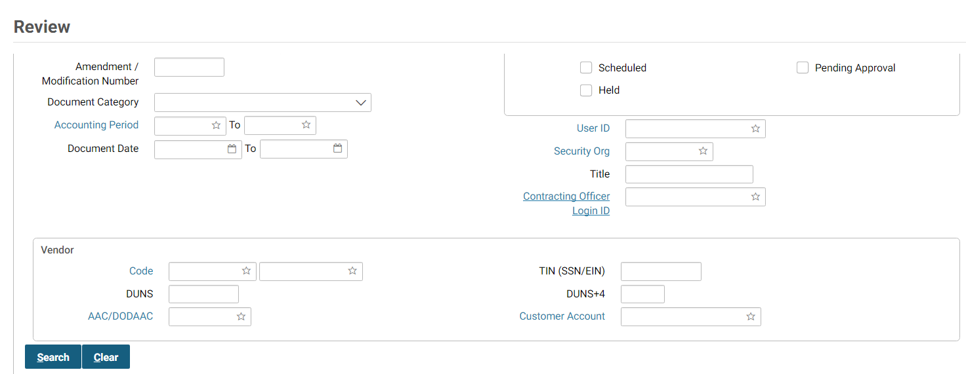
- Enter a document type in the Document Type box.
NOTE: Order, Receipt, Invoice, Direct Pay, or Credit Card document types can be selected.
- Enter the document number of the document in the Document Number field.
- Select the Search button.
- Select the desired document from the generated list and select the View button.
The Header page of the selected document will be displayed. All fields will be protected.
- Select the Header Accounting Lines tab.
The Header Accounting Lines page of the document will be displayed. The accounting dimensions, agreement, or contract info will be modified according to the reorganization.
- Select the desired line and select the Header Accounting Line link.
- The Header Accounting Line page displays.
- View the Reorganization Information box.

How Do I Review A Payment Document Through The Accounts Payable Subsystem?
The following steps describe how to review a payment document through the Accounts Payable Subsystem that has been reorganized in Pegasys.
- Select Transactions - Accounts Payable - Review from the menu bar.
The Review page will be displayed.
Figure 6: Accounts Payable Subsystem Document Review page
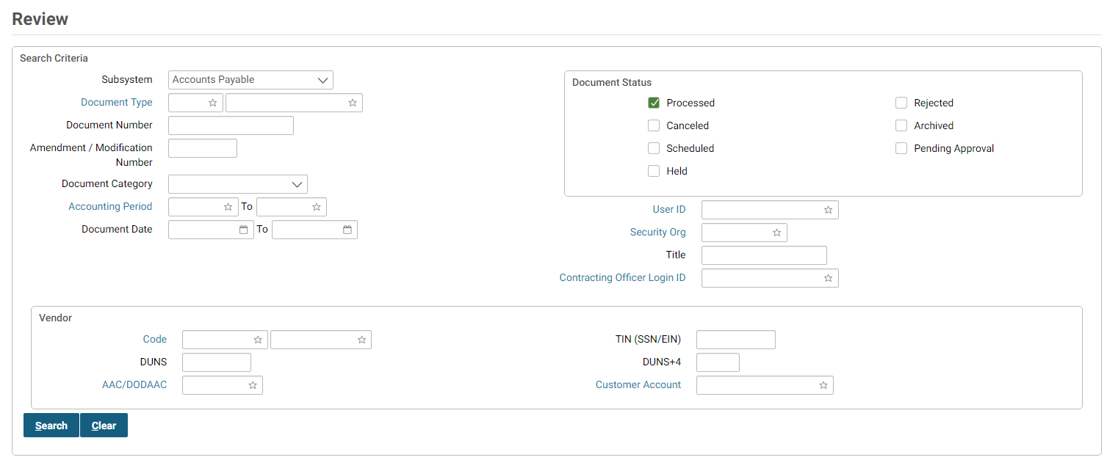
- Enter the payment document type in the Document Type box.
- Enter the document number of the document in the Document Number field.
- Select the desired document from the generated list and select the View button.
The Header page of the selected document will be displayed. All fields will be protected.
- Select the Header Accounting Lines tab.
The Header Accounting Lines page of the document will be displayed. The accounting dimensions, agreement, or contract info will be modified according to the reorganization.
- The Header Accounting Lines page displays.
- Select the appropriate line.
- Select the Header Accounting Lines link.
- View the Reorganization Information box.
The Reorganization Information box will be displayed showing the Reorganization Code, Reorganization Name and Justification of the last reorganization record that affected this accounting line.
Figure 7: Document Level Reorganization Notebook Header Accounting Line Reorganization Information Page
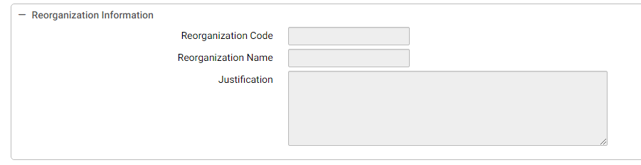

Reports

Reorganization Reports

What Types Of Reorganization Reports Are Available In Pegasys?
The following table summarizes the Reorganization Reports by report name, report menu folder, required fields, and optional fields. Please refer to Section 3.1.2 for procedural steps on how to generate Reorganization Reports.
Table 1: Reorganization Reports
Report Name | Report Menu Folder | Required Fields | Optional Fields
Reorganization Recoveries Report | General System → Reorganization | None | Processing From Date  Processing To Date  Reorganization Type  Reorganization Code
Budget Affected by Global Reorganization Report | General System → Reorganization | None | From Process Date  To Process Date  Status  Select only Active Reorganization Type  Reorganization Sort Order 1  Reorganization Sort Order 2  Reorganization Sort Order 3  Reorganization Sort Order 4  Reorganization Sort Order 5  Reorganization Sort Order 6  Reorganization Sort Order 7  Reorganization Sort Order 8  Reorganization Sort Order 9  Reorganization Sort Order 10

How Do I Generate And Print Reorganization Reports From The Reports Menu?
The following steps describe how to run the Reorganization Reports from the Reports menu.
- Log into Pegasys.
- Select Utilities - Reports - View Reports from the Pegasys menu bar on the desktop.
The View Reports page will be displayed for the available reports.
Figure 8: View Reports Page
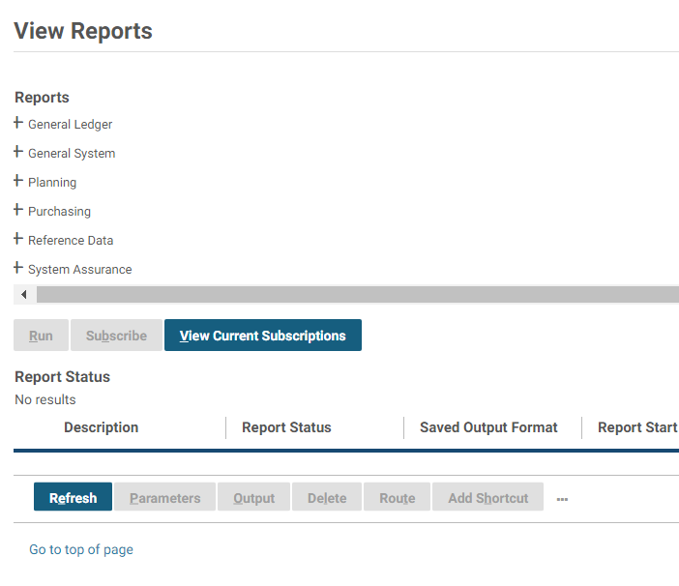
- Expand the General System menu.
- Expand the Reorganization menu.
- Select the report to be viewed or printed and select the Run button.
- Fill in the Parameters group box fields. The Parameters group box will vary based on the selected report.
- Under Options, select the desired Saved Output Format from the drop down list.
Output options are HTML and PDF.
- Select the Run button to run the report.
The selected Reorganization Report will be displayed.

What Type Of Information Do Each Of The Reports Provide Me?
- Reorganization Recoveries Report - The Reorganization Recoveries Report lists which recoveries need to be reorganized. It displays the reorganization code and name of each selected reorganization record and document type, number, and itemized and accounting line number. The report is sorted by reorganization code with secondary sorts by document number and itemized and accounting line numbers.
- Budget Affected by Global Reorganization Report - The Budget Affected by Global Reorganization Report lists budget lines that may be required to be established prior to executing a reorganization. Using the To and From Accounting values, the report will apply the reorganization to select the unique accounting dimension line combinations from the document lines tables. The report lists each unique dimension combination, is sorted by the value provided in the parameters, and summarized according to the parameters.

Document Level Reorganization Batch Jobs
This section describes general procedures that are required to ensure proper operation of the document level reorganization batch jobs. Descriptions of the batch jobs, their parameters, job name, data inputs & outputs, and execution reports are discussed in this section.

What Are The Batch Jobs For The Document Level Reorganization?
Table 2 lists the batch job name, description, script name, expected volume, and any dependencies in order to run the batch job. The following batch jobs should be run on a daily basis anytime between 9 p.m. and 7 a.m. The batch jobs will run for approximately 1-2 hours. The following batch jobs should not run with any batch job that affects the journals.
Table 2: Document Level Reorganization Batch Jobs
Name | Description | Batch Script Name | Expected Volume | Dependency
DOCREORGDAILY | Perform document level reorganizations | docreorgdaily.cmd | Processes 1-10 document level reorganization records | Run after Check Cancellation Reconciliation batch job
DOCRECREORGDAILY | Reorganize recoveries for document level reorganizations | docrecreorgdaily.cmd | Processes 1-10 document level reorganization records | Run after docreorgdaily.cmd has completed

What is the Setup for the Document Level Reorganization Batch Jobs?
Table 3 lists the general information for the Document Level Reorganization Batch Jobs.
Table 3: Document Level Reorganization Batch Job Setup - General
Field | Value
Job Id | DOCREORG
Job Name | Document Reorganization
Process Code | ROREORG
Process Name | Reorganization
Report Options - Save Report to Database | TRUE
Report Options - Generate File Name | FALSE
Report Options - File Name Format | N/A
Report Options - File Name | DOCREORG.rpt
Report Options - Location | BATCHSTATS
Table 4 lists the parameters for the Document Level Reorganization Batch Jobs.
Table 4: Document Level Reorganization Batch Job Setup - Parameters
Parameter | Value
errorsStopProcessingFlag | ‘T’
fromDate | MM/DD/YYYY
processErrorRecordsFlag | ‘T’
processOverrideErrorsFlag | ‘T’
reorgCode | N/A
reorgType | ‘D’
saveDocumentsToTempFlag | ‘T’
toDate | MM/DD/YYYY
userID | ‘runbatchreorg’
Table 5 lists the parameter descriptions for the Document Level Reorganization Batch Jobs.
Table 5: Document Level Reorganization Batch Job Parameter Descriptions
Parameter | Description
errorsStopProcessingFlag | Determines whether the batch job should stop and roll back all uncommitted changes if it encounters an error.  The value is T for document level reorg batch job to prevent partial updates to the document chain in case of error.  The value is F for global reorg batch job to allow all accounting lines without errors to process.
fromDate | If specified, determines the starting date of the period into which the Processing Date of the Reorg code should fall in order to be picked up by the batch job.  The value is blank because all reorg records with past processing date should be processed by the batch job.
processErrorRecordsFlag | Determines whether Reorg records in Error status should be processed by the batch job.  The value is T for document level reorg batch job and global reorg batch job to allow reorg records to be “recycled” every time the batch job is executed.
processOverrideErrorsFlag | Determines whether overridable errors should be overridden by the batch job.  The value is T for document level and global reorg batch jobs to allow overridable errors to be overridden by the batch job.
reorgCode | If specified, determines the Reorg code to be processed by the batch job.  The value is blank for the document level and global reorg batch jobs because all records with a specified processing date should be processed by the batch job.
reorgType | Determines if reorg to be processed is document level (D) or global (G).  The value is D for document level reorg batch job and G for global reorg batch job.
saveDocumentsToTempFlag | Determines whether the accounting lines processed by the batch job and their To and From accounting should be saved to the Reorg history tables.  This parameter should be set to T if Recovery Reorganization batch job will be executed after the Reorganization batch job. The value is T for document level and global reorg batch jobs.
toDate | If specified, determines the ending date of the period into which the Processing Date of the Reorg code should fall in order to be picked up by the batch job.  The batch job script for document level and global reorg batch jobs will set this date to the current date so all reorg records having the processing date from this point back will be processed.
userID | The userID used by the batch job to create new journal and history entries.  The value is runbatchreorg for document level and global reorg batch jobs.
Table 6 lists the general information for the Document Level Reorganization Batch Jobs.
Table 6: Document Level Reorganization Recoveries Batch Job Setup - General
Field | Value
Job Id | DOCRECREORG
Job Name | Document Recovery Reorganization
Process Code | RORECOVERY
Process Name | Reorganization Recovery
Report Options - Save Report to Database | TRUE
Report Options - Generate File Name | FALSE
Report Options - File Name Format | N/A
Report Options - File Name | DOCRECREORG.rpt
Report Options - Location | BATCHSTATS
Table 7 lists the parameters for the Document Level Reorganization Batch Jobs.
Table 7: Document Level Reorganization Recoveries Batch Job Setup - Parameters
Parameter | Value
deleteRecordsAfterProcessing | ‘T’
fiscalMonth | MM
fiscalYear | YY
processingFromDate | MM/DD/YYYY
processingToDate | MM/DD/YYYY
reorganizationCode | ‘D’
userID | ‘runbatchreorg’

What Are The Common Reorganization Errors?
Table 8 lists the Common Reorganization Errors.
Table 8: Common Reorganization Errors
Error Code | Description | Solution
BE0002E | The total spending exceeds the available funding for Budget Node Level and Budget Node Name by Amount. | Document Level Only.  The spending controls on the listed budget node have been violated.  Contact the budget officer to determine if the correct budget is being used.
BE0143E | The appropriation does not exist for Document Type Fund. | The budget has not been set up for the specified Fund.  Contact the budget officer to set up appropriate budgets.
BJ1119E | The accounting strip of the Document does not match the From Accounting. | Document Level Only.  The accounting distribution on the document accounting line has been modified after the Reorganization Notebook has been created, but before the reorg batch job processed the notebook.  Determine whether the reorg is still necessary and, if yes, modify the Reorganization Notebook by selecting Default on the Reorganization Lines page to bring in correct accounting and making the appropriate modifications to the To Accounting section of the page.
GS0027E | The budget node could not find any matching Allowance.  The listed name has not been set up. | Contact the budget officer to set up appropriate budgets.
GS0144E | The Relationship edit with a listed number has been violated. | Document Level Only.  Resolve the error described in the Relationship Edit prior to reprocessing the reorg record.
PC0072E | The transaction date must be within the External Direct agreement start date and end bill date. | Document Level Only.  The agreement listed on the accounting line or in the To Accounting is expired.  Choose a different agreement or enter a Document Date on the General Information page of the Reorganization Notebook that is within the effective dates of the agreement.

Appendix A - Document Level Reorganization Field Definitions
  - General Page
The Document Level Reorganization Notebook will allow GSA to move particular chains in the system from one accounting dimension(s) to another. The first page of the Document Level Reorganization Notebook is the General page. The General page contains information about the reason for the reorganization and the dates of when the reorganization is to take place.
See Figure 9.
Figure 9: General Page
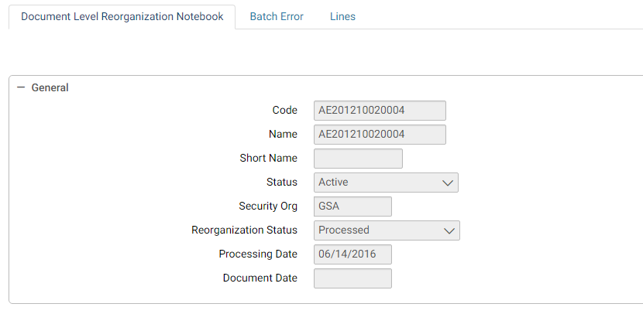
Table 9 - Table 11 provide additional information about General page fields and buttons.
Table 9: General Page Field and Button Descriptions
Field Name | Description | Features
Code | Alphanumeric text used to identify a document level reorganization. GSA will be putting the document number of the first document in the chain to be reorganized as the Code. | Required.
Status | Active or Inactive | Drop down list.
Name | Provides a description of the document level reorganization. GSA will be using the userid of the person creating the reorganization notebook for the Name. | Required.
Short Name | Abbreviated version of the reorganization notebook name. | Optional.  USDA/GSA not using.
Security Org | The security organization established when the document level reorganization was created. | Default to user’s default security organization.
Reorganization Status | Values are the following: Awaiting Approval, Ready for Processing, Error, In Process, Processed. The Reorganization Status will change by actions by the user or batch job. | Drop-down list. System-maintained.
Processing Date | The date the reorganization should be processed. | Required.  GSA will be using the Current Date.
Document Date | The date that will be on the documents that are reorganized. | Optional.
Justification | Displays the Justification information for this document level reorganization. It is a free text field 255 characters long. | Required.  Name of person requesting the action and any additional descriptive information.
Accounting Period Options (group box) | The Use Current Accounting Period option will default. The current accounting period must be open. | Required.  Defaults to Use Current Accounting Period.
Use Specified Accounting Period | Use the specified accounting period. The Use Specified Accounting Period may be selected, however, an open accounting period must be specified. | System Maintained
Table 10: General Page Field and Button Descriptions - Processing Rules (Group Box)
Field Name | Description | Features
Ignore Budget Spending Controls (check box) | If this option is checked, when performing the reorganization to the document chain, it will ignore any budget spending controls that may occur during the reorganization. | Optional.  Defaults to False and GSA will leave this option as unchecked.
Ignore Project Spending Controls (check box) | If this option is checked, when performing the reorganization to the document chain, it will ignore any project spending controls that may occur during the reorganization. | Optional.  Defaults to False and GSA will leave this option as unchecked.
Ignore Contract Spending Controls (check box) | If this option is checked, when performing the reorganization to the document chain, it will ignore any contract spending controls that may occur during the reorganization. | Optional.  Defaults to False and GSA will leave this option as unchecked.
Ignore Blanket Agreement Spending Controls (check box) | If this option is checked, when performing the reorganization to the document chain, it will ignore any blanket agreement spending controls that may occur during the reorganization. | Optional.  Defaults to False and GSA will leave this option as unchecked.
Ignore Relationship Edits (check box) | If this option is checked the reorganization will ignore any relationship edits that may occur during the document chain processing. | Optional.  Defaults to False and GSA will leave this option as unchecked.
Ignore Planning Spending Controls (check box) | If this option is checked, when performing the reorganization to the document chain, it will ignore any planning spending controls that may occur during the reorganization. | Optional.  Defaults to False and GSA will leave this option as unchecked.
Ignore Agreement Spending Controls (check box) | If this option is checked, when performing the reorganization to the document chain, it will ignore any agreement spending controls that may occur during the reorganization. | Optional.  Defaults to False and GSA will leave this option as unchecked.
Ignore Delivery Order Spending Controls (check box) | If this option is checked, when performing the reorganization to the document chain, it will ignore any delivery order spending controls that may occur during the reorganization. | Optional.  Defaults to False and GSA will leave this option as unchecked.
Ignore Prevent Spend Against Expired (check box) | If this option is checked the reorganization will allow spending against expired funds that may occur during the document chain processing. | Optional.  Defaults to False and GSA will leave this option as unchecked.
Reorganize Miscellaneous References (check box) | If this option is checked, when performing the reorganization on the document chain, it will also reorganize any miscellaneous references and their referencing documents. | Optional.  GSA will check this option.
Table 11: General Page Field and Button Descriptions – Properties (Group Box)
Field Name | Description | Features
Last Modified box | Contains the user ID of the last person making updates to the document level reorganization and the date of the last update for the selected document level reorganization. | System-maintained.
Modification Date | Contains the modification date. | System - maintained.
Approved By | Contains the user ID of the last person to approve the document level reorganization and the date of the last document level reorganization approval. | System-maintained.
Approval Date | Contains the date of the approval. | System-maintained.
Batch Errors (Tab) | Displays the Batch Errors page. | System-maintained.
Save (button) | Saves the document level reorganization. | Required.

Batch Errors Button
The Batch Errors tab displays the Batch Errors page that displays the batch errors encountered for this reorganization. Figure 10 displays the Batch Errors page.
Figure 10: Batch Errors Group Box
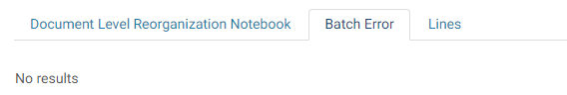
  - Reorganization Lines Page
The Reorganization Lines page contains document accounting line information associated with the reorganization. This page will display the accounting template to be changed and the accounting template that will be used by reorganization to update the document chain.
Figure 11 displays the Reorganization Lines page of the Document Level Reorganization Notebook.
Figure 11: Reorganization Lines Page
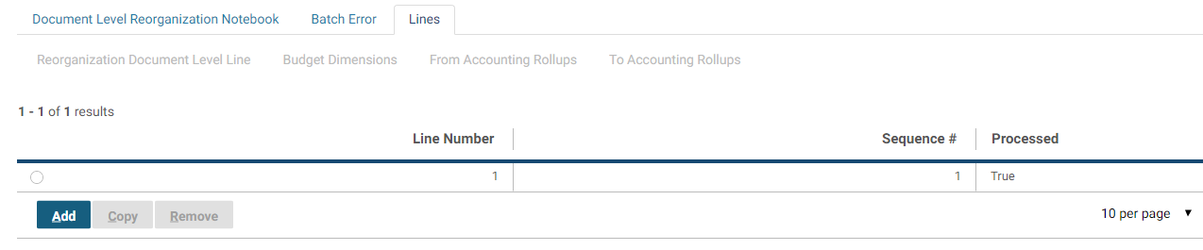
Table 12 - Table 13 provide information about Reorganization Lines page fields and buttons for the reorganization.
Table 12: Reorganization Lines Page Field and Button Descriptions
Field Name | Description | Features
Line Number | A number that uniquely identifies the current line. | Pegasys will default this value to the next sequential number from the highest line number already entered.  System-maintained.
Processed (check box) | Indicates whether this reorganization line has been processed. | System-maintained.
Sequence # | Identifies the order sequence when reorganizing lines. Pegasys will default to next sequence #. | Optional.  USDA/GSA not using.
Apply BFY Change to all Documents | Apply change to all BFY documents. | Checkbox.
Type | Drop-down list containing all document types that can be reorganized. | Required.
Table 13: Reorganization Lines Page Field and Button Descriptions – Reference Document (Group Box)
Field Name | Description | Features
Document Reference | The first document number in the chain to be reorganized. | Required.  Select on the hyperlink to search for values
Itemized Line | The itemized line of the document to be reorganized. | Required if an itemized document is selected.
Accounting Line | The accounting line of the document to be reorganized. | Required.
Default (button) | When the default button is selected, the system will default the accounting and agreement information into the To and From accounting fields on the notebook from the specified accounting line. | Required.
Agreement group box | Displays the Agreement Number group box. Agreement number information will default based on the document and line number selected. | Optional.
Spending Adjustment/Recovery Options group box | Displays the Spending Adjustment and Recovery Options for the Reorganization | Optional.
Debt Account group box | Displays the Debt Account Information | Optional.
Contract group box | Displays the Contracts group box. Contract information will default based on the document and line number selected. | Optional.
Budget Dimensions (tab) | USDA/GSA not using. | Button disabled.
From Accounting (group box) | Displays the From Accounting Dimensions | Optional.
To Accounting (group box) | Displays the To Accounting Dimensions | Optional.

Agreement Group Box
The Agreement Number group box contains agreement number information from the selected document number for the document level reorganization.
Figure 12 displays the Agreement Number dialog box.
Figure 12: Agreement Number Dialog Box
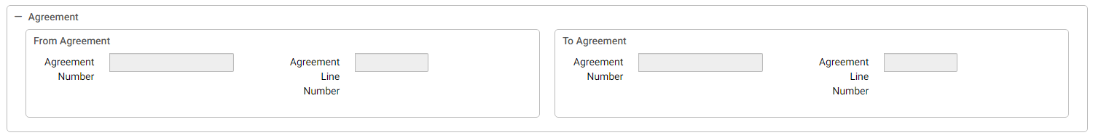
Table 14 - Table 15 provide additional information about the Agreement Number fields.
Table 14: Agreement Number Dialog Box Field Descriptions – From Agreement (Group Box)
Field Name | Description | Features
Agreement Number | Displays the agreement number (e.g., RWA, IBAA) associated with the document accounting line selected for the document level reorganization. | System-maintained.
Agreement Line Number | Displays the line number of the agreement number associated with the document accounting line selected for the document level reorganization. | System-maintained.
Table 15: Agreement Number Dialog Box Field Descriptions – To Agreement (Group Box)
Field Name | Description | Features
Agreement Number | Used to specify an agreement (e.g., RWA, IBAA) to be associated with the document level reorganization. | Optional.  Select on the hyperlink to search for a value. Enter only the numeric portion of the agreement number in Field 1.
Agreement Line Number | Used to specify line number of the Agreement to be referenced to be associated with the document level reorganization. | Enter Line Number in Field 2.
    - Spending Adjustment Recovery Options
The Spending Adjustment Recovery Options group box contains To and From Adjustment Recovery Options as shown in Figure 13.
Figure 13: Spending Adjustment Recovery Options Group Box
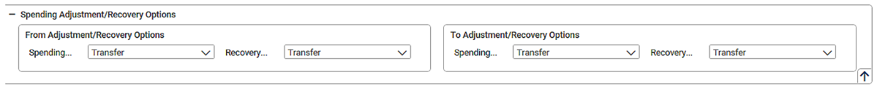
Table 16 provides additional information about the fields.
Table 16: Spending Adjustments/Recovery Options Group Box Field Descriptions
Field Name | Description | Features
Recovery Option | When set to Regenerate, recoveries will be created as if the user made the corrections on line. When set to Exclude, the reorganization process will be prevented from reallocating the recoveries. When set to Backout, the recoveries that were recorded in the From dimensions at the time the transaction was initially processed will be zeroed out. When set to Transfer, the recoveries that were recorded as the transaction was initially processed will be reallocated and moved to the specified To dimensions. | System-maintained.
Spending Adjustment Option | When set to Regenerate, adjustments will be created as if the user made the corrections on line. When set to Exclude, the reorganization process will be prevented from reallocating the adjustments. When set to Backout, the adjustments that were recorded in the From dimensions at the time the transaction was initially processed will be zeroed out. When set to Transfer, the adjustments that were recorded as the transaction was initially processed will be reallocated and moved to the specified To dimensions. | System-maintained.

Debt Account
The Debt Account group box contains debt account information as shown in
Figure 14.
Figure 14: Debt Account Group Box
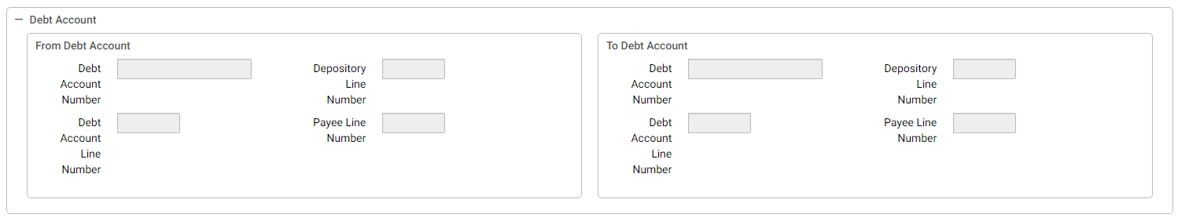
Table 17 - Table 18 provide additional information about the fields.
Table 17: From Debt Account Group Box Field Descriptions
Field Name | Description | Features
Debt Account Line Number | The numeric value entered for the Debt Account Line. | Optional
Debt Account Number | The alphanumeric code defining the debt account. The value entered in this field must be unique. | Optional
Depository Line Number | The numeric user-defined depository line number. | Optional
Payee Line Number | The numeric user-defined payee line number. | Optional
Table 18: To Debt Account Group Box Field Descriptions
Field Name | Description | Features
Debt Account Line Number | The numeric value entered for the Debt Account Line. | Optional
Debt Account Number | The alphanumeric code defining the debt account. The value entered in this field must be unique. | Optional
Depository Line Number | The numeric user-defined depository line number. | Optional
Payee Line Number | The numeric user-defined payee line number. | Optional

Contract
The Contract group box contains contract number information from the selected document number for the document level reorganization as shown in Figure 15.
Figure 15: Contract Group Box
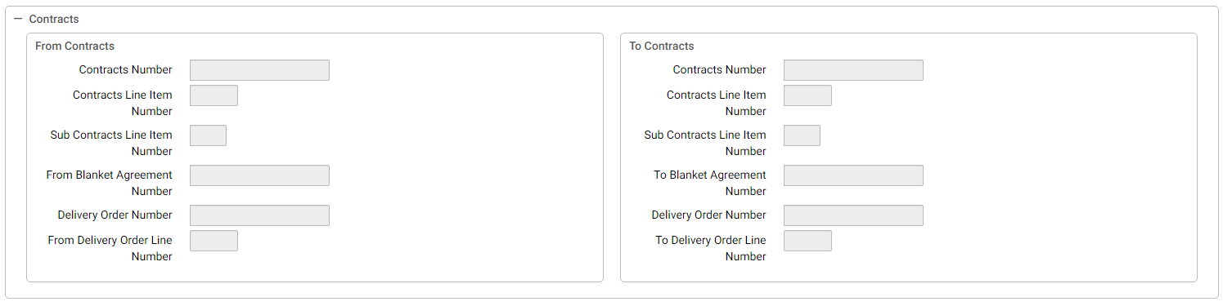
Table 19 lists the Contract Group Box Fileds Descriptions group box.
Table 19: Contract Group Box Field Descriptions
Day | Step | Description
Contract Number | The contract number that applies to this item. The value must be valid in the Contract maintenance table. | System Maintained
Delivery Order Number | The number of the delivery order to which this form applies. | System Maintained
From Blanket Agreement Number | Specifies whether the From Contract is a contract or a blanket agreement. | System Maintained
From Delivery Order Line Number | The delivery order line number from which the document level reorganization is occurring | System Maintained
Sub Contract Line Item Number | The number of the sub-contract line to which this form applies. | System Maintained
To Blanket Agreement Number | Specifies whether the To Contract is a contract or a blanket agreement. | System Maintained
To Delivery Order Line Number | The delivery order line number to which the document level reorganization is occurring. | System Maintained
    - From Accounting Group Box
Figure 16 displays the From Accounting Strip group box.
Figure 16: From Accounting Strip
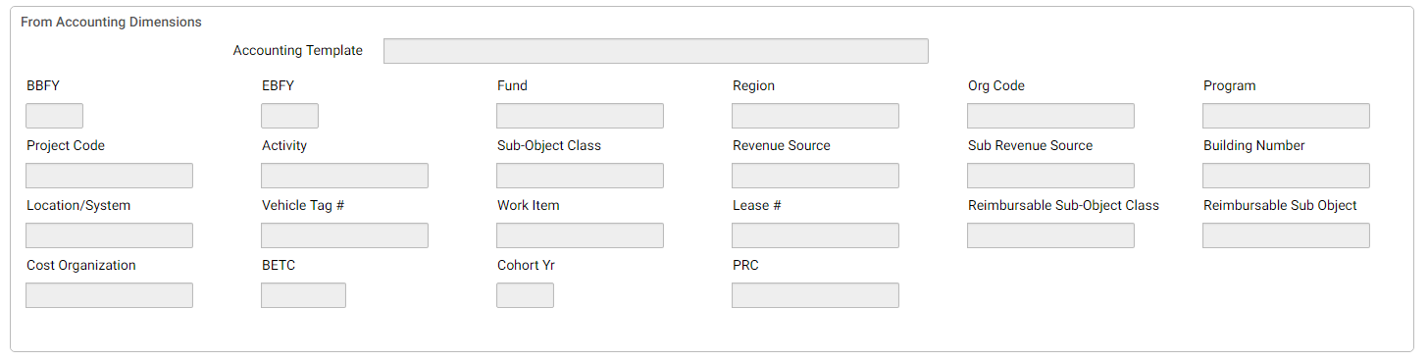
Table 20: From Accounting Strip Field Descriptions
Field Name | Description | Features
Template | The accounting template used to obtain the accounting strip.  Valid values are listed in the Accounting Template Maintenance table. | System-maintained.  Will default based on the document and line number selected.
BFYs | Budget Fiscal Year(s) of the accounting strip for which the form is being processed. Displayed in two fields:  Field 1: Beginning Budget Fiscal Year (BBFY).  Field 2: Ending Budget Fiscal Year, if applicable. (EBFY). | System-maintained.  Will default based on the document and line number selected.
Fund | The fund code of the accounting strip.  Valid values are listed in the Fund Maintenance table. | System-maintained.  Will default based on the document and line number selected.
Reg | The region code of the accounting strip.  Valid values are listed in the Region Maintenance table. | System-maintained.  Will default based on the document and line number selected.
Program | The program code of the accounting strip.  Valid values are listed in the Program Maintenance table. | System-maintained.  Will default based on the document and line number selected.
Activity | The Activity code of the accounting strip. | System-maintained.
Org | The organization code of the accounting strip.  Valid values are listed in the Organization Maintenance table. | System-maintained.  Will default based on the document and line number selected.
Sub-Object Class | The sub object class of the accounting strip.  Valid values are listed in the Sub Object Class Maintenance table. | System-maintained.  Will default based on the document and line number selected.
Sub | Currently not in use. | N/A
Activity | The Activity code of the accounting strip.  Valid values are listed in the Activity Maintenance table. | System-maintained.  Will default based on the document and line number selected.
Proj | The project/grant/case number/audit number code/profit center of the accounting strip.  Valid values are listed in the Project Maintenance table. | System-maintained.  Will default based on the document and line number selected.
Sub | Currently not in use. | N/A
Bldg # | The building number of the accounting strip.  Valid values are listed in the Building Number Maintenance table. | System-maintained.  Will default based on the document and line number selected.
Wrk Itm | The work item/work category code of accounting strip.  Valid values are listed in the Sub Project Maintenance table. | System-maintained.  Will default based on the document and line number selected.
Syst | The system code of the accounting strip.  Valid values are listed in the System Maintenance table. | System-maintained.  Will default based on the document and line number selected.
Veh Tag# | The vehicle tag of the accounting strip.  Valid values are listed in the Vehicle Tag Maintenance table. | System-maintained.  Will default based on the document and line number selected.
Cost Org | Currently not in use. | N/A
Sub | Currently not in use. | N/A
CBFYs | Canceled Budget Fiscal Year(s) that the form has been processed against. | System-maintained.  Will default based on the document and line number selected.
Cancelled Fund | The cancelled fund code that the form has been processed against. | System-maintained.  Will default based on the document and line number selected.

To Accounting Group Box
Figure 17 displays the To Accounting Strip group box.
Figure 17: To Accounting Strip
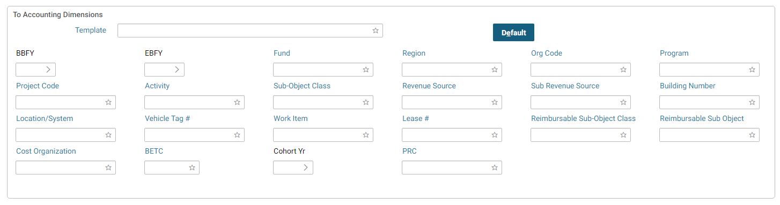
Table 21: To Accounting Strip Field Descriptions
Field Name | Description | Features
Template | The accounting template used to obtain the accounting strip.  Valid values are listed in the Accounting Template Maintenance table. | Required.  Select on the hyperlink to search for values
BFYs | Budget Fiscal Year(s) of the accounting strip for which the form is being processed. Displayed in two fields:  Field 1: Beginning Budget Fiscal Year (BBFY).  Field 2: Ending Budget Fiscal Year, if applicable (EBFY). | Required.  Will default based on the accounting template selected.
Fund | The fund code of the accounting strip.  Valid values are listed in the Fund Maintenance table. | Required.  Will default based on the accounting template selected.
Reg | The region code of the accounting strip.  Valid values are listed in the Region Maintenance table. | Will default based on the accounting template selected.
Program | The program of the accounting strip.  Valid values are listed in the Program Maintenance table. | Will default based on the accounting template selected.
Org | The organization code of the accounting strip.  Valid values are listed in the Organization Maintenance table. | Will default based on the accounting template selected.
Sub-Object Class | The Sub-Object Class of the accounting strip.  Valid values are listed in the Sub-Object Class Maintenance table. | Required.  Select on the hyperlink to search for a value.
Sub | Currently not in use. | N/A
Activity | The activity code of the accounting strip.  Valid values are listed in the Activity Maintenance table. | May default and/or may become required, based on the accounting template selected.  Select the hyperlink to search for values.
Proj | The project/grant/case number/audit number code/profit center of the accounting strip.  Valid values are listed in the Project Maintenance table. | May default and/or may become required, based on the accounting template selected.  Select the hyperlink to search for values.
Sub | Currently not in use. | N/A
Bldg# | The building number of the accounting strip.  Valid values are listed in the Building Number Maintenance table. | May default and/or may become required, based on the accounting template selected.  Select the hyperlink to search for values.
Wrk Itm | The work item/work category code of the accounting strip.  Valid values are listed in the Sub Project Maintenance table. | May default and/or may become required, based on the accounting template selected.  Select the hyperlink to search for values.
Syst | The system code of the accounting strip.  Valid values are listed in the System Maintenance table. | May default and/or may become required, based on the accounting template selected.  Select the hyperlink to search for values.
Veh Tag# | The vehicle tag of the accounting strip.  Valid values are listed in the Vehicle Tag Maintenance table. | May default and/or may become required, based on the accounting template selected.  Select the hyperlink to search for values.
Cost Org | Currently not in use. | N/A
Sub | Currently not in use. | N/A
CBFYs | Canceled Budget Fiscal Year(s) that the form will be processed against. | May default and/or may become required, based on the accounting template selected.
Cancelled Fund | The cancelled fund code that the form will be processed against. | May default and/or may become required, based on the accounting template selected.
Rollups (tabs) | USDA/GSA not using. | Disabled.
Save (button) | Saves the information on the document reorganization notebook and changes the status to Awaiting Approval. | Required.

