United States Department of Agriculture
Budget Execution Pegasys 7.5.1
User Guide
Contract: # HHSN316201200011W
Order # AG-3144-D-16-0278
Version 03.00
May 2018

Table of Contents
Table of Contents 1
Table of Figures 4
Table of Tables 7
Revision Log 8
1 Budget Execution Introduction 10
2 Budget Execution Overview 11
2.1 Budget Execution Concepts 11
2.1.1 Resources 11
2.1.2 Funds 11
2.1.2.1 Fund Durations 11
2.1.2.2 Fund Stages 12
2.1.3 Budgets 12
2.1.3.1 Pegasys Budgets 12
2.1.3.2 Defining Pegasys Budgets 13
2.1.3.3 More on Dimensions 14
2.1.3.4 Budget Levels and Budget Lines 14
2.1.3.5 How Budgets are Updated 15
2.1.3.6 The Budget Hierarchy 15
2.1.3.7 Budget Updates Revisited 16
2.1.3.8 What the Budgets Record 16
2.1.3.9 Spending Controls 17
2.1.3.10 Budgeting and Posting Controls 17
2.1.3.11 Spending Notifications 18
2.1.3.12 “Require Presence” Option 18
2.1.3.13 Generating Multiple Budget Lines 19
2.1.3.14 Limitations 20
2.1.3.15 Constraints 21
2.1.3.16 Budgeting and Posting 21
2.1.3.17 Authority and Availability 22
2.1.3.18 Authority Transfers, Spending Adjustments and Cancelled Year Spending Methods 22
2.1.3.19 Cancelled Year Spending by Subclass Accounts 22
2.1.3.20 Cancelled Year Spending by Treasury Symbol 24
2.1.3.21 Suppression of Recoveries and Adjustments for Conversion 24
2.2 Working with Budgets 24
2.2.1 Establishing a Fund 24
2.2.2 Creating Budgets 24
2.2.3 Correcting Budget Documents 25
2.2.3.1 Processing a New Form for an Existing Budget 25
2.2.3.2 Rules for Modifying Budgets 25
2.2.4 Copying Budgets 26
2.2.5 Transferring Resources 26
2.2.6 Congressional Changes 26
2.2.7 Withdrawing Funds from Budgets 27
3 Budget Pointers 28
4 Budget Setup 29
4.1 Creating a New Fund 29
4.2 Creating a New Budget Form 30
4.3 Correcting a Budget 38
4.4 Copying a Budget 39
4.5 Creating a Budget Reprogramming Form 41
4.6 Appropriation Transfer Form 42
5 Budget Maintenance Tables 43
5.1 Fund Maintenance Table 43
5.2 Budget Dimensions 52
5.3 Budget Execution Options 53
5.4 Constraints 55
5.5 Funding Withdrawal Definition 57
5.6 Mark Sub-Classification 58
5.7 Treasury Symbol 59
5.8 Budget Accounts 65
5.9 Budget Controls Maintenance Table 67
6 Budget Execution Queries 69
6.1 Budget Query 69
6.1.1 Budget Query Buttons 71
6.2 Exportable Fiscal Year Budget Query 72
6.3 Constraint Query 74
6.4 Budget Pending Reprogramming Query 74
7 Budget Execution Reports 76
7.1 General Report Information 76
7.2 Organization Status Report 76
7.2.1 Report Parameters 76
7.2.2 Sample Report 77
7.3 Budget Distribution Report 77
7.3.1 Report Parameters 78
7.3.2 Sample Report 78
7.4 Budget Form Verification Report 78
7.4.1 Report Parameters 78
7.4.2 Sample Report 79
7.5 Fund Status Report 79
7.5.1 Report Parameters 79
7.5.2 Sample Report 79
8 Budget Execution Offline Processes 80
8.1 Budget Deletion Process 80
8.2 Budget Rebuild Process 80
8.3 Carryover/Funding Withdrawal Process 81
8.4 Budget Funds Availability Percent Update Process 82
8.5 Annual Close Estimated Resource Reversal Process 82
8.6 Constraint Rebuild Process 82
8.7 Budget Set Beginning Official Position Process 82
8.8 Budget Control Updater Process 82

Table of Figures
Figure 1: Fund Stages 12
Figure 2: Pegasys Accounting Dimensions Example 13
Figure 3: The Pegasys Budget Hierarchy 15
Figure 4: Pegasys Budget Structure Example 16
Figure 5: Require Presence Example 19
Figure 6: Limitations Example 20
Figure 7: Fund Table - Search Criteria 29
Figure 8: Fund Table - General Section 29
Figure 9: Fund Table - General Section - Name Field 30
Figure 10: Fund Table - General Section - Bureau Field 30
Figure 11: New Budget Form Navigation 31
Figure 12: Create New Budget Form 31
Figure 13: Budget Form - Initial Selection Screen 32
Figure 14: Budget Form - Header Screen - General Section 32
Figure 15: Budget Appropriation Form Line Detail Screen 32
Figure 16: Budget Form - Header Screen - Amounts 33
Figure 17: Budget Form - Sub Budget Form Dimensions 34
Figure 18: Budget Form - Lines Screen 35
Figure 19: Budget Form - Amounts Section 35
Figure 20: Budget Form - Distributions Screen 36
Figure 21: Budget Form - Child Options Screen 37
Figure 22: Budget Form Errors 37
Figure 23: Budget Form Successful Verification Message 38
Figure 24: Budget Form Buttons 38
Figure 25: Budget Form Successful Submit Message 38
Figure 26: Budget Form Correct Screen 38
Figure 27: Budget Form Header Screen 39
Figure 28: Budget Form Creation Navigation 39
Figure 29: New Budget Form Screen 40
Figure 30: Copy Budget Form Screen 40
Figure 31: Budget Reprogramming Form Lines Screen 41
Figure 32: Budget Reprogramming Form From and To Budget Sections 41
Figure 33: New Appropriation Transfer Screen 42
Figure 34: Fund Maintenance Table 43
Figure 35: Fund Maintenance Table - Fund Code Tab 44
Figure 36: Fund Maintenance Table - Fund Allocation Precedence Section 44
Figure 37: Fund Maintenance Table - Spending Adjustment Options 45
Figure 38: Fund Maintenance Table - Authority Transfer Options 45
Figure 39: Budget Dimension Maintenance Table - Search Criteria 53
Figure 40: Budget Execution Options Maintenance Table - Search Criteria 54
Figure 41: Constraints Maintenance Table - Search Criteria 55
Figure 42: Funding Withdrawal Definition - Search Criteria 57
Figure 43: Mark Sub-Classification Maintenance Table - Search Criteria 58
Figure 44: Treasury Symbol Maintenance Table - Search Criteria 60
Figure 45: Budget Account Maintenance Table 66
Figure 46: Budget Controls Maintenance Table 67
Figure 47: Budget Query 69
Figure 48: Budget Activity for Current Year Single Year Appropriation 69
Figure 49: Total Authority, Authority for Distribution and Available Amount Definitions and Calculations 70
Figure 50: Total Authority, Authority for Distribution and Available Amount Definitions and Calculations 70
Figure 51: Budget Activity for Prior Year No Year Fund 70
Figure 52: Budgeted, Total Authority, Authority for Distribution and Available Amount Definitions and Calculations 71
Figure 53: Budget Query Buttons 71
Figure 54: Exportable Fiscal Year Budget Query Menu 73
Figure 55: Exportable Fiscal Year Budget Query Search Results 73
Figure 56: Constraint Query 74
Figure 57: Budget Pending Reprogramming Query 75
Figure 58: Budget Execution Reports 76
Figure 59: Sample Organization Status Report 77
Figure 60: Sample Budget Distribution Report 78
Figure 61: Sample Budget Form Verification Report 79
Figure 62: Sample Fund Status Report 79

Table of Tables
Table 1: Types of Funds 11
Table 2: Pegasys Dimensions 14
Table 3: Spending Controls 17
Table 4: Fund Code Field Descriptions 46
Table 5: Budget Dimension Field Descriptions 53
Table 6: Budget Option Field Descriptions 54
Table 7: Constraints Field Descriptions 55
Table 8: Funding Withdrawal Field Descriptions 57
Table 9: Mark Sub Classification Field Descriptions 58
Table 10: Treasury Symbol Field Descriptions 60
Table 11: Budget Account Field Descriptions 66
Table 12: Budget Controls Field Descriptions 68
Table 13: Budget Query Button Descriptions 71
Table 14: Organization Status Required Parameters 77
Table 15: Budget Distribution Parameters 78
Table 16: Budget Form Verification Parameters 79
Table 17: Fund Status 79

Revision Log
Date | Version No. | Description | Author | Reviewer | Review
2/11/2011 | Draft/ Version .1 | Original Draft | Danielle Becker | Jenna Stegmann | 1/21/2011
11/2014 | Draft/ Version 2 | Draft- Pegasys 7.1.2 upgrade enhancements | Karin Keswani, Dan McNeil | Karin Keswani and Dan McNeil | 11/2014
1/2015 | Final | Removed “The recommended setting of Budget Line for both the Spending Adjustment and Authority Transfer Options fields." line for it did not apply on pages 5 - 43. | Karin Keswani | Karin Keswani | 1/2015
1/17/2018 | Final Version 2 | Revision 2.0 - updated to reflect the following changes for Pegasys 7.5.1 Upgrade:  - Applied 508 standards.  - Updated screen shots and provided Alternate Text.  - Updated section 4.2 to reflect the Simplify Budget and Budget User Interface enhancements.  - Added section 5.9 for the Simplify Budget and Budget User Interface enhancements.  - Updated section 6.1 to reflect the Introduce New Logic on the Current Year Activity Selection Fiscal Year Field in the Budget Query enhancement.  - Added section 8.8 for the Add Ability to Update Child Control Key through Budget Control Updater Batch Process (BECTRLUPDT) enhancement. | Veronica Braxton | Richard Bowman Ashley Magee, Jenny Lewis | 10/2017, 01/2018
5/2018 | Final Version 3 | No additional changes. | Veronica Braxton | Marice Grissom, Jenny Lewis | 5/2018

Budget Execution Introduction
The Pegasys Budget Execution subsystem allows GSA to create a model of the budget structure for each fund, to distribute funding from the appropriation or fund level of the fund to sub-budget levels, to control spending for each budget line, and to review the activity recorded against each budget line.
This manual addresses the following topics:
- Budget Execution Overview
- Budget Execution Forms
- Budget Execution Maintenance Tables
- Budget Execution Queries
- Budget Execution Reports
- Budget Execution Offline Processes

Budget Execution Overview

Budget Execution Concepts

Resources
Many agencies receive one or more congressional appropriations as well as other, non- appropriated sources of income. Pegasys allows GSA to manage appropriated funds and revolving funds.
Budgetary amounts may include statutory reserves, carryover, reimbursements, and recoveries. These amounts can be entered in total, by quarter or, in the case of multi-year funds, by fiscal years.

Funds
In Pegasys, each funding source may be represented by a single fund or divided among several funds. A fund is identified by a GSA-assigned fund code and its budget fiscal year. Pegasys requires each fund to be associated with a Treasury symbol. GSA reports back to the Office of Management and Budget by Treasury symbol.

Fund Durations
Pegasys supports three kinds of funds, reflecting the three major kinds of congressional appropriations and non-appropriated funds (Table 1: Types of Funds).
Table 1: Types of Funds
Fund Type | Duration
Single-year fund | Valid for a single fiscal year.
Multi-year fund | Valid for several fiscal years (the duration is specified as part of the appropriation act). Any resources not used in one fiscal year are available in the next.
No-year fund | Has no set duration. It is valid until the appropriation or authority is cancelled or until the purpose for which it was established is concluded. Because Congress and/or OMB generally release funding on an annual basis (rather than turning over the entire amount as a single sum), Pegasys treats no-year funds as a series of single-year funds, and provides a mechanism that automatically carries remaining balances forward from one year to the next. The No Year option on the Fund Maintenance table designates a fund as a no-year fund; the Carryover option indicates whether balances should automatically be carried forward at the end of the fiscal year.

Fund Stages
A congressional appropriation may pass through three stages in the course of its existence; Pegasys funds and budgets support all three.
- An appropriation is considered unexpired when the obligation authority for the account is still current. New obligations may be incurred and payments made during this period.
No-year appropriations and Revolving funds’ status usually remain unexpired.
- During the five years following the expiration of obligation authority, the appropriation is considered expired. While the appropriation is expired, unobligated balances are not returned to Treasury as surplus funds but are available for recording, adjusting, or liquidating any obligations properly chargeable to the appropriation prior to its expiration.
- Beginning with the sixth year after the expiration of obligation authority, the appropriation is considered cancelled. At this point, all unobligated balances are cancelled and returned to Treasury. The balances are not available for any spending. However, a subclass account of a current, unexpired appropriation may be established for the purpose of recording, adjusting, or liquidating any obligations properly chargeable to the appropriation prior to its cancellation. The available amount of the cancelled appropriation continues to be updated to ensure that spending against the subclass fund does not exceed the original appropriation.
Figure 1: Fund Stages illustrates these comparisons.
Figure 1: Fund Stages

Budgets
A budget is organized in a hierarchy with one or many levels; each level represents how funding is distributed throughout GSA. For example, within a fund, users may divide the resources among geographical locations. A budget would therefore have a regional level, with a line for each of the regions. Within each of these regions, users may want to divide the resources further by adding additional levels for budget activities, organizations, projects, etc.

Pegasys Budgets
Each fund within Pegasys must have at least one budget line at the highest level. For appropriated funds, this level is known as the appropriation; it generally represents the resources appropriated to GSA by Congress. This budget level may reflect the total congressional appropriation or part of the congressional appropriation. For revolving funds, the highest level is known as the fund.
For appropriated funds the second level of the Pegasys budget hierarchy is called the apportionment, because it is often used to represent the OMB’s apportionment of a GSA’s congressional appropriation. For revolving funds, this level is known as the master allowance.
For appropriated funds the remaining levels of the Pegasys budget hierarchy are called the allowance, allotment, operating plan, lower level 1, lower level 2 and level 8. For revolving funds the remaining are called the allowance, operating plan, lower level 1, lower level 2 and level 8. These budget levels, referred to collectively as sub-budgets, are created in the same manner and function in the same way.
Pegasys’ dynamic labeling feature allows budget levels to be renamed according to GSA specific terms.

Defining Pegasys Budgets
Each financial transaction processed in Pegasys records a set of accounting codes, called dimensions, which are associated with the transaction. These dimensions include things such as fund code, BFY (budget fiscal year), region, organization, program, project, etc. A subset of these accounting dimensions is used to define each budget level.
In Pegasys, one or more dimensions define each budget line. For example, to establish an appropriation, a budget user would specify the fund code and BFY. To establish an allowance for a region within that fund, the user would create a budget level defined by the fund code and BFY as well as the region code. If Pegasys’ organization dimension is used to distinguish offices within the region, a budget user would establish an allotment level defined by the fund code, BFY, region code, and organization code.
Figure 2: Pegasys Accounting Dimensions Example illustrates this idea, using fund, division, and organization codes.
Figure 2: Pegasys Accounting Dimensions Example

More on Dimensions
Although Pegasys offers more than twenty accounting dimensions, only eight, see
Table 2: Pegasys Dimensions, are used to define budgets. This subset is referred to as the budget dimensions.
Table 2: Pegasys Dimensions
Budget Dimension | Meaning
Budget Fiscal Years (BFYs)/Fund | Represents a unique fund, valid for a specific period
Region | Represents GSA’s divisional structure
Organization | Represents GSA’s organizational structure
Program | Represents the programmatic breakdown of GSA’s responsibilities. Usually derived from the President’s budget
Sub Object Class | Represents a classification of goods or services on which GSA spends funds
Sub Cost Element | Further defines the classification of goods or services on which GSA spends funds
Project | Represents the planned tasks that GSA is undertaking. Usually have a finite duration
Activity | Represents the functional operations of GSA
In addition, each fund, region, organization, program, sub object class, project, and activity can be associated with up to four roll-ups - a category, class, group, and type - used to group similar codes. For example, if sub object class 112 is used for local transportation, cost element 114 for travel - training, and sub object class 122 for travel - education, users could assign all three sub object class to object class 21. Then if users wanted to report on all travel, they could report on object class 21 instead of having to specify all of the travel object codes.
Users can also use these roll-ups for budgeting. For example, if users wanted to budget for all travel related costs, they would create a budget line for object class 21. Transactions using sub object class 112, 114, 122, etc. would “roll-up” to this single budget line.

Budget Levels and Budget Lines
It is important to remember the difference between budget levels and budget lines. In the budget hierarchy, a dimension defines a level. In our example, the region code dimension defines the allowance level; every allowance in the budget will have a specific value for the region code.
When users add a level to a budget, they indicate which dimensions will be used to define that level. For example, when we added the operating plan level earlier, we specified that this level would use the organization code dimension. When users establish a line, they specify which particular organization code defines that particular line.

How Budgets are Updated
Pegasys has the capability to distinguish between expensed and non-expensed transactions. Budgets can be designated as Obligation-based or Expense-based and will be updated accordingly. The Funds Control field on the Fund Maintenance table determines if the plan is Obligation or Expense-based.
Once users have set up a budget, any transaction processed in Pegasys that uses the budget’s dimensions will update the budget, according to the rules established on the Fund Maintenance table. In the simple budget example, if an obligation used accounting dimensions of fund code 100X, BFY 2006, region 01, and organization code A01B000, it will only process if there exists a budget line which uses the budget dimensions fund code 100X, BFY 2006, region 01, and organization code A01B000.

The Budget Hierarchy
It is often convenient to picture the budget hierarchy as an inverted tree. From the fund and appropriation - which form the root of the tree - the tree branches downward, expanding outward as additional levels are added.
It is also convenient to use “family” terms to describe the relationships between budget lines. For example, in the diagram below, Allowance 00 is a child of the Apportionment, and the parent of Allotments A01A0000 and A01B0000. Allowances 00 and 01 are siblings. Hierarchy illustrates the parent-child budget hierarchy.
Figure 3: The Pegasys Budget Hierarchy
Sub-budget lines inherit their parent’s dimensions. For example, in the diagram above, since the appropriation is defined by fund code 100X and BFY 2006, all apportionment, allowance, and allotment budget lines are also defined by fund code 100X and BFY 2006. Allotments A00A0000 and A00B0000 inherit the region value of 00.
Pegasys’ budget structure allows each division to have a completely different budget structure, as illustrated by the following diagram (see Figure 4: Pegasys Budget Structure Example). Sibling budgets must use the same dimension but children of different parents do not. In this example, each child of Allowance 00 budget line is defined by a project code but each child of Allowance 01 budget line is defined by a Program code.
Figure 4: Pegasys Budget Structure Example

Budget Updates Revisited
As we have seen, Pegasys provides great flexibility in defining a budget structure. Different parts of the budget “tree” may have more budget levels and use different dimensions than others.

What the Budgets Record
When users create a budget, they specify budget amounts in terms of the total outlays - in dollars and FTEs - expected. When transactions are processed against a budget, however, Pegasys categorizes the transactions and tracks the activity in each of the following categories: unliquidated and total pre-commitments, unliquidated and total commitments, unliquidated and total obligations, unliquidated and total accruals, total expenditures, total reimbursements, and actual reimbursable agreements.

Spending Controls
In addition to tracking activity against budgets, Pegasys also allows users to control spending, preventing spending from exceeding the available amount remaining in the budget. Pegasys has four levels of spending control, which determine what Pegasys will do when users try to process a transaction exceeding the budget. The four spending controls available are displayed in
Table 3: Spending Controls.
Table 3: Spending Controls
Spending | Description
None | The transaction is allowed to process, even if there is no available funding.
Warning | The transaction is allowed to process, but the user receives a warning message if the transaction will exceed available funding.
Overrideable | The user receives an overrideable error. If an authorized user overrides the error, the transaction will be allowed to process even if the transaction will exceed available funding; otherwise it will not process.
Reject | The transaction is not allowed to process if there is too little available funding.
Pegasys allows users to set the spending control level separately for spending and for FTE usage. Pegasys also allows users to set the spending control level separately for each budget line, allowing the budgets to be tailored to suit specific circumstances.
Example: Central Office (00) has an allowance of $75M with spending controls set to “Reject.” It allots $20M each to Project A, Project B, and Project C, leaving $15M unallotted with spending controls of “Overrideable.” This way, if any project needs to spend more than the $20M allotted to it, an authorized user can approve the transaction, allowing the project to spend part of the $15M kept in reserve at the allowance level. Because the spending control level for the allowance is set to “Reject,” however, total spending for all three both projects can never exceed $75M.

Budgeting and Posting Controls
Spending controls prevent spending from exceeding a budget’s amount, but do not prevent a budget from being over-distributed. Pegasys offers four levels of budget controls, which determine how funding is distributed from one level to the next. For example, if the budgeting control level were set to “Reject” for the $75M allowance, Pegasys would prevent users from allotting more than $75M total to the three allotment budget lines. Like spending controls, budgeting controls can be set separately for spending and FTEs. Pegasys also allows users to set the budgeting and posting control levels separately for each budget line, allowing the budgets to be tailored to suit specific circumstances.
Pegasys also offers four levels of posting controls, which determine what Pegasys will do if users attempt to post more to a budget’s children than has been posted to the parent budget. Posting controls operate independently of the budgeting controls.

Spending Notifications
Spending controls inform users when they try to process transactions that exceed a budget’s amount. Pegasys also offers an email notification feature that notifies the budget’s supervisor - rather than the user processing the document - when spending or FTE usage against the budget reaches a certain level.
There are two main notification criteria that can be set for each budget line. When “Spending Exceeds % of Budget” is set, the system will notify the listed supervisor(s) that the budget line spending has reached the pre-defined amount. When “Available Amount Less Than” is set, the system will notify the listed supervisor(s) when the budget line’s Available Amount is less than the specified amount. Additional functionality includes setting Agreement and Agreement Reimbursement warnings.
Example: A user want to be alerted when spending against an allowance budget line has reached 95% of its total amount, in case it will be necessary to reprogram budget resources. Users can turn on spending notification for the allowance, setting the notification threshold at 95%. When spending reaches or exceeds this threshold, Pegasys will automatically send an email message alerting the designated supervisor(s) to this fact.

“Require Presence” Option
Section 2.1.3.1 mentioned that any transaction processed in Pegasys must match a budget to its lowest level. While this is generally true, it is possible to set up the budget to work otherwise. To see why this might be useful, consider the following example. Suppose GSA is using this budget, from one of the previous examples (see Figure 5: Require Presence Example).
Figure 5: Require Presence Example
A user is responsible for the budget for allotment CD00. She would like to be able to see how much is being spent within the allotment for various OMB Object Classes. To do this, she could add an operating plan level, defined by OMB Object Class. It would be necessary to create operating plan budget lines for every possible OMB Object Class, to assure no transaction is rejected. As an alternative, Pegasys allows users to turn off presence control for the operating plan level. When presence control is on, any transaction processed in Pegasys must match a defined budget, at its lowest level. When presence control is turned off for a budget level, Pegasys system generates a new operating plan each time a new OMB Object Class is needed.

Generating Multiple Budget Lines
The previous section mentions that budget lines will be automatically generated, if necessary, when presence is not required. Several additional considerations are involved when multiple budget lines are created. When determining how to create a single budget line, Pegasys uses the budget structure as defined on the parent budget, rather than the one defined on the Fund Maintenance table.
If a transaction results in the need for multiple lines to be created, Pegasys checks the System Generate At All Levels flag on the Fund Maintenance table. If the flag is set to no, only one budget line will be created (as defined on the parent budget). If the flag is set to yes, more than one level of the budget may be system generated. Users may track activity at several levels without having to manually process budgets for these levels.
If the dimensions on the Fund Maintenance table match the structure of the existing budget, the child budget options for the newly created lines are set according to the Fund Maintenance table. The next level is then generated based on the child budget options.

Limitations
Congress or OMB may put special restrictions - called limitations - on the way that GSA can use its appropriated resources. For example, the appropriation act may specify that users cannot use more than $10M of the $100M appropriation for travel expenses.
A restriction such as this can be difficult to accommodate in the budget structures described so far, because detailed budget items such as a particular object class (travel is represented by OMB object class 21) are usually set up toward the bottom of the budget hierarchy. In this case, though, users need the restriction to apply to the budget as a whole.
To solve this problem, Pegasys allows users to attach limitations to budgets. Although limitations are most frequently used at the appropriation level, they can be used on any budget line. Pegasys limitations allow users to specify restrictions for additional budget dimensions, without specifying additional budget levels. Limitations track all of the same financial data as budgets; can be divided into quarters or fiscal years, and support four levels of spending control.
In the travel example previously described above, users would attach a limitation, defined by the object class for travel, to the appropriation that was set up in Pegasys. Users would set up the limitation for $10M, and set its spending control level to “Reject.” Then any transaction processed against the appropriation that uses the travel object code - no matter what its other dimensions are - will be checked against the limitation’s total amount. Transactions that do not use the travel object code will not be affected by the limitation.
Figure 6: Limitations Example illustrates the limitation’s relationship to the budget hierarchy for the example described above.
Figure 6: Limitations Example

Constraints
Constraints create thresholds that limit the movement of funds within an appropriation. These thresholds are calculated based on an entered upper limit or a lower limit, the Beginning Official Position, and the processed Mark amounts. The Beginning Official Position is set by the Budget Set Beginning Official Position batch process. The amount can be entered as either an amount or a percentage. If an amount and a percentage are entered, the system will enforce the less restrictive of the two. There are two types of constraints, Congressional and Managerial.
- Congressional Constraints are created for a specific budget node, so they apply to only one fund. These constraints define limits set by Congress for the funds that may be transferred into and out of the particular budget node without requiring Congressional approval.
- Managerial Constraints are defined for a particular dimension value and may be created for an unlimited number of funds. These constraints apply to all budget nodes that include the specified dimension. Managerial Constraints define limits set by the management of GSA for the funds that may be transferred into and out of budget nodes without requiring additional GSA approval.
Constraints are validated upon processing budget documents. If a constraint is exceeded, an error message is returned in the level defined on the reference record of the particular constraint. These levels include, None, Informational, Overridable, and Error.

Budgeting and Posting
Whenever users enter a dollar amount for a budget, they may specify a budgeted amount and a posted amount. Such a distinction is not made for FTEs. When users budget an amount, that amount is added to the budget’s total authority (see Authority and Availability section) but is not available for spending. When users post an amount, it is made available for spending. If the amount users wish to post has not already been budgeted, they must budget it at the same time that it is posted.
It is often convenient to specify a budget amount without posting it. For example, if users want to set up the entire budget hierarchy before they begin spending against it, they would budget the amounts at each level (budgeted amounts can be distributed to lower levels). Once users had the budget set up the way they wanted it, they would go back and post the amounts for each budget, making them available for spending.
Users can use a similar method to restrict the amount that can be spent against a budget in a fiscal quarter. To do so, users would budget the entire amount for the budget, but only post each quarter’s amount at the start of the quarter. This way, the money budgeted to a quarter cannot be spent before that quarter begins.

Authority and Availability
The two most important dollar amounts for any budget are its total authority and its available amount.
A budget’s total authority represents all of the possible funding from various sources. For example, at the Pegasys appropriation level, the total authority may include the funding directly appropriated to GSA, reimbursements collected or expected to be collected against the appropriation, recoveries that have been recorded for the appropriation, and various other amounts. For more information on how authority is calculated for each level, see the Budget Amounts section.
A budget’s available amount is the total amount that can be spent against the budget. This amount is based on the total amount posted to the budget, with any spending, reimbursements, or other transactions that affect the budget figured in. For more information on how the available amount is calculated, see the Budget Amounts section.

Authority Transfers, Spending Adjustments and Cancelled Year Spending Methods
Authority transfers, spending adjustments, cancelled year spending by treasury symbol and subclass accounts are the models used to record current-year activity against a prior budget fiscal year (BFY). The model used depends on both the type of appropriation (single-year, multi-year, no-year) and its state (unexpired, expired, cancelled).
- Spending adjustments (obligation adjustments, accrual adjustments, and expenditure adjustments) occur when obligations, accruals, or expenditures for an expired single-, multi-, or no-year or an unexpired multi- or no-year appropriation are increased or decreased. Both upward and downward, paid and unpaid, expired and unexpired, obligation, accrual, and expenditure adjustments are tracked for each appropriation.
- Authority transfers occur when the available amount of a prior-year budget is increased or decreased during a subsequent year for an unexpired multi- or no-year fund. Authority transfers and spending adjustments often occur for the same transaction.
For more information on spending adjustments and authority transfers, refer to the Recoveries and Spending Adjustment sections of online help.

Cancelled Year Spending by Subclass Accounts
Subclass accounts are used to record spending against cancelled single- and multi-year appropriations. Subclass accounts always draw funding from the current year’s appropriation, but are used to distinguish activity for a cancelled appropriation. To use the subclass method to record spending against cancelled funds, the Subclass Accounts indicator should be set to true on the Treasury Symbol maintenance table.
Once an appropriation is cancelled, no transactions may be processed directly against it. Any transactions must instead be processed against a current, unexpired appropriation.
For example, assume that it is 1998 and users must pay an obligation that was legally established in 1991 but never recorded in the system. Users now need to enter an obligation and then a payment. However, the appropriation against which the obligation should be charged is now cancelled, since it is more than six years past the expiration of the appropriation’s authority. Therefore, users are no longer allowed to spend against the appropriation, so the obligation must be paid out of the current appropriation. Spending for cancelled appropriations must follow these rules:
- Spending for the cancelled appropriation must be done out of an appropriation established for the same purpose as the cancelled appropriation.
- Spending for the cancelled appropriation is limited to one percent of the current appropriation, or the available amount for the current appropriation, whichever is less.
- Spending for the cancelled appropriation must be tracked separately from spending for the current appropriation.
- Spending cannot exceed the remaining balance of the cancelled appropriation. For example, if the available amount for the 1991 fund is $1M, users cannot process a $2M obligation even if there is plenty of money in the current appropriation.
Pegasys meets these requirements through the use of subclass accounts. Returning to the previous example, in order to spend against the 1991 appropriation users would set up a fund defined as a subclass account setting aside up to one percent of the funds in the 1998 appropriation. This subclass account can be budgeted just like any other appropriation: users can set whatever dimensions, levels, and spending controls they desire. The fund is set up with the Treasury symbol for the 1998 appropriation.
How subclass accounts are budgeted will depend on the requirements of GSA. For example, users may want to track spending against the cancelled appropriation at the same level of detail as the original budget. In this case, users would set up a separate subclass account for each cancelled appropriation, with budget structures identical to those of the original budgets.
When users need to process a transaction for a cancelled appropriation, they use the subclass account instead. The transaction will be validated against the subclass account’s budget, just as if it was a current budget. Pegasys will also require users to enter the cancelled fund for which the spending was intended. The system will then verify that sufficient resources remain in the designated cancelled fund.
The transaction may not exceed funds available for either the subclass account or the cancelled appropriation. The transaction will update both budgets, but general ledger updates will only occur for the subclass account.

Cancelled Year Spending by Treasury Symbol
The purpose of cancelled year spending by treasury symbol method is to provide a simplified method for tracking spending against cancelled appropriations. To use the Treasury Symbol method to record spending against cancelled funds, the Subclass Accounts indicator should be set to false on the Treasury Symbol maintenance table.
For example, a user would like to enter a valid expenditure against an expired appropriation. The user cites the cancelled appropriation on the expenditure document. The system will check the cancelled year available amount for the treasury symbol as well as the cancelled year spending amount for the treasury symbol associated with the cancelled fund. As long as the expenditure processed does not increase the spending amount above 1% of the available amount for the treasury symbol, the document will be processed.

Suppression of Recoveries and Adjustments for Conversion
In converting from existing systems to Pegasys, it is often necessary to process transactions from prior years in the current year. However, these transactions should not generate prior-year recoveries or spending adjustments, since when they were originally processed in the existing system, they were processed against funds that were current at that time. Recoveries and adjustments are suppressed when processed during conversion accounting periods. Accounting periods can be designated as conversion periods on Accounting Period Maintenance.

Working with Budgets
This section describes the general procedures for setting up and maintaining budgets.

Establishing a Fund
Before users can create a budget, they must set up the fund on which the budget is based. The Fund Maintenance table is used to define and maintain funds.

Creating Budgets
After users have set up a fund, they create budgets by processing forms similar to the forms used to process transactions elsewhere in Pegasys. For example, users can enter an appropriation form to create an appropriation, an apportionment form to create an apportionment, an allotment form to create an allotment, etc. Budget entry forms and the procedures for creating them are described in section 4.2 Creating a New Budget Form.
Like other Pegasys forms, processed budget forms become budget documents. Budgets, however, exist independently of the documents used to create or update them. Budgets and budget documents can in this regard be compared to bank accounts and deposit and withdrawal slips. The first budget document a user processes for a given line is like the initial deposit that establishes a bank account. Once the account is established, users can deposit and withdraw funds using a different deposit or withdrawal slip each time.

Correcting Budget Documents
Like other Pegasys documents, budget documents can be corrected. To correct a budget, select Transactions → Budget Execution → Correct and specify the form users wish to correct. Steps on how to correct a budget are described in 4.3 Correcting a Budget.
When a budget user corrects a budget document, the form displays the initial values from the processed document. For example, a budget user processed an A1 appropriation form, creating an appropriation for Fund 100X. On this form, a total of $100,000 is budgeted, and the budget’s spending controls are set to “Reject.” A second A1 appropriation form for the same fund is later processed to add an additional $10,000 to the budget, and to change the spending control level to “Overrideable.” At this point, the total budget amount is $110,000 and the budget's spending control level changed from "Reject" to "Overrideable." If the original A1 is corrected, the corrected form will have a budgeted amount of only $100,000 and the prior spending control level of “Reject.” In essence, correcting the original budget document negates the effect of all subsequent budget documents.

Processing a New Form for an Existing Budget
Because budgets exist independently of the forms and documents used to create them, typically a budget user modifies a budget by processing a new form against the budget, instead of correcting the form originally used to create the budget.
To modify a budget in this fashion, follow the same steps to create a new budget. To modify an appropriation, the budget user would create a new A1 appropriation form, specifying the same fund as when the budget was originally established. Once the user has specified the budget dimensions, the current values of the existing budget line will pre-populate the form.

Rules for Modifying Budgets
Regardless of which method users use to modify a budget, the following rules apply:
- Users cannot change the dimensions that define a budget’s children if any child budgets already exist.
- Users cannot change a budget line’s dimension values if the line has children or if any activity has occurred against the budget.
- If users do change a budget lines dimension values, any limitations for the line will be deleted.
- If users modify any amount or option that causes a budget line or limitation’s available dollar or FTE amount to fall below zero, they may receive an error or warning message, depending on the budget’s spending control level. For example, if the budget’s spending control level is set to “Reject,” users would not be able to process a modification that reduces the budget’s available amount below zero.

Copying Budgets
Pegasys provides the capability to copy an entire budget structure or portion of a budget structure from one fund to another. For example, the copy function can be used when a fund’s budget is similar from one year to the next. Instead of re-entering the entire budget at the beginning of the fiscal year, users can copy the prior year’s budget and then make whatever adjustments are necessary. Steps on how to Copy a budget are described in Section 4.4 Copying a Budget.
The following rules apply when users copy a budget:
- The fund users want to copy the budget to must already exist.
- The old fund and the new fund must have the same duration and must have the same settings for the following options: No Year, Apply Reimbursements at All Levels, Track Agreements at All Levels, Appropriation Budget Est at Lower Level, Appropriation Control Budgeting, Appropriation Control FTE Budgeting, Multiple Apportionments, Use Apportionment Level, Apportionment Dimensions, and Apportionment Require Presence.
When users copy a budget level, all budgets below it in the hierarchy are copied, as are any limitations attached to any of the budgets. Actual activity against the budget (including recoveries, adjustments, transfers in, transfers out, carryovers in, carryovers out) is not copied. Even if the original budget was baselined, the copy will not be.

Transferring Resources
The Pegasys budget entry forms are used to create budgets and to transfer resources from one budget level to the next. Pegasys also provides two forms that allow users to transfer resources between established budgets at the same level:
- The Budget Reprogramming Form can be used to transfer resources between budget lines within a fund or Treasury symbol. For example, users can use the reprogramming form to transfer resources from one sub-allocation to another. Steps on how to create a budget reprogramming form are described in section 4.5 Creating a Budget Reprogramming Form.
- The Appropriation Transfer Form can be used to transfer resources between GSA’s appropriations or revolving funds, or between GSA’s appropriations or revolving funds and those of another agency. Steps on how to create an appropriation transfer form are described in Section 4.6 Appropriation Transfer Form.

Congressional Changes
Changes to budget distribution made by Congressional committees can be recorded on the Mark Document. This document records changes against a budget in any of eight classifications:
- Allocated with Prejudice: Congressional action adjusting a specific budget and the funding cannot be replaced if removed.
- Allocated without Prejudice: Congressional action adjusting a specific budget and the funding can be replaced if removed.
- Rescission/Deduction: Cancellation and withdrawal of budget authority previously provided by Congress before the authority has expired.
- Supplemental: Additional Congressional funding after the initial appropriation.
- Unallocated with Prejudice: Non-specific Congressional action normally directed against a particular type of spending where funding cannot be replaced if removed.
- Unallocated without Prejudice: Non-specific Congressional action normally directed against a particular type of spending where funding can be replaced if removed.
- Withhold: Funding appropriated by Congress but not available for spending until a certain release is obtained or permission granted.
- Withhold Release: Funding appropriated by Congress that had been previously recorded as Withhold, but have now been released for spending.
Mark Document Sub-Classifications are available to create more specific updates against a budget. These are user-defined on the Mark Sub Classification Maintenance table and may be GSA-specific.
A processed Mark Document updates the total budgetary authority and the portion of the budget’s amount that remains available for spending. This update may occur as an increase or a decrease, based on the Mark’s Classification.

Withdrawing Funds from Budgets
Pegasys provides GSA the ability to automatically withdraw funding from any budget node. This is accomplished through the use of the Funding Withdrawal Maintenance table and the Carryover/Funding Withdrawal batch process.

Budget Pointers
To assist in the budget entry process, budget structures are copied from one fiscal year to the next. Initially budget amounts are set to $0.00 and spending controls are set to None.
- Budgets are hierarchical. The top level of a budget must be completed before its sub budgets.
- Once actual dollar amounts are budgeted and posted for a particular line, the spending controls are typically set to Reject.
- Pegasys 6.5.0 removed the limitation that required GSA to withdraw available budget authority at the end of the initial year to facilitate further distribution of funds in the next fiscal year of a multi-year fund. This alleviates the enforcement of the edits on a fiscal year by fiscal year basis unless the OMB requires re-apportionment.

Budget Setup

Creating a New Fund
- Navigate to Reference → Dimensions → Funds → Fund Code.
Figure 7: Fund Table - Search Criteria
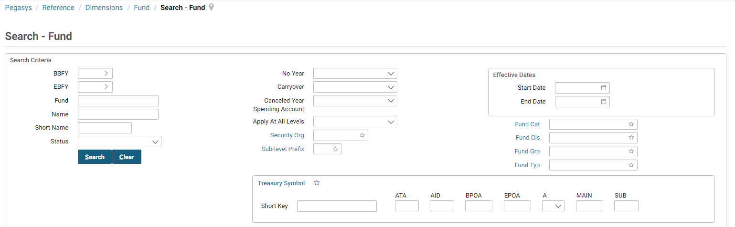
- Select the New button to create a new Fund.
Figure 8: Fund Table - General Section
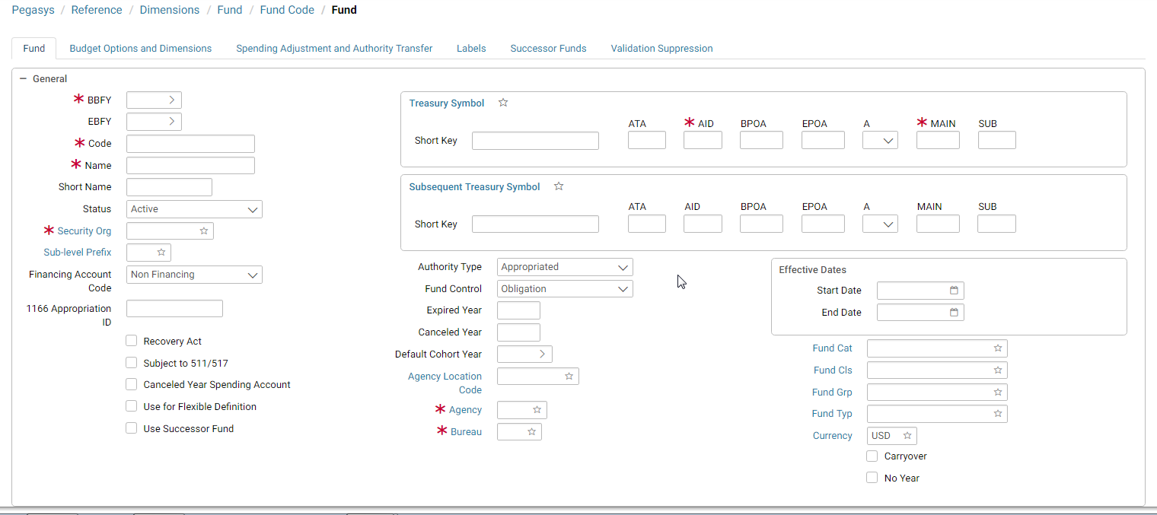
- Enter a Beginning Budget Fiscal Year (BBFY).
Ending Budget Fiscal Year (EBFY) is optional, depending upon the type of fund.
- Enter a Code in the Code field.
- Enter a Name in the Name field.

Figure 9: Fund Table - General Section - Name Field
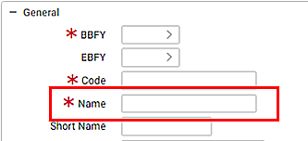
- Enter a Treasury Symbol in the Treasury Symbol field.
- Enter an Agency in the Agency field.
- Enter a Bureau in the Bureau field.
Figure 10: Fund Table - General Section - Bureau Field
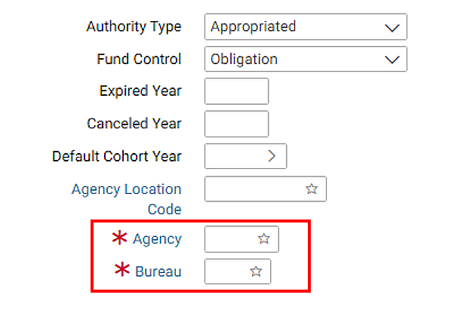
- Enter all other applicable fields.
- Select the Save button.

Creating a New Budget Form
GSA’s practice is to establish the budget structures prior to the beginning of each fiscal year based on the previous year’s budget structure. In this example it is assumed that the budget settings and values are populated based on the initial budget structure. The steps below demonstrate adding funding from an existing budget line using a new budget form. The example uses a revolving fund so an R1 document will be created. If the user is using an appropriated fund, an A1 document would be created.
- Navigate to Transactions → Budget Execution → New → Budget Creation.
Figure 11: New Budget Form Navigation
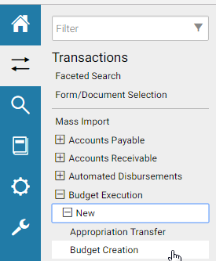
- Enter the Document Type for the budget line you would like to add.
- Select the Generate button to generate the Document Number.
Figure 12: Create New Budget Form
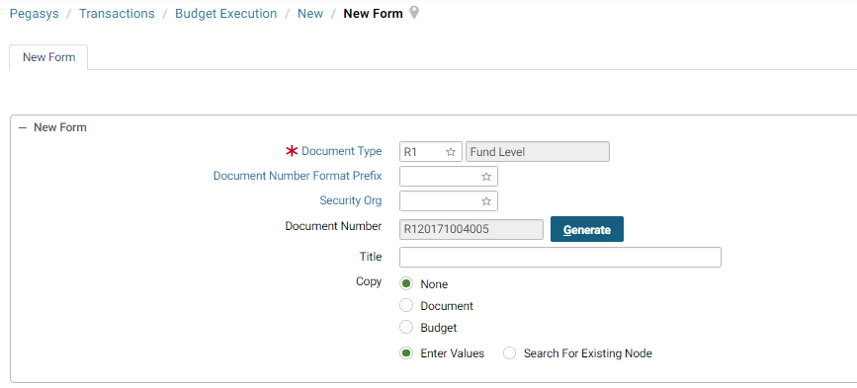
- Select the Fund link to search for a Fund. Enter search criteria and select Search. Select a fund. If you already know the fund you would like to use, enter it in the appropriate fields.
Figure 13: Budget Form - Initial Selection Screen
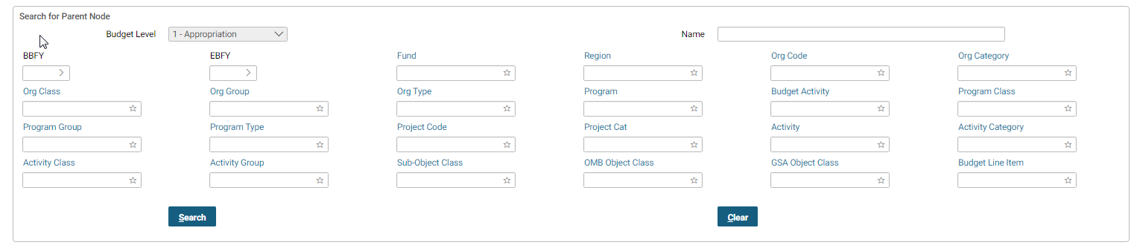
- Select the Search button to search for Budget Nodes.
- Once a budget line is selected, select the Finish button at the bottom of the form.
- Enter Title and Budgeted By information.
Document Date, Accounting Period, and Reporting Accounting Period will default when the form is verified or processed. The Security Organization will also default according to your User ID.
- Select the Budget Line and select the Setup Child button on the Header tab.
Figure 14: Budget Form - Header Screen - General Section
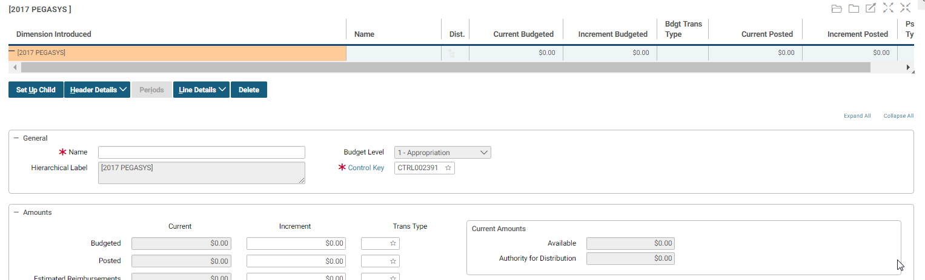
- Enter the Name.
The Control Key will default. The Control key defines authority and spending controls and the Transaction Type (a code used in combination with the Document Type to infer General Ledger postings) to be defaulted on budget forms. Control Keys are stored on the Budget Control Maintenance Table.
See section 5.9 Budget Controls Maintenance Table.
Figure 15: Budget Appropriation Form Line Detail Screen
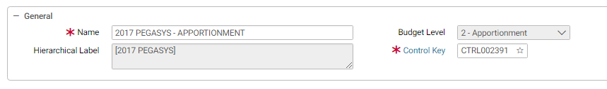
- In the Amounts section, enter the full amount to be budgeted in the Budgeted - Increment field. Enter the full amount to be posted in Posted - Increment field. Enter additional information as necessary.
Figure 16: Budget Form - Header Screen - Amounts
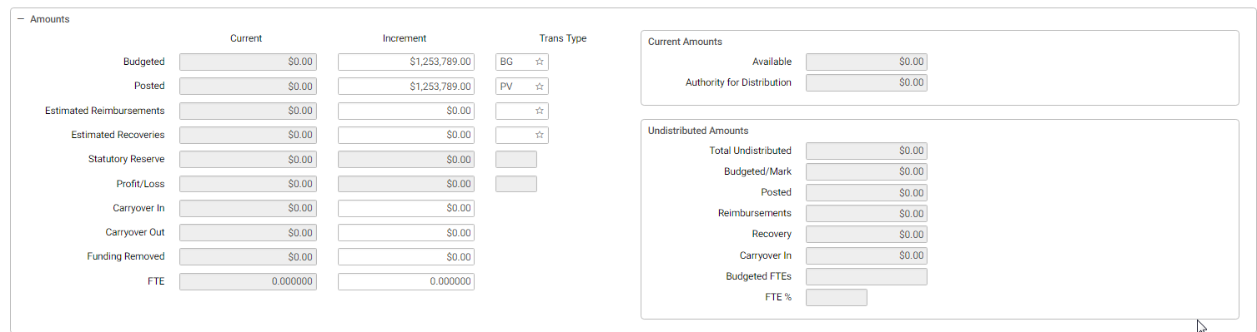
- Select the Set up Child button. The Sub Budget Form Dimensions page is displayed. Enter the specific dimensions for this budget line and then select the Search button. Select the Budget Level and select the Apply button.
Figure 17: Budget Form - Sub Budget Form Dimensions
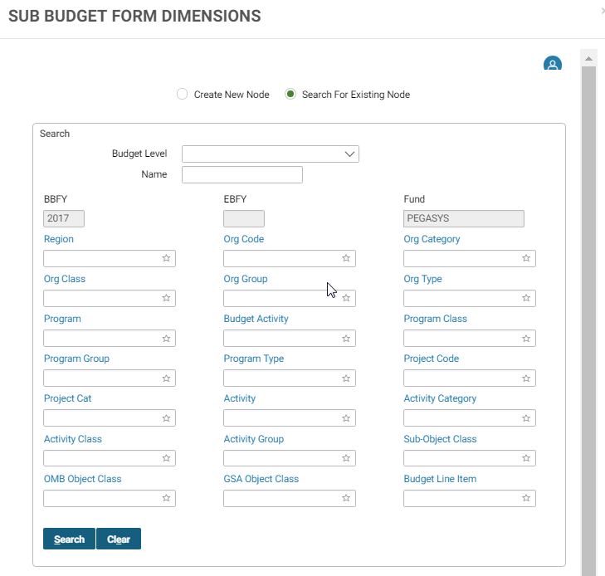
- Verify the Name is the same as its parent line, with the hierarchical level changed, and the new dimension added to the end of the name.
Figure 18: Budget Form - Lines Screen
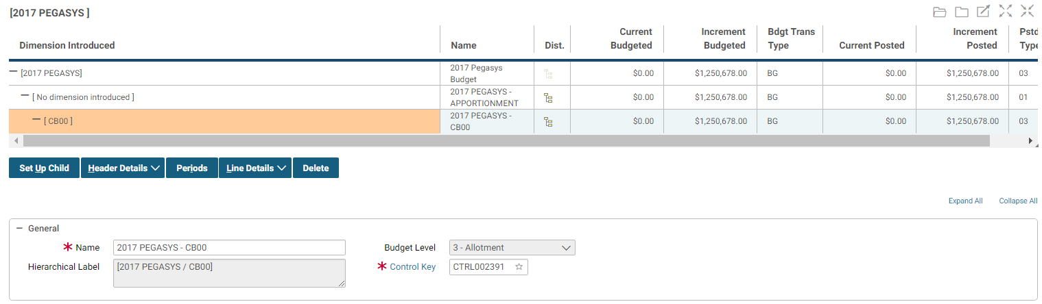
- In the Amounts section, enter the full amount to be budged in the Budgeted - Increment field. Enter the full amount to be posted in Posted - Increment field. Enter additional information as necessary. Review the Budgeted Trans Type and Posted Trans Type.
Figure 19: Budget Form - Amounts Section
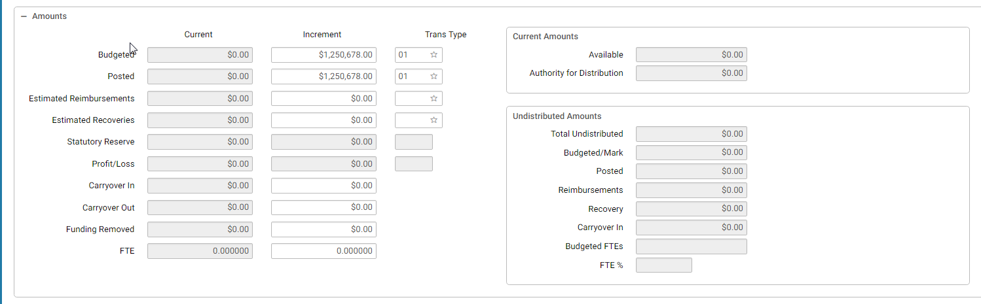
- In the Amounts section, values may also be entered for the estimated reimbursements, estimated recoveries, carryover in, and carryover out.
- Select the Periods button to budget and post funding by quarters.
- The Distributions tab displays.
Figure 20: Budget Form - Distributions Screen
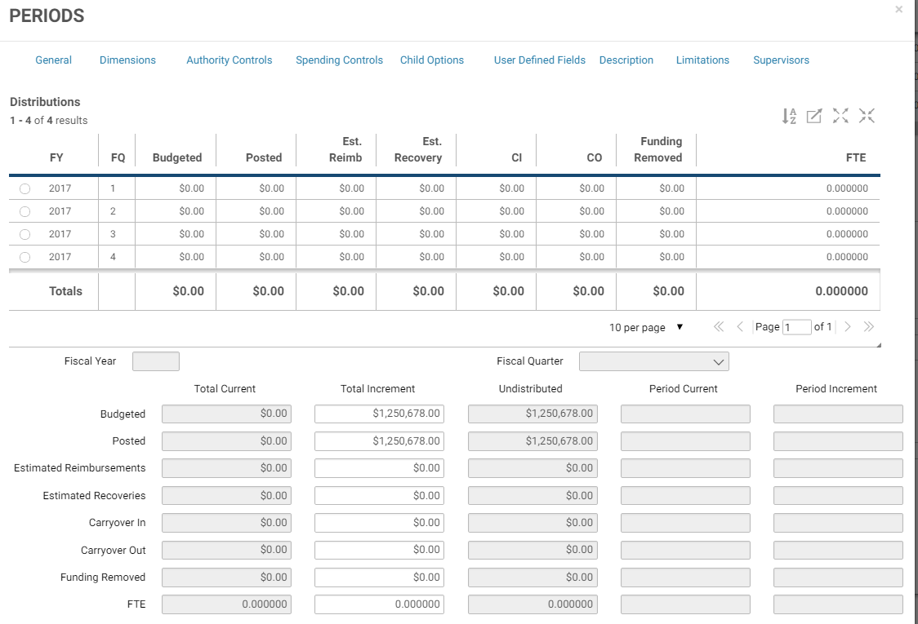
- Select the radio button for a particular quarter and enter the budgeted and posted amount for that quarter. Repeat this step for the remaining quarters.
Estimated reimbursements, estimated recoveries, FTEs, carryover in, Funding Removed, and carryover out amounts may also be distributed by quarter.
- Select the Previous button when finished with each quarter.
- Often after funding is budgeted and posted for a budget line, the budgeting controls, posting controls, and each spending control is set to Reject.
On the Lines tab, in the Controls group box (select Line Details then Child Options), review the Budgeting Controls, Posting Controls, and each of the different type of Spending controls and change them if necessary.
If the budgeting and posting controls are set to reject, then the funding distributed to the lower budget lines cannot exceed the funding for this line. Likewise, if the spending controls are set to reject, total pre-commitments, commitments, obligations, accruals, expenditures, and expenses cannot exceed the posted amount.
Figure 21: Budget Form - Child Options Screen
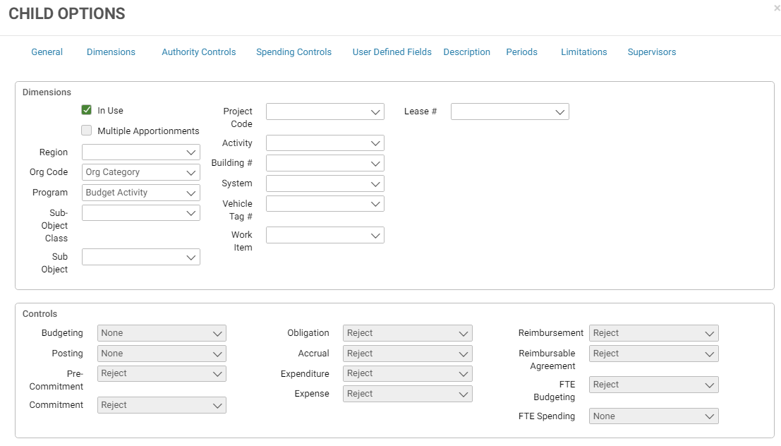
- Review the settings that will be applied to this budget line’s sub budgets. Most child options cannot be changed, once the sub budgets have been created.
- To create additional budget lines, highlight the appropriate level of the budget and select the Setup Child button. Follow the steps above to add details for the newly created budget line.
- Select the Verify button to check for possible errors.
- A red circle with an X indicates errors to be corrected. Select the error to be taken to the relevant area on the page.
Figure 22: Budget Form Errors
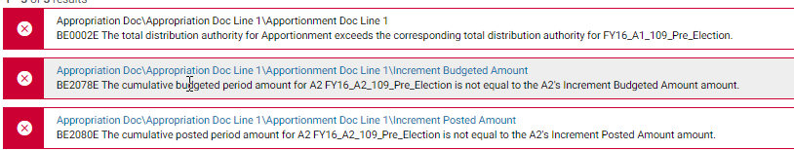
- Verify the form again after errors have been corrected. A successful verification message indicates no errors exist.
Figure 23: Budget Form Successful Verification Message
- Select the Submit button to send the form to the processing queue when all budget lines have been created.
Figure 24: Budget Form Buttons
- Once the form has been successfully submitted you will receive the following message:
Figure 25: Budget Form Successful Submit Message
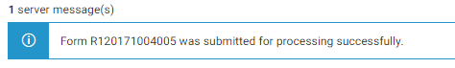

Correcting a Budget
GSA’s customary practice for modifying dollar amounts is to create a new form. In the case where a user just processed a budget form and the amount was incorrect, it is possible to correct it using the following steps.
- Navigate to Transactions → Budget Execution → Correct
Figure 26: Budget Form Correct Screen
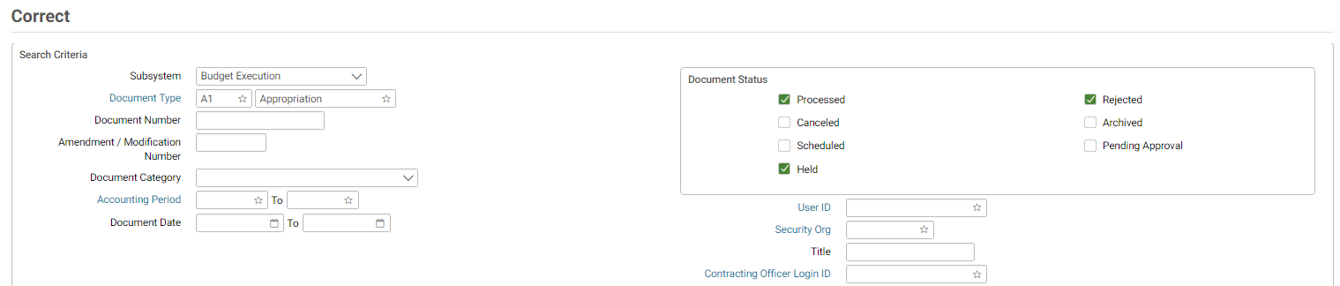
- Enter the Document Number of the Budget to be corrected and select the Search button. Choose the document from the search criteria and select the Correct button.
- Correct the document as necessary.
Figure 27: Budget Form Header Screen
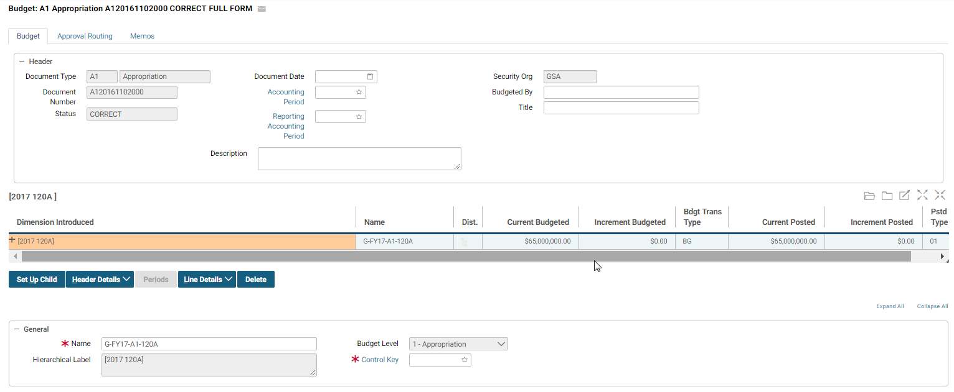
- When all updates have been made select the Verify and Submit buttons.

Copying a Budget
- Navigate to Transactions → Budget Execution → New → Budget Creation
Figure 28: Budget Form Creation Navigation
- Enter the Document Type, enter or select the Generate button to generate the Document Number, and in the Copy group box select Budget.
Figure 29: New Budget Form Screen
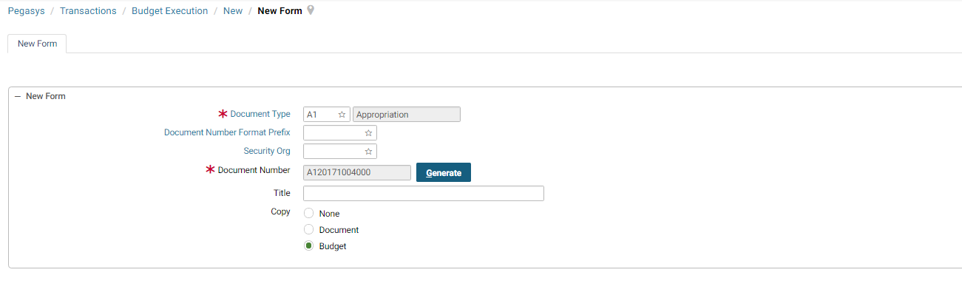
- Select the Next button.
- On the Copy Budget tab, enter the From Budget or the budget that is to be copied and select the Next button.
Figure 30: Copy Budget Form Screen
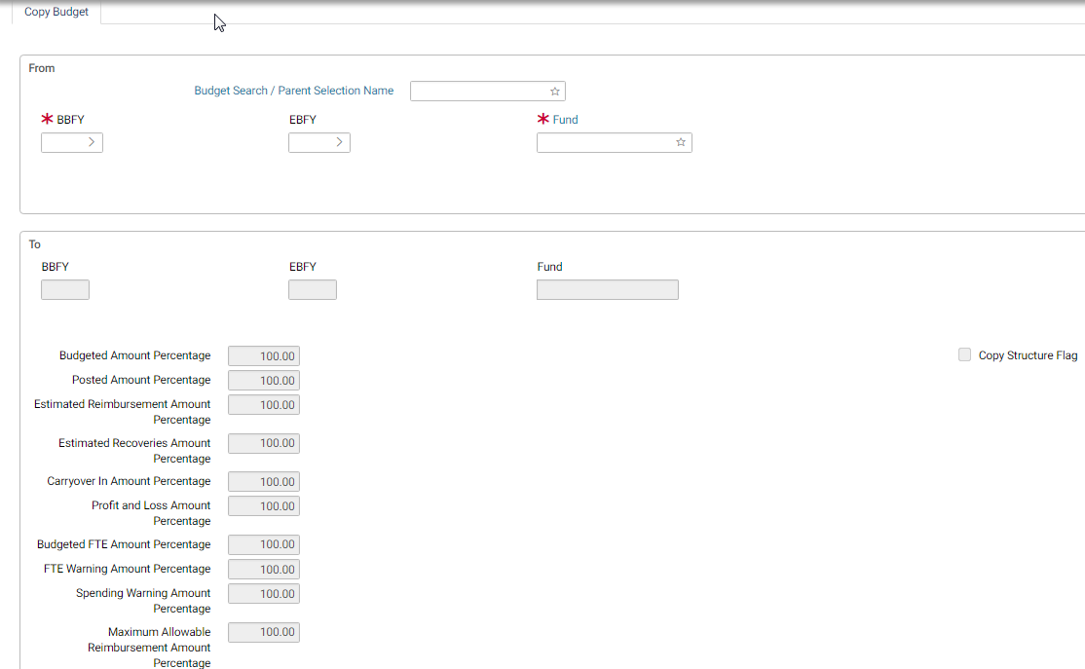
The To section on the same tab will be active. Enter the To Fund Dimensions for the new budget that is to be created. To create $0.00 budget lines, check the Copy Structure Flag; otherwise, specify the percentage of each budget resource to be copied. Select the Finish button.
- Make any necessary changes and select Verify and Submit.
NOTE: All names and amounts are copied exactly from the original budget, change any other amounts or settings as necessary.

Creating a Budget Reprogramming Form
- Navigate to Transaction → Budget Execution → New → Budget Reprogramming
- Enter the Document Type BR and select the Generate button.
- Select the Finish button.
- Select the Lines tab and select the Add button.
Figure 31: Budget Reprogramming Form Lines Screen
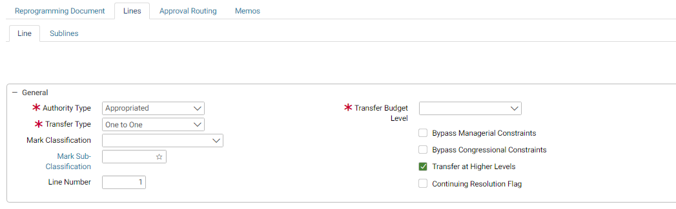
- Choose a Transfer Budget Level and enter a Transfer Amount.
- Populate the From and To Budget group box fields.
Figure 32: Budget Reprogramming Form From and To Budget Sections
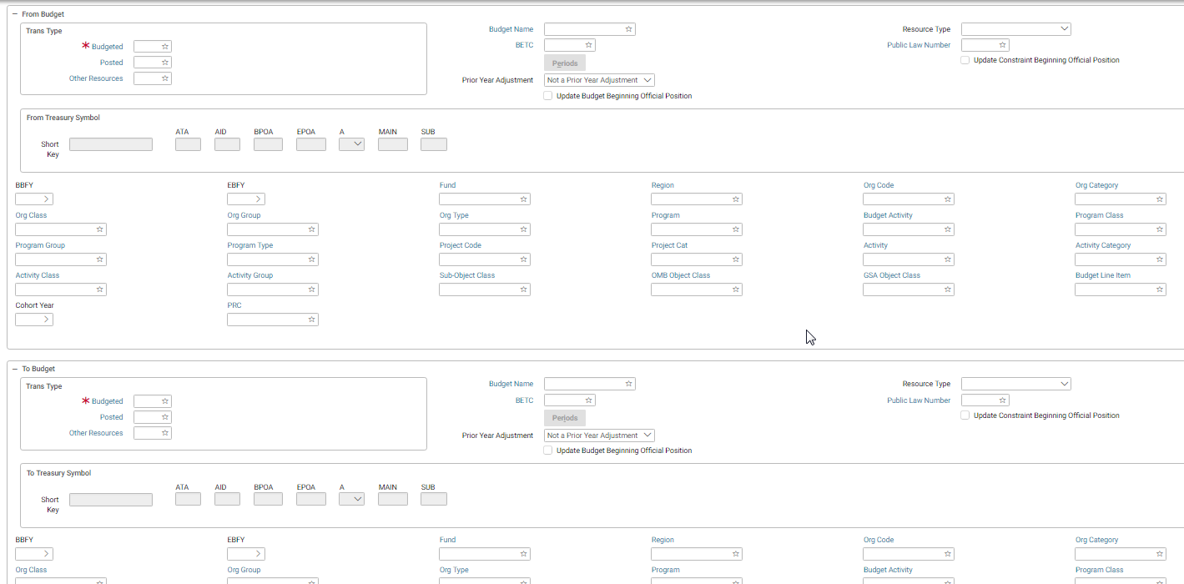
- Add approvals to the Approval Routing tab if necessary and select the Verify and Submit buttons.

Appropriation Transfer Form
- Navigate to Transactions → Budget Execution → New → Appropriation Transfer
Figure 33: New Appropriation Transfer Screen
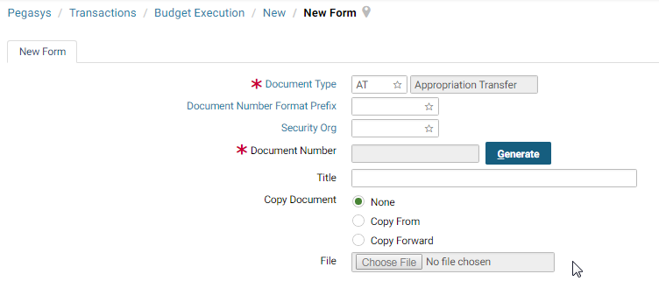
- Enter the Document Type AT and select the Generate button to generate a Document Number.
- Select the Finish button.
- Select the Accounting Lines tab and select the Add button.
- In the Line Amounts group box, enter an Amount.
- Populate the To and From group box fields.
- Enter an approval on the Approving Routing tab if necessary; otherwise select the Verify and Submit buttons.

Budget Maintenance Tables

Fund Maintenance Table
In Pegasys, the starting point for budgeting is the fund, which represents budgetary resources set aside for a particular purpose. Funds may be established to track congressional appropriations, or they may be used for other purposes, such as deposit and receipt funds. Each fund has its own budget structure, allowing the user to track resources at different levels of detail for different funds. Budgetary and spending controls are also specified separately for each fund, allowing users to tailor the management controls of each fund to suit their specific needs. A fund is required on almost all Pegasys transactions because a fund specifies where money is drawn from or where collected money is recorded. In the Fund maintenance table in
Figure 34: Fund Maintenance Table (sometimes referred to as the Fund Code maintenance table), the user defines the GSA’s funds and how the funds can be used in budgets and transactions across GSA.
Figure 34: Fund Maintenance Table
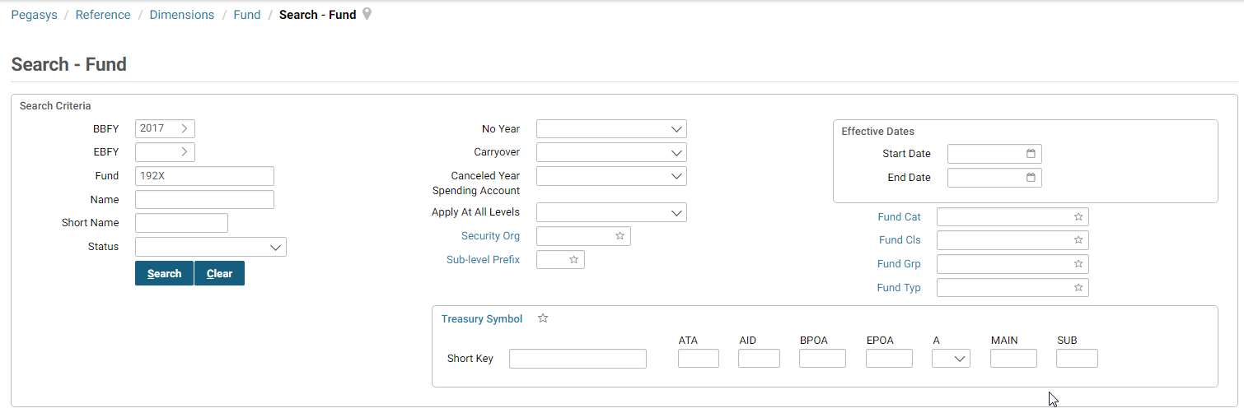
Figure 35: Fund Maintenance Table - Fund Code Tab
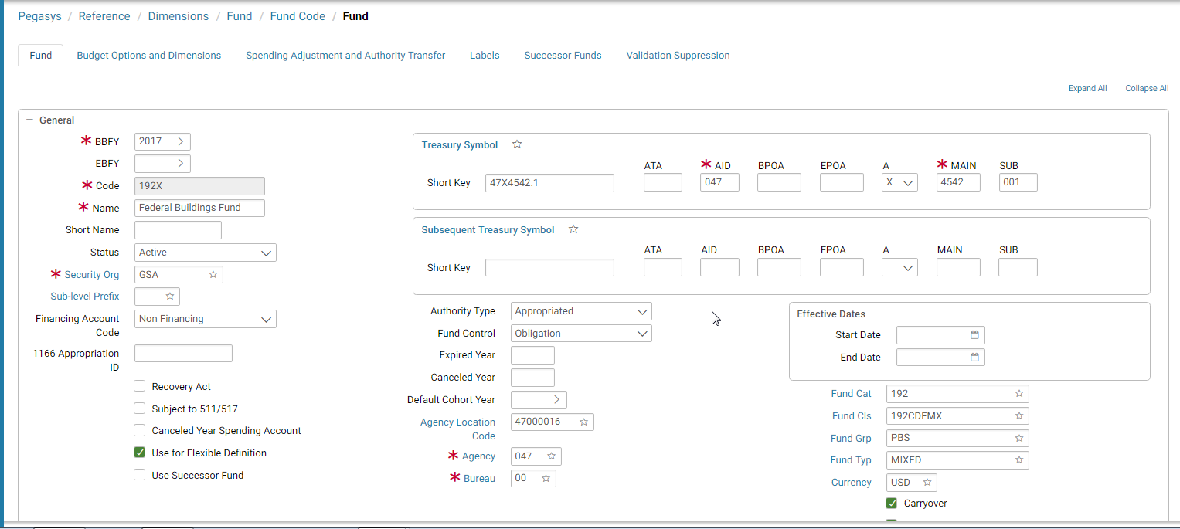As a result of the evolving Treasury system modernization effort, the structure of the treasury symbol is changing to the Component Treasury Symbol structure. The component structure is reflected in the Treasury Symbol section of the Fund Maintenance Table.
Figure 36: Fund Maintenance Table - Fund Allocation Precedence Section
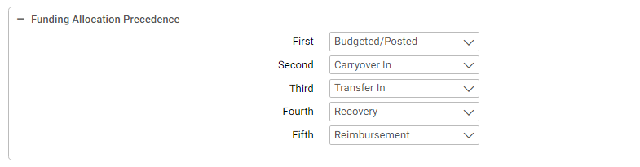
A new section of fields appear in the Fund Maintenance table in the Funding Allocation Precedence box. The order in which to allocate the carryover out or funding removed amounts will be determined by the funding precedence hierarchy defined on the fund table. The funding precedence will include a series of five drop down lists where the agency can determine how to allocate the funding. The baseline default settings of precedence are:
- Budgeted/Posted
- Transfer In
- Carryover In
- Recovery
- Reimbursement
Figure 37: Fund Maintenance Table - Spending Adjustment Options
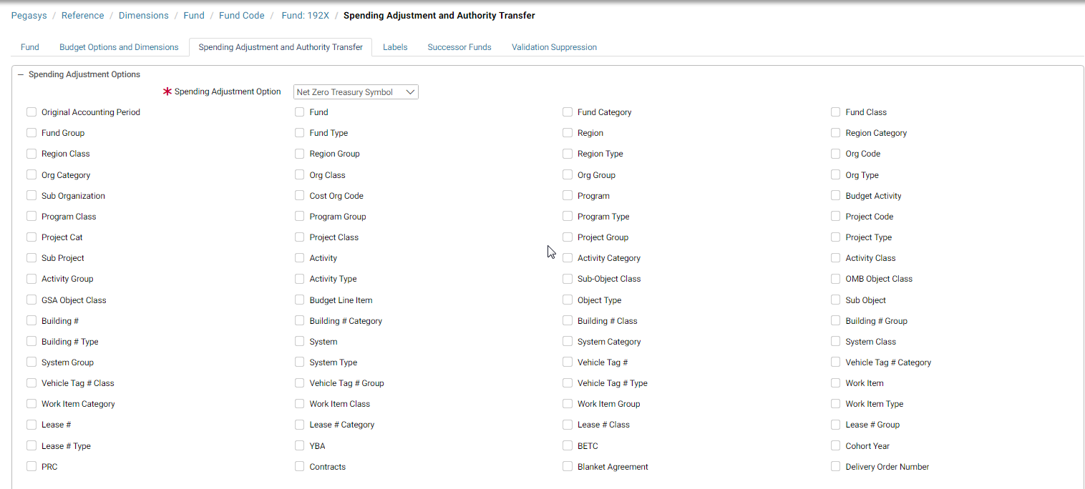
The Spending Adjustment Options tab allows agencies to define the elements that are used to evaluate spending transactions to determine if spending adjustments and/or authority transfers should be generated. The spending adjustment options are applicable to all funds whereas the authority transfer options are applicable to un-expired multi-year funds and no-year funds. The Spending Adjustment Option and Authority Transfer Option fields determine the level of detail that is used to evaluate if the net spending is modified and if a spending adjustment should be generated. This option can be supplemented by checking the dimensions fields to include additional elements as part of the evaluation. If budget line is selected, the agency can optionally choose additional budget elements to include in the grouping evaluation by checking any of the dimensions fields in the respective sections.
Figure 38: Fund Maintenance Table - Authority Transfer Options
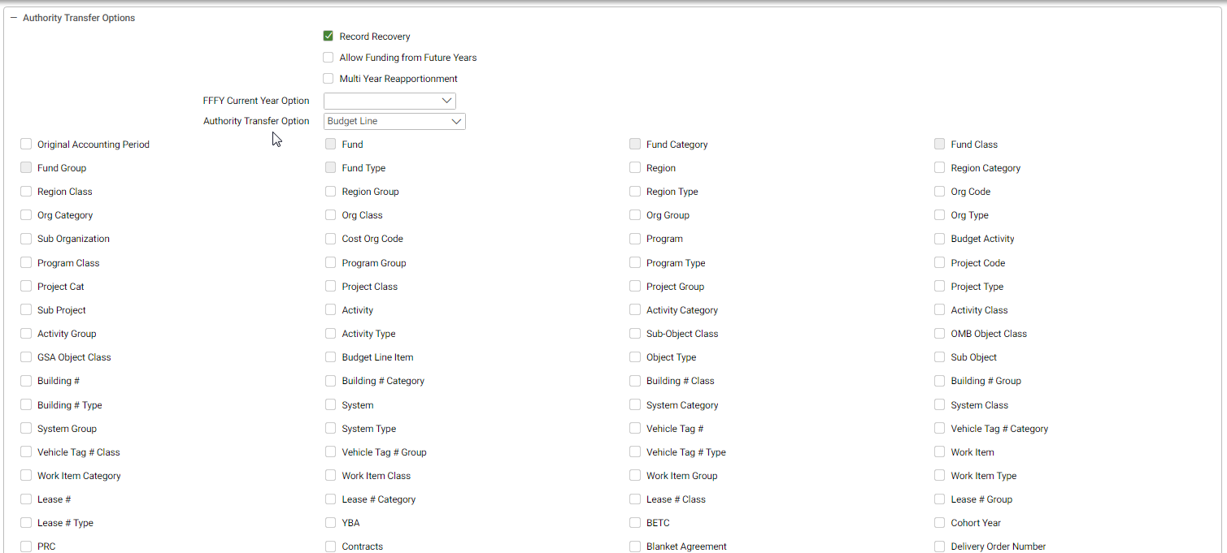
Table 4: Fund Code Field Descriptions
NOTE: A complete list of Fund Code Field Descriptions can be found in Online Help. Select the drop down arrow in the upper right hand corner and select Support. Select the Show hyperlink in the upper left hand corner. Select Search. Enter Fund Code Maintenance Table and select Go.
Field Name | Description
1166 Appropriation ID | The properly formatted Appropriation ID that will be carried over to the State 1166 files.
Agency * | A code identifying the agency for external reporting purposes. The agency code must be valid in the Agency maintenance table.
Agency Location Code | The Agency Location Code or range of Agency Location Codes for which the data belongs. Represents the disbursing entity (agency, bureau, and accounting station) that accomplished the disbursement or collection.
Authority Type | The authority type: Appropriated, Receipt, Revolving, or Other.
BBFY * | The beginning budget fiscal year of the fund. The combination of BFYs and fund must be valid in the Fund maintenance table.
Bureau * | A two-digit code identifying the agency bureau code for external reporting purposes. The bureau code must be valid in the Bureau maintenance table in combination with the entered agency. This field is required if the vendor type is government.
Cancelled Year | The year the fund was cancelled.
Cancelled Year Spending Account | Indicates whether this fund represents the portion of the current appropriation, which has been designated to capture spending activity originally chargeable to a cancelled appropriation.
Carryover | Indicates whether unused budgetary authority can be carried over to the following fiscal year for No Year funds. Only enabled when the No Year checkbox is true.
Code * | The unique alphanumeric identifier of the item.
Currency | The key currency for all budget updates in the system. Inferred from the budget's fiscal year(s) and fund on the transaction's accounting line.
Default Cohort Year | Year that will be used as the default cohort year if no cohort year is entered on transactions referencing the fund.
EBFY | The ending budget fiscal year of the fund. The combination of BFYs and fund must be valid in the Fund maintenance table.
Effective Dates | The effective start and end dates of the item. Please enter the value in the following format: MM/DD/YYYY or MMDDYY.
Expired Year | The year the fund expired.
Financing Account Code | Sets the value for the Financing Account Indicator. Valid values are Direct, Guaranteed, and Non Financing. If the Financing Account value is Direct or Guaranteed the Default Cohort Year is required. If the Financing Account value is Non Financing the Default Cohort Year must be blank.
Fund Cat | A fund dimension that is a higher-level roll-up of the fund code. The value must be valid in the Fund Category maintenance table.
Fund Cls | A fund dimension that is a higher-level roll-up of the fund code. The value must be valid in the Fund Class maintenance table.
Fund Grp | A fund dimension that is a higher-level roll-up of the fund code. The value must be valid in the Fund Group maintenance table.
Fund Typ | A fund dimension that is a higher-level roll-up of the fund code. The value must be valid in the Fund Type maintenance table.
Funds Control | Indicates whether budget updates associated with this fund are expense-based or obligation-based. Valid values: Expense and Obligation.
Name * | The name associated with the unique alphanumeric identifier of the item.
No Year | Indicates whether the fund is a No Year fund. No Year funds do not have set time limits; they are valid until all money has been expended or until the task for which the fund was established has been completed. An ending budget fiscal year is not allowed if No Year is selected.
Recovery Act | Indicates whether the fund is marked for Recovery and Reinvestment Act monies.
Security Org | The established security organization for the item. When performing maintenance, the security org establishes what group the item will be associated with. Only users specified in the security organization will have access to this item.
Short Name | The name to appear on reports when there is not enough space for the full name.
Status | Determines whether the code is active or inactive.
Sub-level Prefix | The unique code that is a component piece of the Treasury Symbol, representing a programmatic breakdown of the account for Treasury publication purposes. The values are defined by the Agencies to capture organization related data. The code is up to 2 characters long, in alphanumeric format. It is displayed at the beginning of the Treasury Symbol inside parenthesis. Example: Treasury Symbol 27 characters: (41)18-4704/051234.888 where Sub-level Prefix = 41, Agency = 18, Source Agency = 47, Fiscal Year From = 2004, Fiscal Year To = 2005, Main Account = 1234 and Sub Account = 888.
Subject to 511/517 | Indicates the fund must use a different Treasury Symbol after the initial period of availability has passed. Enables the Subsequent Treasury Symbol field.
Subseq. Treasury Symbol | The treasury symbol recorded in the journals when the fiscal year of the document is greater than the EBFY of the fund, if one exists, or greater than the BBFY of the fund, if no EBFY exists. Must be valid on the Treasury Symbol maintenance table. Enabled when Subject to 511/517 is set to True.
Treasury Symbol * | The U.S. Treasury Symbol to be used for the item.
Use for Flexible Definitions | Indicates whether the user can establish flexible definitions (that is, different general ledger posting models based on fund).
Use Successor Fund | Indicates the fund is eligible to use successor fund logic when performing carryover and authority transfers. Enabled for no-year and multi-year funds. When true, enables the Successor Fund button.
Activity | Indicates a limitation edit exists when the activity dimension (code, category, class, group, or type) is used on a spending transaction. Spending controls can also be set against the limitation (Valid Values: None, Reject, Warning, Override).
Allow Funding from Future Years | Indicates whether a No Year fund is eligible for authority transfers from a current year budget to a prior year budget. This field defaults to not checked. Enabled for funds where No Year flag = True and Record  Recovery = True.
Allow New Spend Against Expired | Indicates whether the user can process new spending activity (for example, un obligated payments, increases in obligations, etc.) against the fund once it has expired.
Allow Spend Against Cancelled | Indicates whether the user can process spending activity (for example, un obligated payments, increases in obligations, etc.) against the fund once it has been cancelled.
Apply Reimbursements at all Levels | Indicates whether reimbursements are eligible to be distributed to all lower budget levels. Reimbursements are distributed to lower budget levels only if the revenue source code used in the transaction is reimbursable and can be applied to all levels. If not checked, reimbursements are only recorded at the appropriation level. Cannot be changed once an appropriation exists for the fund.
Division | Indicates a limitation edit exists when the division dimension (code, category, class, group, or type) is used on a spending transaction. Spending controls can also be set against the limitation (Valid Values: None, Reject, Warning, Override).
Multi-Year Reapportionment | Indicates whether a Multi Year fund is eligible for authority transfers. This field defaults to not checked. Enabled for funds where both BBFY and EBFY are not null.
Object | Indicates a limitation edit exists when the object dimension (code, category, class, group, or type) is used on a spending transaction. Spending controls can also be set against the limitation (Valid Values: None, Reject, Warning, Override).
Organization | Indicates a limitation edit exists when the organization dimension (code, category, class, group, or type) is used on a spending transaction. Spending controls can also be set against the limitation (Valid Values: None, Reject, Warning, Override).
Prevent New Use | When set to True, this indicator allows existing spending chains to be liquidated and closed within tolerances, but no new spending chains can be associated with the code.
Program | Indicates a limitation edit exists when the program dimension (code, category, class, group, or type) is used on a spending transaction. Spending controls can also be set against the limitation (Valid Values: None, Reject, Warning, Override).
Project | Indicates a limitation edit exists when the project dimension (code, category, class, group, or type) is used on a spending transaction. Spending controls can also be set against the limitation (Valid Values: None, Reject, Warning, Override).
Record Recovery | Indicates whether a No Year fund is eligible for authority transfers between a prior year budget and a current budget. This field defaults to not checked. Enabled for funds where No Year flag = True.
Spending Adjustment Level * | The level at which a documents lines will be summarized when determining whether to record an unexpired or expired spending adjustment. Valid values: None, Line, Net Zero Treasury Symbol, Net Zero BBFY/EBFY/Fund, Net Zero Budget Line Default value: BBFY/EBFY/Fund.
Spending Adjustment Update Level | The level at which a spending adjustment updates the budget and the dimensions captured on the associated General Ledger postings. Valid values: Fund, Budget Line, Accounting Line Default value: Fund Required if Spending Adjustment Level <> None.
Sub Object | Indicates a limitation edit exists when the sub object dimension (code, category, class, group, or type) is used on a spending transaction. Spending controls can also be set against the limitation (Valid Values: None, Reject, Warning, Override).
Track Agreements at all Levels | Indicates whether all agreements associated with this fund are tracked.
Suppress Accounting Dimension Validation | Indicates whether accounting dimension validation is suppressed for document lines using this fund. If so, entity validation must also be suppressed.
Suppress Entity Validation | Indicates whether entity validation is suppressed for document lines using this fund.
Suppress Reference Document Validation | Indicates whether reference document validation is suppressed for document lines using this fund. If so, entity validation must also be suppressed.
Use Partition Validation Options | Indicates whether the Fund uses the validation options of its Partition.
Validate Checkboxes | Indicates whether to override accounting dimension suppression for the given accounting dimension.
Budget Options
Accrual | The level of accrual control for the budget level. Valid values: None, Overrideable, Reject, or Warning.
Apportionment Budget Category | The apportionment can be designated as Category A, B, C, or D. Category A indicates that the apportionment specifies how much of the appropriation is available to an agency. The Office of Management and Budget may also specify how resources are distributed across calendar quarters. Category B indicates that the apportionment may specify the distribution of resources across time periods other than quarters. Category B apportionments may also be made on the basis of activities, projects, objects, etc. Category C budgets are not apportioned. D budgets are reimbursable.
Apportionment Limitation Number | The number from 00 to 99 that identifies the limitation represented by this fund code. This field is used for the SF-133 Report on Budget Execution. The Limitation Number is required for category B budgets and is otherwise not allowed.
Budget Est. Reimbursements at Lower Level | Determines whether the system should record recoveries at the next budget level.
Budgeting | The level of budgeting controls used at the budget level. Valid values: None, Overrideable, Reject, and Warning.
Carryover Out Option | Indicates whether the carryover amount is based on amounts in the budget or amounts in GL accounts marked for Carryover on the Year End Account Definitions maintenance table. Enabled if Carryover = True. Valid values: Budget, General Ledger, None.
Commitment | The level of commitment control for the budget level. Valid values: None, Overrideable, Reject, or Warning.
Expenditure | The level of expenditure control for the budget level. Valid values: None, Overrideable, Reject, or Warning.
Expense | The level of expense control for the budget level. Valid values: None, Overrideable, Reject, or Warning.
FTE Budgeting | The level of FTE budgeting controls used at the budget level. Valid values: None, Overrideable, Reject, and Warning.
FTE Spending | The level of FTE spending control for the budget level. Valid values: None, Overrideable, Reject, or Warning.
Obligation | The level of obligation control for the budget level. Valid values: None, Overrideable, Reject, or Warning.
Posting | The level of posting control for the budget level. Valid values: None, Overrideable, Reject, or Warning.
Pre-Commitment | The level of pre-commitment control for the budget level. Valid values: None, Overrideable, Reject, or Warning.
Record Carryover In at Lower Level | Determines whether the carryover in will be recorded at the lower budget level.
Record Recoveries at Lower Level | Determines whether the system should record recoveries at the next budget level.
System Generate at all Levels | When the System Generate At All Levels option is checked and the Require Presence option is off, this option generates a budget line at multiple levels if a spending transaction is processed against an accounting distribution that does not match an existing budget line.
NOTE: The asterisk (“*”) denotes a required field.

Budget Dimensions
The Budget Dimensions table (Figure 39: Budget Dimension Maintenance Table) provides the ability to create a budget structure using multiple rollups of the same budget dimension as well as the dimension code. This table shows where the sub-budget dimensions to be displayed on affected pages throughout the system can be configured. Table 5: Budget Dimension Field Descriptions describes the fields in the Budget Dimension table.
Figure 39: Budget Dimension Maintenance Table - Search Criteria
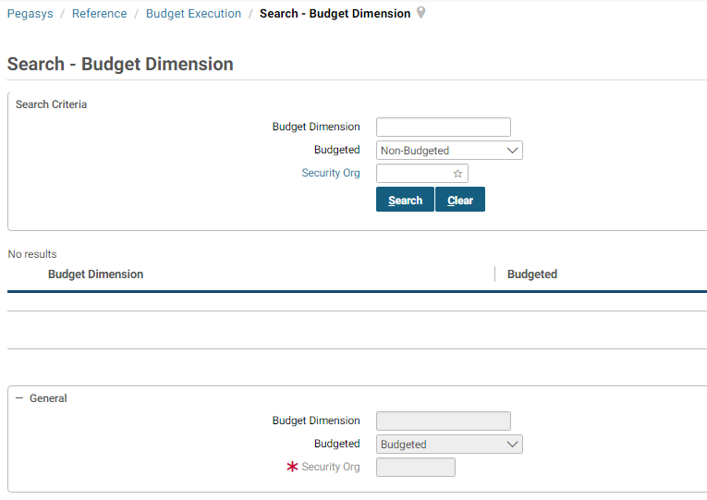
Table 5: Budget Dimension Field Descriptions
Field Name | Description
Budget Dimension | The name of the budget dimension.
Budgeted | If set to Budgeted, the selected sub-budget dimension will be displayed on affected pages throughout the system. If set to Non- Budgeted, the selected sub-budget dimension will not be displayed on affected pages.

Budget Execution Options
Figure 40: Budget Execution Options Maintenance Table specifies whether obligations, commitments, and reservations affect the Available Amount of Pegasys budgets in a given fiscal year. A budget's available amount is shown on the Budget query.
Table 6: Budget Option Field Descriptions describes the fields in the Budget Execution Options Table.
Figure 40: Budget Execution Options Maintenance Table - Search Criteria
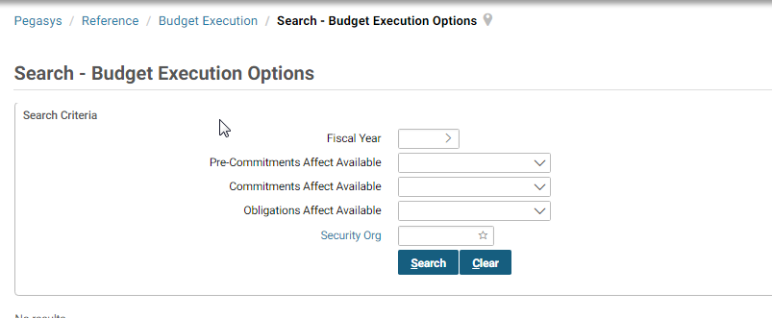
Table 6: Budget Option Field Descriptions
NOTE: A complete list of Budget Option Field Descriptions can be found in Online Help. Select the drop down arrow in the upper right hand corner and select Support. Select the Show hyperlink in the upper left hand corner. Select Search. Enter Budget Execution Options Maintenance Table and select Go.
Field Name | Description
Commitments Affect Available Amount | Indicates whether commitments are included in the available amount calculation. A check indicates that commitments reduce the available amount, while no check indicates that commitments do not reduce the available amount.
Fiscal Year * | Identifies the fiscal year to which the item is assigned.
Obligations Affect Available Amount | Indicates whether obligations are included in the available amount calculation. A check indicates that obligations reduce the available amount, while no check indicates that obligations do not reduce the available amount.
Reservations Affect Available Amount | Indicates whether reservations are included in the available amount calculation. A check indicates that reservations reduce the available amount, while no check indicates that reservations do not reduce the available amount.
Security Org | The established security organization for the item. When performing maintenance, the security org establishes what group the item will be associated with. Only users specified in the security organization will have access to this item.
NOTE: The asterisk (“*”) denotes a required field.

Constraints
Figure 41: Constraints Maintenance Table is used to define congressional and managerial constraints to be used as limits of fund transfers on documents in the budget execution subsystem. Table 7: Constraints Field Descriptions describes the fields in the Constraint Table.
Figure 41: Constraints Maintenance Table - Search Criteria
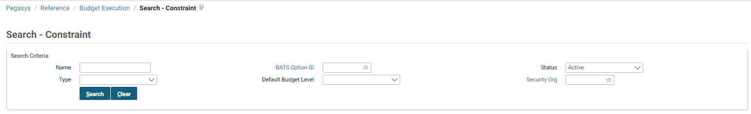
Table 7: Constraints Field Descriptions
NOTE: A complete list of Constraints Field Descriptions can be found in Online Help. Select the drop down arrow in the upper right hand corner and select Support. Select the Show hyperlink in the upper left hand corner. Select Search. Enter Constraint Maintenance Table and select Go.
Field Name | Description
Constraint Control * | Indicates the type of message returned is a constraint is exceeded. Valid values are None, Overridable, Reject, and Warning.
Constraint Type * | The source of the Constraint. The Valid values: Congressional or Managerial.
Name * | The unique value that defines this constraint. Constraint names may be duplicated only if the Constraint Type is different.
Security Org | The established security organization for the item. When performing maintenance, the security org establishes what group the item will be associated with. Only users specified in the security organization will have access to this item.
Status | Indicates whether the constraint will be enforced.
Constraints
Lower Constraint % | Defines the lower percentage of the constraint.
Lower Constraint Amount | Defines the lower amount of the constraint.
Upper Constraint % | Defines the upper percentage of the constraint.
Upper Constraint Amount | Defines the upper amount of the constraint.
Dimensions
Activity | An alphanumeric code that specifies an activity dimension. The value must be valid in the Activity maintenance table.
Division | An alphanumeric code that specifies a division dimension. The value must be valid in the Division maintenance table.
Object | An alphanumeric code that specifies an object dimension. The value must be valid in the Object maintenance table.
Organization | An alphanumeric code that specifies an organization dimension. The value must be valid in the Organization maintenance table.
Program | An alphanumeric code that specifies a program dimension. The value must be valid in the Program maintenance table.
Project | An alphanumeric code that specifies a project dimension. The value must be valid in the Project maintenance table.
Sub Object | An alphanumeric code that specifies a sub object dimension. The combination of object and sub object must be valid in the Sub Object maintenance table.
Budget Object | The object whose budget is updated when this object is coded on a spending transaction. Required if a Usage value of Coded is selected. Must be valid object on the Object maintenance Table with an usage indicator of Budget or Either.
Budget Organization | Required if a Usage value of Coded is selected; otherwise, it’s not allowed. The value entered in this field must be a valid on the Organization maintenance table with an usage indicator value of Budget or Either.
Budget Program | Required if a Usage value of Coded is selected. The program whose budget is updated when this program is coded on a spending transaction. The value in this field must be valid on the Program maintenance table and have an usage indicator of Budget or Either.
NOTE: The asterisk (“*”) denotes a required field.

Funding Withdrawal Definition
On the Funding Withdrawal Definition table (Figure 42: Funding Withdrawal Definition), the user defines funding withdrawal details and the budget nodes from which funding is withdrawn. Records on this table can be processed using the Carryover/Funding Withdrawal batch job. Table 8: Funding Withdrawal Field Descriptions describes the fields in the Funding Withdrawal Definition Table.
Figure 42: Funding Withdrawal Definition - Search Criteria
Table 8: Funding Withdrawal Field Descriptions
NOTE: A complete list of Funding Withdrawal Field Descriptions can be found in Online Help. Select the drop down arrow in the upper right hand corner and select Support. Select the Show hyperlink in the upper left hand corner. Select Search. Enter Funding Withdrawal Definition Maintenance Table and select Go.
Field Name | Description
Authority Type | The authority type: Appropriated, Receipt, Revolving, or Other.
Currency Code | The currency code of the item. Must be a valid value on the Currency Code maintenance table.
Enabled | Indicates whether or not the record is enabled for funding Withdrawal. Yes indicates the record will be picked up and processed during the Carryover/Funding Withdrawal batch process.
From/To Budget Level | The lowest and highest budget levels from which funding will be withdrawn. Enabled when Authority Type indicator is not blank. Valid values when Authority Type = Appropriated: Appropriation, Apportionment, Allocation, Suballocation, Allotment, Suballotment, Allowance, Suballowance, or blank Valid values when Authority Type = Revolving or Other: Determined by system settings. Default value: blank.
Fund Status | The status of the funds from which funding is withdrawn. Valid values: Unexpired = Funds where Fiscal Year/Closing Fiscal Year parameter is less than Fund Expired Year and Cancelled Year; funds where Expired Year and Cancelled Year fields are not populated. Expired = Funds where Fiscal Year/Closing Fiscal Year parameter is greater than or equal to Fund Expired Year and less than Cancelled Year. Cancelled = Funds where Fiscal Year/Closing Fiscal Year parameter is greater than or equal to Fund Cancelled Year. Expiring = Funds where Fiscal Year/Closing Fiscal Year parameter plus 1 is greater than or equal to Fund Expired Year and less than Cancelled Year. Cancelling = Funds where Fiscal Year/Closing Fiscal Year parameter plus 1 is greater than or equal to Fund Cancelled Year. Default value: blank.
Removal Amount | The amount of funds to be withdrawn.
Removal Percentage | The percentage of funds to be withdrawn.

Mark Sub-Classification
Figure 43: Mark Sub-Classification Maintenance Table provides the ability to create another level of detail for the classifications available on the Mark form. Figure 43: Mark Sub-Classification Maintenance Table describes the fields in the Mark Sub-Classification Table.
Figure 43: Mark Sub-Classification Maintenance Table - Search Criteria
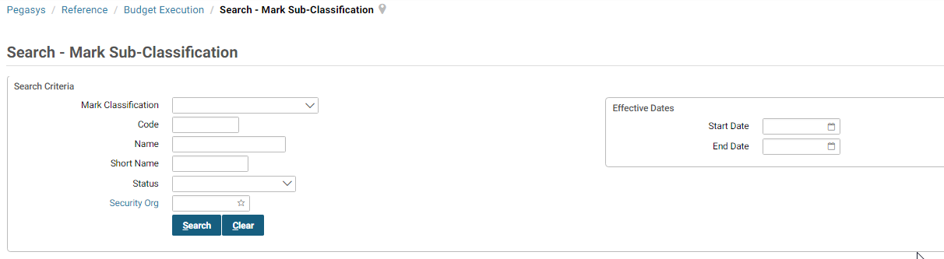
Table 9: Mark Sub Classification Field Descriptions
NOTE: A complete list of Mark Sub Classification Field Descriptions can be found in Online Help. Select the drop down arrow in the upper right hand corner and select Support. Select the Show hyperlink in the upper left hand corner. Select Search. Enter Mark Sub Classification Maintenance Table and select Go.
Field Name | Description
Code* | The unique alphanumeric identifier of the item.
Effective Dates | The effective start and end dates of the item. Please enter the value in the following format: MM/DD/YYYY or MMDDYY.
Mark Classification* | Determines the code to which this corresponds. Valid values include: Allocation with Prejudice, Allocation without Prejudice, Rescission/Deduction, Supplemental, Unallocated with Prejudice, Unallocated without Prejudice, Withhold, Withhold Release.
Name* | The name associated with the unique alphanumeric identifier of the item.
Security Org | The established security organization for the item. When performing maintenance, the security org establishes what group the item will be associated with. Only users specified in the security organization will have access to this item.
Short Name | The name to appear on reports when there is not enough space for the full name.
Status | Determines whether the code is active or inactive.
NOTE: The asterisk (“*”) denotes a required field.

Treasury Symbol
The Treasury Symbol maintenance table (Figure 44: Treasury Symbol Maintenance Table) is used to define valid Treasury symbols for use in GSA’s activities. On this reference table, GSA can capture the Sub-level Prefix Code which is part of the Common Government-wide Accounting Classification (CGAC) initiative. Table 10: Treasury Symbol Field Descriptions describes the fields in the Treasury Symbol Table.
Figure 44: Treasury Symbol Maintenance Table - Search Criteria
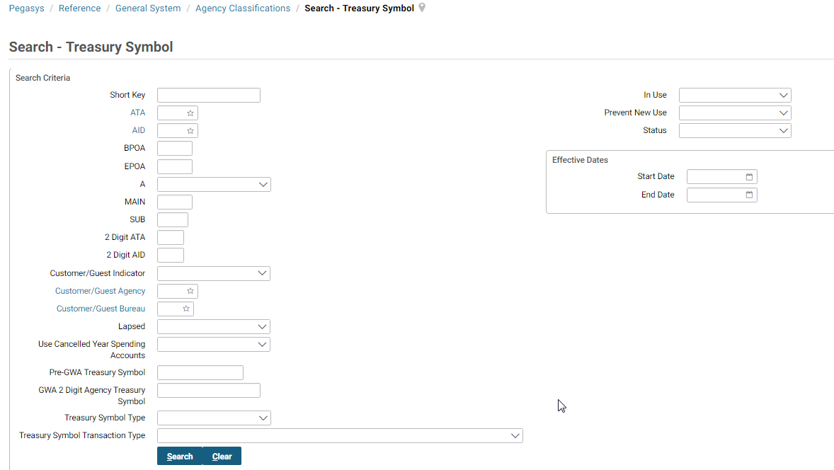
Table 10: Treasury Symbol Field Descriptions
NOTE: A complete list of Treasury Symbol Field Descriptions can be found in Online Help. Select the drop down arrow in the upper right hand corner and select Support. Select the Show hyperlink in the upper left hand corner. Select Search. Enter Treasury Symbol Maintenance Table and select Go.
Field Name | Description
Agency * | A code identifying the agency associated with the Treasury symbol. The agency code must be valid in the Agency Code maintenance table. If the Customer/Guest Indicator is selected, this field is required; otherwise, it is not allowed.
Availability Type | Indicates the type of accounts that are available through the Treasury Symbol. Valid values include No Year Account, Clear/Suspense Account, Treasury Central Summary GL Account, and Merged Surplus Account. System defaults to a blank selection.
Available From Year | Must be a four-digit first year of a multiple-year fund.
Available To Year | If entered and if Available From is not entered: Four-digit year of a single-year fund. Four-digit year of a multi-year fund. X - to represent a no-year fund. F - to represent a clearing account. Other one-character alphanumeric character. Blank - to represent certain receipt accounts. If Available From is entered, must be a four-digit last year of a multi-year fund.
Budget Account | The budget account code associated with the Treasury Symbol.
Budget Account Name | The associated Name field for the referenced Budget Account Code value.
Customer/Guest Agency | A two-digit code identifying the guest agency associated with the Treasury symbol. The bureau code must be valid in the Bureau Code maintenance table. If the Customer/Guest Indicator is selected, this field is required; otherwise, it is not allowed.
Customer/Guest Bureau | A two-digit code identifying the guest bureau associated with the Treasury symbol. The bureau code must be valid in the Bureau Code maintenance table. If the Customer/Guest Indicator is selected, this field is required; otherwise, it is not allowed.
Customer/Guest Indicator | Indicates whether or not this Treasury symbol belongs to another agency with which the user conducts interagency business. If this option is checked, only the security organization (required), description, Treasury Symbol (required), 224-Indicator, Agency Code (required), and Customer/Guest Bureau Code fields can be entered.
Fund Symbol * | The unique identifier for the fund symbol.
Lapsed | Indicates whether or not this Treasury symbol updates the SF-2108s Lapse column. If the Customer/Guest Indicator is selected, this field is disabled.
Partition * | Partition Code of the item. Must be valid on Partition maintenance table and must be valid in conjunction with other elements of the accounting strip. Partition must be enabled for Partition parameters to be displayed.
Pre-GWA Treasury Symbol | The old Treasury Symbol format that was used before the GWA initiative, for use by processes that have not yet been transitioned to the new format.
Security Org | The established security organization for the item. When performing maintenance, the security org establishes what group the item will be associated with. Only users specified in the security organization will have access to this item.
SF-224 Classification * | Indicates in which column on the SF-224 report this Treasury symbol is reported. Valid choices are Receipt, Disbursement, Both, and Neither. If the Customer/Guest Indicator is selected, this field is optional; otherwise, it is not allowed.
Source Agency | A two-digit code representing the source funds associated with this Treasury symbol. Not allowed if Customer/Guest Indicator is selected.
Sub-Account | The number identifying a lower level of tracking for a Treasury Symbol.
Treasury Symbol | The code that defines the Treasury symbol. The Treasury symbol is potentially made up of the following fields: Agency, Source Agency, Available From, Available To, Fund Symbol and Sub-Account.
Use Cancelled Year Spending Accounts | Determines the method for tracking spending against cancelled appropriations.
Spending Adjustment Default Posting Fund
BBFY | The beginning budget fiscal year of the fund. The combination of BFYs and fund must be valid in the Fund maintenance table.
Code | The unique alphanumeric identifier of the item.
EBFY | The ending budget fiscal year of the fund. The combination of BFYs and fund must be valid in the Fund maintenance table.
External Reporting Information
Fund Status | The status of the funds from which funding is withdrawn. Valid values: Unexpired = Funds where Fiscal Year/Closing Fiscal Year parameter is less than Fund Expired Year and Cancelled Year; funds where Expired Year and Cancelled Year fields are not populated. Expired = Funds where Fiscal Year/Closing Fiscal Year parameter is greater than or equal to Fund Expired Year and less than Cancelled Year. Cancelled = Funds where Fiscal Year/Closing Fiscal Year parameter is greater than or equal to Fund Cancelled Year. Expiring = Funds where Fiscal Year/Closing Fiscal Year parameter plus 1 is greater than or equal to Fund Expired Year and less than Cancelled Year. Cancelling = Funds where Fiscal Year/Closing Fiscal Year parameter plus 1 is greater than or equal to Fund Cancelled Year. Default value: blank.
Public Law Number | The public law number of the appropriation or continuing resolution.
Suffix | Any suffix, prefix, or miscellaneous information about the fund. Not allowed if Customer/Guest Indicator is selected.
Year Indicator | The year of the fund. It is entered in the format xx/yy, where xx is the last 2 digits of the first fiscal year and yy is the last 2 digits of the last fiscal year. Not allowed if Customer/Guest Indicator is selected.
Record Type 7
Code | The unique alphanumeric identifier of the item.
Effective Dates | The effective start and end dates of the item. Please enter the value in the following format: MM/DD/YYYY or MMDDYY.
Fiscal Year | Identifies the fiscal year to which the item is assigned.
Name | The name associated with the unique alphanumeric identifier of the item.
Security Org | The established security organization for the item. When performing maintenance, the security org establishes what group the item will be associated with. Only users specified in the security organization will have access to this item.
Short Name | The name to appear on reports when there is not enough space for the full name.
BETC
Name | The name on the BETC maintenance table for the selected BETC value.
IPAC Indicator | The IPAC indicator on the BETC Maintenance table for the selected BETC value. Indicates the type of activity that is occurring. Valid values include Blank, Payment, Collection, Payment Adjustment, and Collection Adjustment.
Effective Start Date | Designates the start date of the TSYM/BETC combination. Must be a valid date format of MM/DD/YYYY or MM/DD/YY.
Effective End Date | Designates the end date of the TSYM/BETC combination. Must be a valid date format of MM/DD/YYYY or MM/DD/YY.
Default | Indicates whether the selected BETC Code is set as the default. Only one record can have a Default Indicator of Yes. Valid values include Yes and No. Defaults to No.
BETC Code | The Business Event Type Code (BETC). An 8 character code used to indicate the type of activity being reported.
Adjustment BETC | Indicates whether the BETC code is an adjustment.
Sub Level Prefix
End Date | The date to end or deactivate the item. Enter in the MM/DD/YY or MM/DD/YYYY format.
Name | The name associated with the sub-level prefix code.
Start Date | The date to start or to activate the item. Enter in the MM/DD/YY or MM/DD/YYYY format.
Sub-level Prefix | The unique code that is a component piece of the Treasury Symbol, representing a programmatic breakdown of the account for Treasury publication purposes. The values are defined by the Agencies to capture organization related data. The code is up to 2 characters long, in alphanumeric format. It is displayed at the beginning of the Treasury Symbol inside parenthesis. Example: Treasury Symbol 27 characters: (41)18-4704/051234.888 where Sub-level Prefix = 41, Agency = 18, Source Agency = 47, Fiscal Year From = 2004, Fiscal Year To = 2005, Main Account = 1234 and Sub Account = 888.
NOTE: The asterisk (“*”) denotes a required field.

Budget Accounts
Figure 45: Budget Account Maintenance Table is used to enter and maintain Budget Accounts designated by the Office of Management and Budget (OMB). The OMB forms these accounts by concatenating the OMB Agency, OMB Bureau, and Budget Account Code. The Budget Accounts themselves can be associated with one or more Treasury Symbols.
Table 11: Budget Account Field Descriptions describes the fields in the Budget Account Table.
Figure 45: Budget Account Maintenance Table
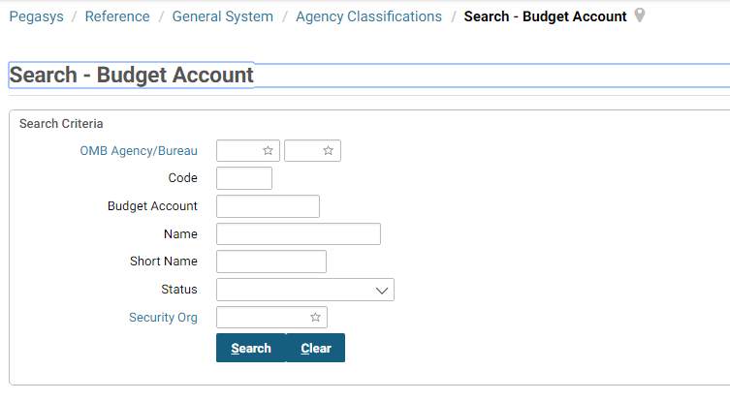
Table 11: Budget Account Field Descriptions
NOTE: A complete list of Budget Account Field Descriptions can be found in Online Help. Select the drop down arrow in the upper right hand corner and select Support. Select the Show hyperlink in the upper left hand corner. Select Search. Enter Budget Accounts Maintenance Table and select Go.
Field Name | Description
Budget Account | The code that uniquely represents a budget account issued by OMB, which may be composed of one or more Treasury Accounts. The OMB Agency, OMB Bureau, and Budget Account Code concatenated together form the Budget Account which is associated with one or more Treasury Symbols. Value logic: OMB Agency - 3 character OMB Agency value followed by a dash; OMB Bureau - 2 character OMB Bureau followed by a dash; OMB Bureau - 2 character OMB Bureau followed by a dash. For example, a Budget Account Code of 005-04-0013 is comprised of OMB Agency = 005, OMB Bureau = 04, and OMB Bureau = 04.
Code * | The main account code that represents the combination of Agency, Bureau, and Budget Account Code and is used as part of the Treasury Account Symbol, unless it represents a consolidated account (more than one Treasury Account). Also known as the Main Account Code.
Effective Dates | The effective start and end dates of the item. Please enter the value in the following format: MM/DD/YYYY or MMDDYY.
Name * | The title or short description of the OMB Budget Account.
OMB Agency/Bureau * | The Agency Code and the Bureau Code designated by the Office of Management and Budget (OMB). These values combined correspond to a Treasury Agency value. This combined value is used as part of the Budget Account.
Security Org | The established security organization for the item. When performing maintenance, the security org establishes what group the item will be associated with. Only users specified in the security organization will have access to this item.
Short Name | The name of the OMB Budget Account that will appear on reports when there is not enough room for the full name.
Status | The status of the item. Can include values like Active and Inactive.
NOTE: The asterisk (“*”) denotes a required field.

Budget Controls Maintenance Table
Figure 46: Budget Controls Maintenance Table provides a central location where authority and spending controls can be defined. The options are definable per a unique Control Key Code that will be applied to a budget node either on a budget form or through the Budget Control Updater (BECTRLUPDT) batch process which will update the budget entity with the Control Key and its associated authority and spending controls for the specified budget nodes.
Table 12: Budget Controls Field Descriptions describes the fields in the Budget Controls Table.
Figure 46: Budget Controls Maintenance Table
Table 12: Budget Controls Field Descriptions
NOTE: A complete list of Budget Controls Field Descriptions can be found in Online Help. Select the drop down arrow in the upper right hand corner and select Support. Select the Show hyperlink in the upper left hand corner. Select Search. Enter Budget Accounts Maintenance Table and select Go.
Field Name | Description
Budget Control Updater Batch Job | The batch job code associated with the Budget Control Updater Batch Process
Budget Levels | Indicates the budget levels to which the budget controls will apply.
Code * | The unique alphanumeric identifier of the item.
Name * | The name of the item.
Partition * | The code designating the partition. Must be valid on the Partition maintenance table and must be valid in conjunction with other elements of the accounting strip. Partition must be enabled for Partition parameters to be displayed. Multiple partitions are allowed.
Security Org * | The established security organization for the item. When performing maintenance, the security org establishes what group the item will be associated with. Only users specified in the security organization will have access to this item.
NOTE: The asterisk (“*”) denotes a required field.

Budget Execution Queries

Budget Query
The Budget query (Figure 47: Budget Query) provides users with information about the status of budgets and about the transactions that have updated them. Settings on the Budget Execution Options table affect the information presented in the Budget Query. All amount values are displayed in the format of the fund currency used to create the budget.
Figure 47: Budget Query
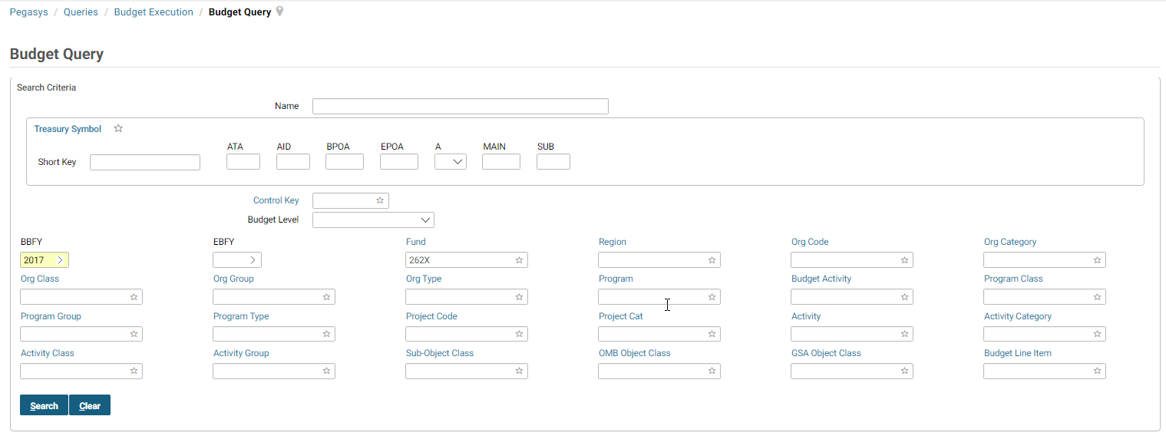
Figure 48: Budget Activity for Current Year Single Year Appropriation and
Figure 51: Budget Activity for Prior Year No Year Fund display Activity screens from the budget query for a current year single fund and prior year no year fund.
Figure 48: Budget Activity for Current Year Single Year Appropriation
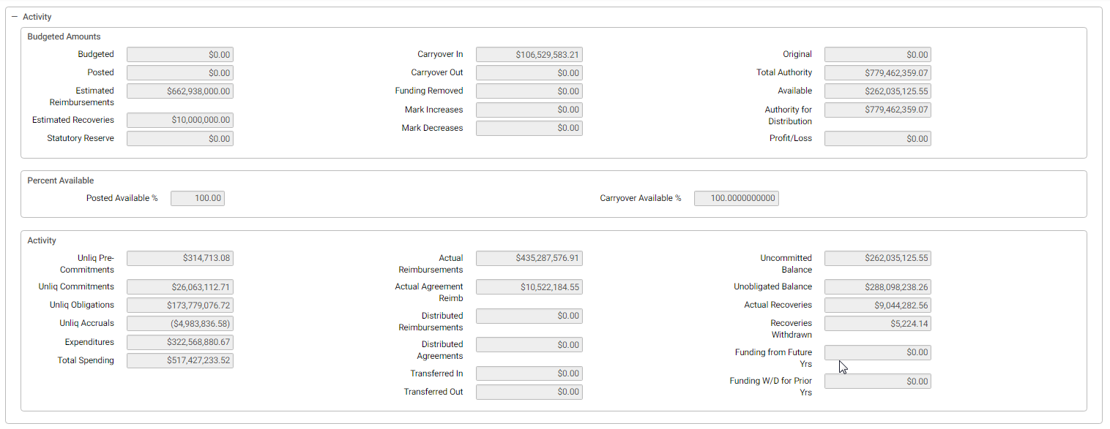
The Current Year Activity Selection Fiscal Year drop down allows the tracking of current year activity and current year total amounts and defaults to the current Fiscal Year.
Figure 49: Total Authority, Authority for Distribution and Available Amount Definitions and Calculations
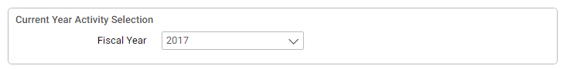
Figure 50: Total Authority, Authority for Distribution and Available Amount Definitions and Calculations
Figure 51: Budget Activity for Prior Year No Year Fund
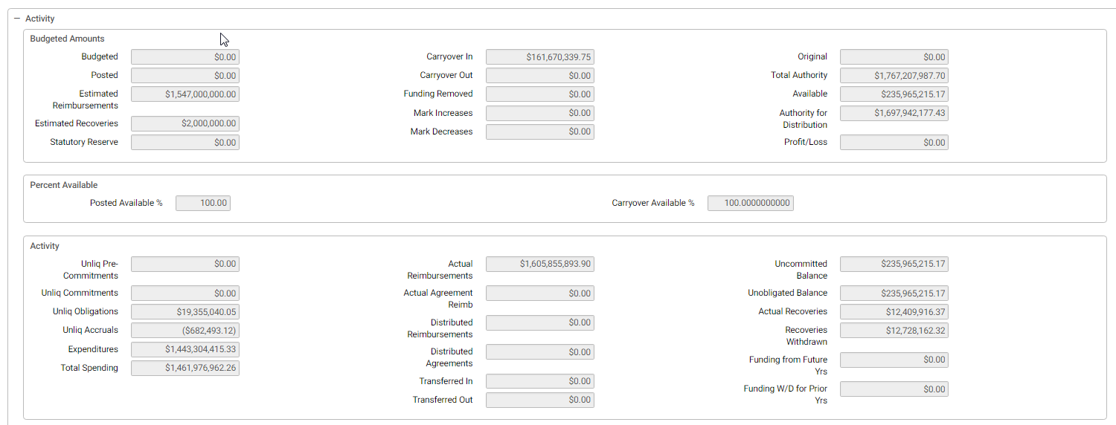
Figure 52: Budgeted, Total Authority, Authority for Distribution and Available Amount Definitions and Calculations

Budget Query Buttons
The Budget Query has several buttons to help the user view detailed information. Select the ellipsis (…) to view additional buttons. These buttons are listed below in Figure 53: Budget Query Buttons and Table 13: Budget Query Button Descriptions.
Figure 53: Budget Query Buttons
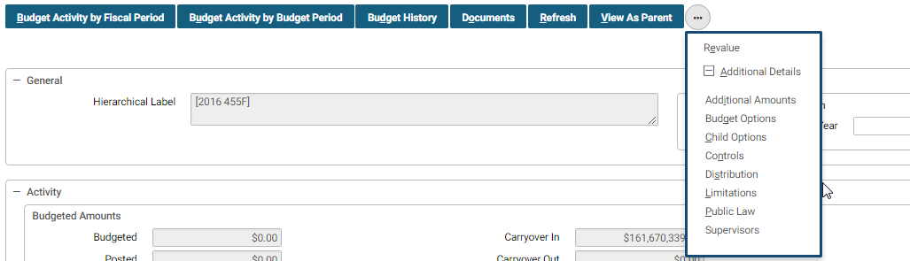
Table 13: Budget Query Button Descriptions
NOTE: A complete list of Budget Query Button and Field Descriptions can be found in Online Help. Select the drop down arrow in the upper right hand corner and select Support. Select the Show hyperlink in the upper left hand corner. Select Search. Enter Budget Query and select Go.
Budget Query Button | Description
Budget History | This button displays all budget documents that updated the budget level. The user is able to view the budget information by periods and can open any budget document listed is this query.
Additional Amounts | This button displays additional amounts such as spending adjustments, authority transfer, and BATS.
Documents | This button displays all spending documents that updated the budget. The user is able to view all adjustments and can open any document that is listed in this query.
Refresh | When this button is selected it updates the budget query with all information that has been processed against the budget up until that point.
Budget Activity by Budget Period | This button combines the functionality existing under the ‘Period Details by Fiscal Year’ and ‘Period Details by Quarter’ and displays budget activity summarized by the budget period used for that budget node.
Supervisors | This button contains the supervisors of the budget level.
Budget Options | This button displays the Dimensions, settings, transaction type, and child options for the budget.
View as Parent | When this button is selected it allows the user to view the budget query at its parent budget level.
Limitations | This button displays all limitations associated with the budget level.
Revalue | This button displays the Budgeted Amounts and Activity Amounts which can be revalued or modified.
Budget Activity by Fiscal Period | This button displays budget activity summarized by the budget fiscal period.
Public Law | This button displays the public law summary information.

Exportable Fiscal Year Budget Query
The Budget Query described in the previous section, requires the user to select a specific budget line first and then displays budget dimensions and related amounts for the particular budget line. The Exportable Fiscal Year Budget Query provides the ability to search for multiple budget lines and displays budget dimensions and related amounts for all resulting budget lines.
The user then has the option to select a specific budget line to view additional details or to export all of the budget lines into a CSV file or an Excel file.
The Exportable Fiscal Year Budget Query is accessed by navigating to Queries → Budget Execution → Exportable Fiscal Year Budget Query.
Figure 54: Exportable Fiscal Year Budget Query Menu
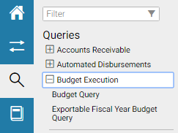
Figure 55: Exportable Fiscal Year Budget Query Search Results
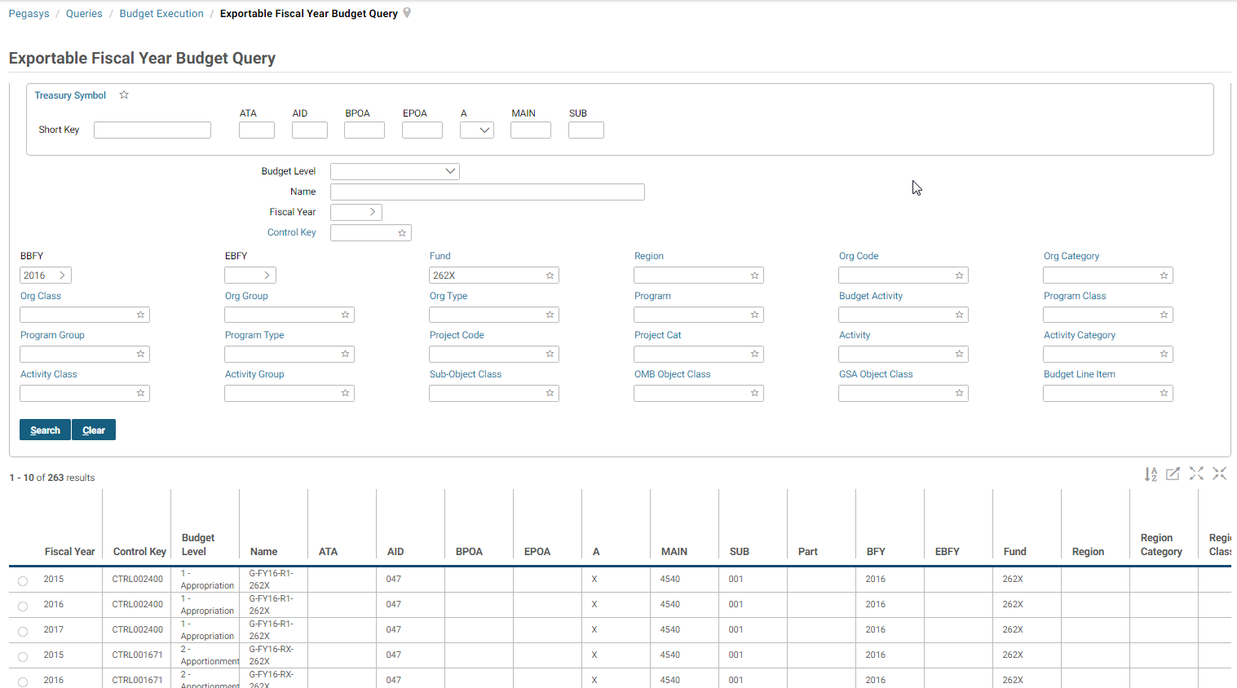
The Select button displays the same information as the Budget Query Detail as the Budget Query described in the previous section.
The Budget History button displays all budget documents processed against the selected budget line.
The Document button displays all transactions processed against the selected budget line. The View as CSV button provides the option to download all listed budget lines as a Comma Separated Value file.
The View as Excel button provides the option to download all listed budget lines as an Excel spreadsheet.

Constraint Query
The Constraint query (Figure 56: Constraint Query) provides users with information about the constraints of budgets and how they affect them. Constraints create thresholds that limit the movement of funds within an appropriation. These thresholds are calculated based on an entered upper limit or a lower limit, the Beginning Official Position, and the processed Mark amounts. There are two types of constraints, Congressional and Managerial. Pegasys provides the ability to query on either Congressional and/or Managerial constraints. Once the query results are displayed, details about the specific constraint can be viewed. Constraints are defined on the Constraint Maintenance table.
Figure 56: Constraint Query

Budget Pending Reprogramming Query
The Budget Pending Reprogramming query (Figure 57: Budget Pending Reprogramming Query) allows the user to approve pending Budget Reprogramming documents. Reprogramming documents may be set to require approval before the transfer will complete. This option is set through the Pending RP checkbox in the Rules section of the Document Type Maintenance table. (This checkbox is only valid for document types in the RP document category.) If the checkbox is checked, the document type requires mid-process approval through the Pending RP query. Processing a document of this type will cause the funding to be removed from the From budget, but not added to the To budget.
In order to complete the transaction, the user must select the document record from the Pending RP query and either Approve or Disapprove. Approve will complete the transaction by sending the funds to the To budget. Disapprove will revert the transaction, sending the funds back to the From budget and therefore not making any changes to the To budget.
Figure 57: Budget Pending Reprogramming Query
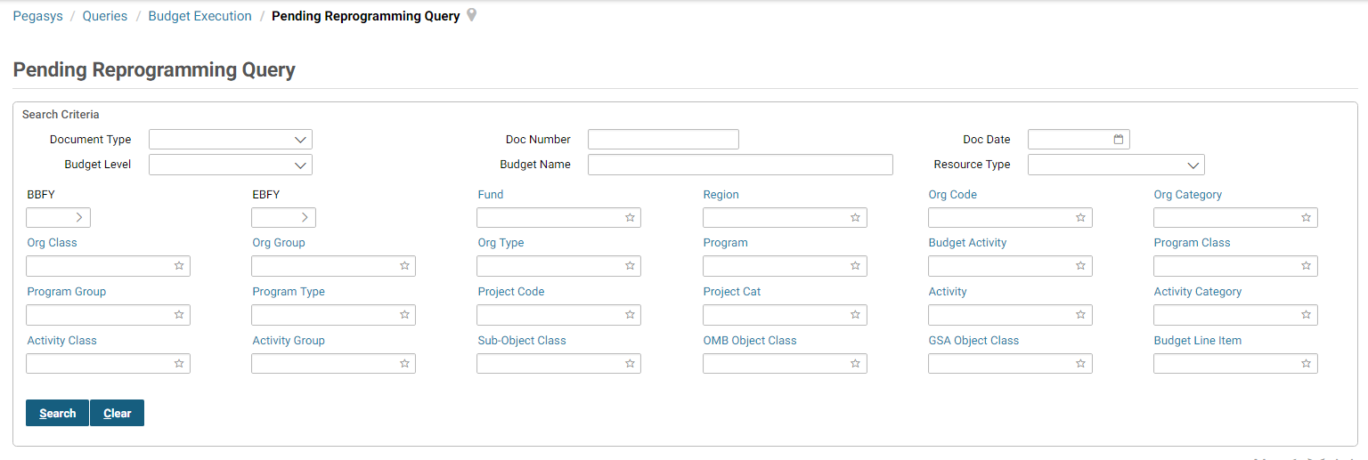

Budget Execution Reports
This section describes the Budget Execution reports that are accessible in Pegasys. The reports referenced in this section can be run using the following path: UtilitiesReportsView Reports.
By selecting on the icon next to Budget Execution, users can see the entire group of reports available (see Figure 58: Budget Execution Reports).
Figure 58: Budget Execution Reports
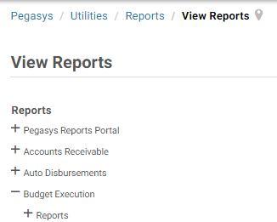

General Report Information
The user may indicate a Saved Output Format of either Private or Shared. If Private is selected the report will only be made available on the report status maintenance table to the user who executed the report. If Shared is selected, the user must also designate a Security Organization for whom view access is permitted. Reports executed with a Saved Output Format of Shared are available on the report status maintenance table to any user belonging to the designated shared access Security Organization.

Organization Status Report
The Organization status report displays current month, current quarter and year-to-date obligations, undelivered orders, and YTD unliquidated commitments.

Report Parameters
Table 14: Organization Status Required Parameters displays the required parameters for the Organization Status report.
Table 14: Organization Status Required Parameters
Parameter Name | Description
BFY | The beginning fiscal year to be used for the report.
Fiscal Month | The fiscal month to be used for the report.
Region | The region to be used for the report.
Fund | The fund to be used for the report.

Sample Report
Figure 59: Sample Organization Status Report displays a sample of the organization status report.
Figure 59: Sample Organization Status Report
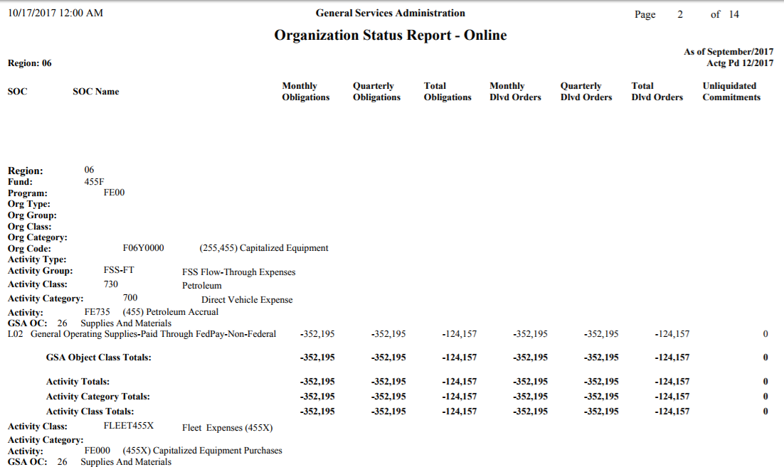

Budget Distribution Report
The Budget Distribution report displays budget information for each level in a selected budget. The information displayed includes the Budget Amount, Posted Amount, as well as each budget line’s Total Authority.

Report Parameters
Table 15: Budget Distribution Parameters displays the required parameters for the Budget Distribution report.
Table 15: Budget Distribution Parameters
Parameter Name | Description
BFY | The beginning fiscal year to be used for the report.
Fund | The fund to be used for the report.

Sample Report
Figure 60: Sample Budget Distribution Report displays a sample Budget Distribution Report.
Figure 60: Sample Budget Distribution Report
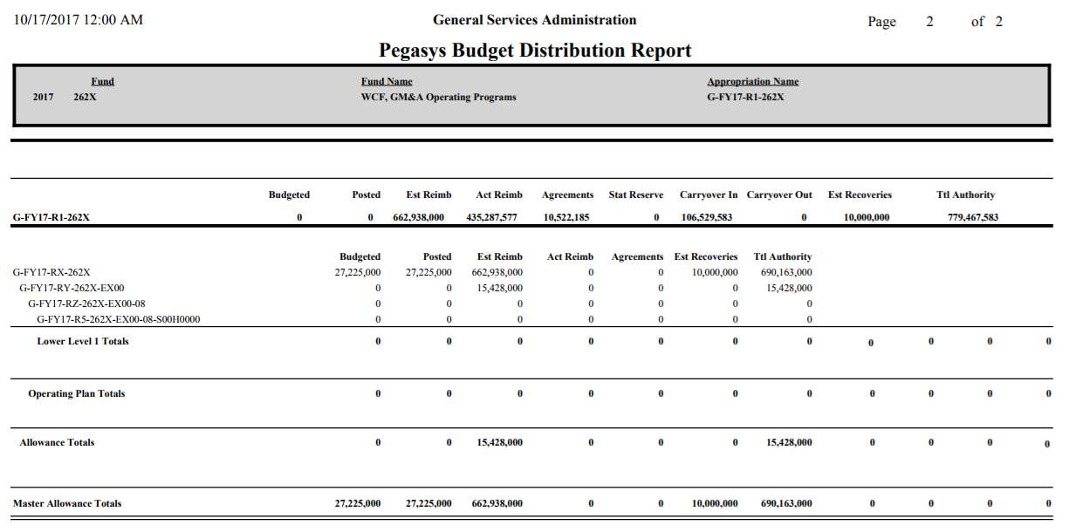

Budget Form Verification Report
The Budget Form Verification report displays all the items selected budget form, including respective BFY, Fund Name, and Document Date.

Report Parameters
Table 16: Budget Form Verification Parameters displays the required parameters for the Budget Form Verification report.
Table 16: Budget Form Verification Parameters
Parameter Name | Description
Document Type | The budget form document type to be used for the report.
Document Number | The budget form document number to be used for the report.

Sample Report
Figure 61: Sample Budget Form Verification Report Verification displays a sample Budget Form Verification report.
Figure 61: Sample Budget Form Verification Report
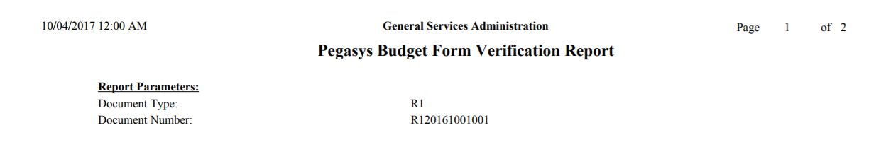

Fund Status Report
The Fund Status report displays current budget authority, spending authority, obligations, accruals, expenditures, total spending, and the available amount for a selected budget level.

Report Parameters
Table 17: Fund Status displays the required parameters for the Status of Funds report.
Table 17: Fund Status
Parameter Name | Description
Budget Level | The fund budget level to be used for the report.

Sample Report
Figure 62: Sample Fund Status Report
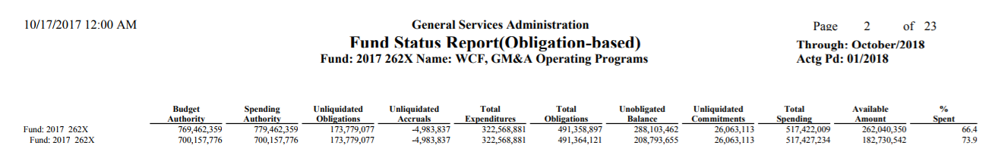

Budget Execution Offline Processes
This section describes the batch jobs for the Budget Execution subsystem. The following processes are related to the Pegasys Budget Execution subsystem:
- Budget Deletion Process.
- Budget Rebuild Process.
- Carryover/Funding Withdrawal Process.
- Budget Funds Availability Percent Update Process.
- Annual Close Estimated Resource Reversal Process.
- Constraint Rebuild Process.
- Budget Set Beginning Official Position.

Budget Deletion Process
The Budget Deletion Process is intended to delete a budget structure in its entirety or in a particular section. Documents that created the budget that is to be deleted by this process or documents that referenced it still exist as a record, but are invalid. In order for a budget to be deleted, all values in it must be backed out to zero. The total budgeted amount, total posted amount, estimated reimbursements amount, estimated recovery amount, statutory reserve amount, carryover in, carryover out, total spending, and expended FTEs all must be zero. The execution report generated by the batch process warns the user of documents that reference the deleted budget.

Budget Rebuild Process
The Budget Rebuild Process is used to retroactively update a budget with transactions that were processed before it was created. After the process runs, the budget has the same data as if it had always existed. The Budget Rebuild Process produces a report listing all transactions that violate the budget’s spending controls. The process honors presence control settings. When users select a budget for rebuild, the selected budget node and all of the budget’s children are rebuilt. The Budget rebuild job clears the spending in the limitations but it does not rebuild spending in limitations. If a budget has spending controls turned on, Pegasys produces a report when it rebuilds the budget, listing all transactions that violate the budget’s spending controls. Because these transactions have already been processed in Pegasys, they cannot be prevented from processing during the rebuild process - they are only listed. This means that after the rebuild process is run, it is possible for a budget’s available amount to be exceeded, even if spending controls are on.

Carryover/Funding Withdrawal Process
GSA uses the Carryover/Funding Withdrawal batch process to automatically withdraw uncommitted funding at any time during the fiscal year by any combination of dimensions. This process can also perform carryover processing during an GSA’s annual close activities. For more information on the carryover portion of the process, see the Annual Close User’s Guide. The Funding Withdrawal process selects the affected budget nodes and the funding withdrawn amount based on the records established in the Funding Withdrawal Maintenance table. The same amount is removed from each budget node, regardless of budget level, for all nodes selected by a single Funding Withdrawal record. The amount is determined as follows:
- Amount on the Funding Withdrawal record.
- Percentage on the Funding Withdrawal record multiplied by the From Budget Level’s Available Amount.
- From Budget Level’s entire Available Amount if neither an amount nor a percentage is present on the Funding Withdrawal Definition record.
The system records funding withdrawn by creating and processing budget documents based on the Document Type and Posted Transaction Type of the budget level. The Document Number is determined by using automated document number generation logic. The Funding Removed Increment field, found under the Other Resources button at each budget level, is used to record the funding withdrawn amount. Budget documents to record funding withdrawn are posted to the journals in the accounting period determined by the Closing Fiscal Month and Closing Fiscal Year parameters.
Prior to updating each budget node, the batch process calculates the budget node’s Available, Authority Eligible for Distribution, and Total Authority amounts after adding the Funding Removed Increment amount to the stored Funding Removed for the budget node - that is, the calculations include the Funding Removed amount that the batch process is going to withdraw.
If all the calculations produce amounts greater than or equal to zero, the Funding Removed Increment amount is added to the current Funding Removed amount for the budget node and processing continues.
If the Available amount calculation produces a negative amount, updates to the budget node’s Funding Removed amount occurs based upon the budget node’s Spending Control setting.
If the Authority Eligible for Distribution or Total Authority calculation results in a negative amount, updates to the budget node’s Funding Removed amount occur based upon the budget node’s Budget Control setting.
Funding Withdrawal can be run in either Preliminary or Final mode. Preliminary mode creates the same output file as Final mode, but it does not actually create documents and therefore does not update the journals or GL rollup tables. Document Numbers generated for the Preliminary run cannot be re-used, and so a user running the Funding Withdrawal batch process in Preliminary and Final mode for the same data will not see the same Document Numbers in each run’s output file.
In addition, a user can manually record funding withdrawn amounts by populating the Funding Removed Increment field when processing budget forms.

Budget Funds Availability Percent Update Process
The Budget Funds Availability Percentage Update process allows GSA to automatically set or reset the funds availability percent for a given budget (that is, all nodes of a given budget fiscal year, fund combination).

Annual Close Estimated Resource Reversal Process
The Annual Close Estimated Resource Reversal Process reduces the amount of a budget’s anticipated reimbursements and recoveries to match the actual amounts. For each selected budget where estimated amounts exceed realized amounts, the system creates a new budget form to increment the Estimated Reimbursements and/or Estimated Recoveries amounts to match the actual amounts.
This process can be run in preliminary or final mode. If not specified, the process runs in preliminary mode, and no forms are created in the database. When run in final mode, the system processes the forms. Any errors encountered are printed to the batch execution report.

Constraint Rebuild Process
The Constraint Rebuild process is used to retroactively update a constraint with budget transactions that were processed before it was created. After the process runs, the Constraint Query will display the same data as if the constraint had always existed. The Constraint Rebuild process produces a report listing all transactions that violate the constraint’s upper and lower thresholds, but cannot prevent these transactions from processing, as they were already processed, prior to the rebuild. The Constraint Rebuild process can either be run to incrementally update the existing balance on the constraint or to clear all amounts on the constraint to zero and start rebuilding from the beginning. These options are entered in the batch process parameters.

Budget Set Beginning Official Position Process
The Budget Set Beginning Official Position is used to set a budget node or constraint’s beginning official position. This amount is used with the upper and lower limits set on the Constraint Maintenance table to determine a budget node or constraint’s upper and lower thresholds. The parameters of this process allow the amount to be set on a constraint, a budget node, or both.

Budget Control Updater Process
The Budget Control Updater process updates the budget entity with the Control Key and its associated authority and spending controls for the specified budget nodes. The process provides the ability to update budgeting and spending controls for multiple budget lines at once.

