Training Manual
Module 23:
Performance Management for
Employees
Table of Contents

Module 23: Performance Management for Employees 2
Section 1: Establish a Performance Plan 2
Topic 1.1: Create a Performance Plan 2
Topic 1.2: Update a Performance Plan 5
Topic 1.3: Acknowledge a Performance Plan 10
Section 1 Summary 11
Section 1 Practice Exercises 11
Section 1 Notes 12
Section 2: Mid-Year Progress Review 13
Topic 2.1: Self-Assessment 13
Topic 2.2: Acknowledge Mid-Year Progress Review 19
Section 2 Summary 21
Section 2 Practice Exercises 21
Section 2 Notes 21
Section 3: Evaluation 22
Topic 3.1: Nominate Participant Reviewers 22
Topic 3.2: Completing a Participant Evaluation 25
Topic 3.3: Complete Self-Assessment 27
Topic 3.4: Acknowledge Evaluation 32
Section 3 Summary 33
Section 3 Practice Exercises 33
Section 3 Notes 33

Module 23: Performance Management for Employees

In this module you will learn about performance management as an employee. This module will convey information about performance plans, mid-year progress reviews, evaluations, and IDP documents.

Section 1: Establish a Performance Plan

This section provides an overview about performance plans. Employees can create, update and acknowledge performance plans in HR Links to track and manage performance goals.
The following topics will be covered in this section:
Topic 1.1 – Create a Performance Plan
Topic 1.2 – Update a Performance Plan
Topic 1.3 – Acknowledge a Performance Plan

Topic 1.1: Create a Performance Plan

This topic will cover creating a performance plan. As an employee, you can initiate, update and save your performance plan. Your Supervisor will be responsible for finalizing and completing your performance plan.
Below is an example of how to navigate to your employee performance dashboard, where you can start a new performance plan, or update/view an in-progress performance plan.
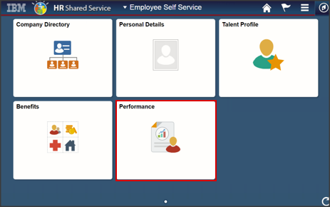
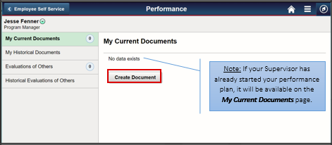
To start your performance plan, click Create Document. Next, make the following selections on the Create Document page.
- Select the performance Period Begin Date and Period End Date by clicking the calendar icons.
- Select Performance Document from the Document Type drop-down menu.
- Select No from the Clone from Prior Document slider switch.
- Note: If you have a prior year performance document you would like to copy and edit, select Yes from the Clone from Prior Document slider switch and search for the document you wish to copy.
- Select the applicable performance plan template from the Template drop-down menu (e.g., GSA employees select “GSA Annual Performance Plan”).
- Click Create.
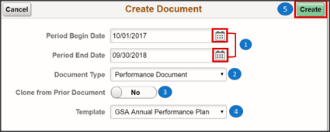

Click the newly created performance document to open. Continue to Topic 1.2 for instructions on adding content to and saving your performance plan.
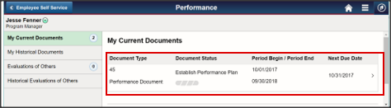

Topic 1.2: Update a Performance Plan

This topic will cover adding content to and saving a performance plan. Your Supervisor is responsible for finalizing and submitting your performance plan.
Below is an example of a blank performance plan.
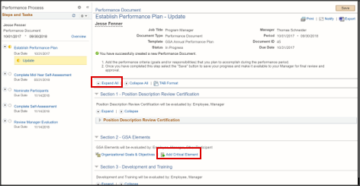
Click Expand All to expand all sections of the performance plan. Click Add Critical Element to add content to this performance plan.
Review the options available on the Add Element page: 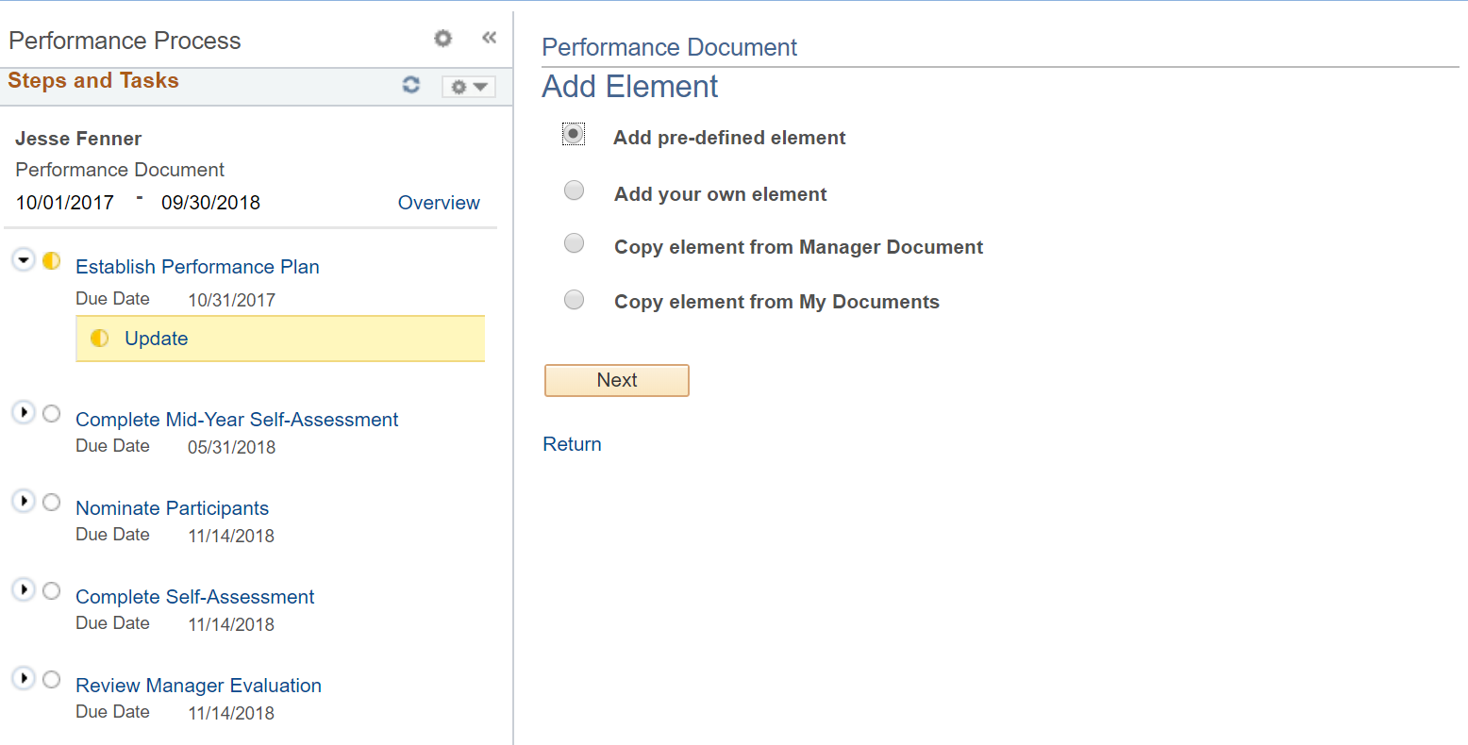
- Add pre-defined element: Add element from the content library. For employees with supervisory responsibilities, use this option to add the required 40% leadership elements.
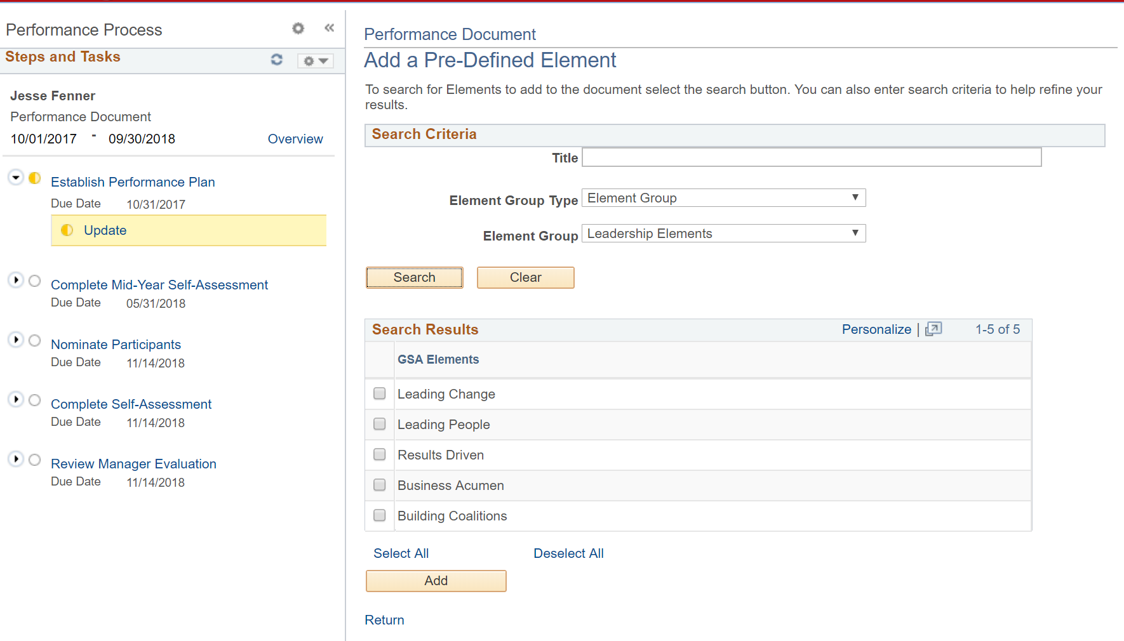
Add your own element: Build a custom element from scratch. Under General Measures and Derived From field be sure to list all the appropriate goals. HR Links may also permit one goal if available to be linked to a element within the system. Need help reference the Managers Guide For Developing Effective Plans
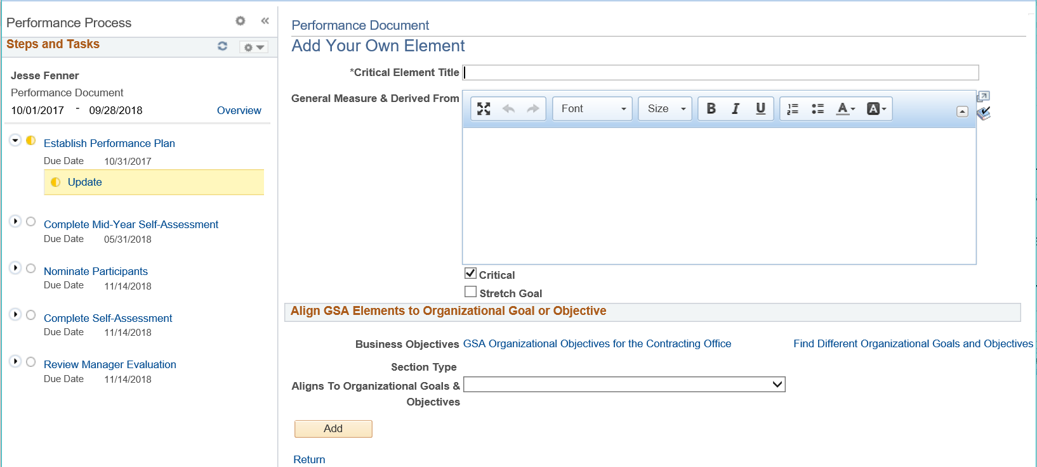
- Copy element from Supervisor Document: If your Supervisor has completed performance documents available, they will be available to select elements from.
- Copy element from My Documents: If you have completed performance documents, they will be available to select elements from.
The example below shows a performance plan with a pre-defined element and a custom element.
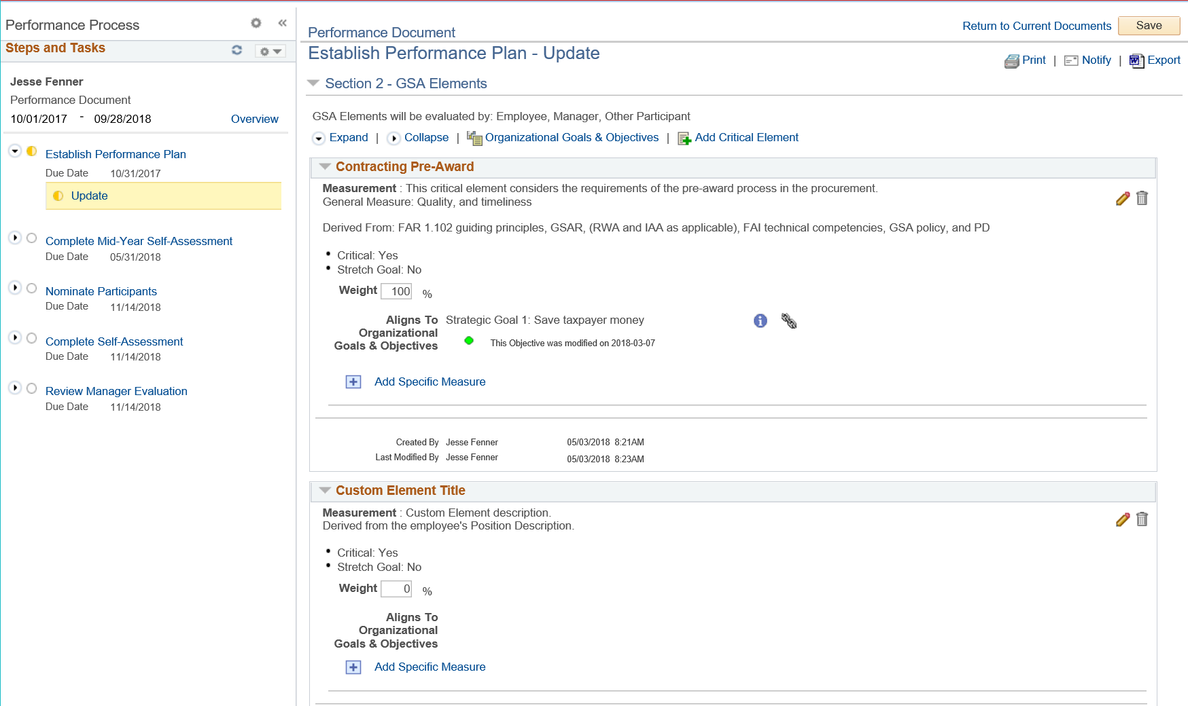
To add a Specific Measure to a critical element, click Add Specific Measure.
Review the options available on the Add a Specific Measure page:
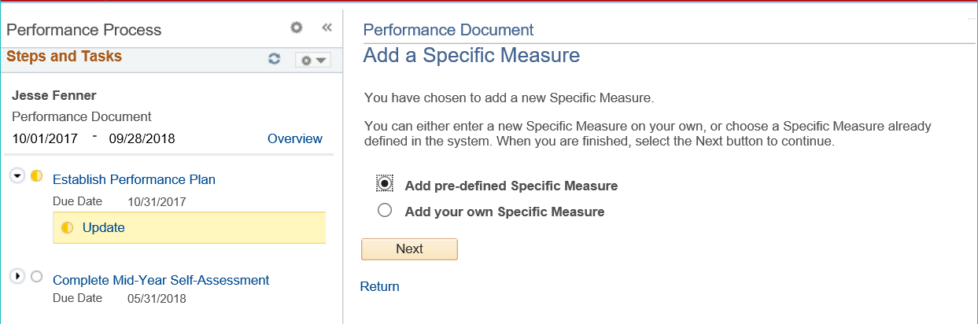

- Add pre-defined Specific Measure: Add Specific Measure from the content library. This option is only available when a pre-defined element is selected.
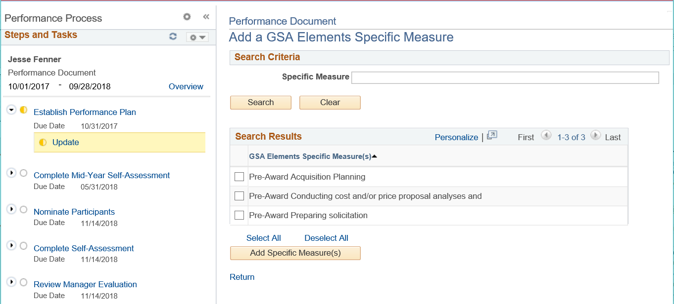
- Add your own Specific Measure: Build a custom Specific Measure from scratch.
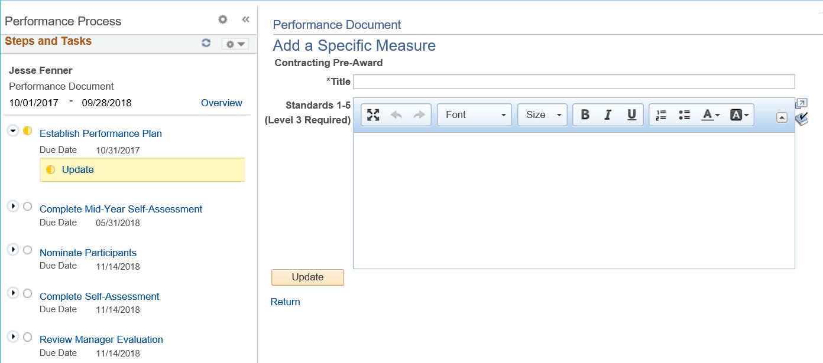
The example below shows a performance plan with pre-defined Specific Measures added to the pre-defined element. Add a weight for each element in the Weight field. To edit an element or Specific Measure, click the pencil icon. To delete an element or Specific Measure, click the trash can icon.
Click Save to save your work. 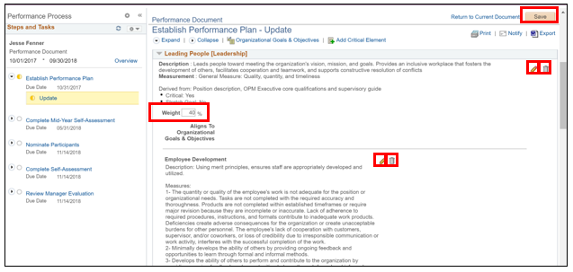
Your Supervisor can view the progress of this performance document at all times.

Topic 1.3: Acknowledge a Performance Plan

This topic will cover acknowledging a performance plan after your Supervisor has finalized and submitted the plan for your review.
First, you will return to HR Links and navigate to the Performance tile on your Employee Self-Service fluid page. On your Current Documents page, select your performance plan.
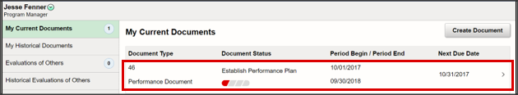
Note: The document status is based on due dates established for the performance cycle. In the example above, the status bar is red because the document is overdue. The due date, listed under the Next Due Date column is October 31, 2017.
On the performance document page, click Acknowledge after you after you have reviewed your completed performance plan.
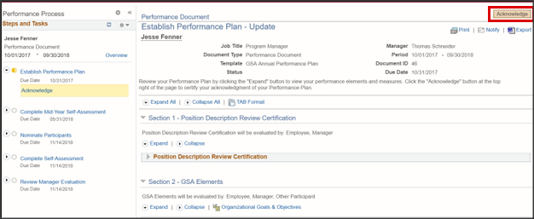

Use the radio buttons to designate if you agree or disagree with your performance plan. If you select I disagree, use the text field to document your explanation. Click Confirm to complete your acknowledgment.
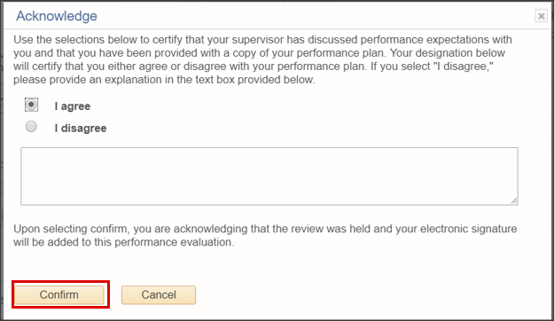

Section 1 Summary

In this section, performance plans were reviewed. You should now be able to:
- Objective 1: Create a Performance Plan
- Objective 2: Update a Performance Plan
- Objective 3: Acknowledge a Performance Plan

Section 1 Practice Exercises
Exercise | Instructions
Exercise 1: Create a new performance plan | Navigate to My Performance fluid page, click create document, enter document criteria
Exercise 2: Update a performance plan | Add elements, add Specific Measures, assign weightings, save document
Exercise 3: Acknowledge a performance plan | Acknowledge performance plan

Section 1 Notes

__________________________________________________________________________________________________________________________________________________________________________________________________________________________________________________________________________________________________________________________________________________________________________________________________________________________________________________________________________________________________________________________________________________________________

End of Section 1

Section 2: Mid-Year Progress Review

This section provides employees with an overview of the functionality available to support Mid-Year Progress Reviews in HR Links.
The following topics will be covered in this section:
Topic 2.1 – Self-Assessment
Topic 2.2 – Acknowledge Mid-Year Progress Review

Topic 2.1: Self-Assessment

HR Links provides employees with the opportunity to submit a self-assessment at both the Mid-Year Progress Review and final evaluation. You can begin entering notes in your self-assessment immediately after acknowledging your performance plan. This topic covers entering comments, saving and submitting your mid-year self-assessment.
Below is an example of the employee dashboard after a performance plan has been completed. You can access your employee dashboard from the Employee Self-Service fluid page by clicking the Performance tile, as explained in Topic 1.1.
Click your performance document, shown below, to begin your self-assessment.
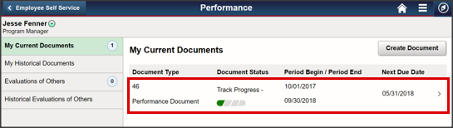
Note: The document will automatically open to the self-assessment page if your performance plan has been completed. If your performance plan has not been completed, return to Topic 1.3 to acknowledge your performance plan, or contact your Supervisor for assistance.
Click Expand All to view all critical elements. Upon expanding, Employee Comments boxes will be available for each element. A GSA Elements Summary text box is also available for overall, or summary, comments.
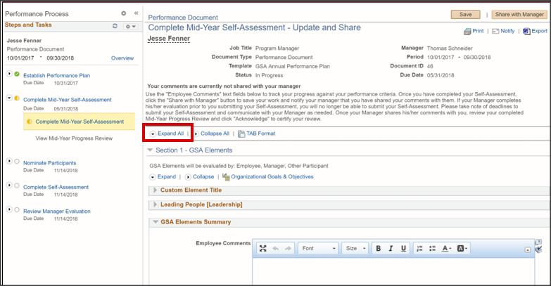
Note: Your Supervisor cannot see your comments until you click the Share with Manager button. See below for details.
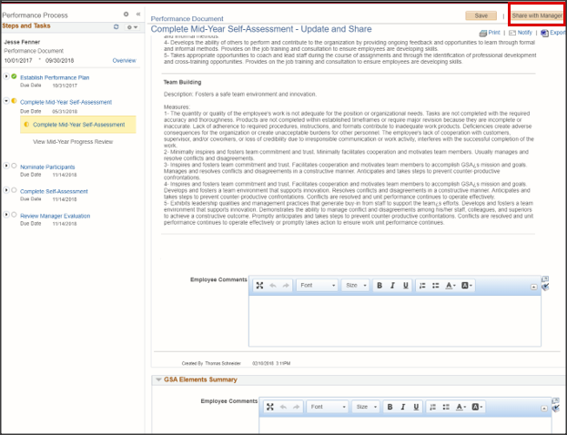
Enter comments in each text box, as desired, and click Save.
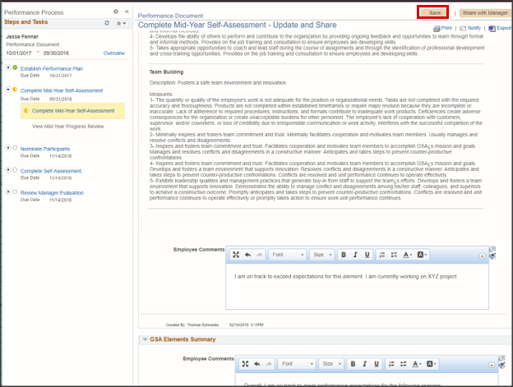
Enter comments, as desired, in the Training and Development section. Click Save.
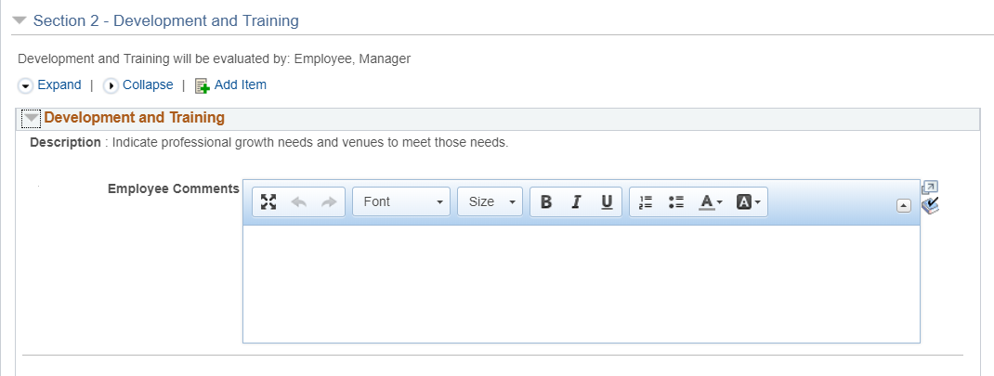
Clicking Save allows you to save and return to your self-assessment later.
If you wish to upload supporting attachments, you may do so in the Attachments section.
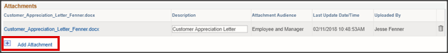
When you are ready to share your self-assessment with your Supervisor, click Share with Manager. Click Confirm.
Note: You can click Share with Manager up until your Supervisor completes your Mid-Year Progress Review. If your Supervisor completes your Mid-Year Progress Review before you submit your Self-Assessment, you will no longer be able to submit your Self-Assessment for consideration at your Mid-Year Progress Review.
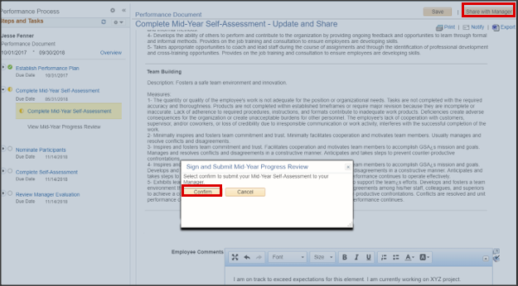
If you need to make changes to your Self-Assessment after you submit, but before your Supervisor completes your Mid-Year Progress Review, click View Mid-Year Progress Review.
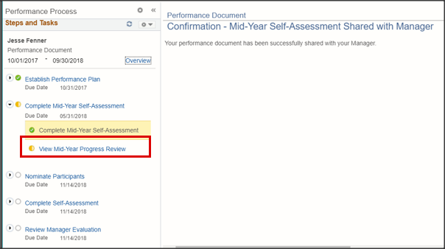
Click Stop Sharing.
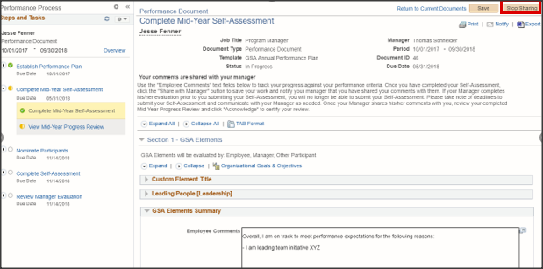
Click Stop Sharing to confirm.
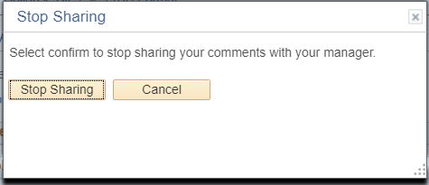
Your self-assessment is now editable. You can make your changes and re-share with your Supervisor using the Share with Manager button when you are ready to submit.

Topic 2.2: Acknowledge Mid-Year Progress Review

In this topic we will discuss Acknowledging your Mid-Year Progress Review. Once your Supervisor has completed your review you will receive a notification asking you to return to HR Links to review and acknowledge that you have received your Mid-Year Progress Review.
Once you have returned to HR Links, click to open your performance document. You will be automatically directed to your Mid-Year Progress Review. Click Expand All to view your Supervisor’s comments.
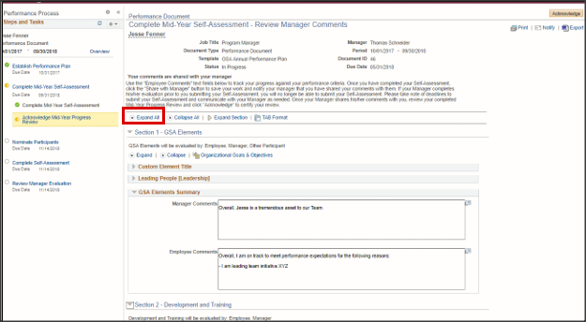
Review your Mid-Year Progress Review and click Acknowledge to indicate that you have completed your review.
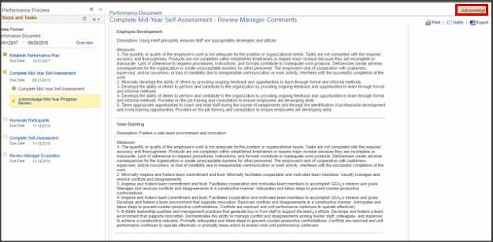
Click Confirm to complete your Mid-Year Progress Review.
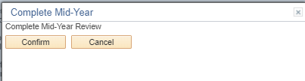

Section 2 Summary

In this section, Mid-Year Progress Reviews within performance management were reviewed. You should now be able to:
- Objective 1: Self-Assessment
- Objective 2: Acknowledge Mid-Year Progress Review

Section 2 Practice Exercises

Exercise | Instructions
Exercise 1: Self-Assessment | Navigate to self-assessment, enter comments, share with supervisor
Exercise 2: Acknowledge Mid-Year Progress Review | Review Mid-Year Progress Review, acknowledge

Section 2 Notes

__________________________________________________________________________________________________________________________________________________________________________________________________________________________________________________________________________________________________________________________________________________________________________________________________________________________________________________________________________________________________________________________________________________________________

End of Section 2

Section 3: Evaluation

This section provides employees with an overview of the functionality to support evaluations within HR Links.
The following topics will be covered in this section:
Topic 3.1 – Nominate Participant Reviewers
Topic 3.2 - Completing a Participant Evaluation
Topic 3.3 – Complete Self-Assessment
Topic 3.4 – Acknowledge Evaluation

Topic 3.1: Nominate Participant Reviewers

This topic covers nominating participant reviewers in HR Links. The system allows both employees and Supervisors to nominate and track participant reviews. However, only Supervisors can submit nominations. Once nominated, participant reviewers receive a notification alerting them of the evaluation request.
To nominate participant reviewers, return to your performance document and click Nominate Participants. Click Add Nominees.
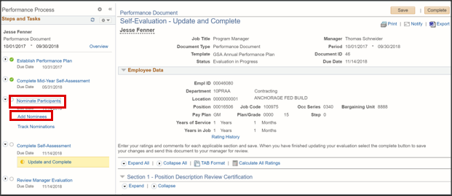
Click Add Other Participant.
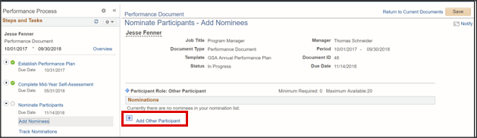
On the Person Search page, enter the applicable search criteria to search for the correct participant reviewer. Click Search.
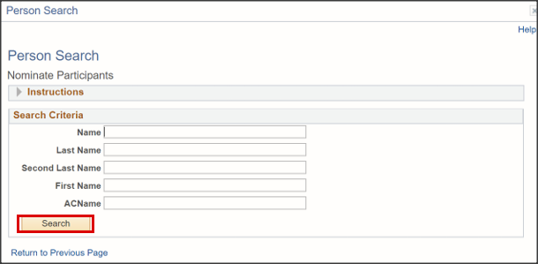
Select the checkbox next to the employee name and click OK.
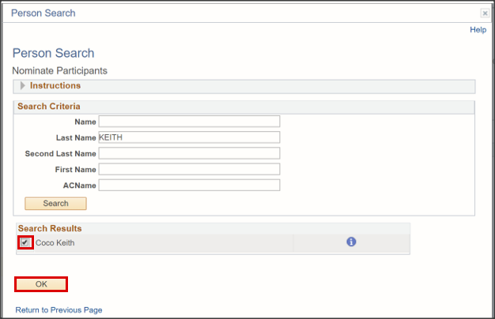
Click Save. Throughout the evaluation process, you can view the status of your nominations by clicking the Track Nominations link under Nominate Participants from the Steps and Tasks menu.
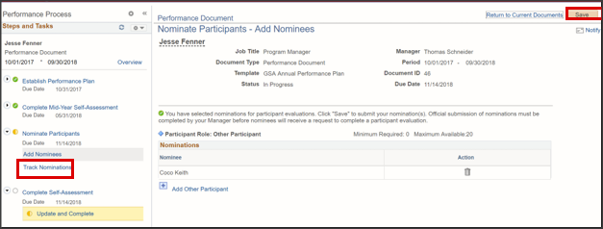
Clicking Save will make your nomination available to your Supervisor for submission.

Topic 3.2: Completing a Participant Evaluation

This topic covers accepting and completing a Participant Evaluation. As discussed in Topic 3.1, employees can save nominees, but only Supervisors can submit nominations to participant reviewers. If you receive a request to complete a participant evaluation, navigate to the Employee Self-Service fluid homepage and click the Performance tile.
Below you will see the employee dashboard. On the left menu, there is a 1 next to Evaluation of Others, indicating there is a participant evaluation in your queue. Click Evaluations of Others to proceed.
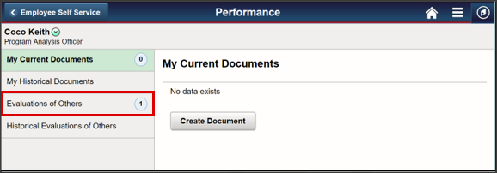
The page is split into two sections: Pending Evaluation Requests and Current Evaluations. To accept and begin the participant evaluation, select the checkbox next to the employee name and click Accept.
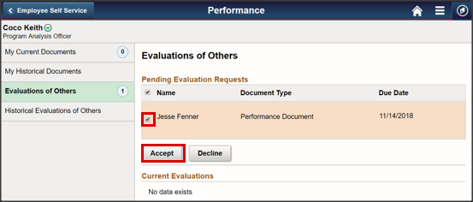
The evaluation will automatically move to the Current Evaluations section. Note: When there are no pending evaluations, the Pending Evaluation section is hidden.
Click the evaluation to begin.
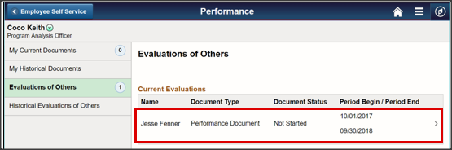
Click Expand All to expand the Elements sections. For each element, select a Rating and enter comments, where applicable.
Note: A Rating must be selected for each element. If the work described by an element does not pertain to the work you are being asked to review, select “NR – Not Rated” and proceed to the next element.
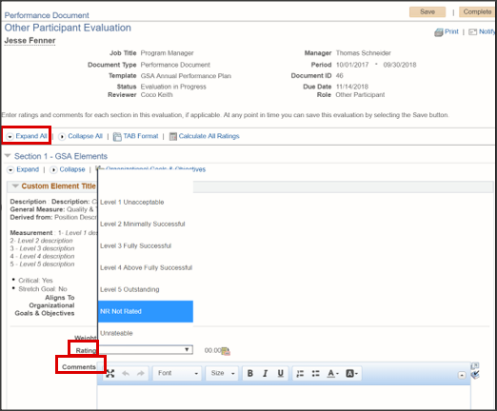
Enter comments in the GSA Elements Summary section and click the calculator button next to Rating.
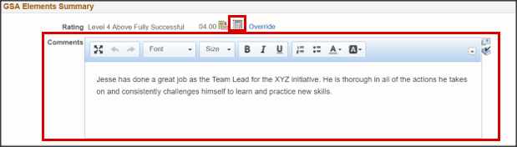
Click Save to save your work and return to the evaluation later.
When you have finalized the evaluation and are ready to submit, click Complete.
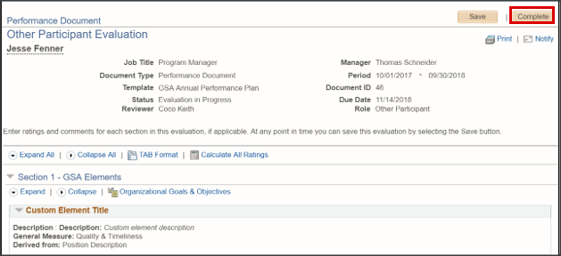
Click Confirm.
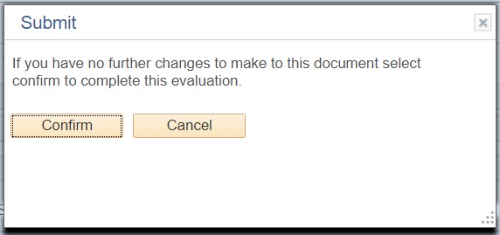
Your evaluation has now been shared with the employee’s Supervisor.

Topic 3.3: Complete Self-Assessment

This topic covers completing a self-assessment in support of your evaluation. You can begin entering notes in your self-assessment immediately after acknowledging your Mid-Year Progress Review. This topic covers entering comments, saving and submitting your self-assessment.
Below is an example of the employee dashboard after a Mid-Year Progress Review has been completed. You can access your employee dashboard from the Employee Self-Service fluid page by clicking the Performance tile, as explained in Topic 1.1.
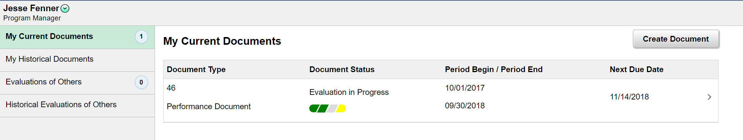
Click the performance document, to begin your self-assessment.
Note: The document will automatically open to the self-assessment page if your Mid-Year Progress Review has been completed. If your Mid-Year Progress Review has not been completed, return to Topic 2 to acknowledge your review, or contact your Supervisor for assistance.
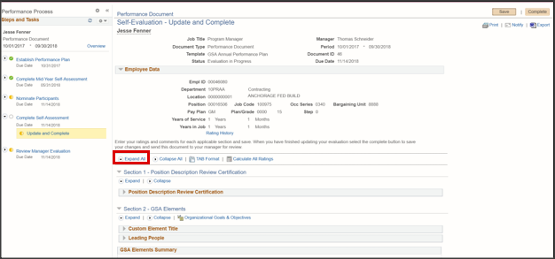
Click Expand All to view all critical elements. Upon expanding, Employee Rating drop-down menus will be available for each Specific Measure. For each element, an Employee Rating drop-down menu and an Employee Comments textbox will be available.
Note: Selecting Employee Ratings is optional. You can submit your Self-Assessment without selecting Ratings.
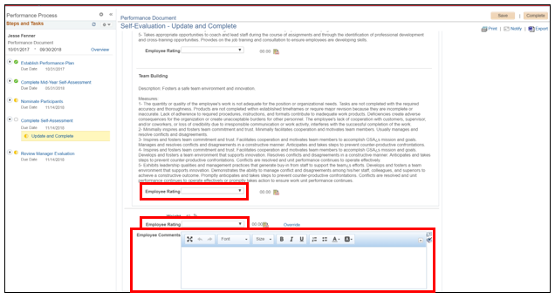
A GSA Elements Summary text box is also available for overall, or summary, comments. If you selected Specific Measure and element ratings, click the Calculator icon to calculate your Employee Summary Rating.
Enter comments in each text box and select ratings, as desired.
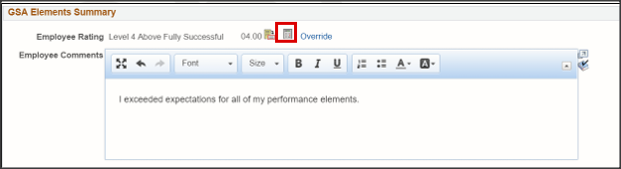
Note: Your Supervisor cannot see your comments until you click the Complete button. See below for details.
Enter comments, as desired, in the Training and Development section.
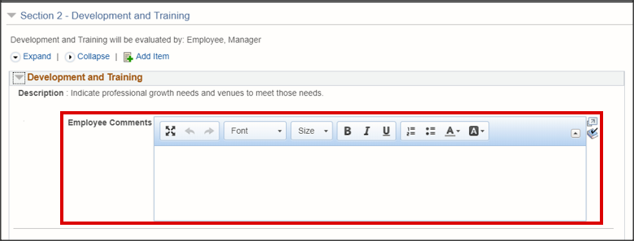
Click Save.
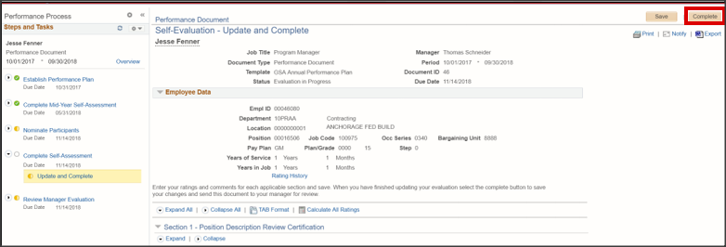
Clicking Save allows you to save and return to your self-assessment later.
If you wish to upload supporting attachments, you may do so in the Attachments section.
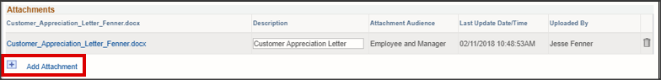
When you are ready to share your self-assessment with your Supervisor, click Complete. Click Confirm.
Note: You cannot stop sharing your self-assessment after you have submitted it to your Supervisor.
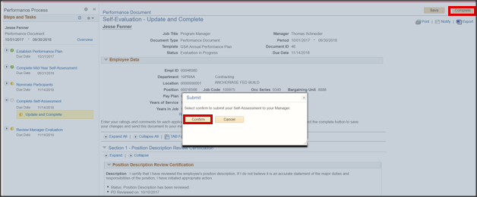

Topic 3.4: Acknowledge Evaluation

In this topic we will discuss Acknowledging your Manager Evaluation. Once your Supervisor has completed your evaluation you will receive a notification asking you to return to HR Links to review and acknowledge that you have received it.
Once you have returned to HR Links, click to open your performance document. You will be automatically directed to the Manager Evaluation. Click Expand All to view your Supervisor’s comments.
Once you have completed your review, click Acknowledge.
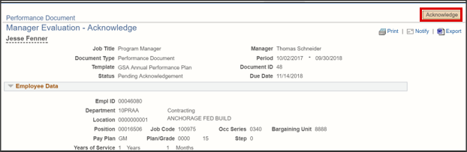
Click Confirm.
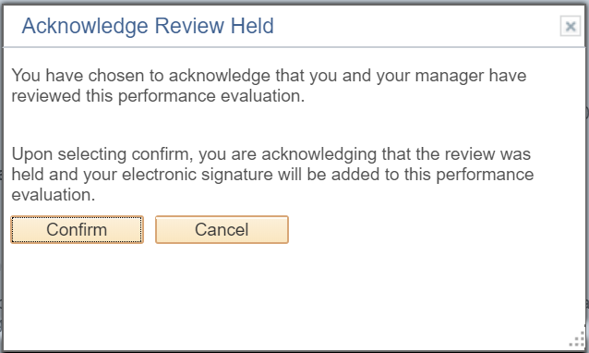

Section 3 Summary

In this section, evaluations within performance management were reviewed. You should now be able to:
- Objective 1: Nominate Participant Reviewers
- Objective 2: Complete Self-Assessment
- Objective 3: Acknowledge Evaluation

Section 3 Practice Exercises

Exercise | Instructions
Exercise 1: Nominate Participant Reviewers | Navigate to performance document, search for participant reviewer, click save
Exercise 2: Complete Self-Assessment | Navigate to self-assessment, enter comments, click Complete to share with supervisor
Exercise 3: Acknowledge Evaluation | Review Manager Evaluation, Acknowledge

Section 3 Notes

____________________________________________________________________________________________________________________________________________________________________________________________________________________________________________________________________________________________________________________________________________________________________________________________________________________________________________________________________________________

End of Section 3

End of Module 23

