NAVIGATING THROUGH BUSINESS OBJECTS
Tips for Creating a Presentation-Worthy Report
Dated for Reference: December 27, 2019

Table of Contents
Creating a Presentation-Worthy Report
Change Report Title; Add Information including Making Prompt Values Visible in the Header
Modifying Column Headers
Add Section, Section Break, Sub Totals
Adding a Logo Available on a Local Drive
How NOT to Lose Header Information When Downloading in EXCEL

Creating a Presentation-Worthy Report
The steps within this section will take take a basic adhoc and create the following:
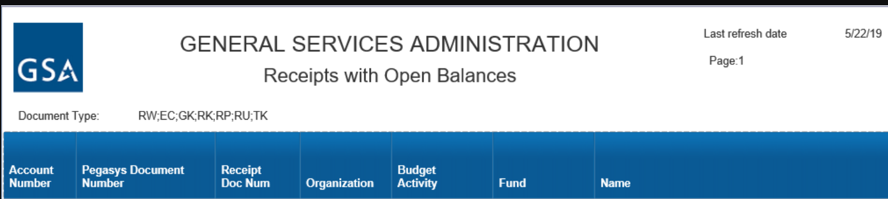

The below example ad-hoc report is based on the Pegasys – Accounts Payable Universe. The data sources are the receipts header table in Pegasys (MF_IC) and the receipts accounting line table (MF_IC_HDAL).
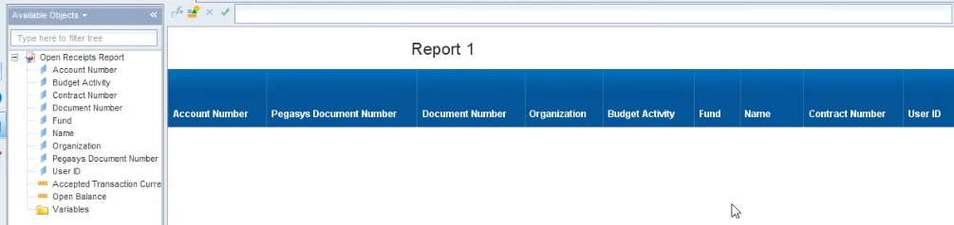

How NOT to Lose Header Information When Downloading in EXCEL
If you intend to download the report in excel, Report Titles, Logos, Report Elements such as Page #, Prompt Values, Refresh Date, etc. must be in the outside the report HEADER.
In the snapshot below the title Report 1 is in HEADER section/cell of the report.
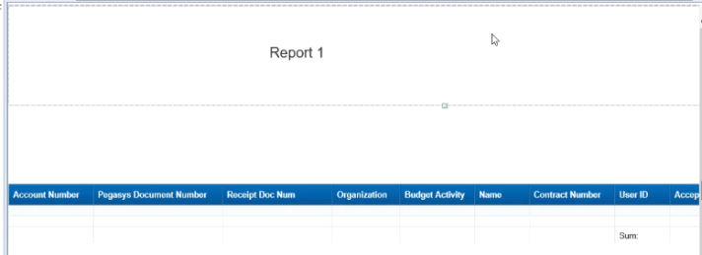
To move this outside of the header section/cell of the report, right click within the cell containing the Report 1 title…..
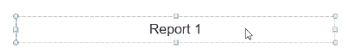
……select cut from the drop down menu, move your cursor below the dashed lines outlining the header cell and paste.
In the snapshot below, the Report 1 title is now outside the header section/cell of the report. The header section of the cell of the report is now blank.
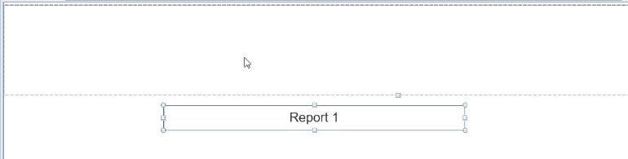
You may want to hide the header section/cell of the report so that you don’t inadvertently add elements to the header. To hide the header section cell, from the menu select Page Setup, Header and Show to toggle the “show” option off, i.e. hide the header.
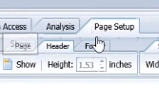

Change Report Title; Add Information including Making Prompt Values Visible in the Header
If intending to download the report to excel see also “How NOT to Lose Header Information When Downloading in EXCEL”.
Change the title from Report 1 to something more meaningful. There are two options to accomplish this.
- Option 1: Locate the tab name at the bottom left of the report window. Double click on the name of the tab and rename. By doing so both the tab name Report Name will change.
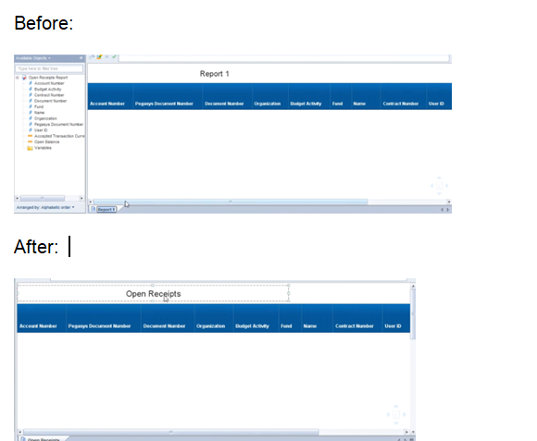

- Option 2: You can just change the name of the report and keep the tab name in tact by double clicking on the report name and in the second box down enter the new name for the report and hit enter.
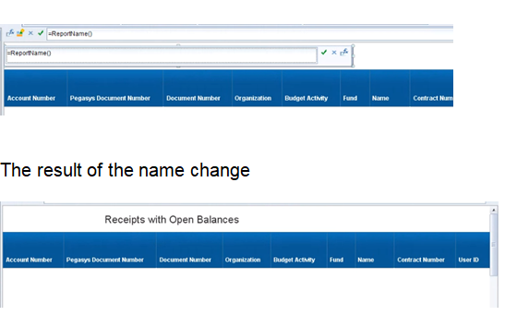

Make Prompts Visible on Report With-in the Header
If intending to download the report to excel see also “How NOT to Lose Header Information When Downloading in EXCEL”.
Whereas you can display the value entered at the prompt, for presentation purposes, it is preferable to add a label for the prompt value. Before adding the labels, expand the size of the header. Hover over the top portion of your report to expose the header cell. With your cursor on the small open square at the bottom portion of the cell, drag down and release. A plus sign simple will appear to reflect that you are in the appropriate location to expand the cell.

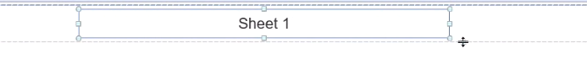
To create a label, with the report open in design mode click on Report Element, then Cell and then Blank. You should see “click to insert cell here. Press Esc to cancel this action” which will allow you to position a blank cell on your report.
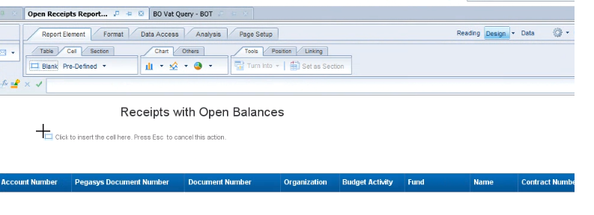
Now that you have a blank cell, double click the inside and type a label and hit enter
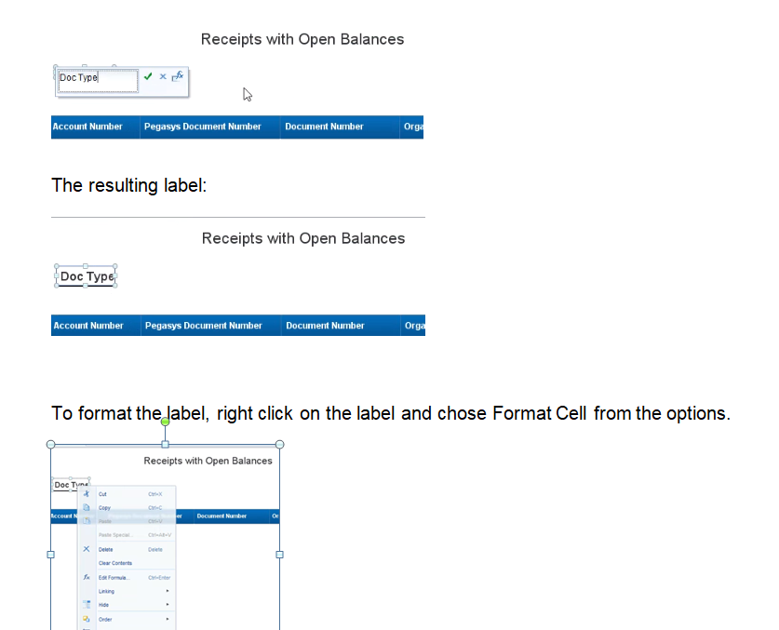

Now that you have a label for your prompt value, in order to add the value click on Report Element, then Cell then use the Drop Down menu next to pre-defined to choose prompt. The prompt values residing in your report will automatically be displayed for selection. You should see “click to insert cell here. Press Esc to cancel this action” which will allow you to position a blank cell on your report. Once you position the cell, it will default to and underline. Here again you can right click and chose format cell. Keep in mind that the value will not appear until you schedule the report to run. Repeat the process for adding additional values returned by the user defined prompt to your header.

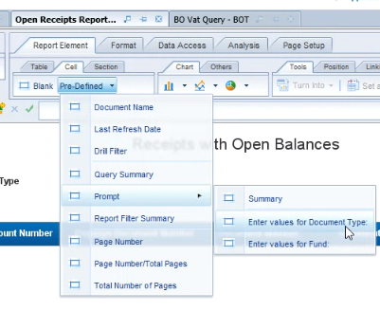
Helpful Hint: To align your labels, click on the “Report Elements” tab, then click on the “Position” tab, then click on the drop down arrow to the right of “Align” and selecthit your ctrl key and the next label and then with both highlighted right click and chose Align to view alignment options.
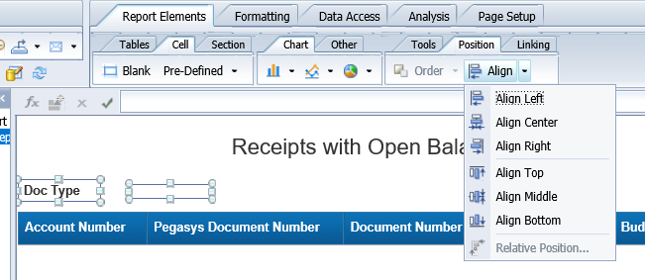
Helpful Hint: The Pre-Defined Options also contains additional items you may find useful to add to your report such as Last Refresh Date, Page Numbers etc. Follow the same steps using blank and pre-defined to add these options. As an alternative the Page Setup Option in the menu bar is also available.
Helpful Hint: by using the blank option you can also create informational footers at the bottom of your report by simply placing the blank cell towards the bottom of the report and entering verbiage such as
Modifying Column Headers
Changing Column Headers
In the example below, clarity can be added to Document Number by changing the column header.
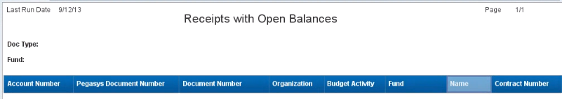
To change the column header double click in the column header to display text box containing existing header name.

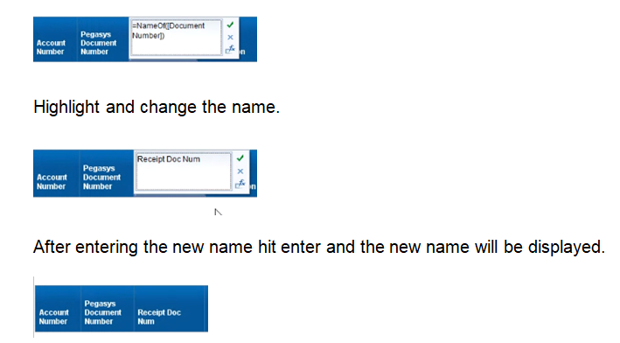

Wrapping Column Headers
Click on Header Name, Select Text, Then Select Wrap Text
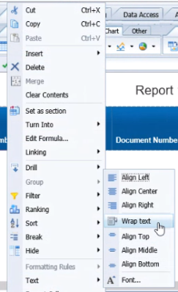
Helpful Hint: To reformat multiple headers hold ctrl key down while highlighting columns and then right click and chose format cell.
Add Section, Section Break, Sub Totals
Add a Section / Section Break: There are two options when creating sections within a report.
To add a section break, with the report open in Design Mode click on a data within the column you want to create the section break on. From the menu bar chose Table Layout, Break to group the report data by the element you selected. Note: If a break on the report already exists, you will need to remove the break under the Table Layout, Break menu.
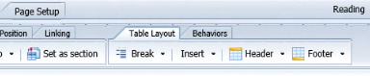
In the below example, the section break was established for Fund
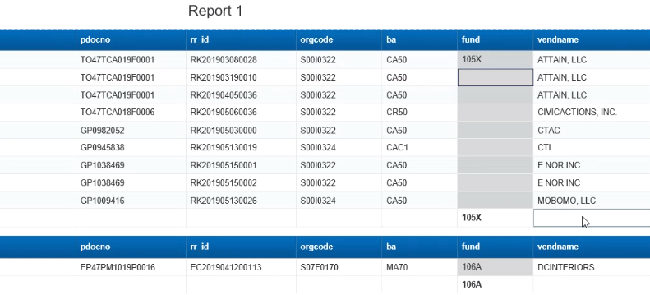
To set as a section, with the report open in Design Mode click on a data within the column for which you want to create the section. From the menu bar chose Tools, Set as Section to group the report data by the element you selected, created a sub-title with that element and remove the element as a column of your report.
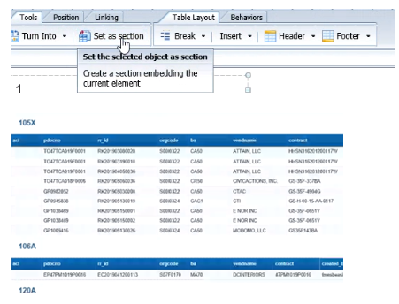
To Add Sub Totals in Design Mode, chose Analysis then Functions and then the one of the operatives, ie. Sum, Count, Percentage, etc….
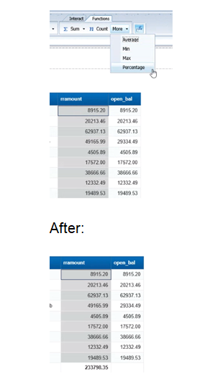
Helpful Hint: To reformat amounts hold ctrl key down while highlighting columns and then chose Formatting, Number and then from the drop down the number format of choice. Or right click and choose format cell.
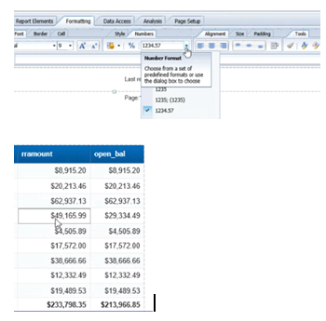

Adding a Logo Available on a Local Drive
If intending to download the report to excel see also “How NOT to Lose Header Information When Downloading in EXCEL”.
To add a logo from a local drive, begin by adding a blank cell in the header. Reminder, your header must be expanded large enough to accommodate the logo.
Once a blank is cell added, Right Click with the blank cell, Format Cell, Image From File, Edit, Browse to locate image. Once the image is selected, chose upload.
