Financial Data Reporting System: CFO Business Intelligence Password Reset Instructions
If after attempting to log in to https://corporateapps.gsa.gov/applications/financial-apps/business-intelligence/ , you encounter an account or password not recognized error message, please follow the below steps to determine if your password has expired.
Account information not recognized: Invalid username or password.
To reset your business objects password, please exit the business objects log in screen and access the self-service password reset application here --> https://webappsreset.gsa.gov.
The user id to enter at the WebApps User Password Reset screen is your business objects user name.
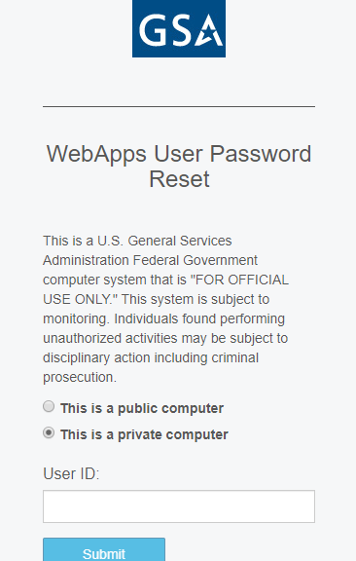
After entering a valid business objects user name you will be provided with a secure login number.
At the create new password screen, we suggest making your password at least 12 characters with one uppercase, one special character, and at least 1 number. Make sure you receive a confirmation notice that your password has changed. At this point exit the website.
Once you have received confirmation please wait 15 minutes before trying to log on to the business intelligence log in screen https://corporateapps.gsa.gov/applications/financial-apps/business-intelligence/ with your business intelligence user name and new password.
If you are continuing to have issues, please contact the Business Applications Service Desk and provide your business intelligence user id and the error message you are receiving.
Business Applications Service Desk Email: businessapps@gsa.gov
Business Applications Service Desk Phone Number: 866-450-6588
Your ticket will be assigned to a member of the Business Intelligence team who will provide further assistance.

Please note that an “Account Disabled” error message requires a different remedy so please ensure you convey the error message you are receiving in order to more efficiently trouble shoot the root cause of your login issue.

